**UNIVERSITY OF MINDANAO**

Matina, Davao City



**FINAL PLATE**

**___________________________**

**In Partial Fulfillment**

**of the Requirements for**

**BCES2 (7717) – Earthquake Engineering**

**_________________________________________**

**Submitted by:**

Pangapalan, Peter Gino A.

**Submitted to:**

Engr. Geffren Bernardo

Table of Contents

ACKNOWLEDGEMENT 4

INTRODUCTION 5

ARCHITECTURAL AND STRUCTURAL PLANS 6

HAZARD HUNTER, SHORT AND LONG PERIOD 24

SEISMIC PARAMETERS 37

SOLUTIONS ( CENTER OF MASS AND RIGIDITY ) 39

TABULATION WEIGHT AND RIGIDITY 64

CENTER OF MASS, CENTER OF RIGIDITY 65

ECCENTRICITY 65

COMPUTATION OF BASE SHEAR BASED ON STATIC PROCEDURE 66

PARAMETERS 67

NV,NA,CV,CA,T 68

BASE SHEAR, STOREY LATERAL FORCE 69

DIRECT AND TORSIONAL COEFFICIENT 71

STRUCTURAL ANALYSIS USING ( PORTAL,CANTILEVER AND FACTOR METHOD) 76

FRAME 1 77

PORTAL METHOD OF ANALYSIS 78

CALCULATION: 78

DIAGRAMS: 83

TABULATION OF FORCES: 86

CANTILEVER METHOD OF ANALYSIS: 90

CALCULATION 90

DIAGRAMS 95

TABULATION OF FORCES: 98

FACTOR METHOD OF ANALYSIS: 102

CALCULATION: 102

DIAGRAMS 116

TABULATION OF FORCES 119

FRAME C 123

PORTAL METHOD OF ANALYSIS 124

CALCULATION: 124

DIAGRAMS 129

TABULATION OF FORCES: 132

CANTILEVER METHOD OF ANALYSIS 137

CALCULATION: 137

DIAGRAMS 144

TABULATION OF FORCES: 147

FACTOR METHOD OF ANALYSIS 152

CALCULATION: 152

DIAGRAMS 166

TABULATION OF FORCES: 169

# ACKNOWLEDGEMENT

In carrying out our ultimate assignment, we had to rely on the guidance and assistance of someone deserving of our profoundest appreciation. We would like to extend our heartfelt thanks to everyone who showed up, believed in our abilities and offered unwavering faith in our potential to successfully complete this project.

Foremost, our sincerest thanks and appreciation go to our Earthquake Engineering professor, Engr. Geffren D. Bernardo, whose support enabled us to complete these Plates. His guidance allowed us to deeply understand the coursework, an asset to us as budding engineers. The knowledge we've gained will surely be utilized in our future work. We are likewise grateful for his patience while he waited for our progress.

Next, we wish to express our heartfelt appreciation to our families for their emotional and financial backing. Their constant encouragement and unwavering faith gave us the courage to see this project through to the end. Additionally, we are thankful for our classmates and friends who joined us in this journey. Their excellent cooperation and steadfast support were invaluable.

Our friends deserve a special mention; their constant support and reminders to take breaks and have fun in stressful times made this challenging task far more manageable. We couldn't be more grateful.

Lastly, we want to express our deepest appreciation to our benevolent Heavenly Father, who guided us, provided us with the necessary strength to accomplish this task, and kept us safe from all harm and peril.

# INTRODUCTION

An earthquake is an abrupt shifting of rocky materials below the Earth's crust, leading to anything from mild to severe tremors. While the movement of tectonic plates primarily causes earthquakes, smaller seismic activities can result from volcanic eruptions, collapse of surface or subsurface rock formations, or underground explosions. These sudden ground shakes pose significant threats to man-made structures.

A resource titled "The Constructor" explains that one seismic effect harmful to buildings is the inertia force produced within a structure during an earthquake. When an earthquake occurs, the base of a building shakes, but the roof initially remains still. However, due to its attachment to the walls and columns, the roof is eventually pulled along with the building's base. Ammon (2019) further clarifies that this inertial shearing of the structure can stress weak walls and joints, leading to structural failure or even complete collapse. The shaking frequency and type depend on the structure itself.

To make constructions earthquake-resistant, materials resilient to seismic activities are employed. For instance, wood and concrete possess varying degrees of earthquake resistance. Concrete structures should preferably incorporate concrete slabs or steel, whereas wooden structures need to be firmly anchored to their foundations. Ensuring the safety of our buildings and homes from earthquakes is paramount. We need to prioritize preventing the loss of lives over property damage. Making our structures virtually earthquake-proof can circumvent such issues.

Earthquake engineering is a comprehensive approach to ensure infrastructure resilience in a seismically unpredictable future. It is an interdisciplinary field incorporating structural engineering, structural dynamics, seismology, materials engineering, geotechnical engineering, risk and decision analysis, and probability and reliability theory ("Exponent," n.d.). Heoc (2021) defines earthquake engineering as an interdisciplinary engineering field that considers seismic activities in the design and analysis of structures such as buildings and bridges. The primary aim is to make structures more earthquake-resistant.

Every nation should prioritize earthquake engineering as it can mitigate the impact of earthquakes, including landslides, soil liquefaction, tsunamis, and structural damage to buildings, bridges, and highways. By constructing new structures capable of enduring intense ground shaking, earthquake engineering helps reduce the risk of disasters that populations face.

# ARCHITECTURAL AND STRUCTURAL PLANS

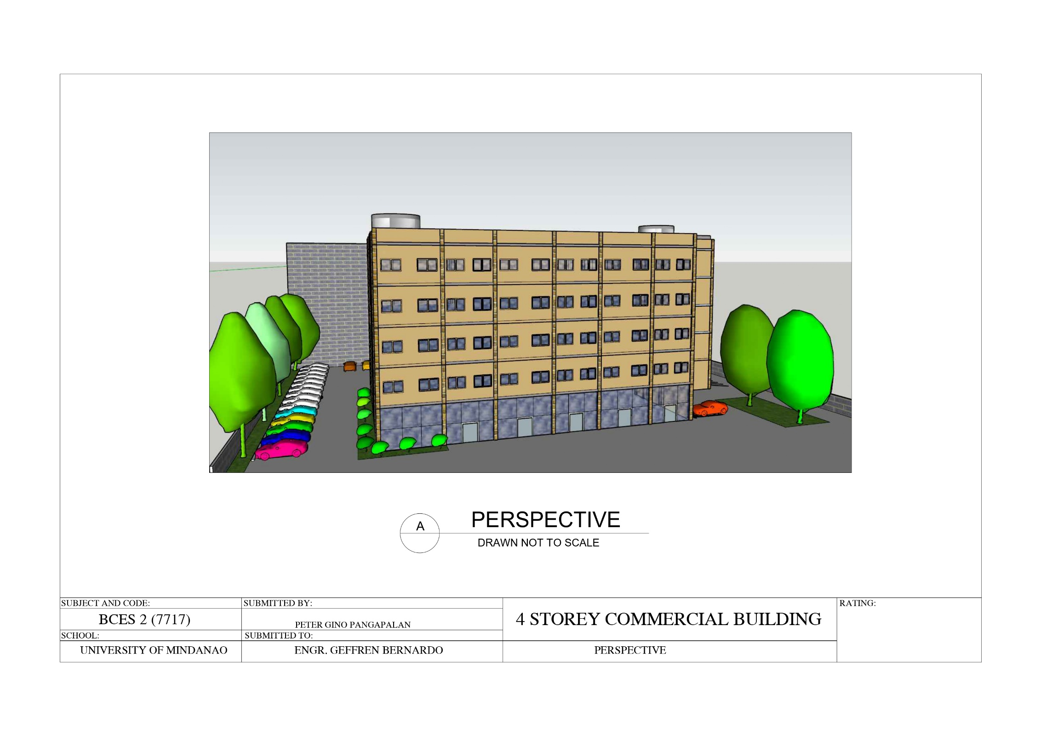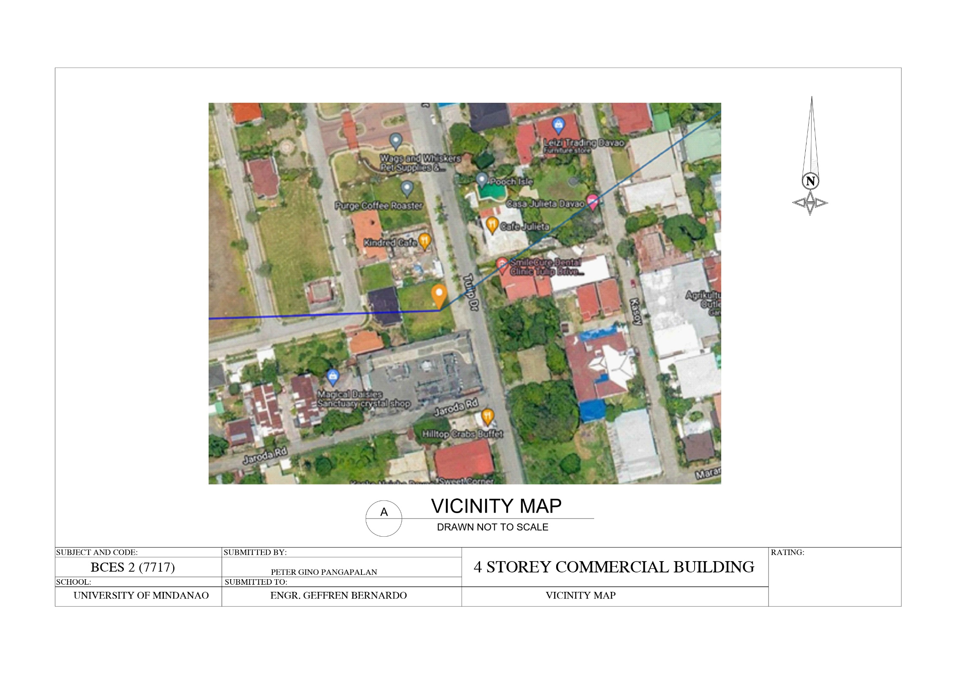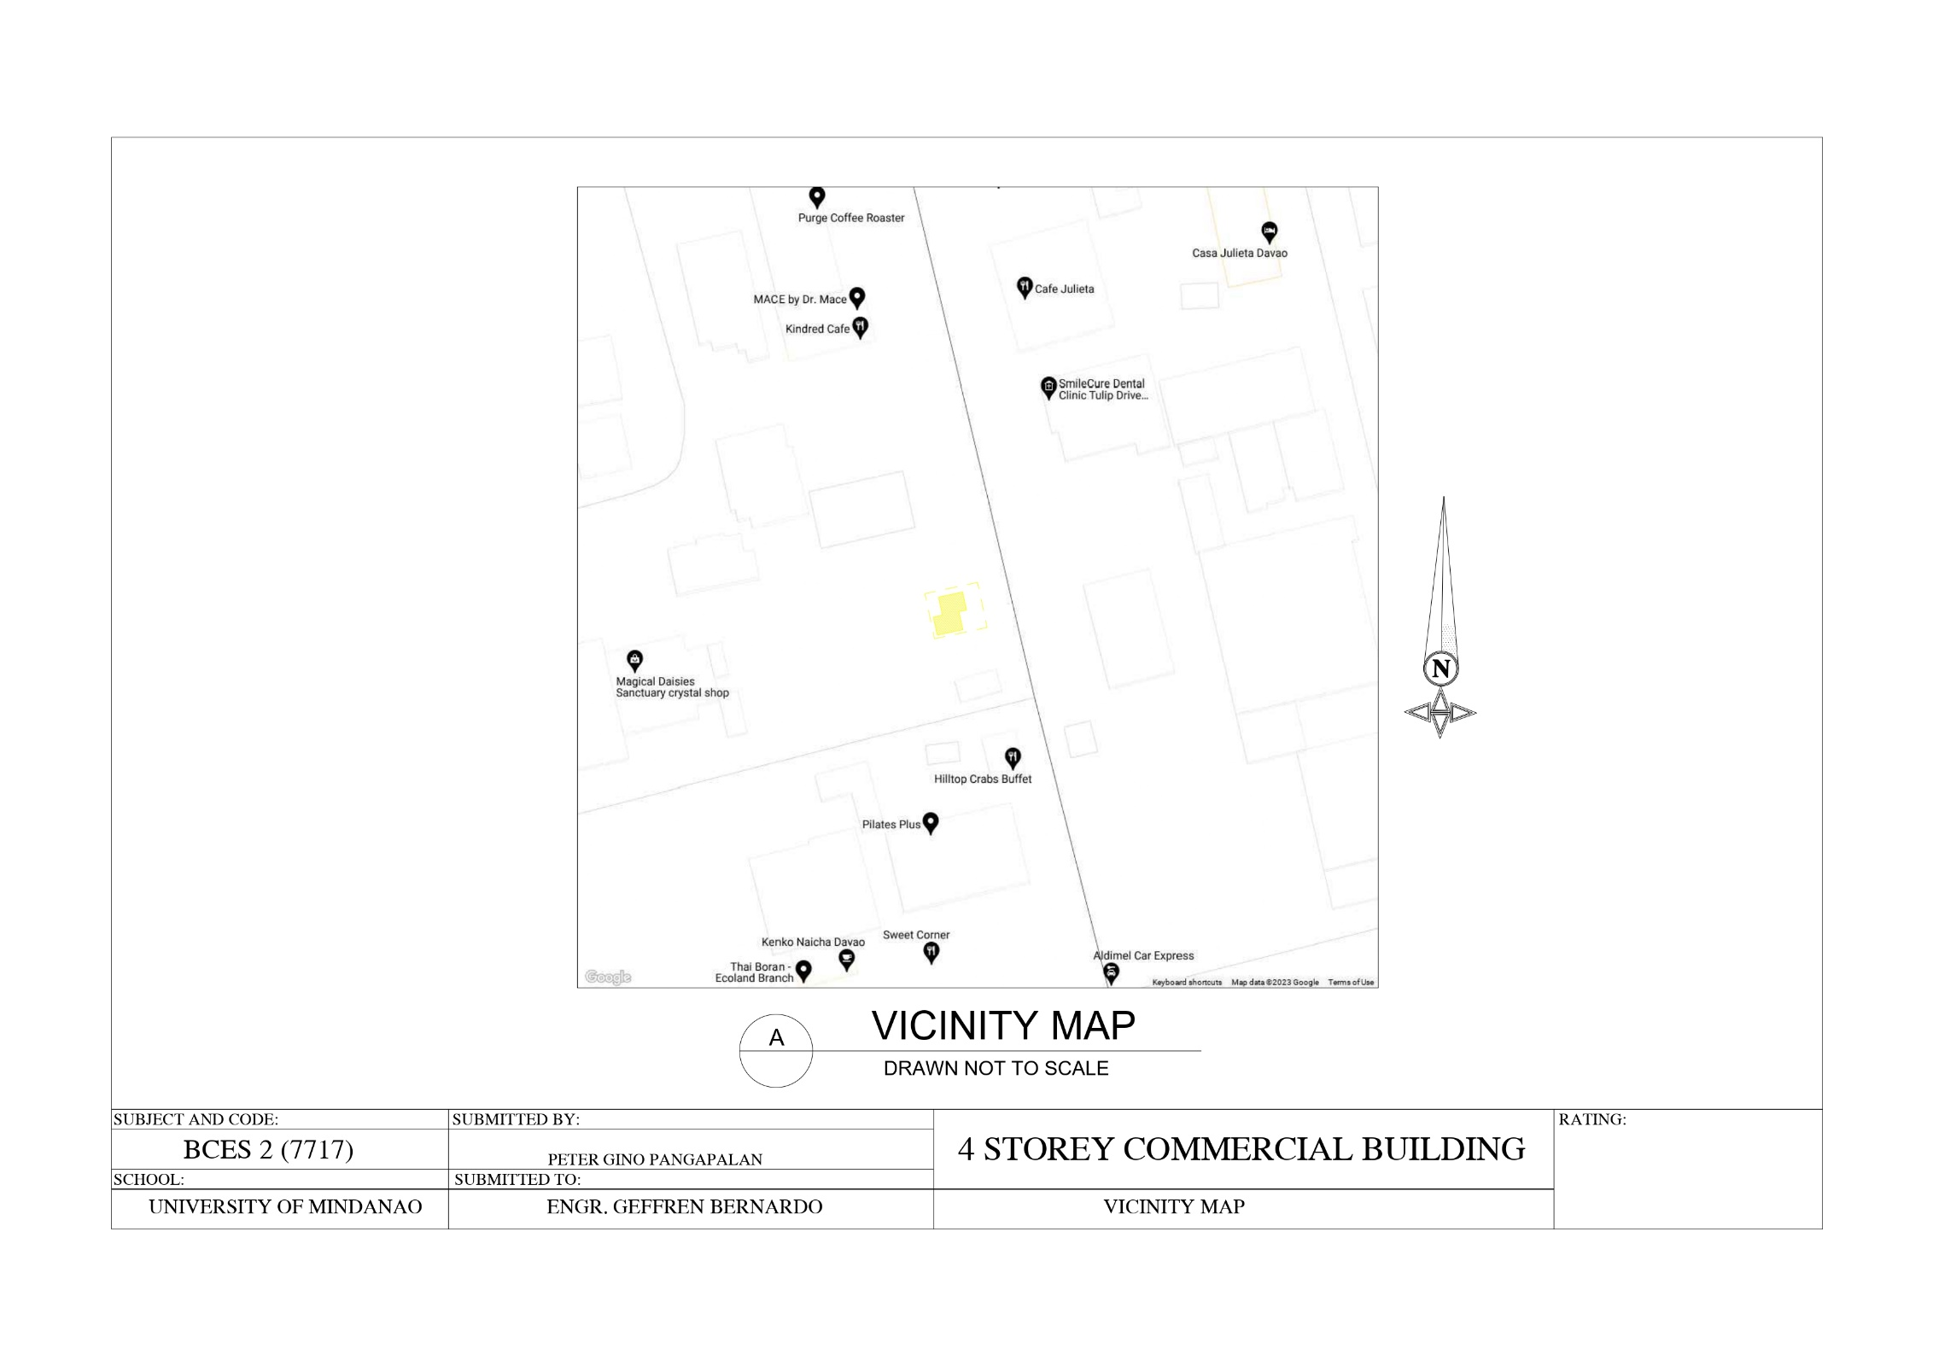

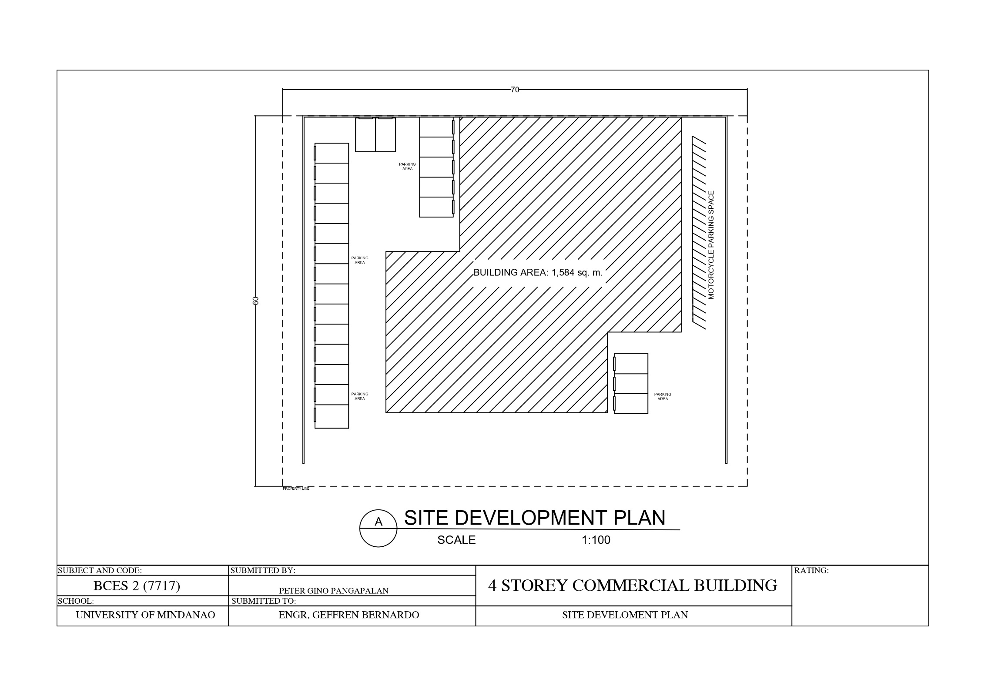

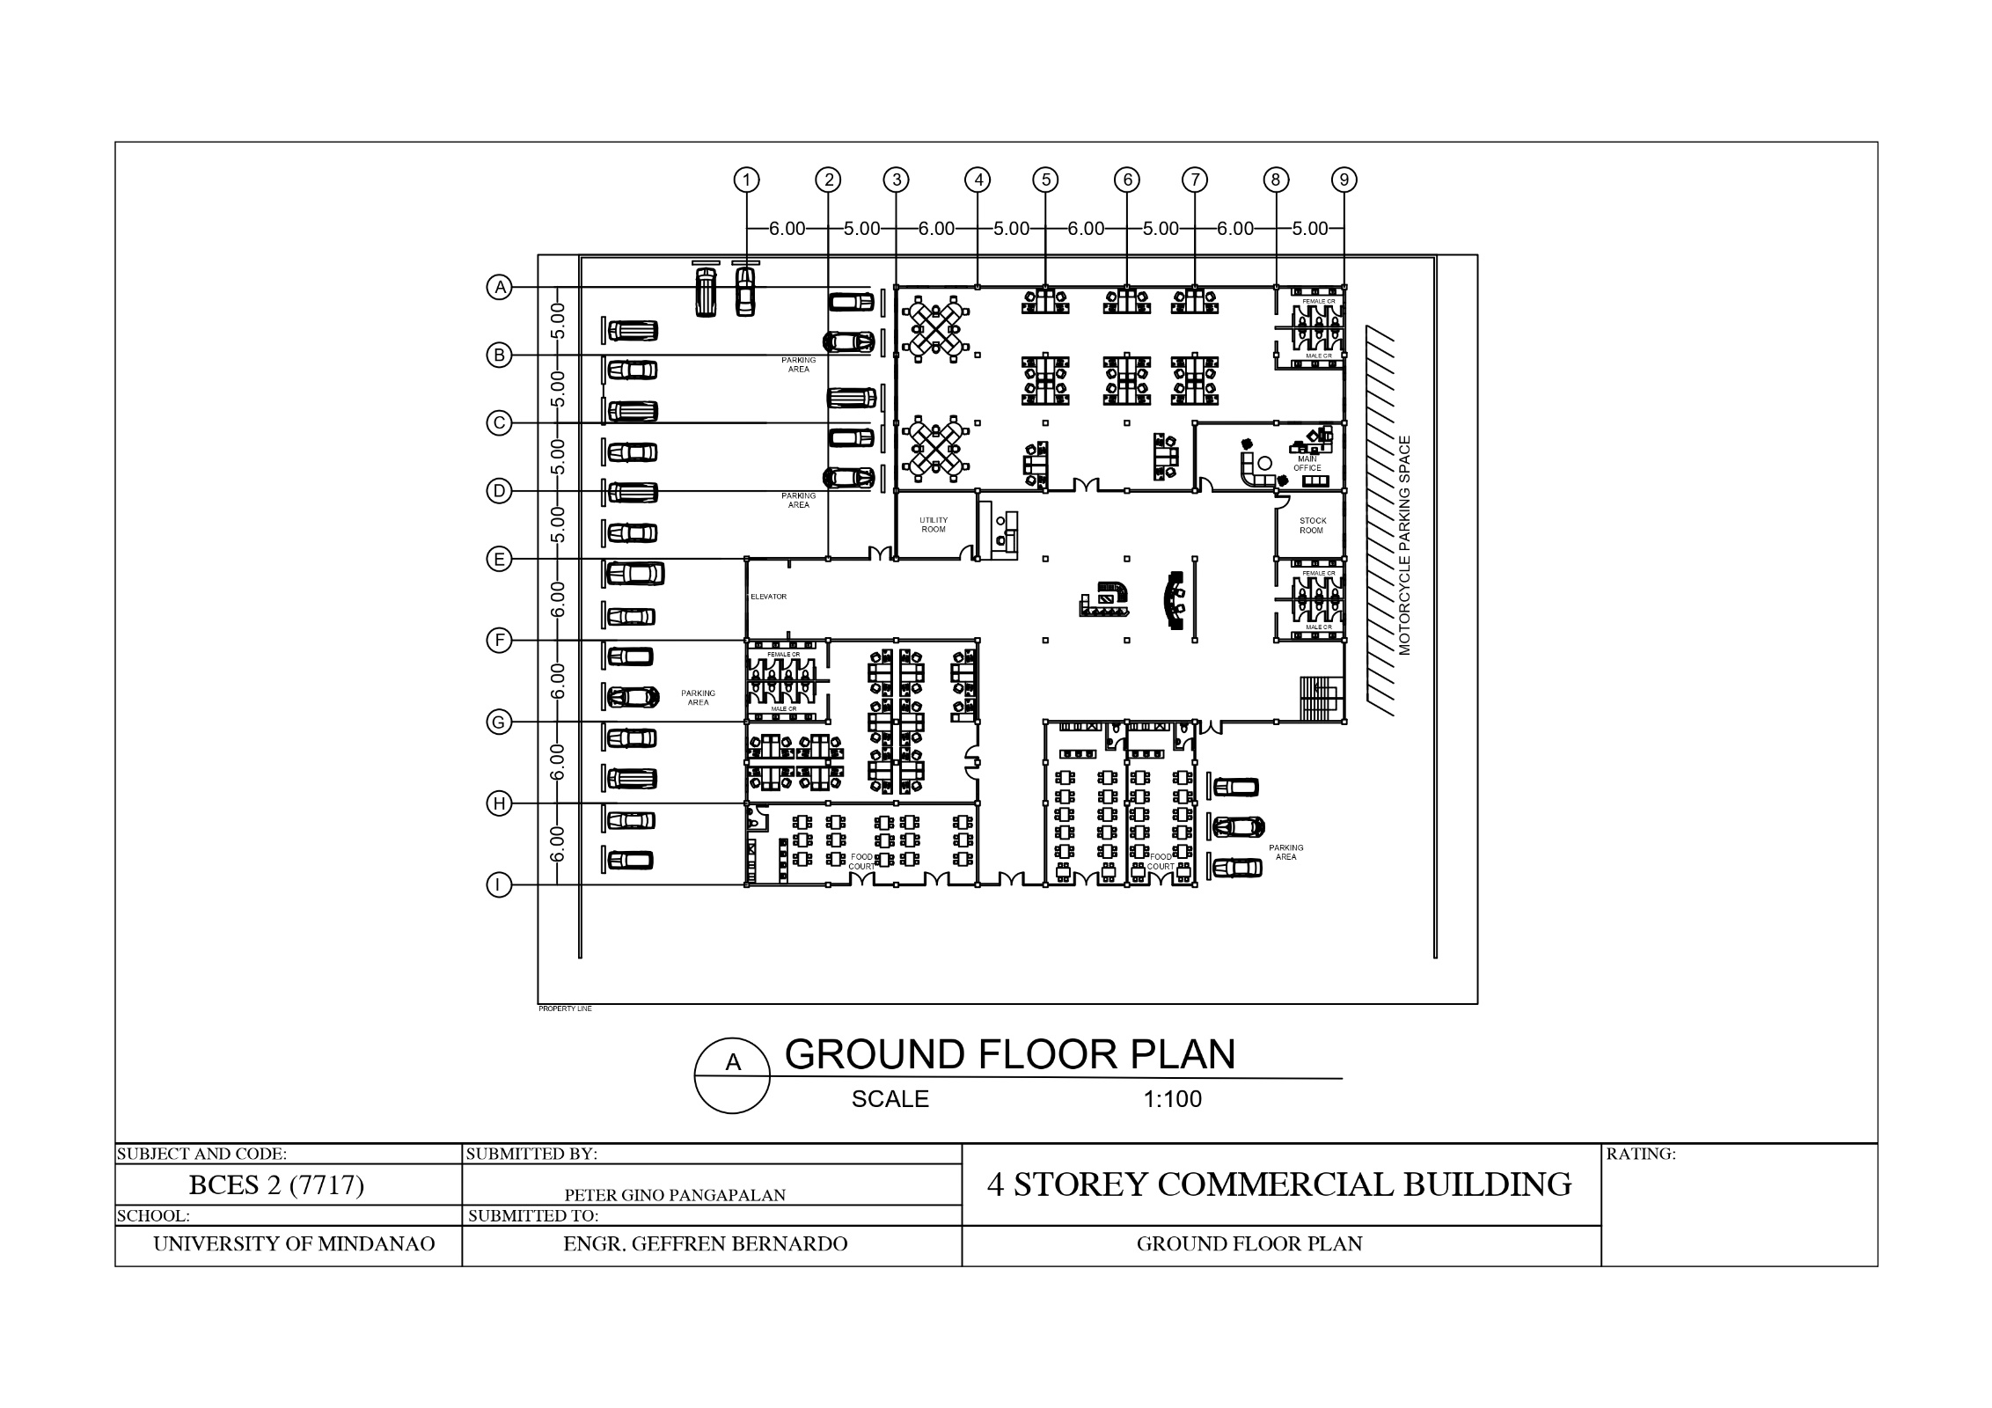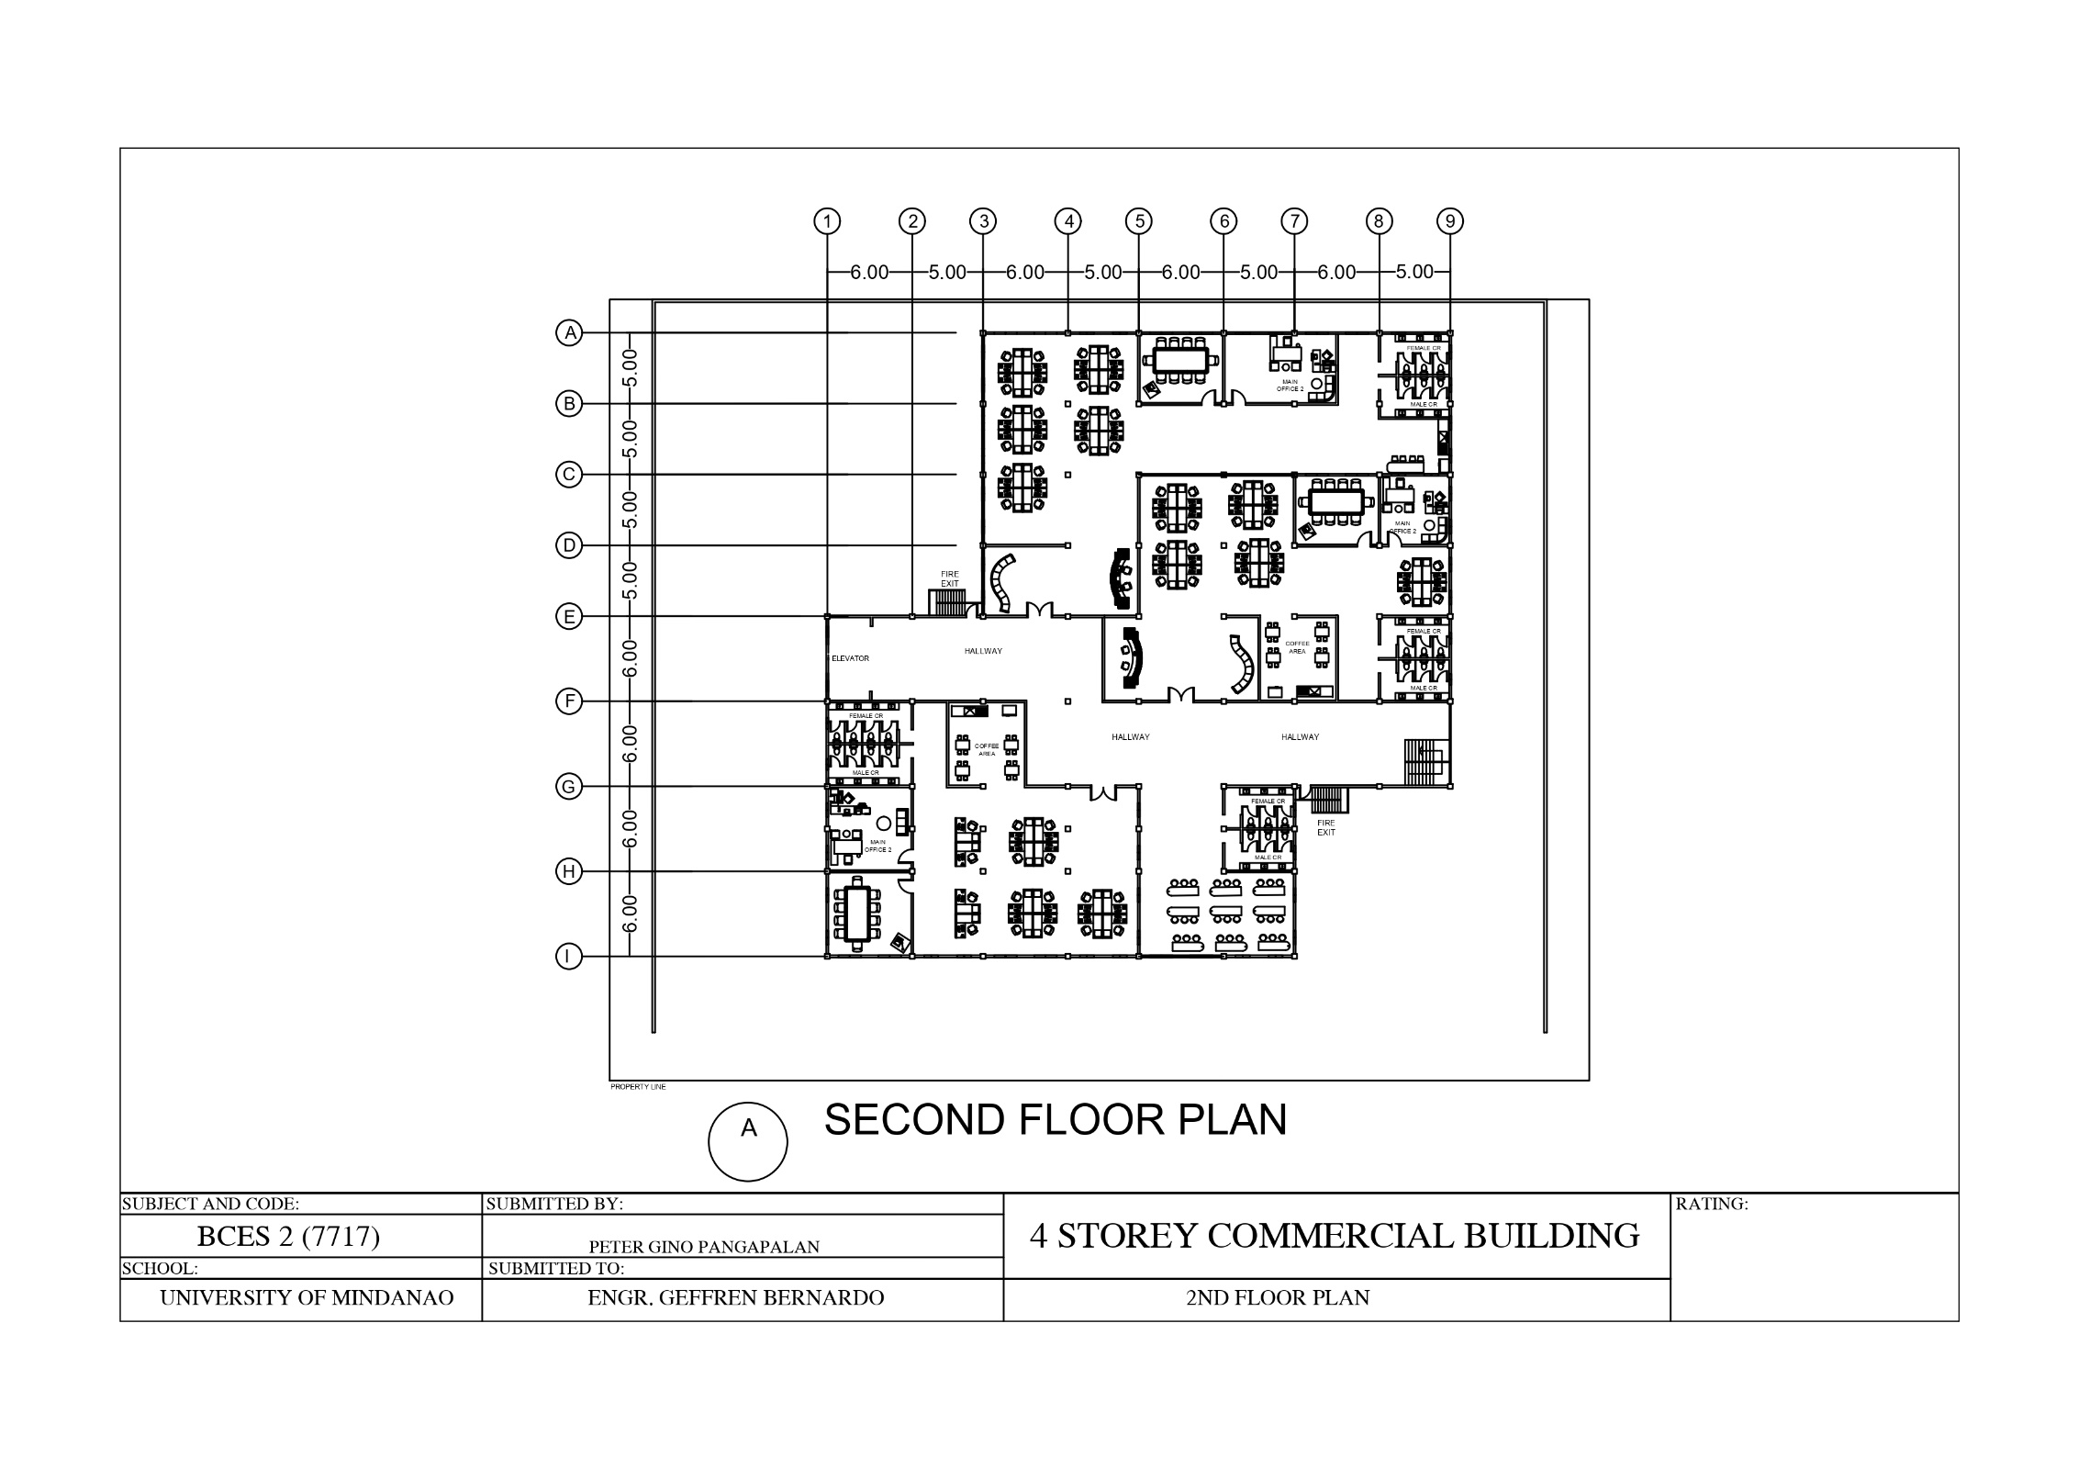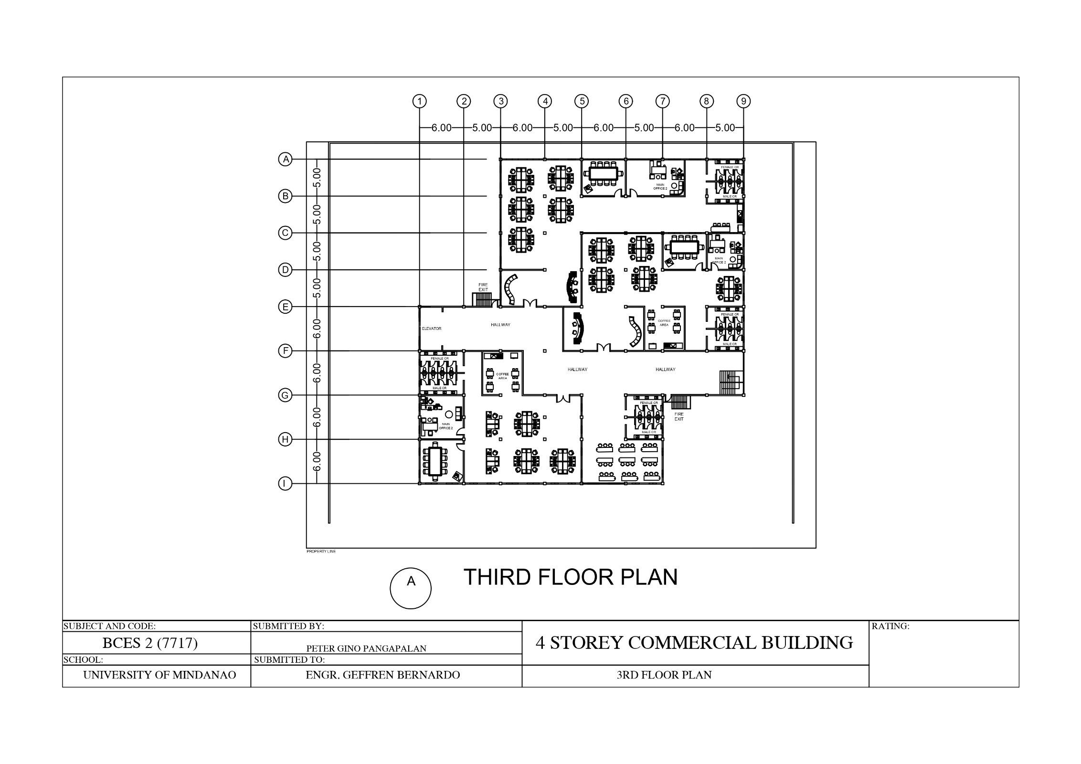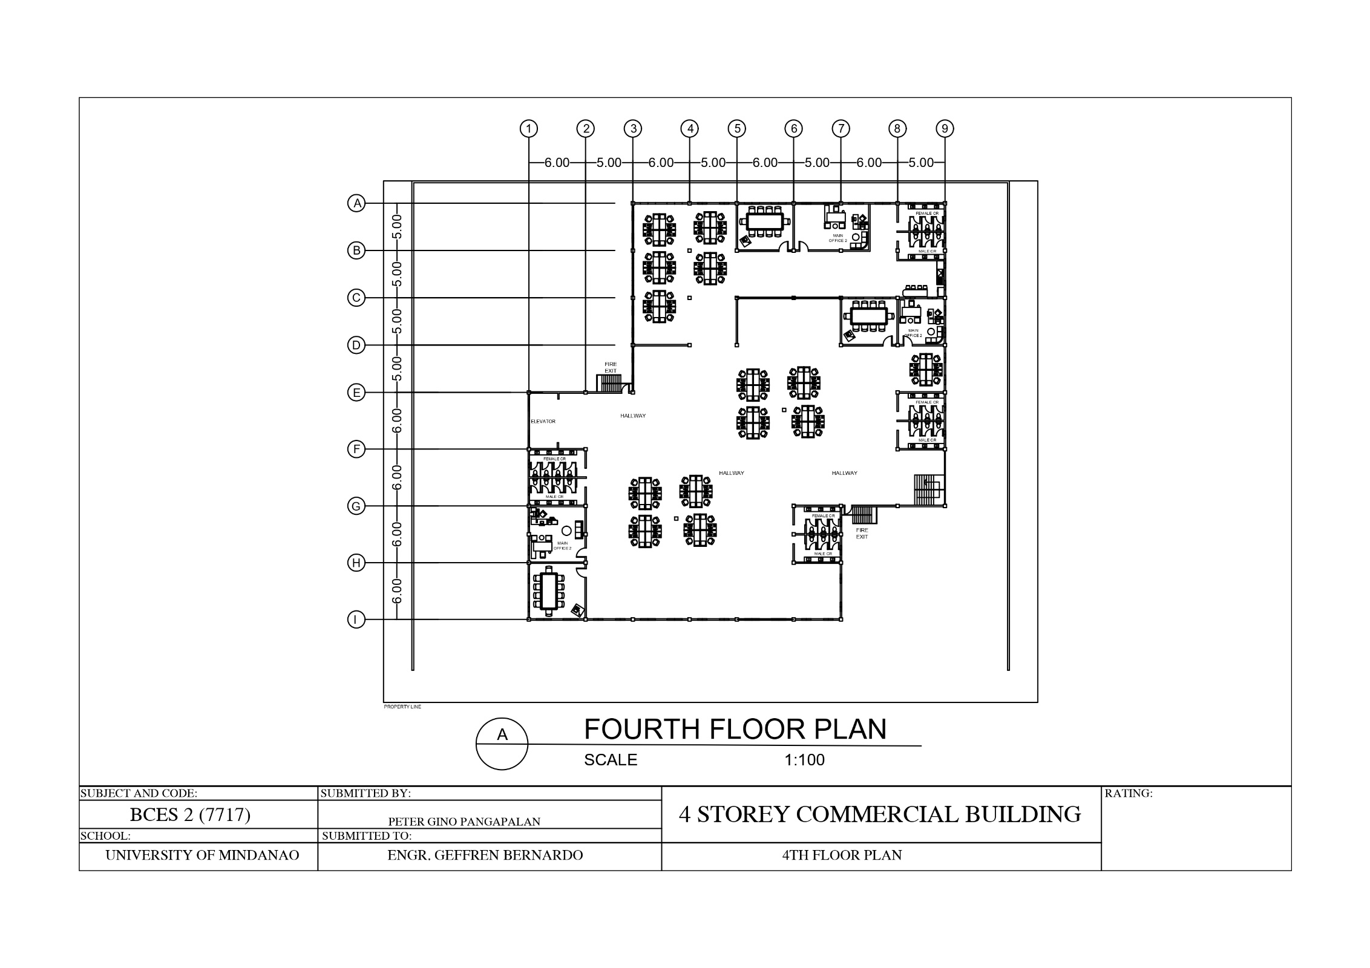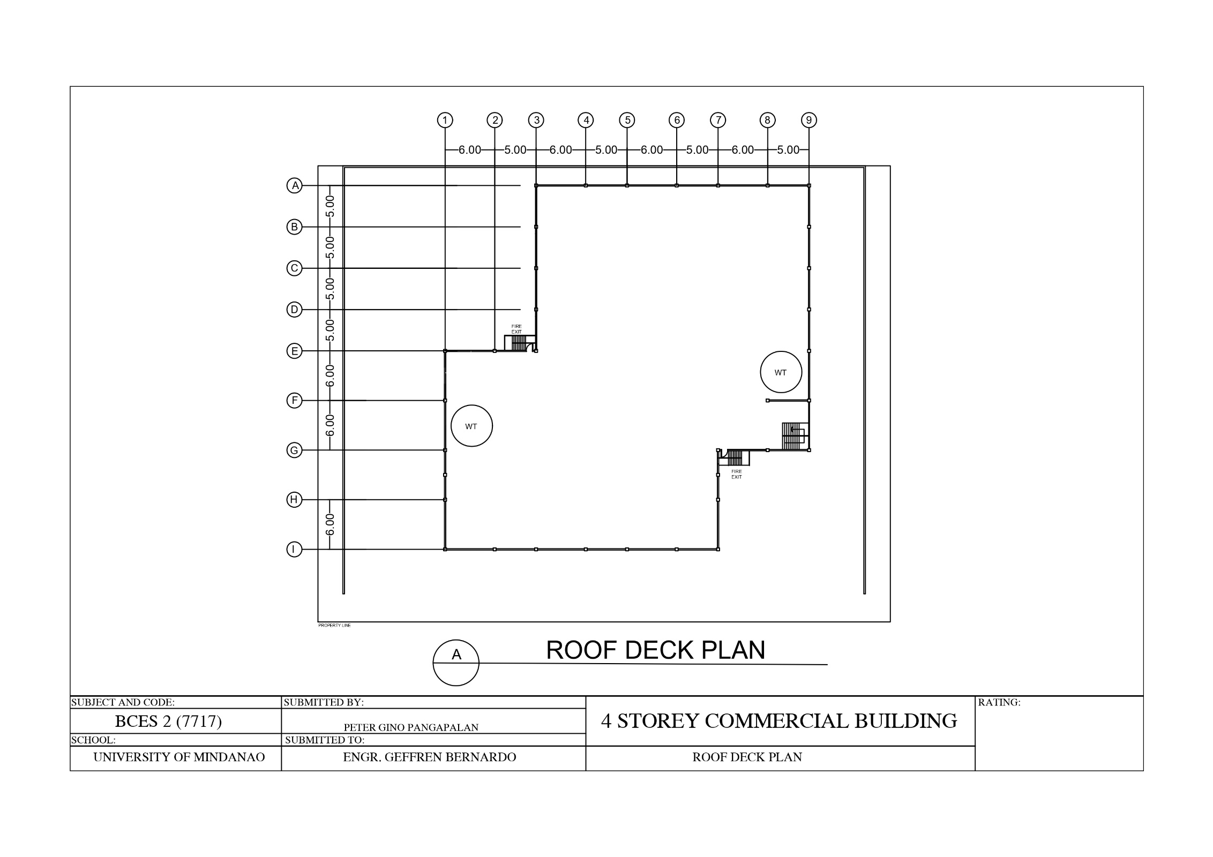 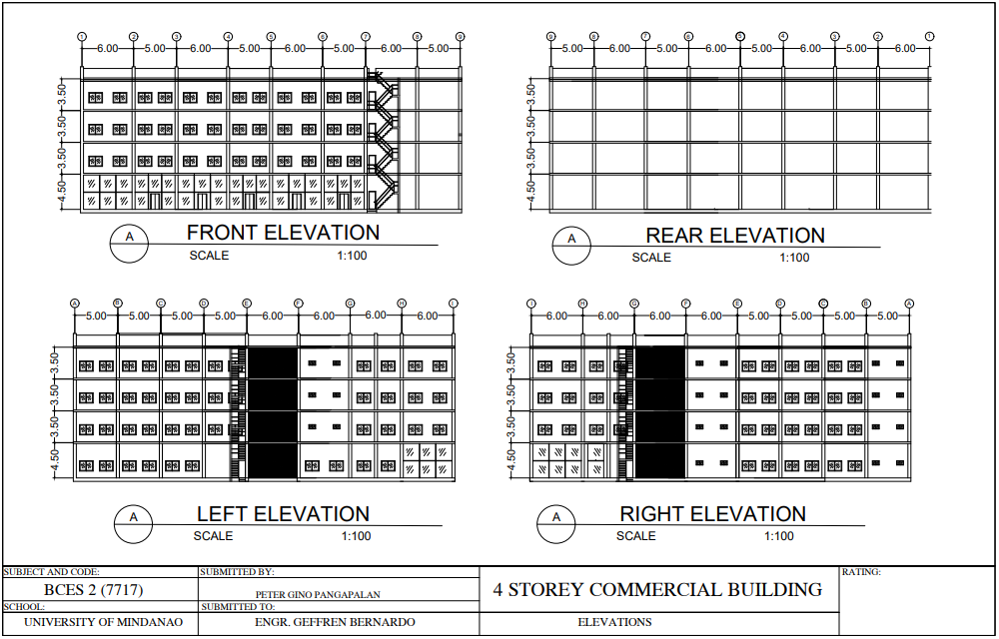

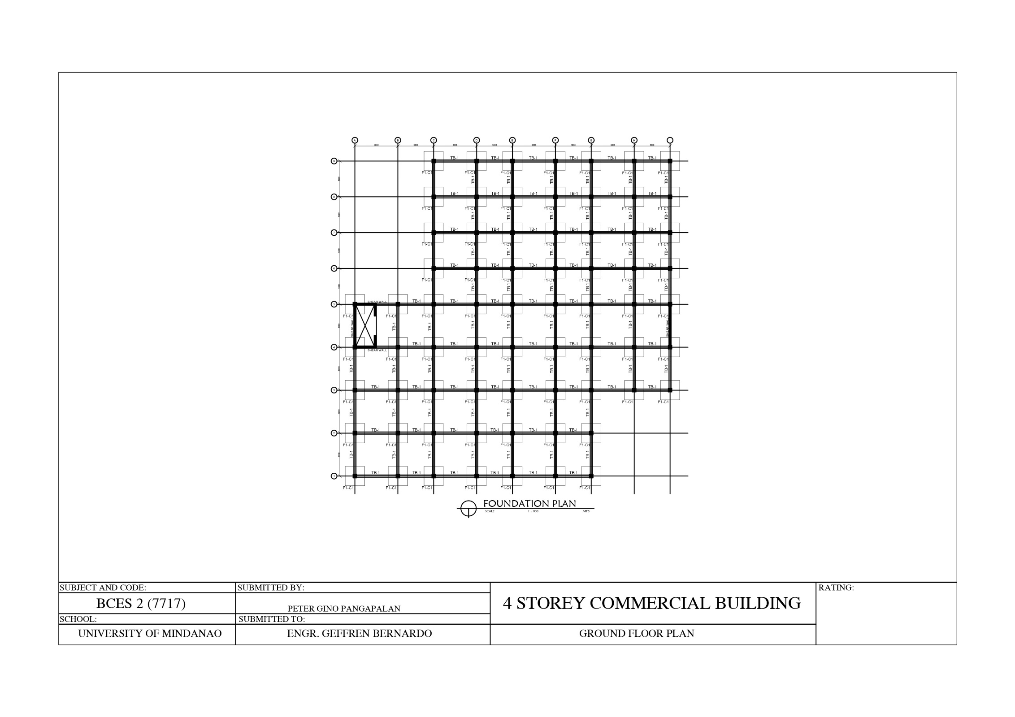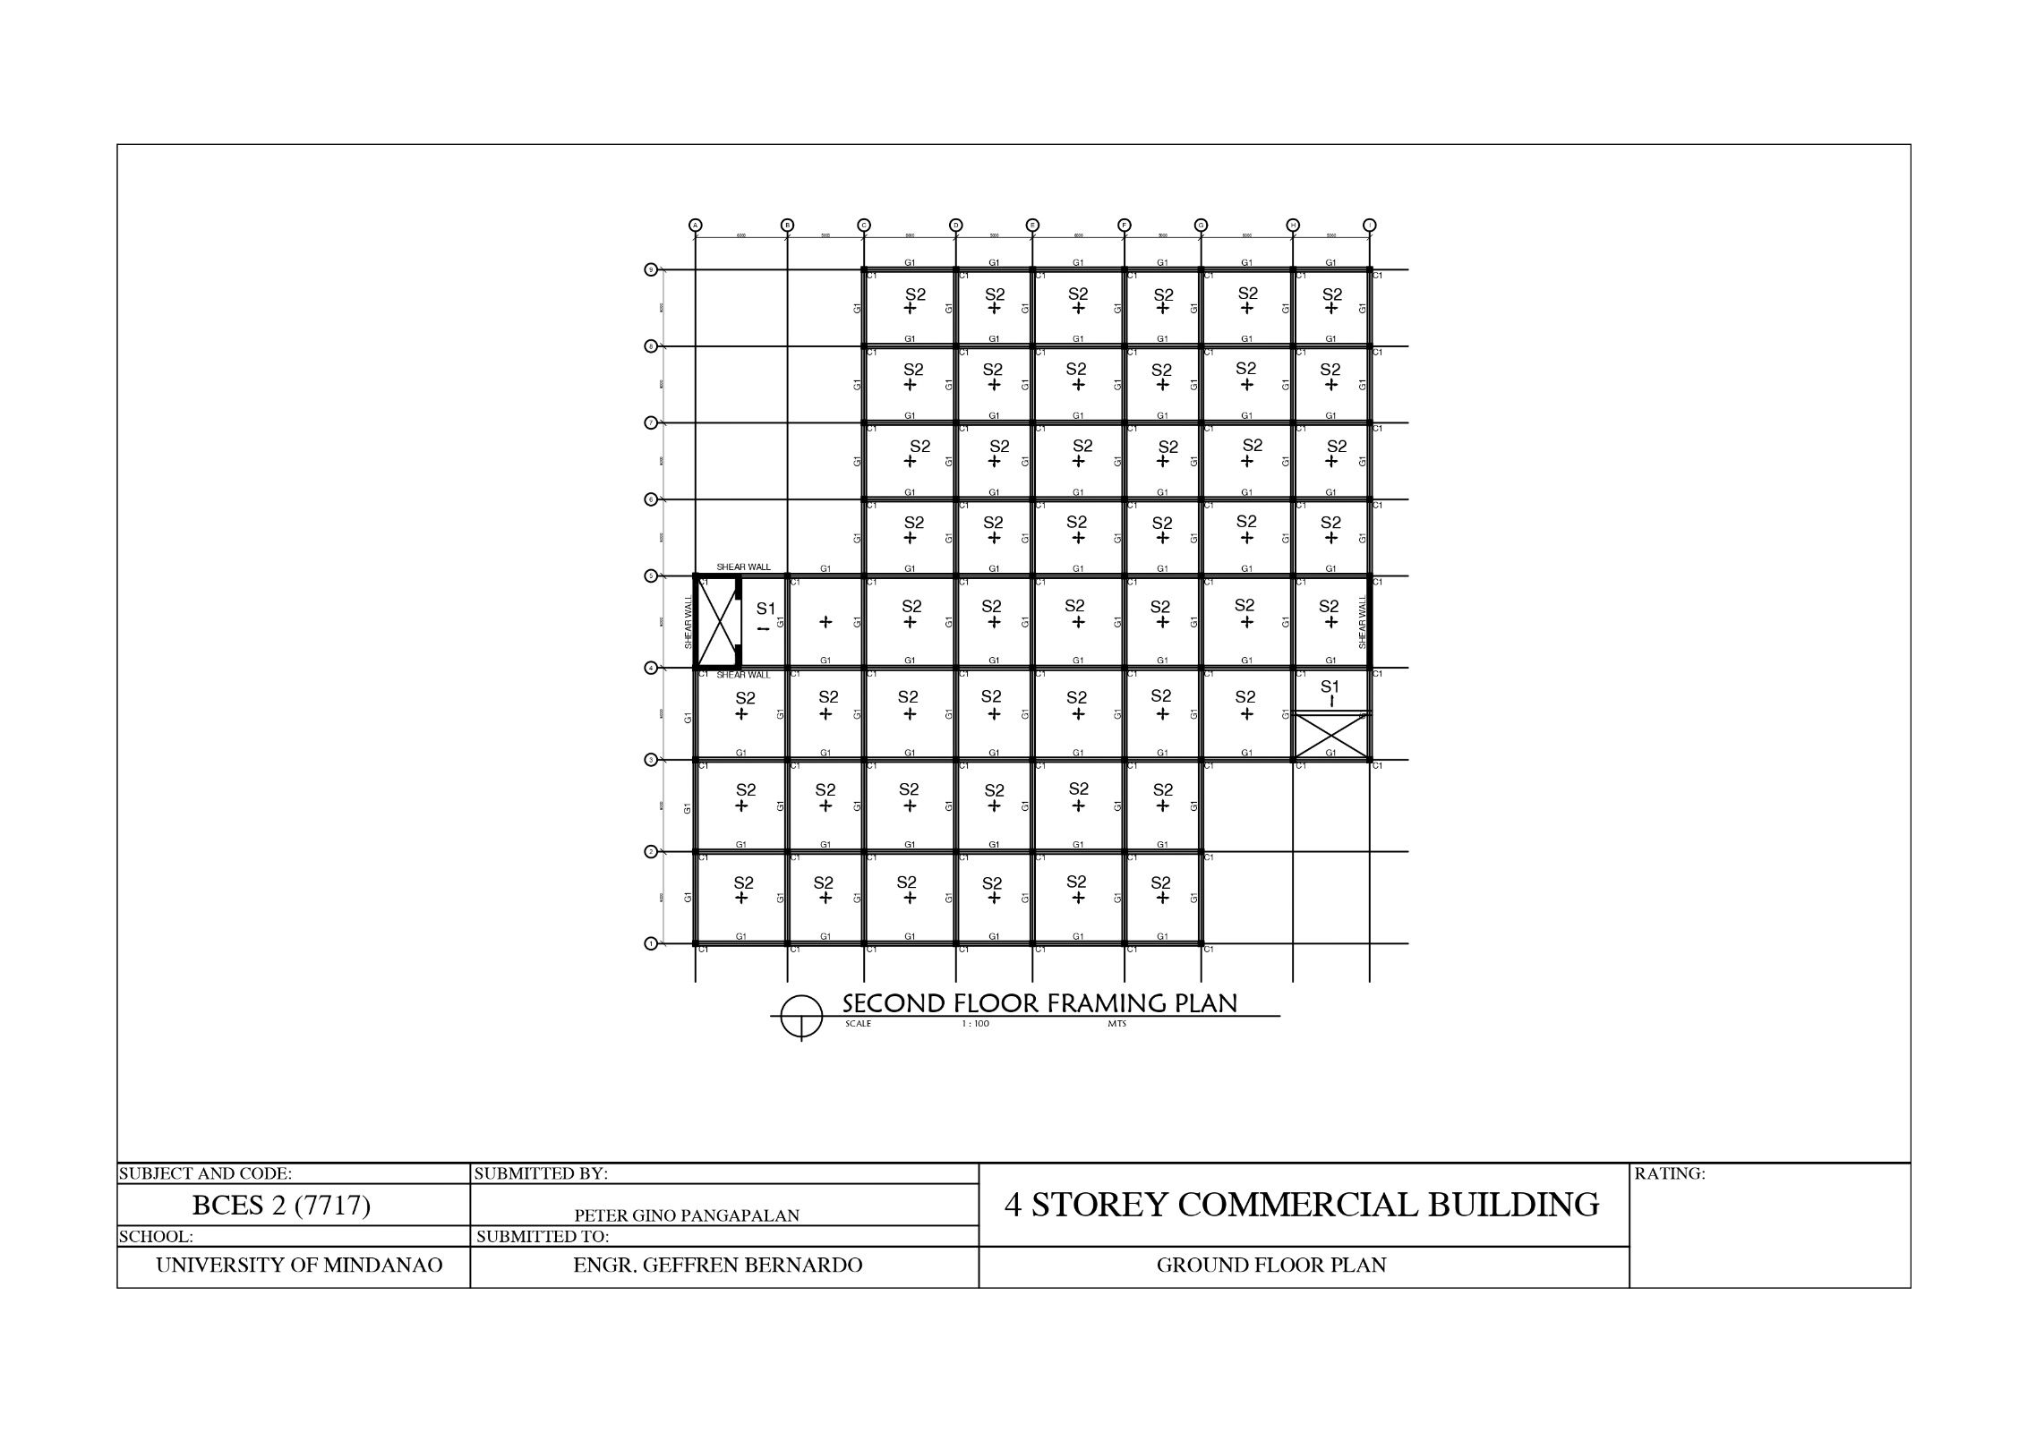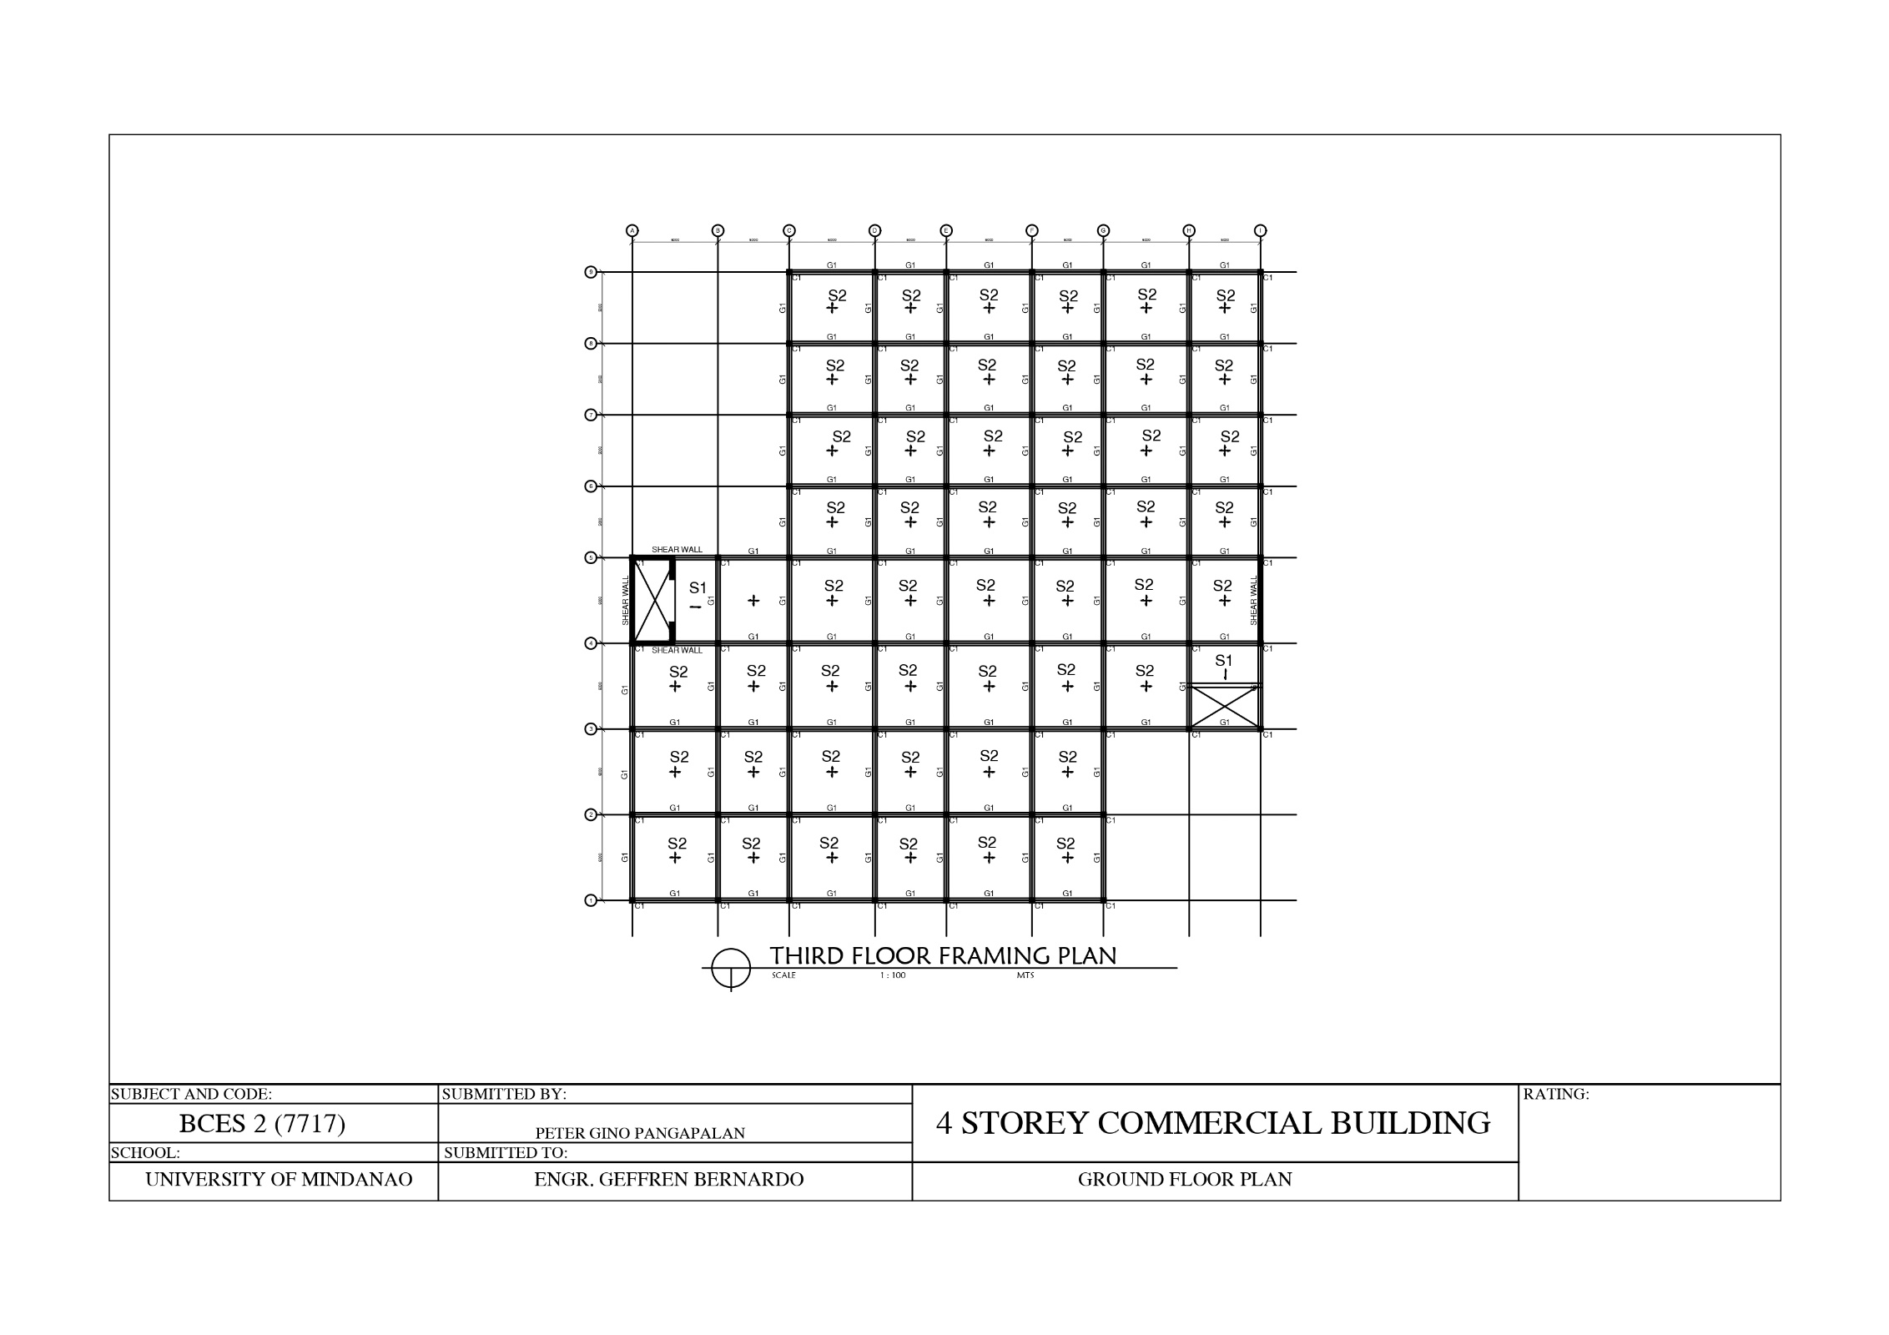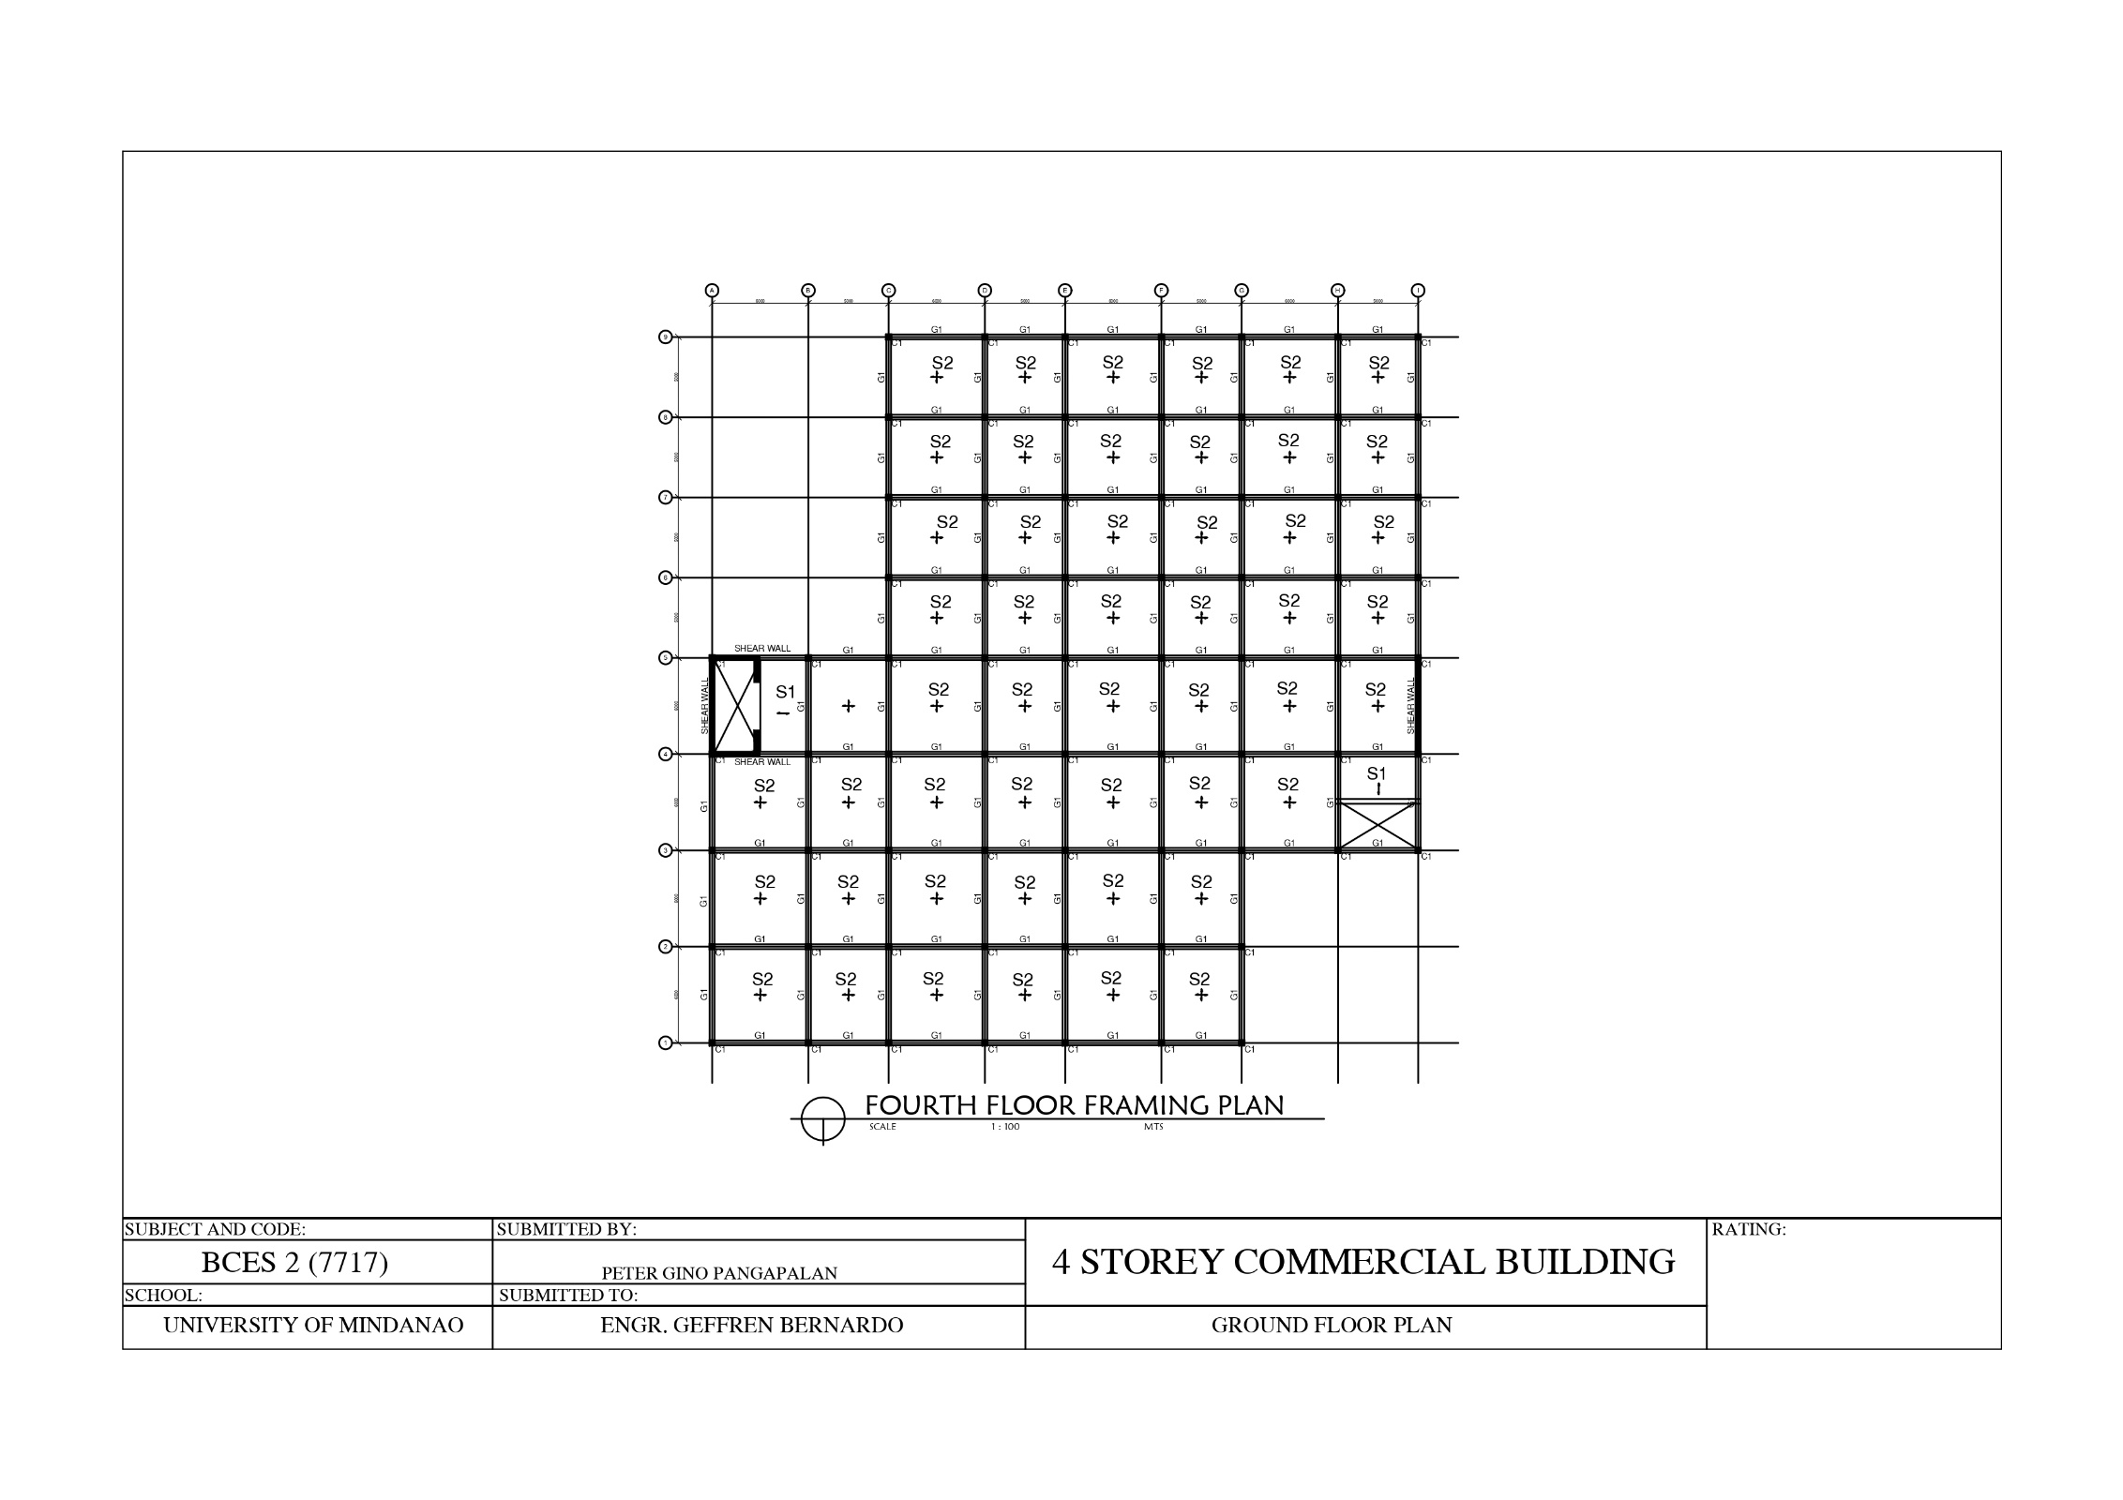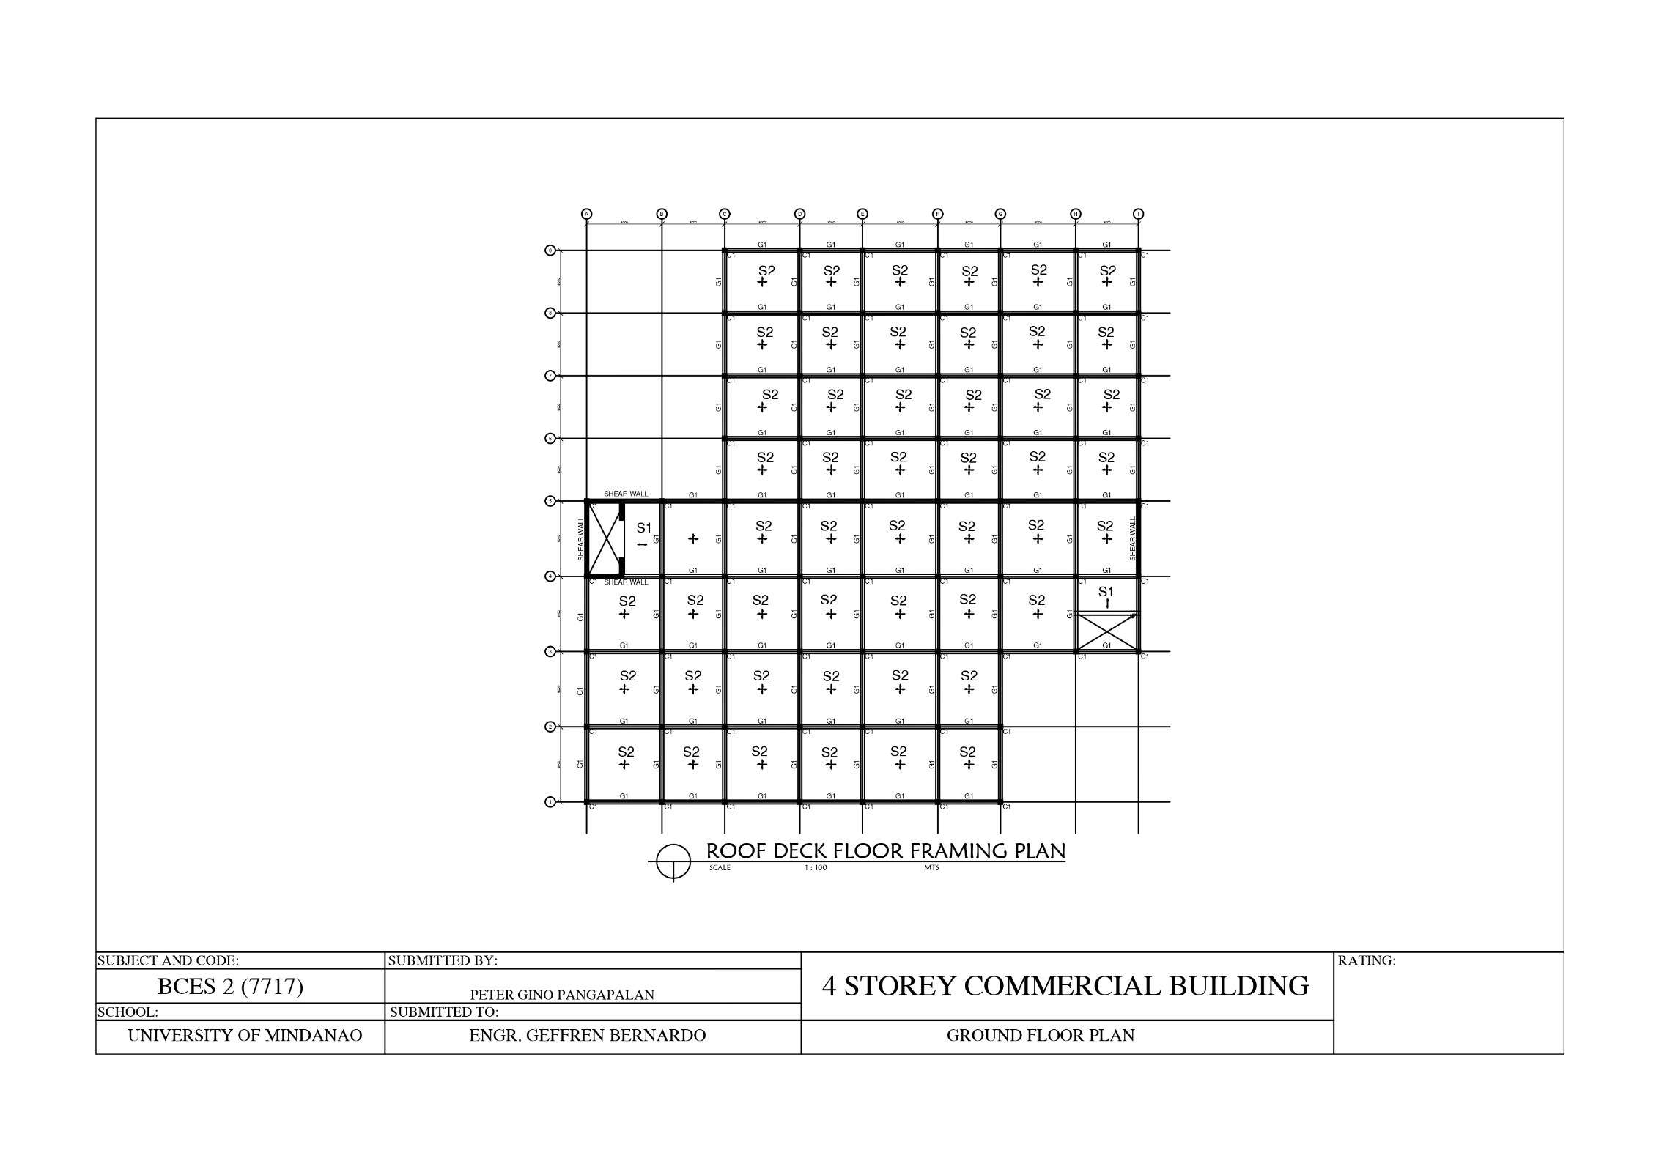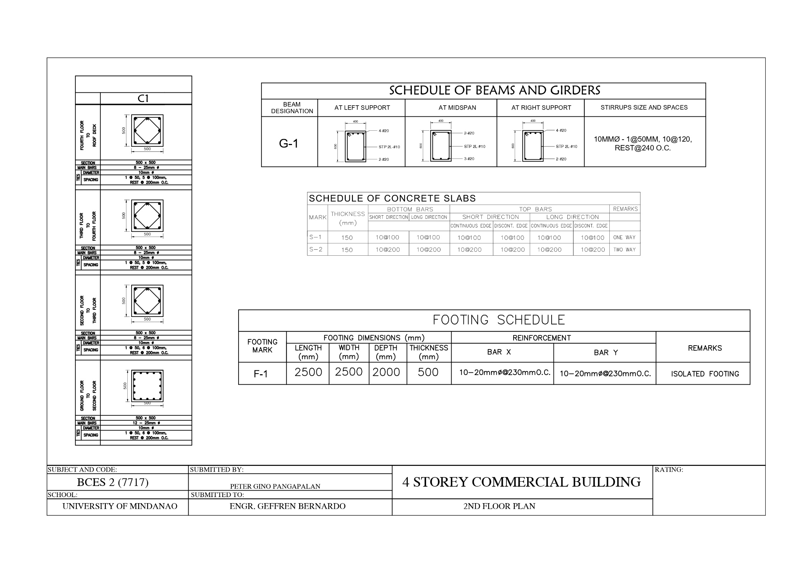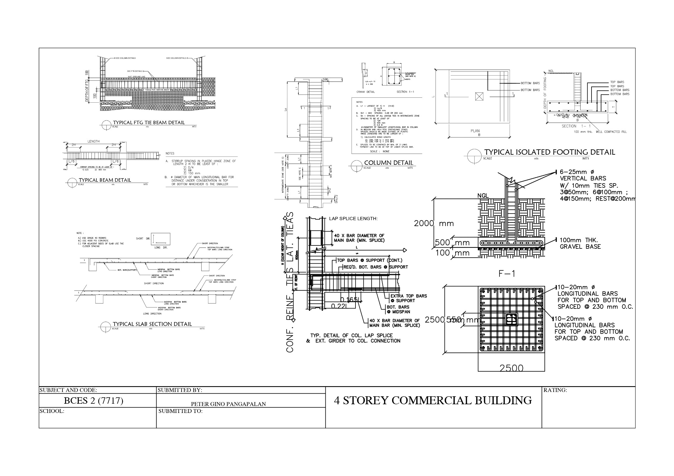

# HAZARD HUNTER, SHORT AND LONG PERIOD

**VICINITY MAP FROM HAZARD HUNTER**

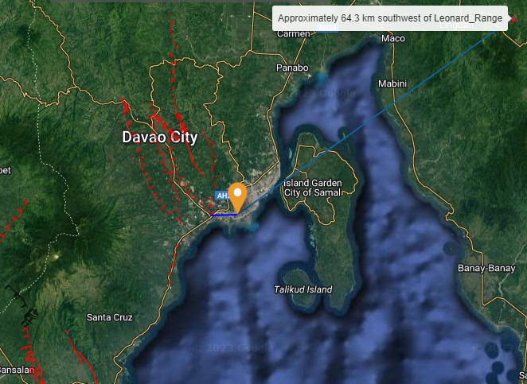

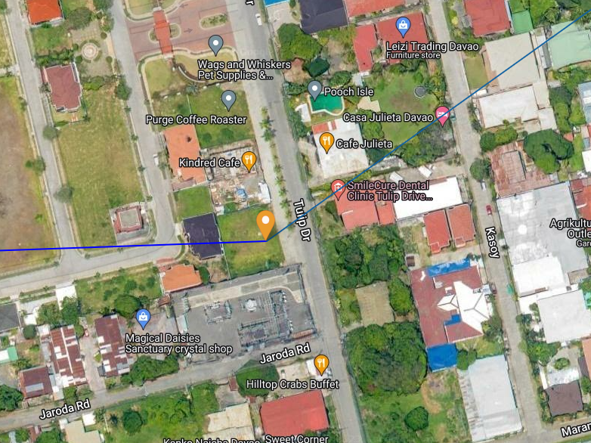

**COORDINATES:**

**7° 3' 24.43", 125° 35' 19.42"**

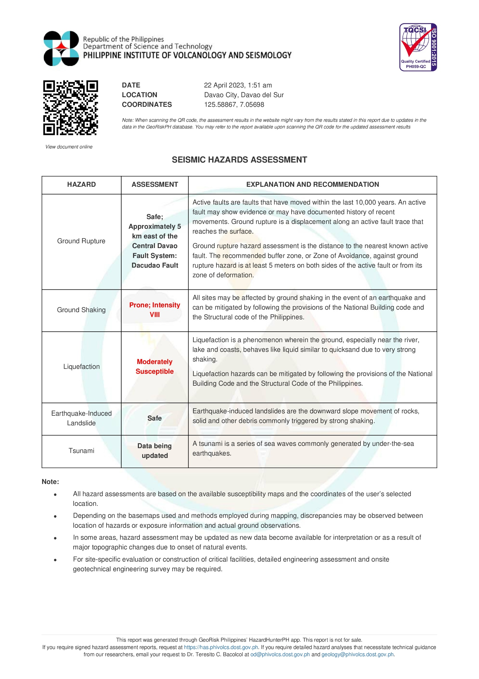

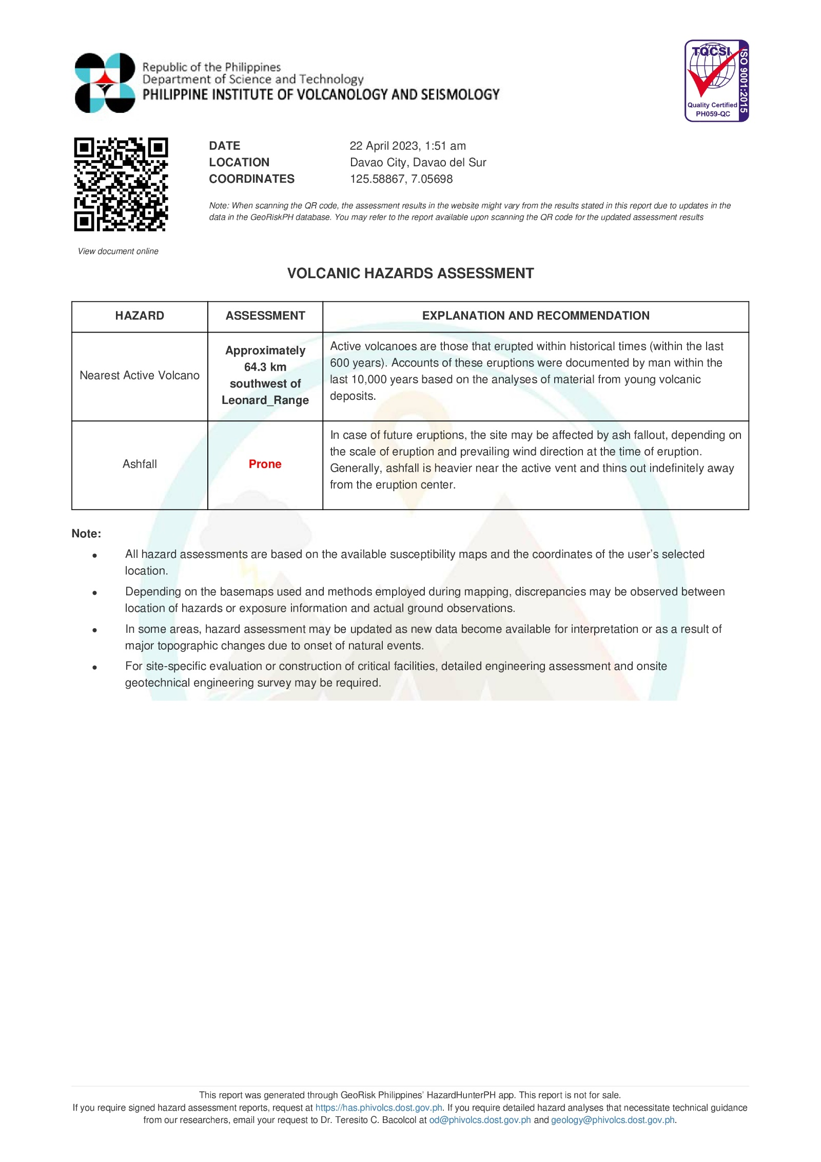

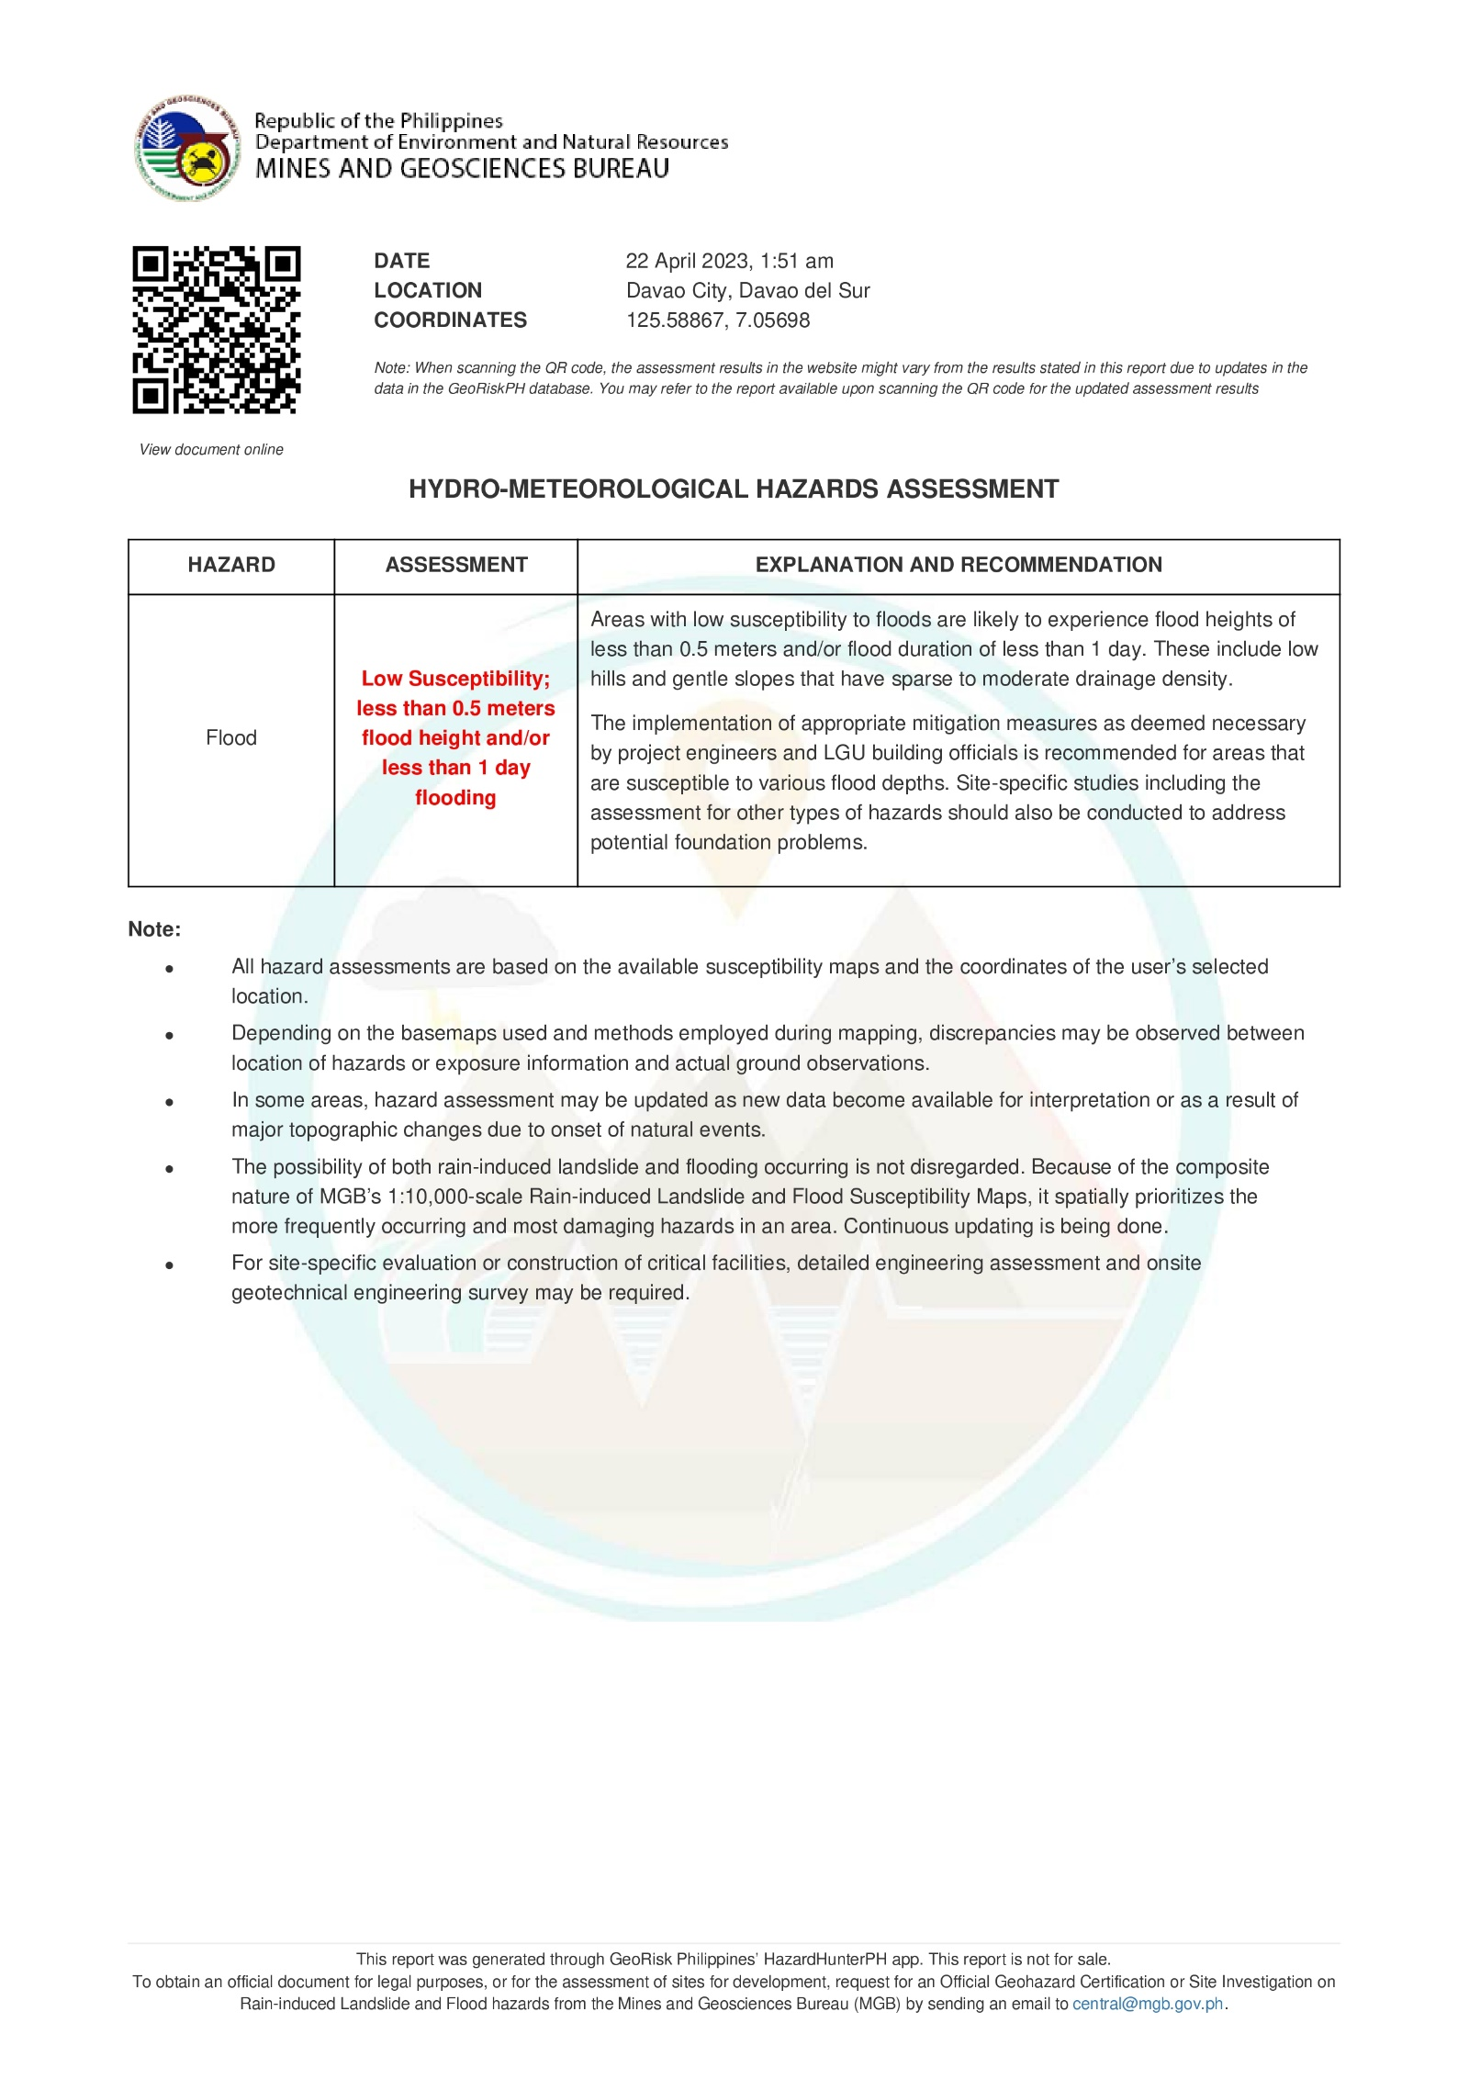

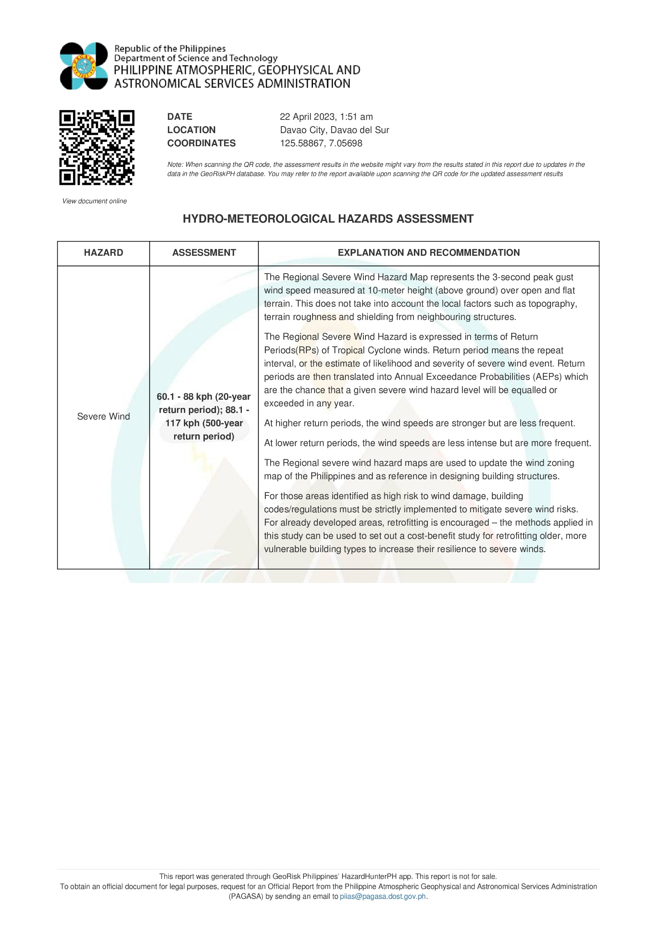

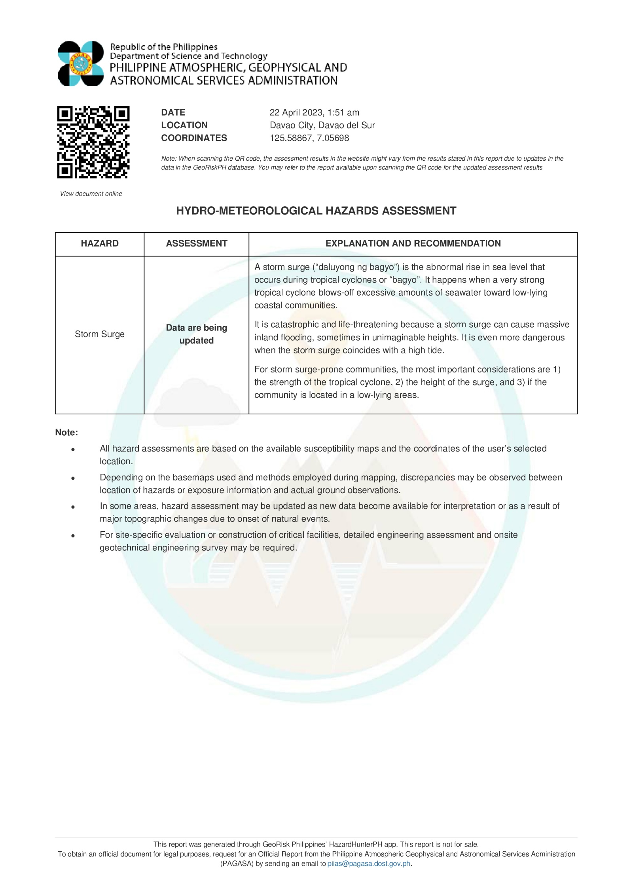

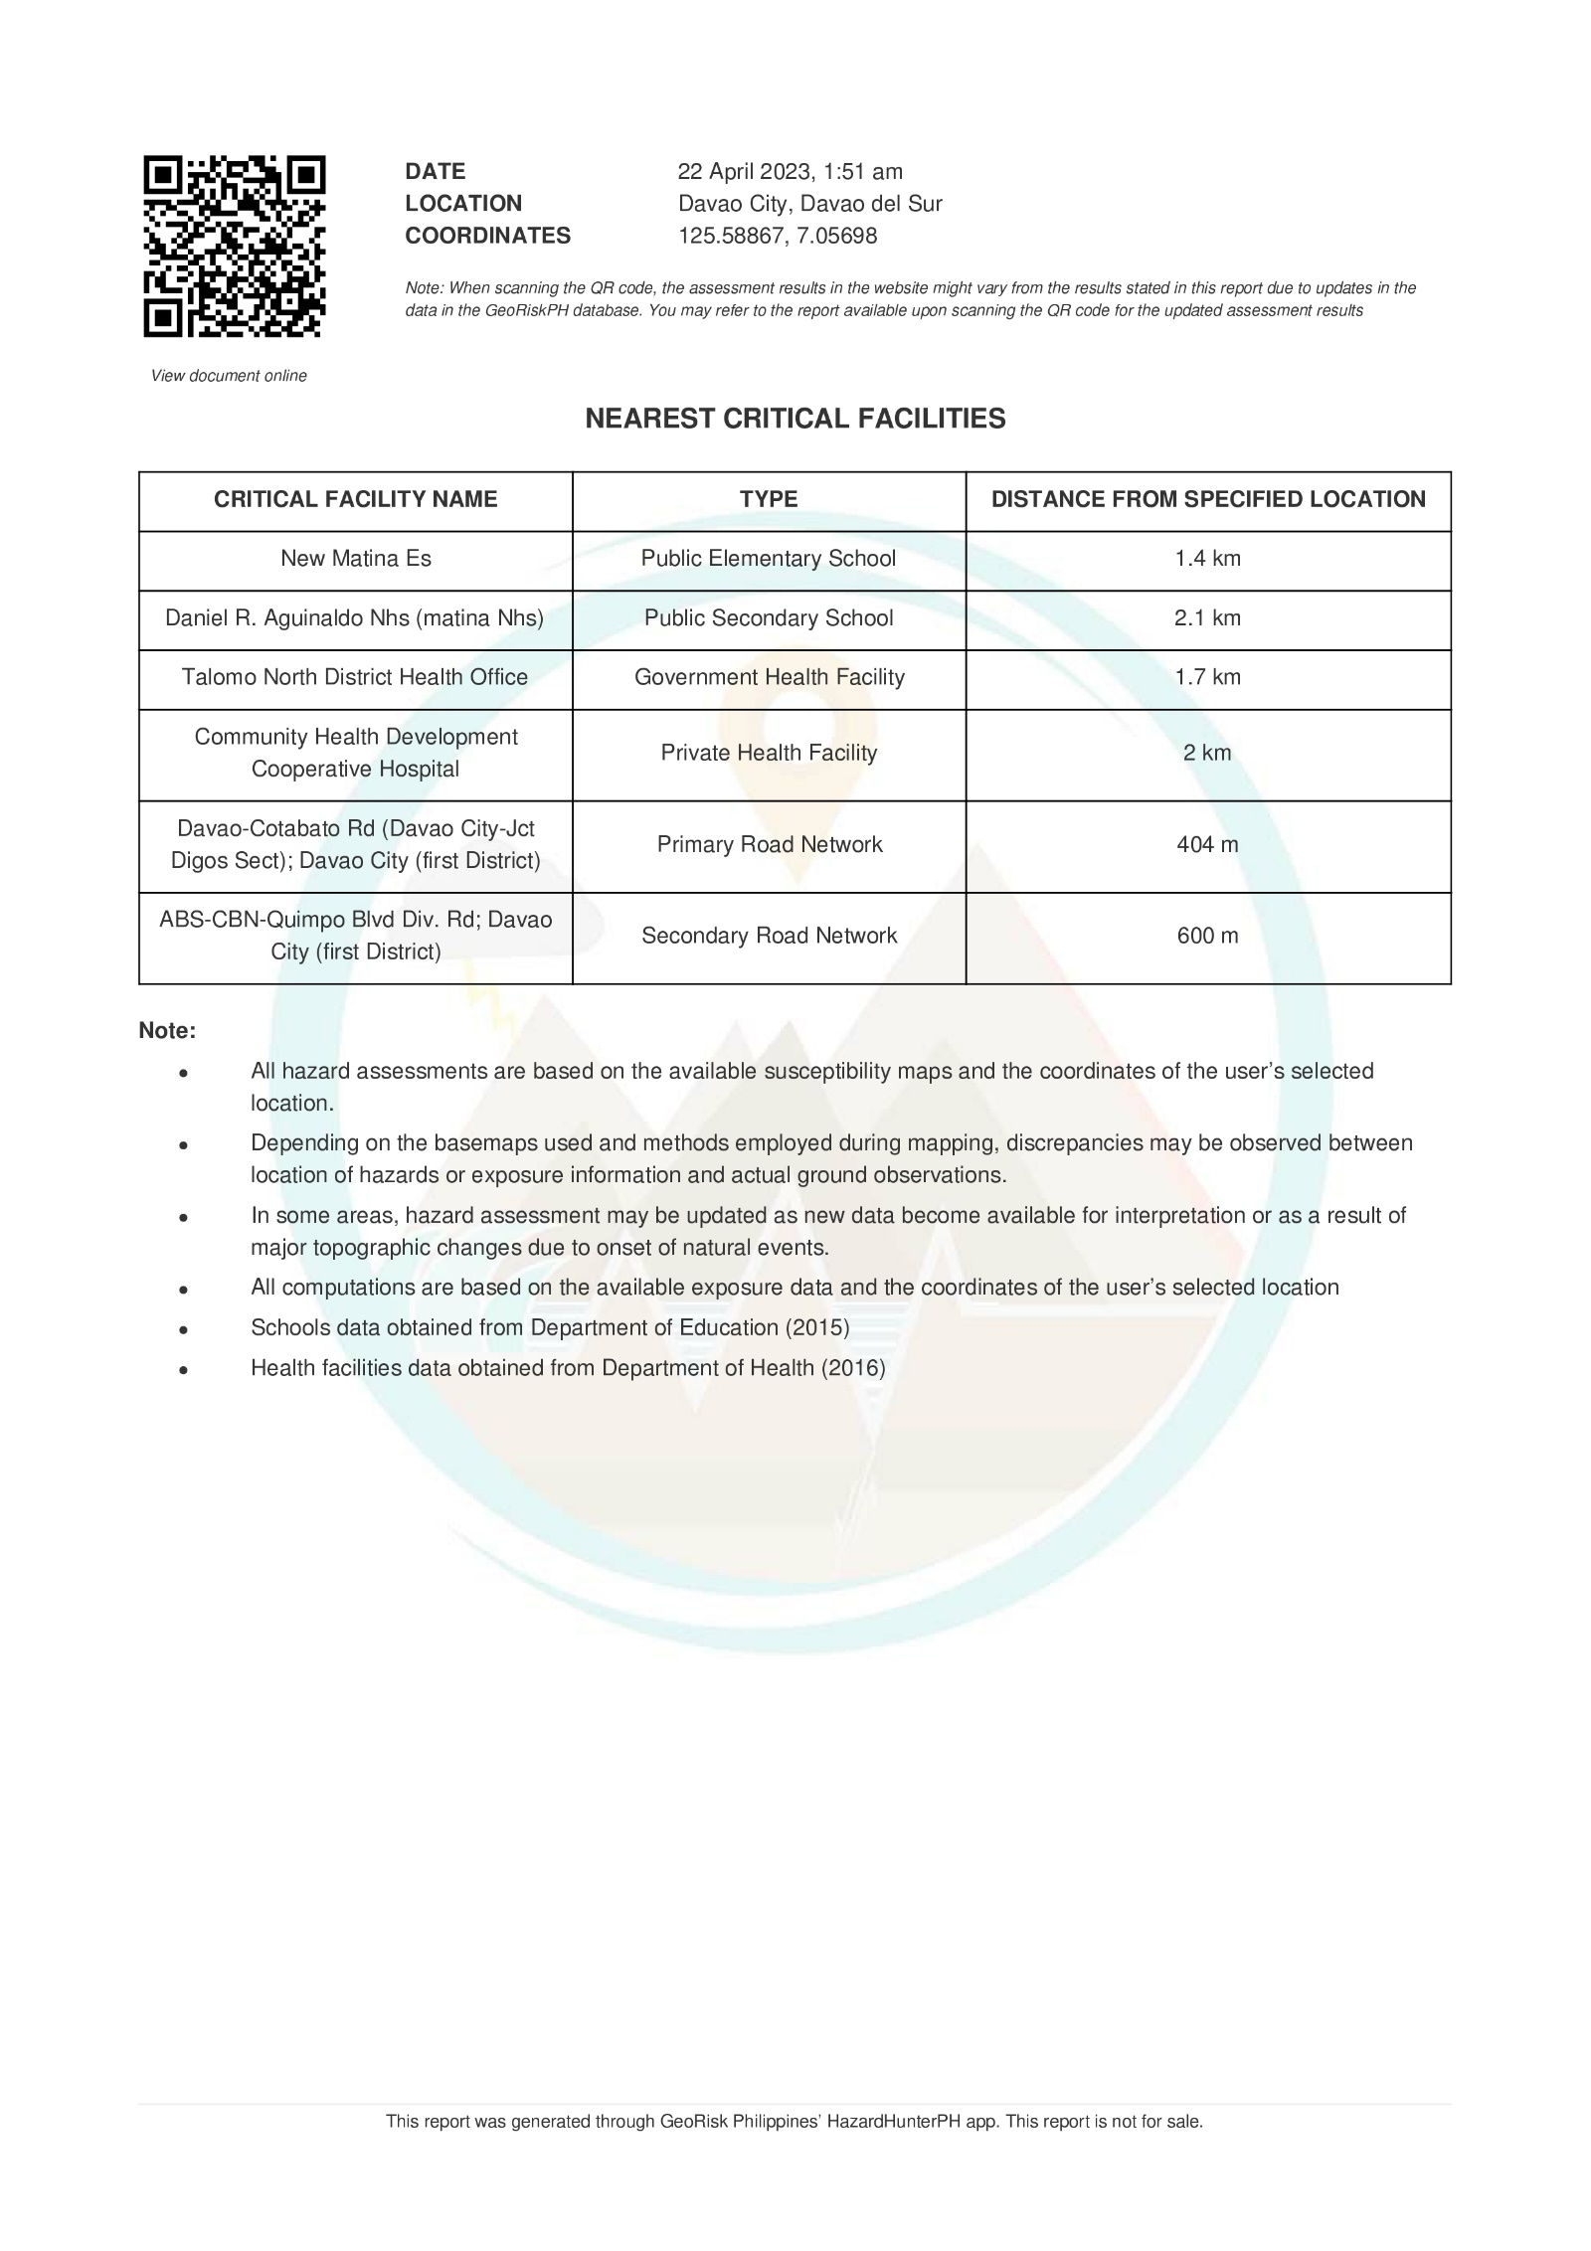

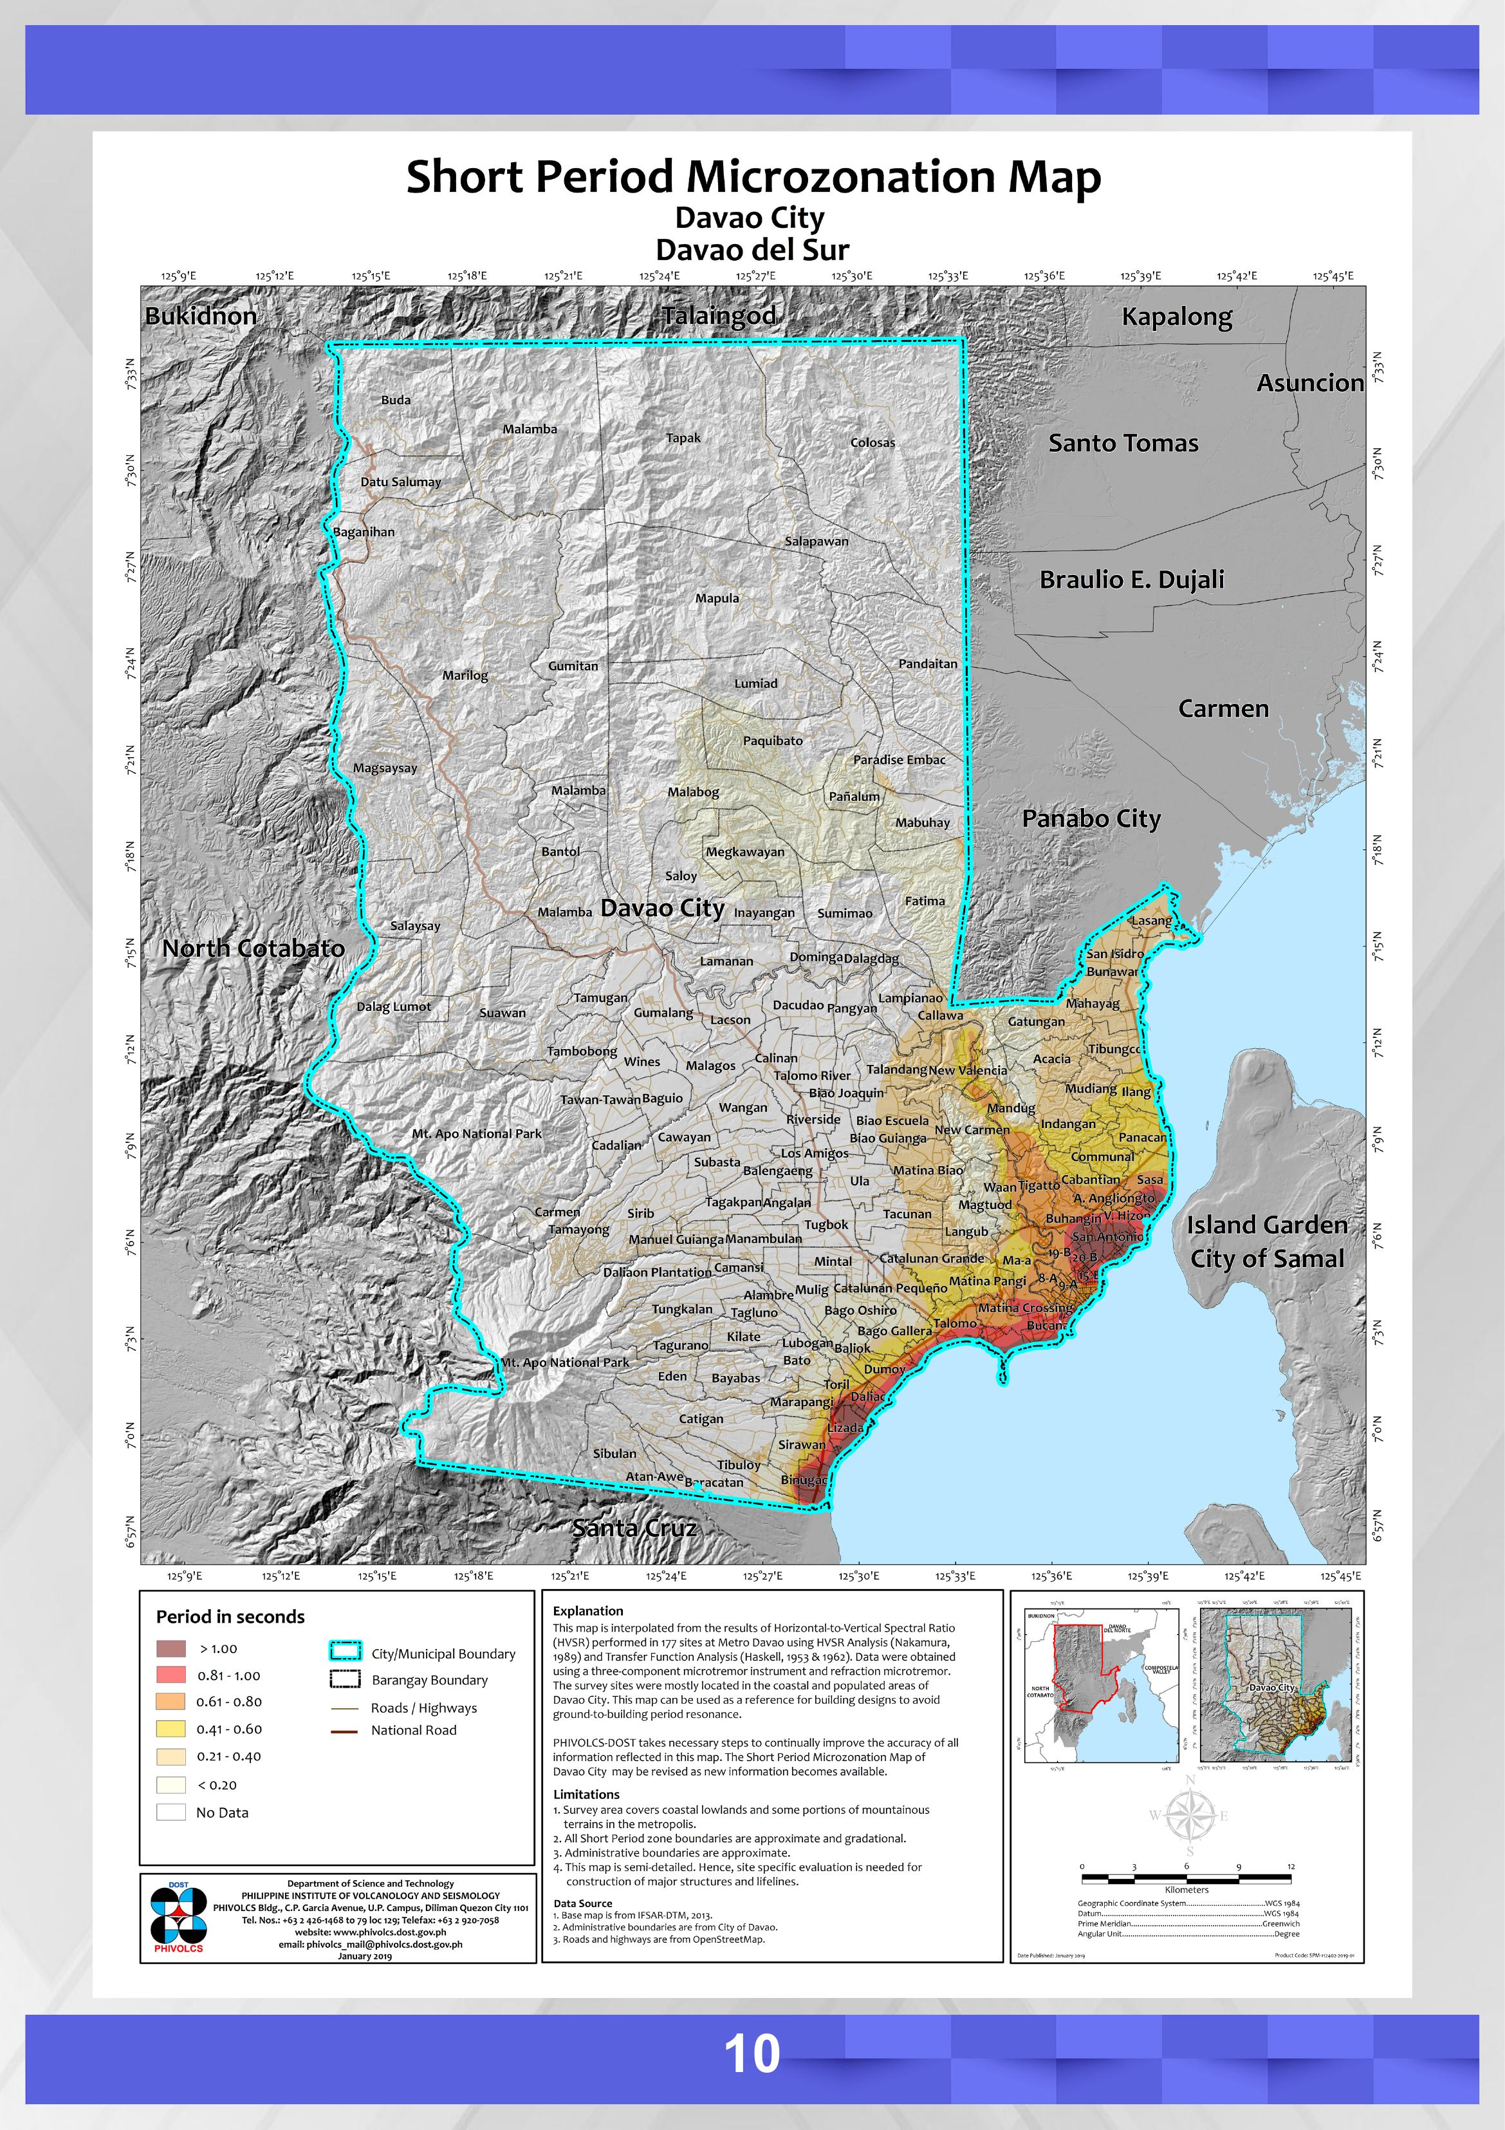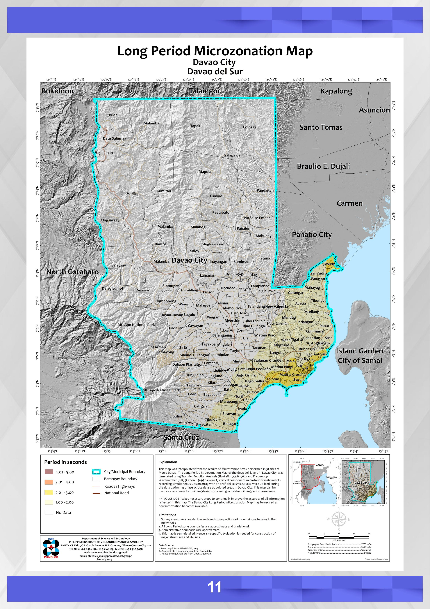

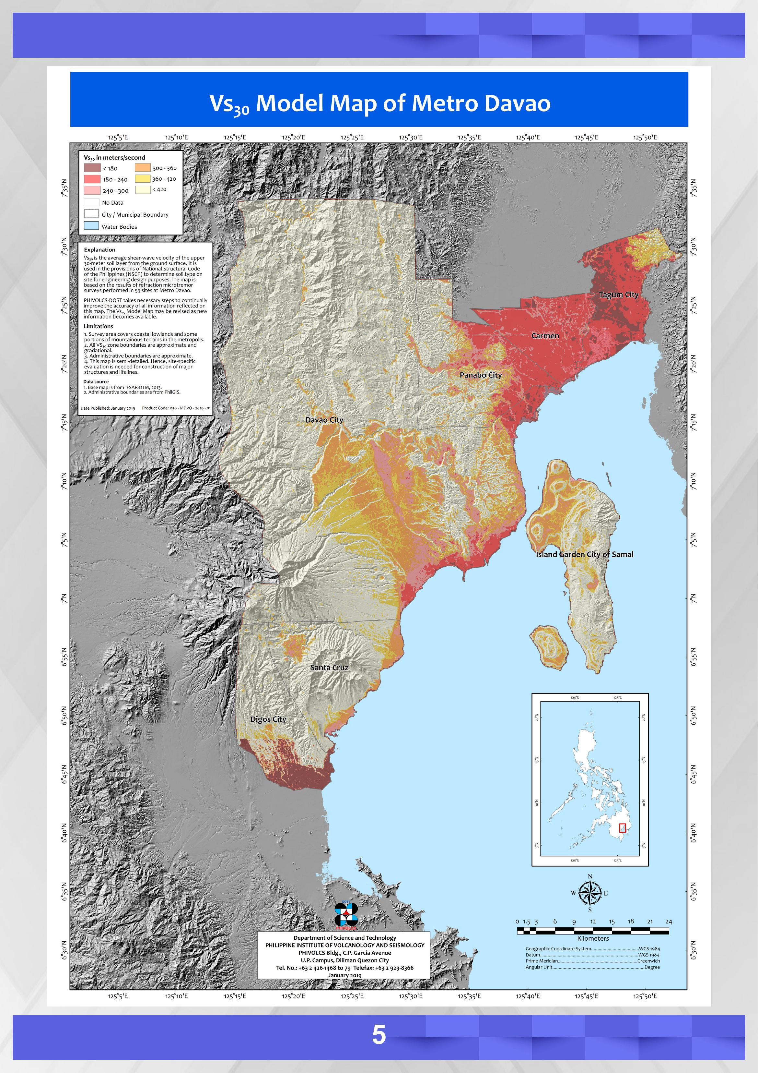

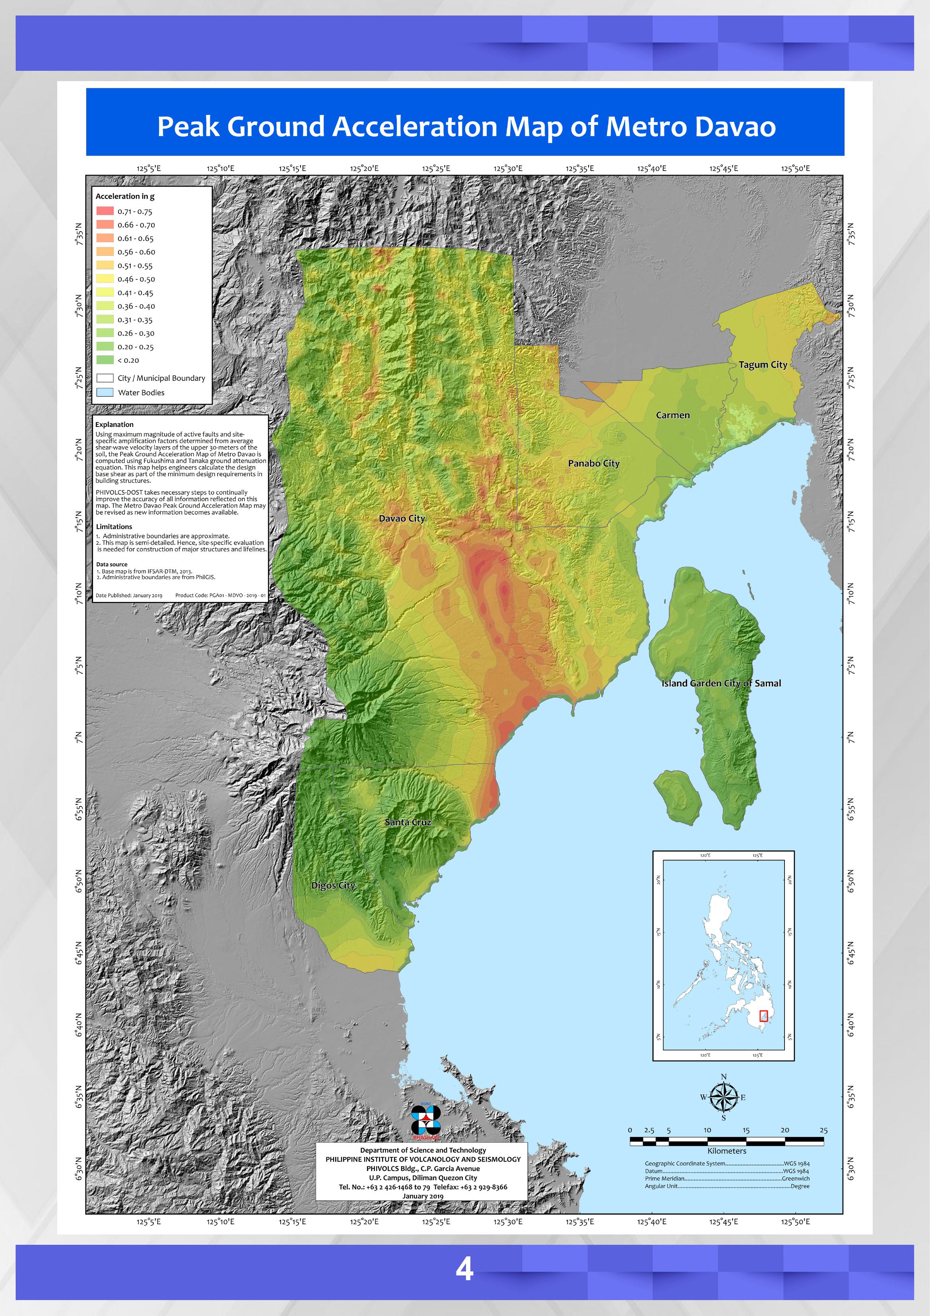

**VS30: 180 – 240 KM/S**

**PEAK GROUND ACCELERATION:0.51-0.55**

**SHORT PERIOD: 0.61-0.80**

**LONG PERIOD: 2.01 – 3.00**

# SEISMIC PARAMETERS

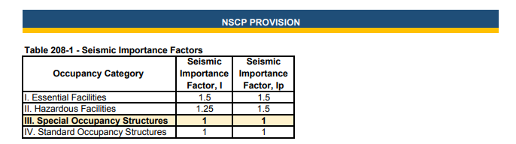

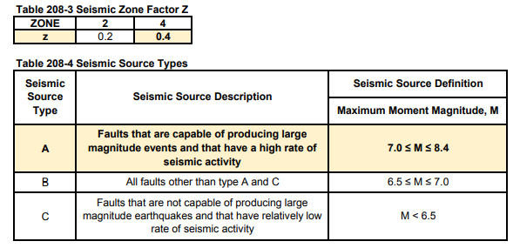

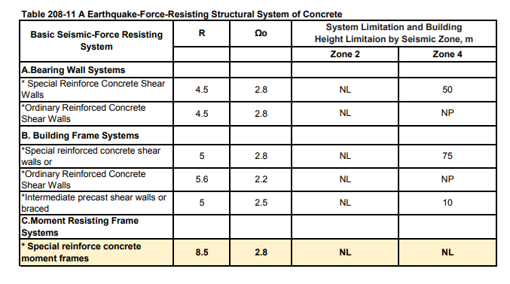

# SOLUTIONS ( CENTER OF MASS AND RIGIDITY )

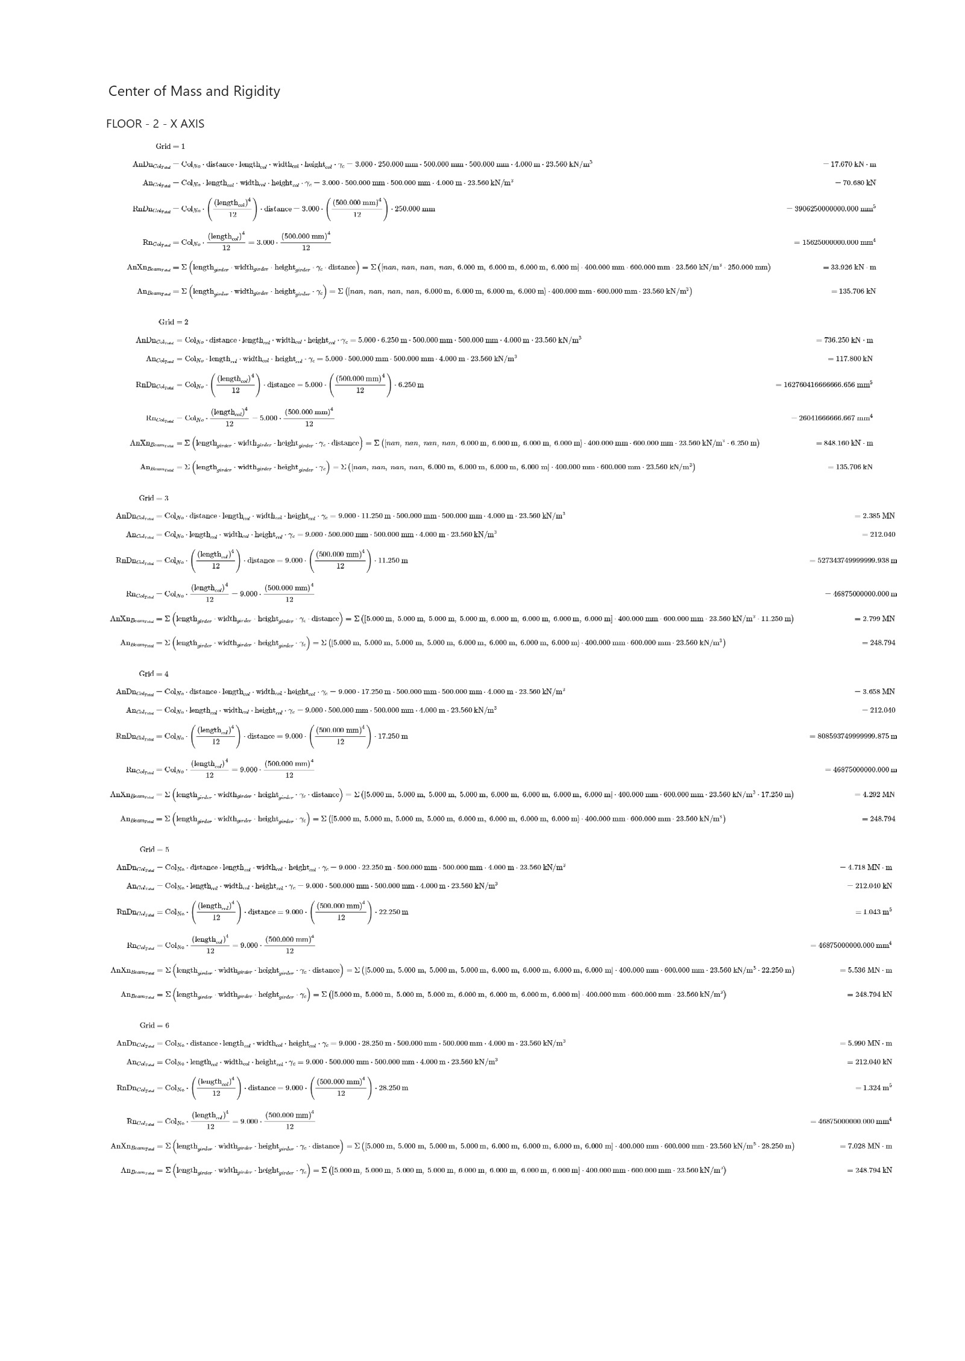

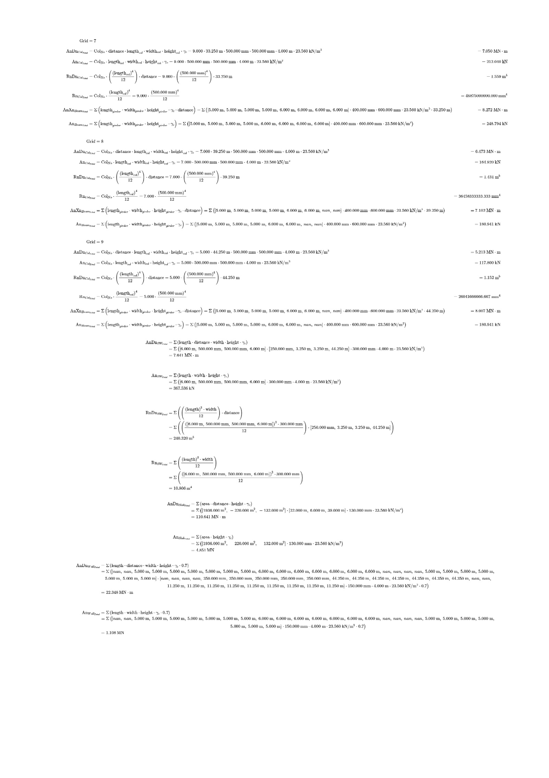

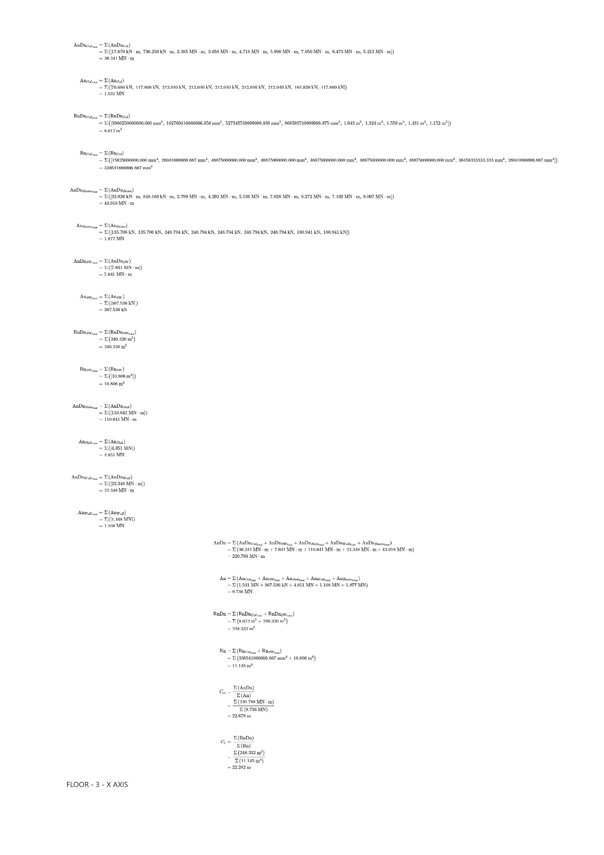

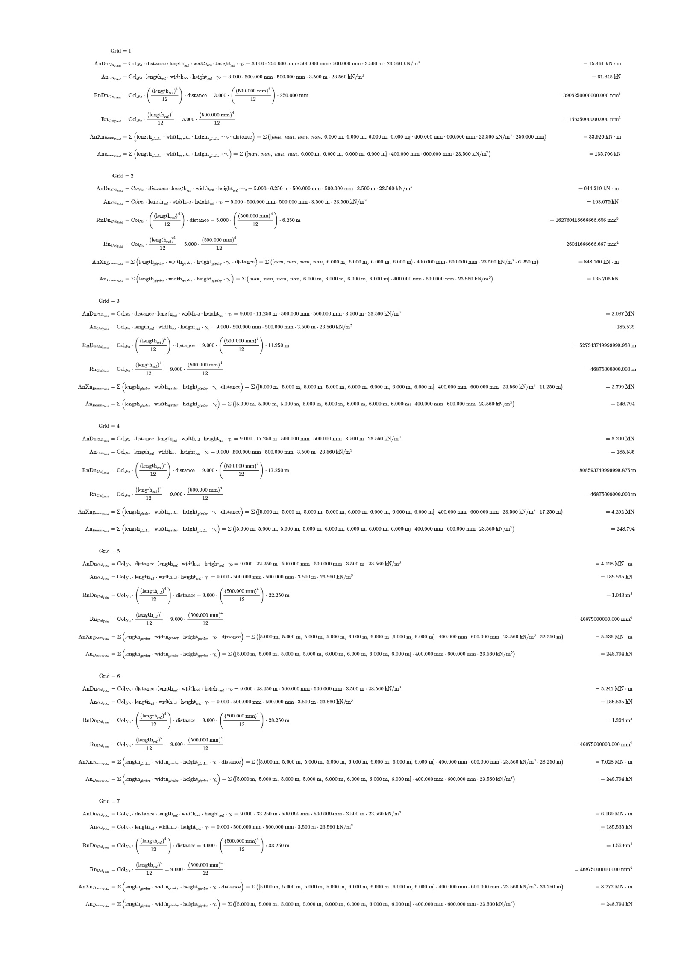

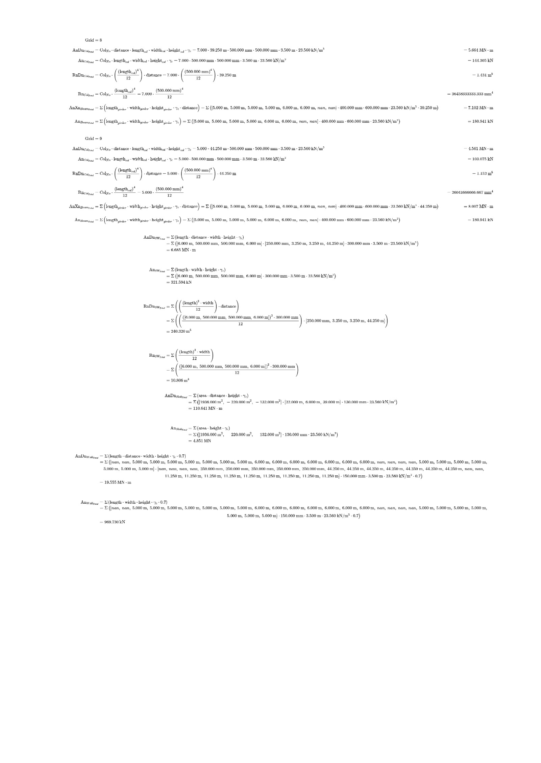

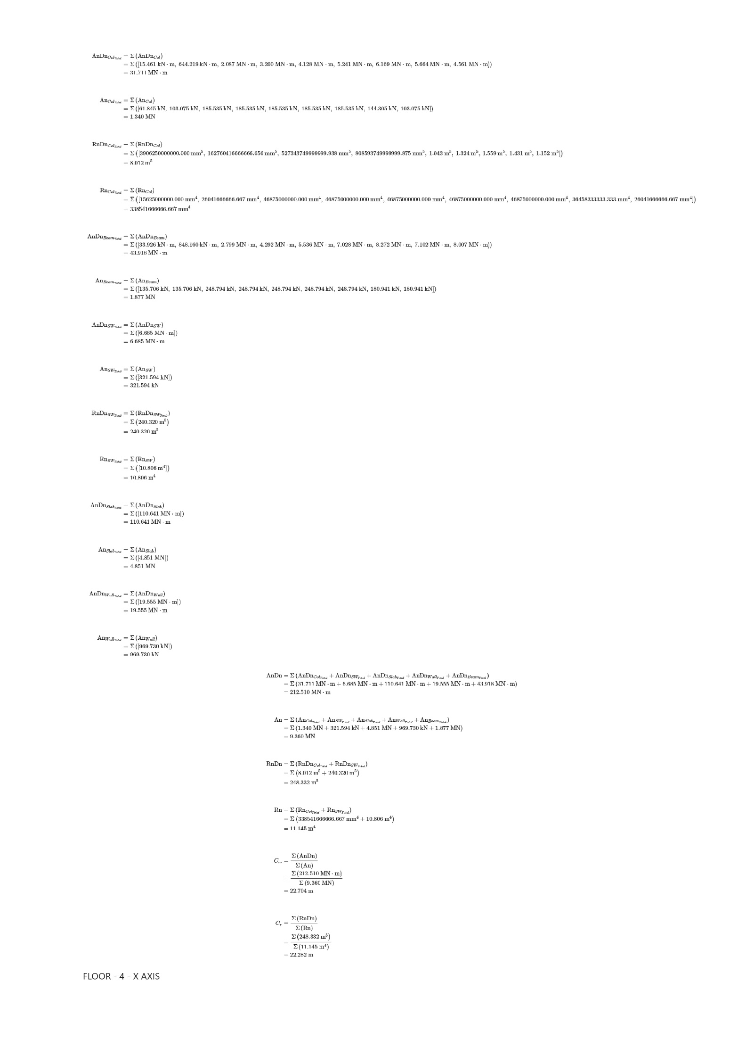

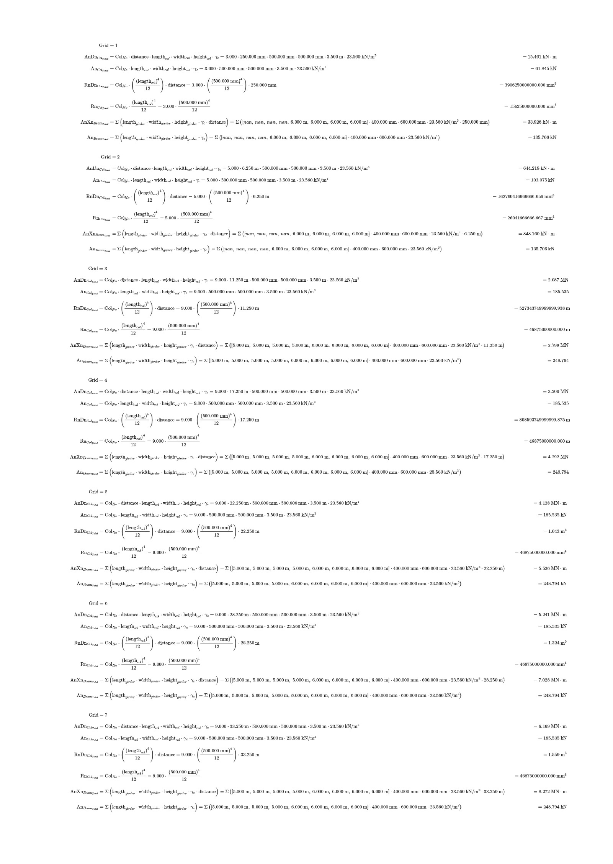



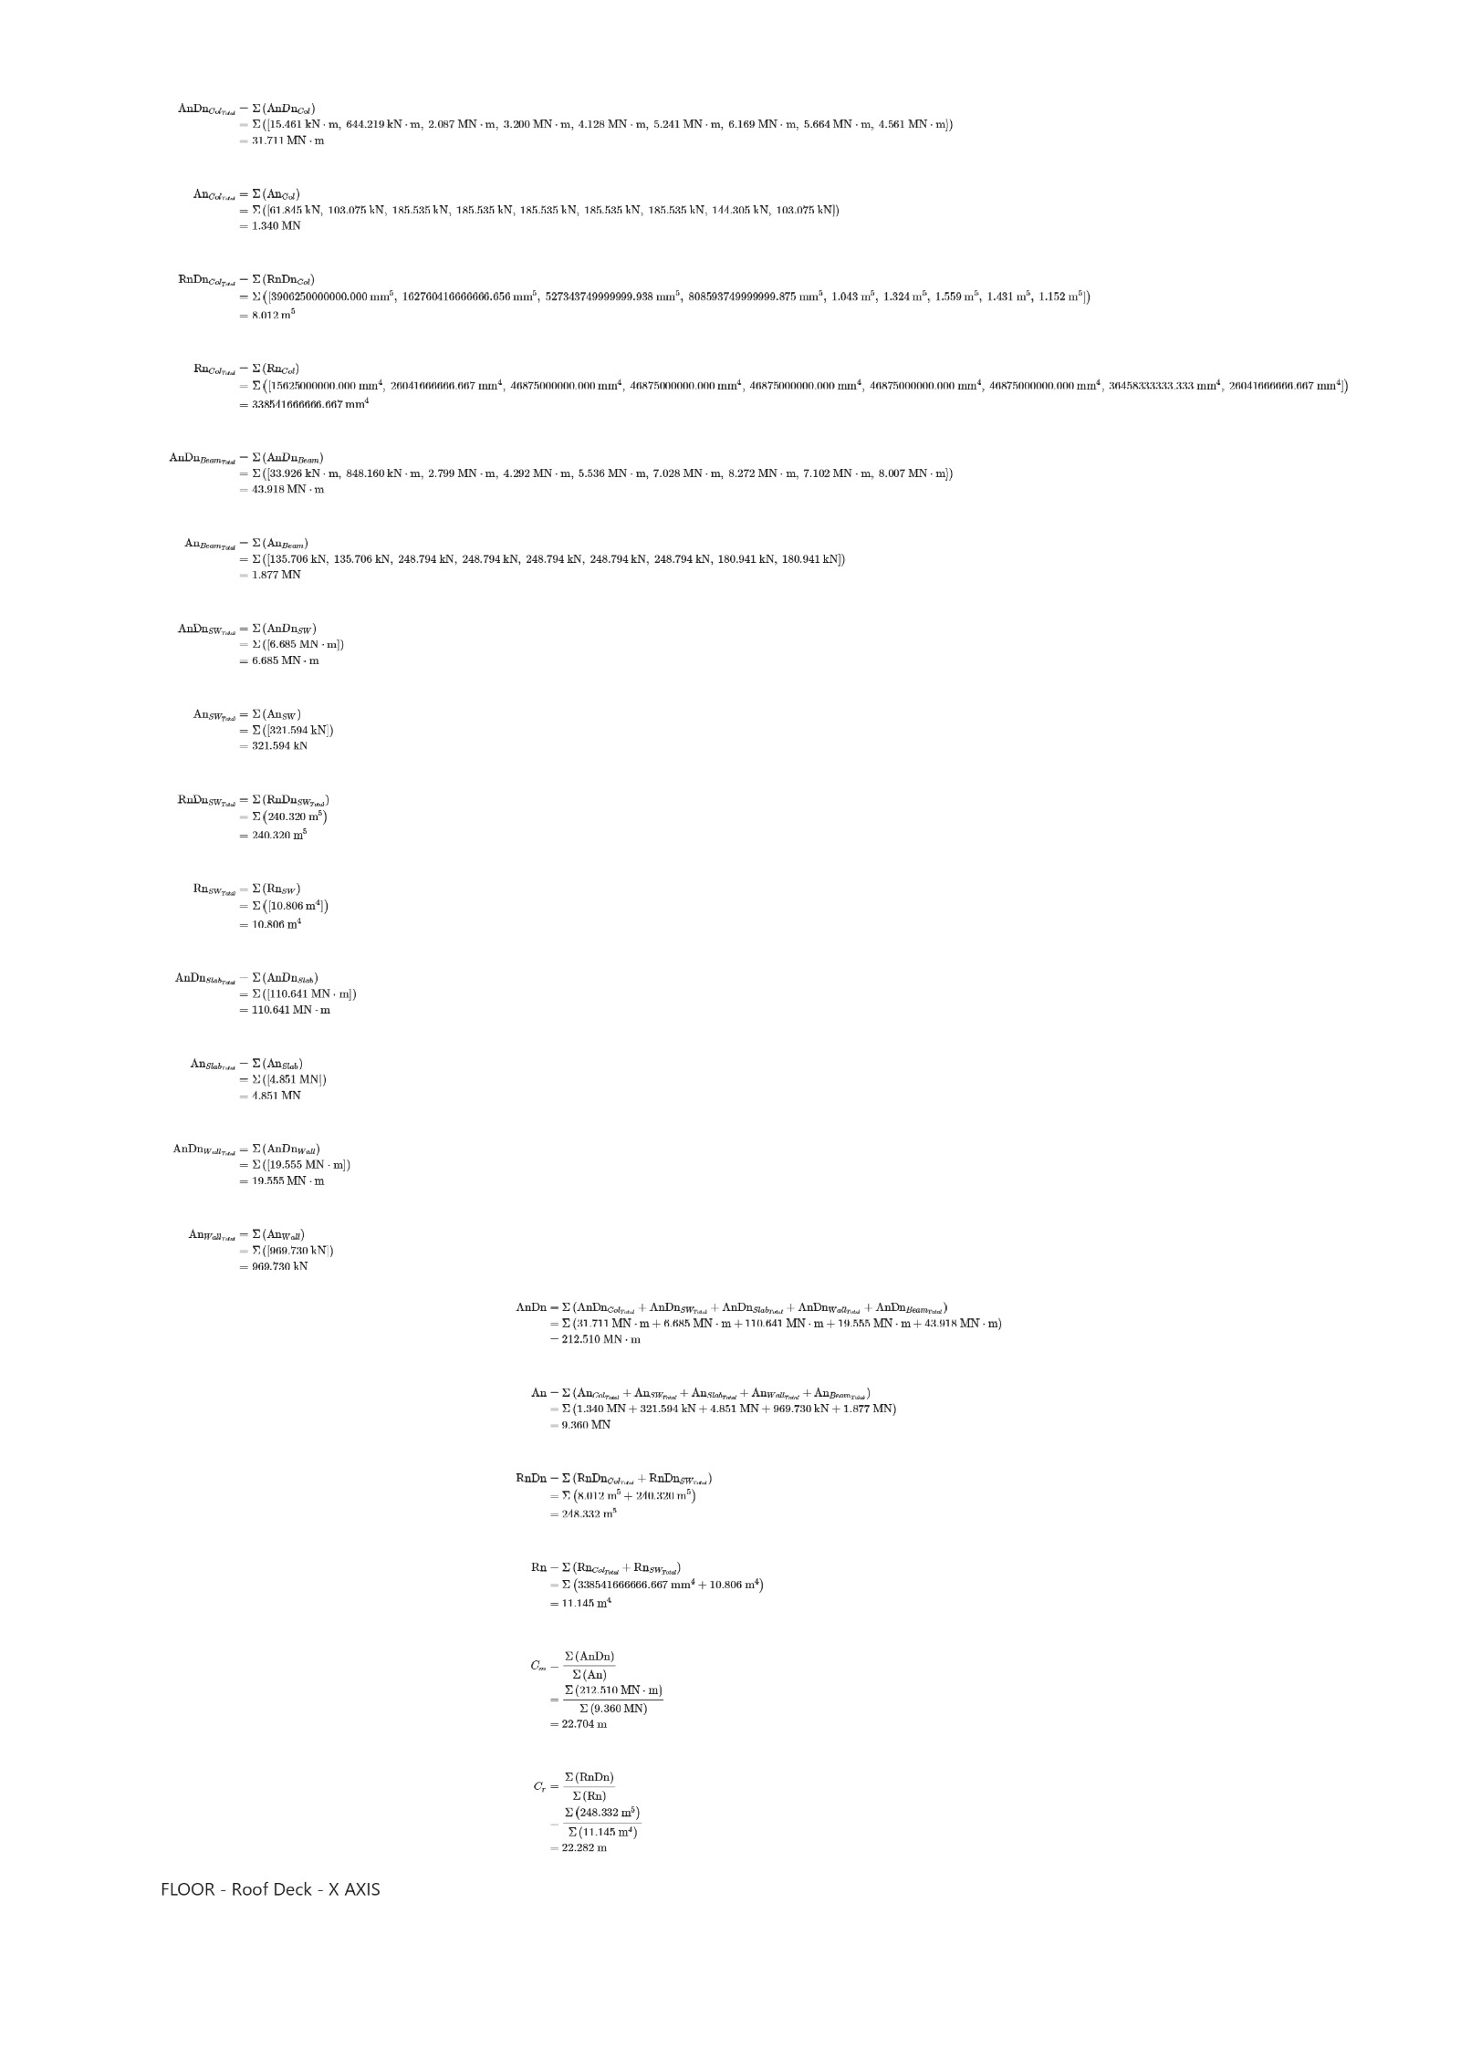

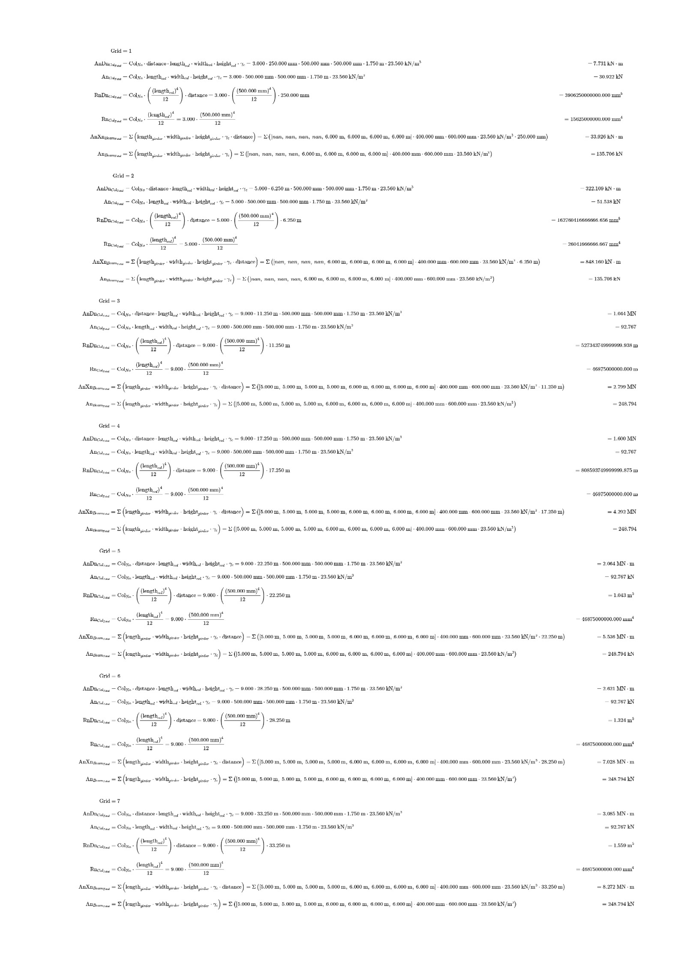

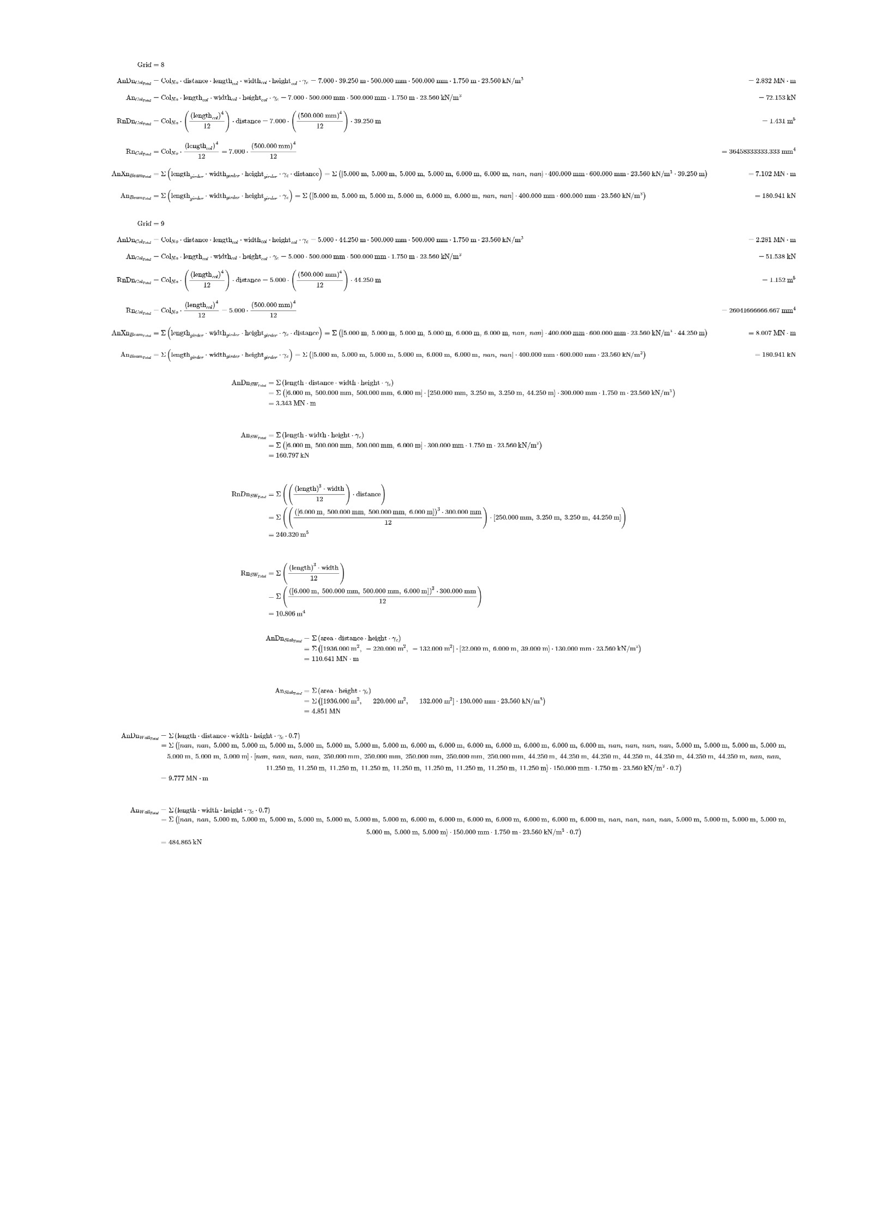

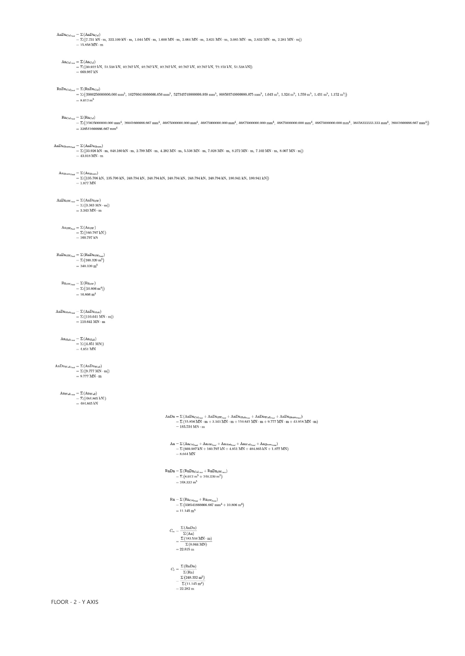

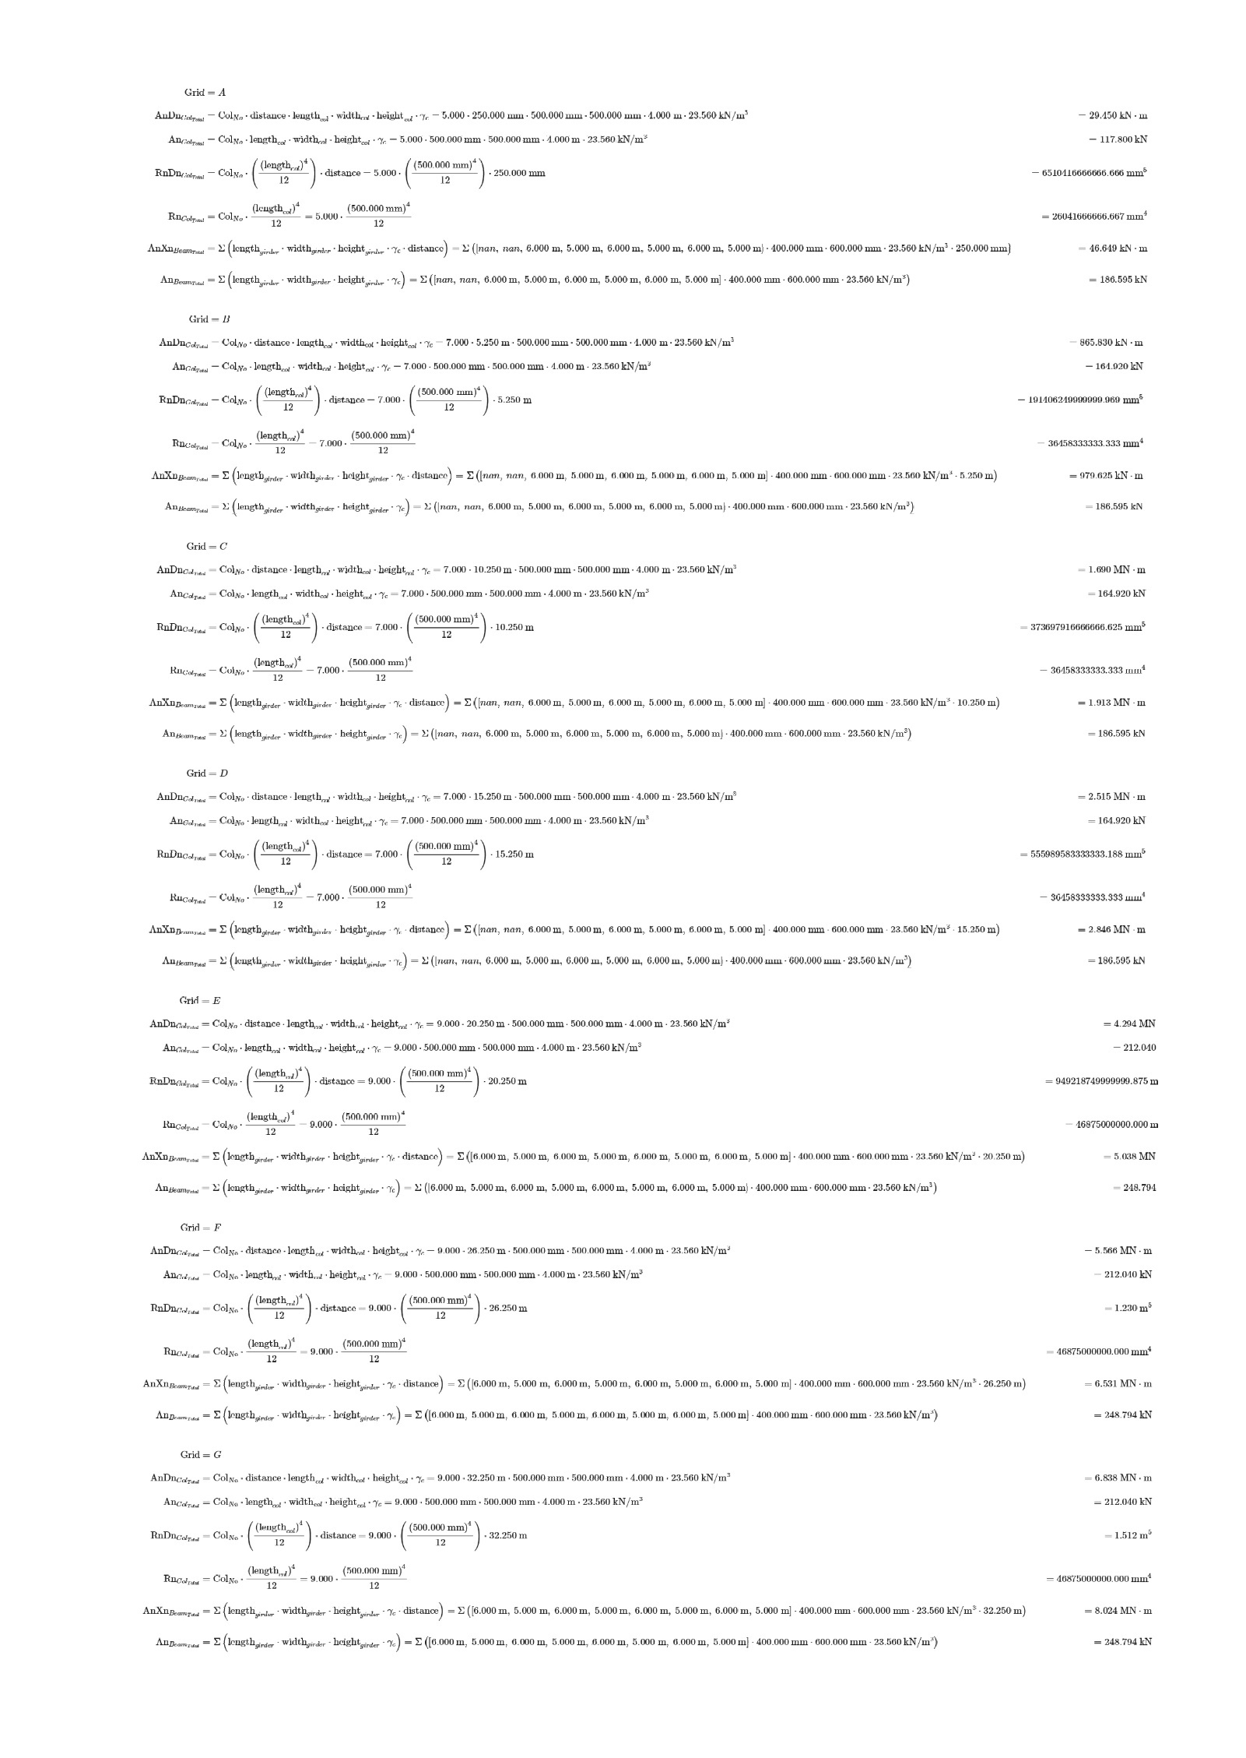

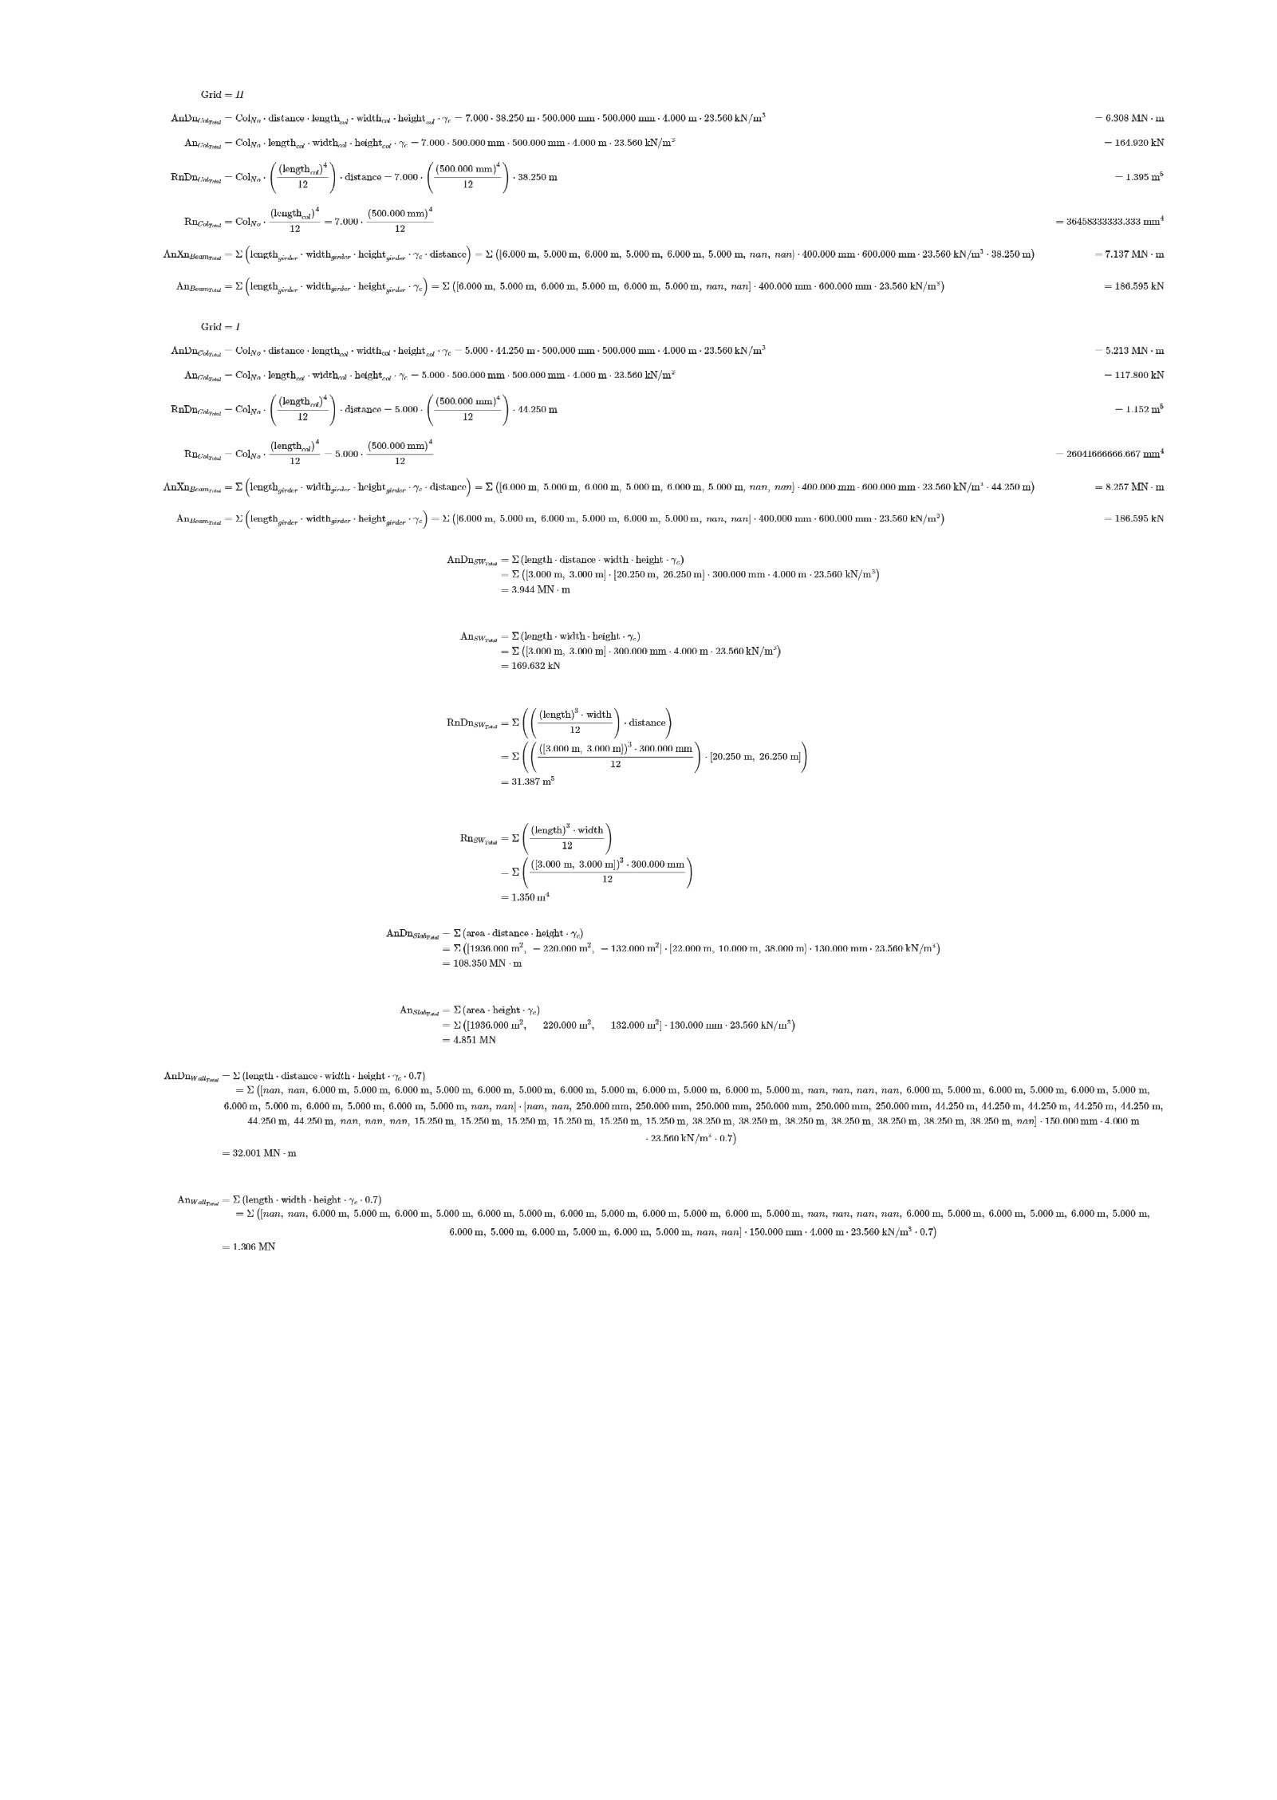

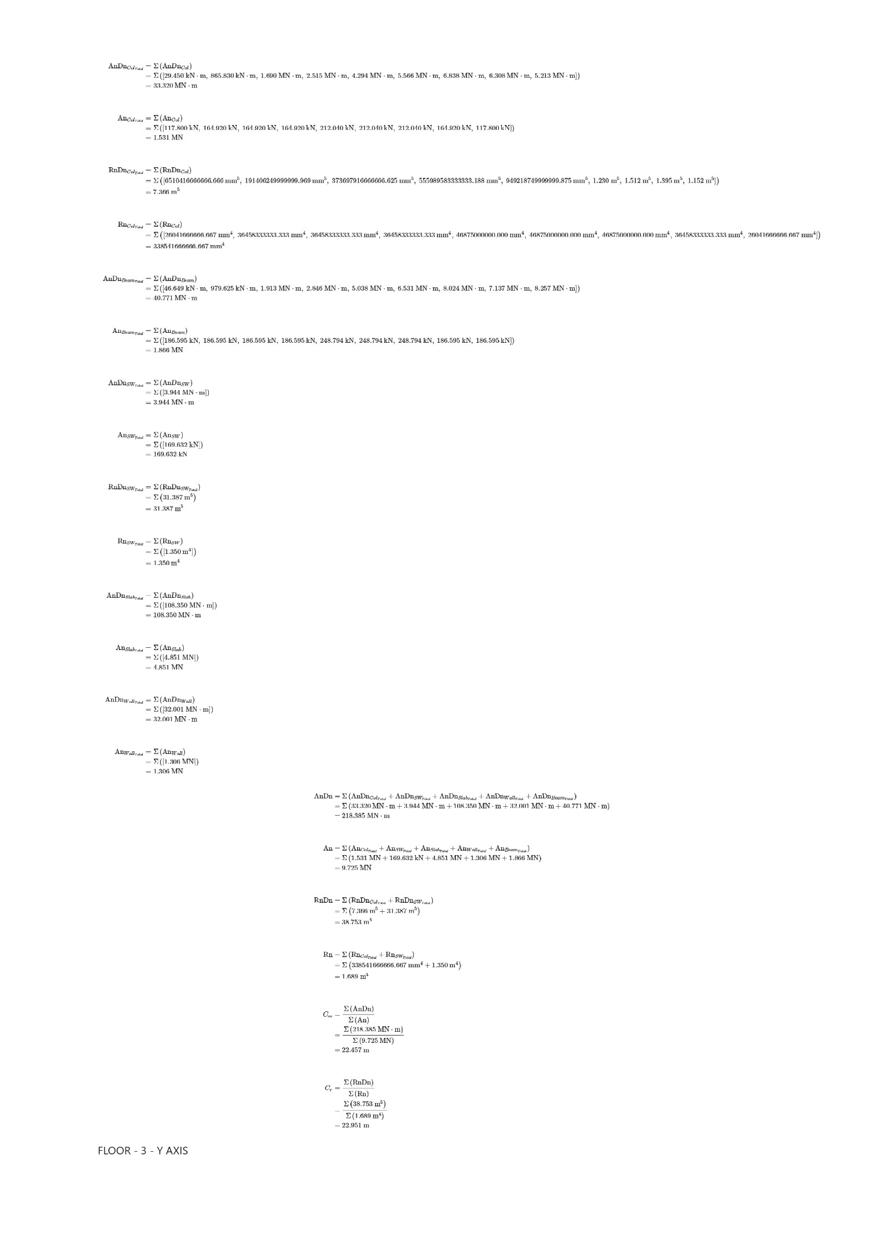

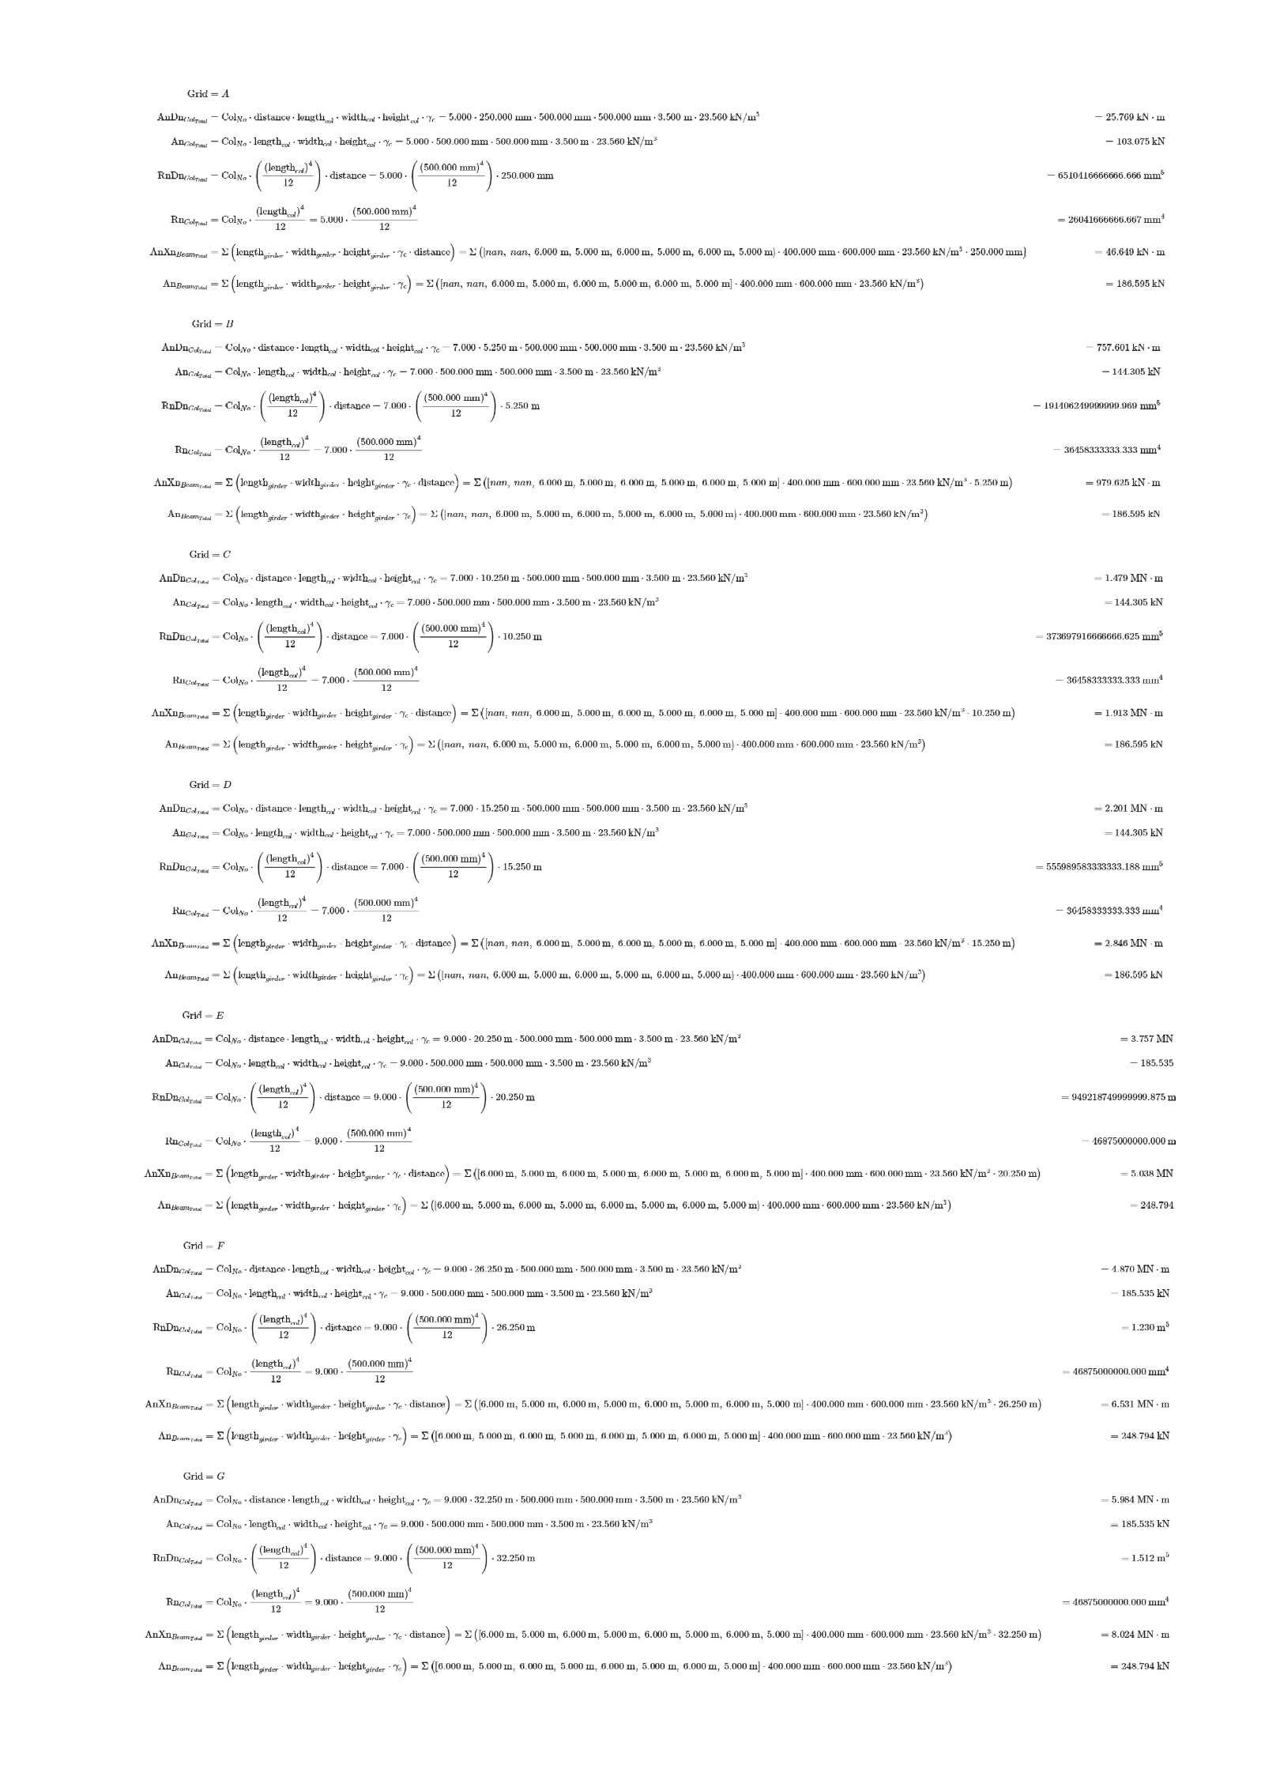

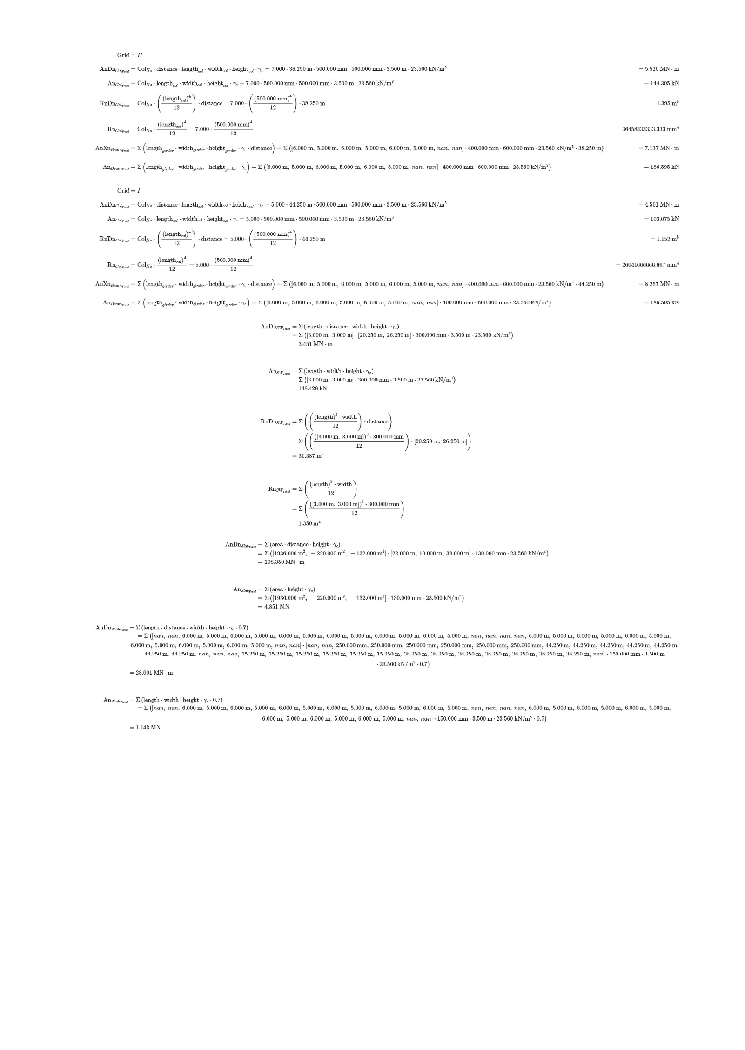

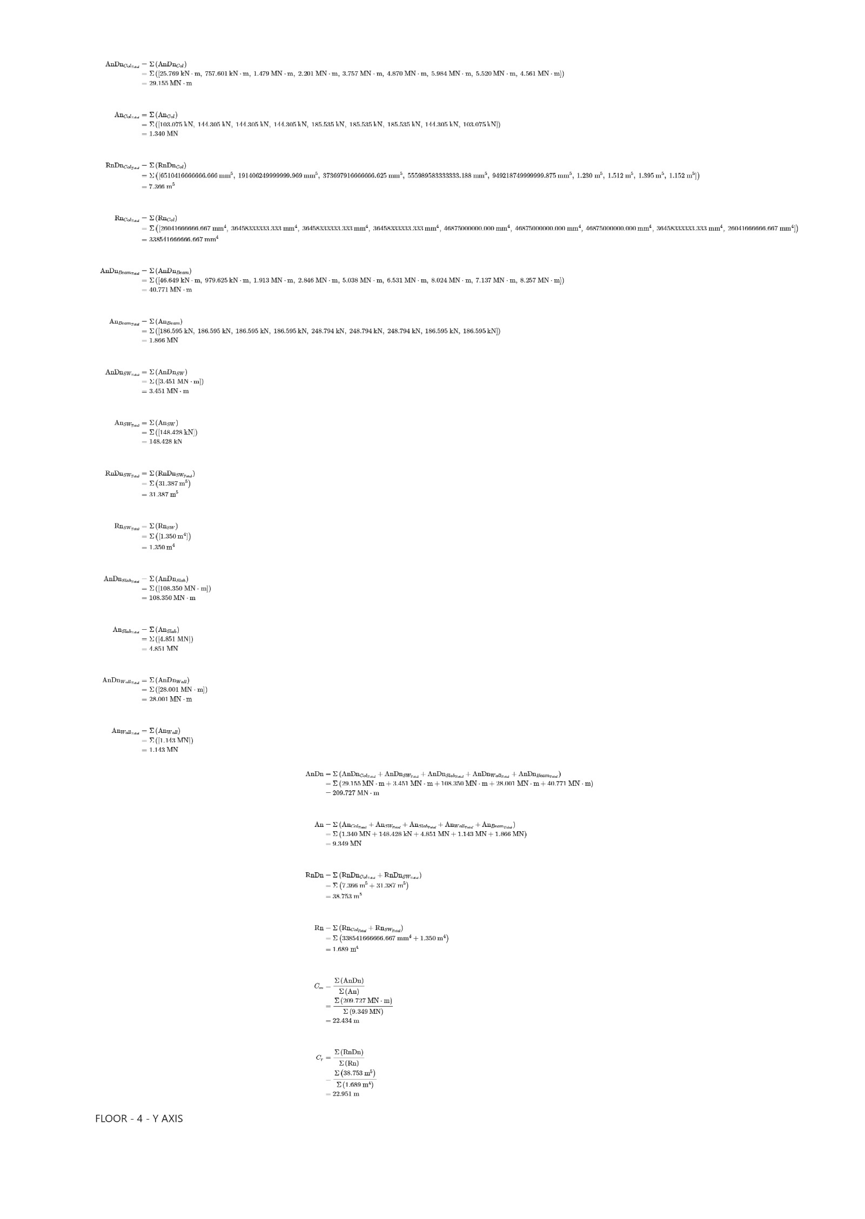





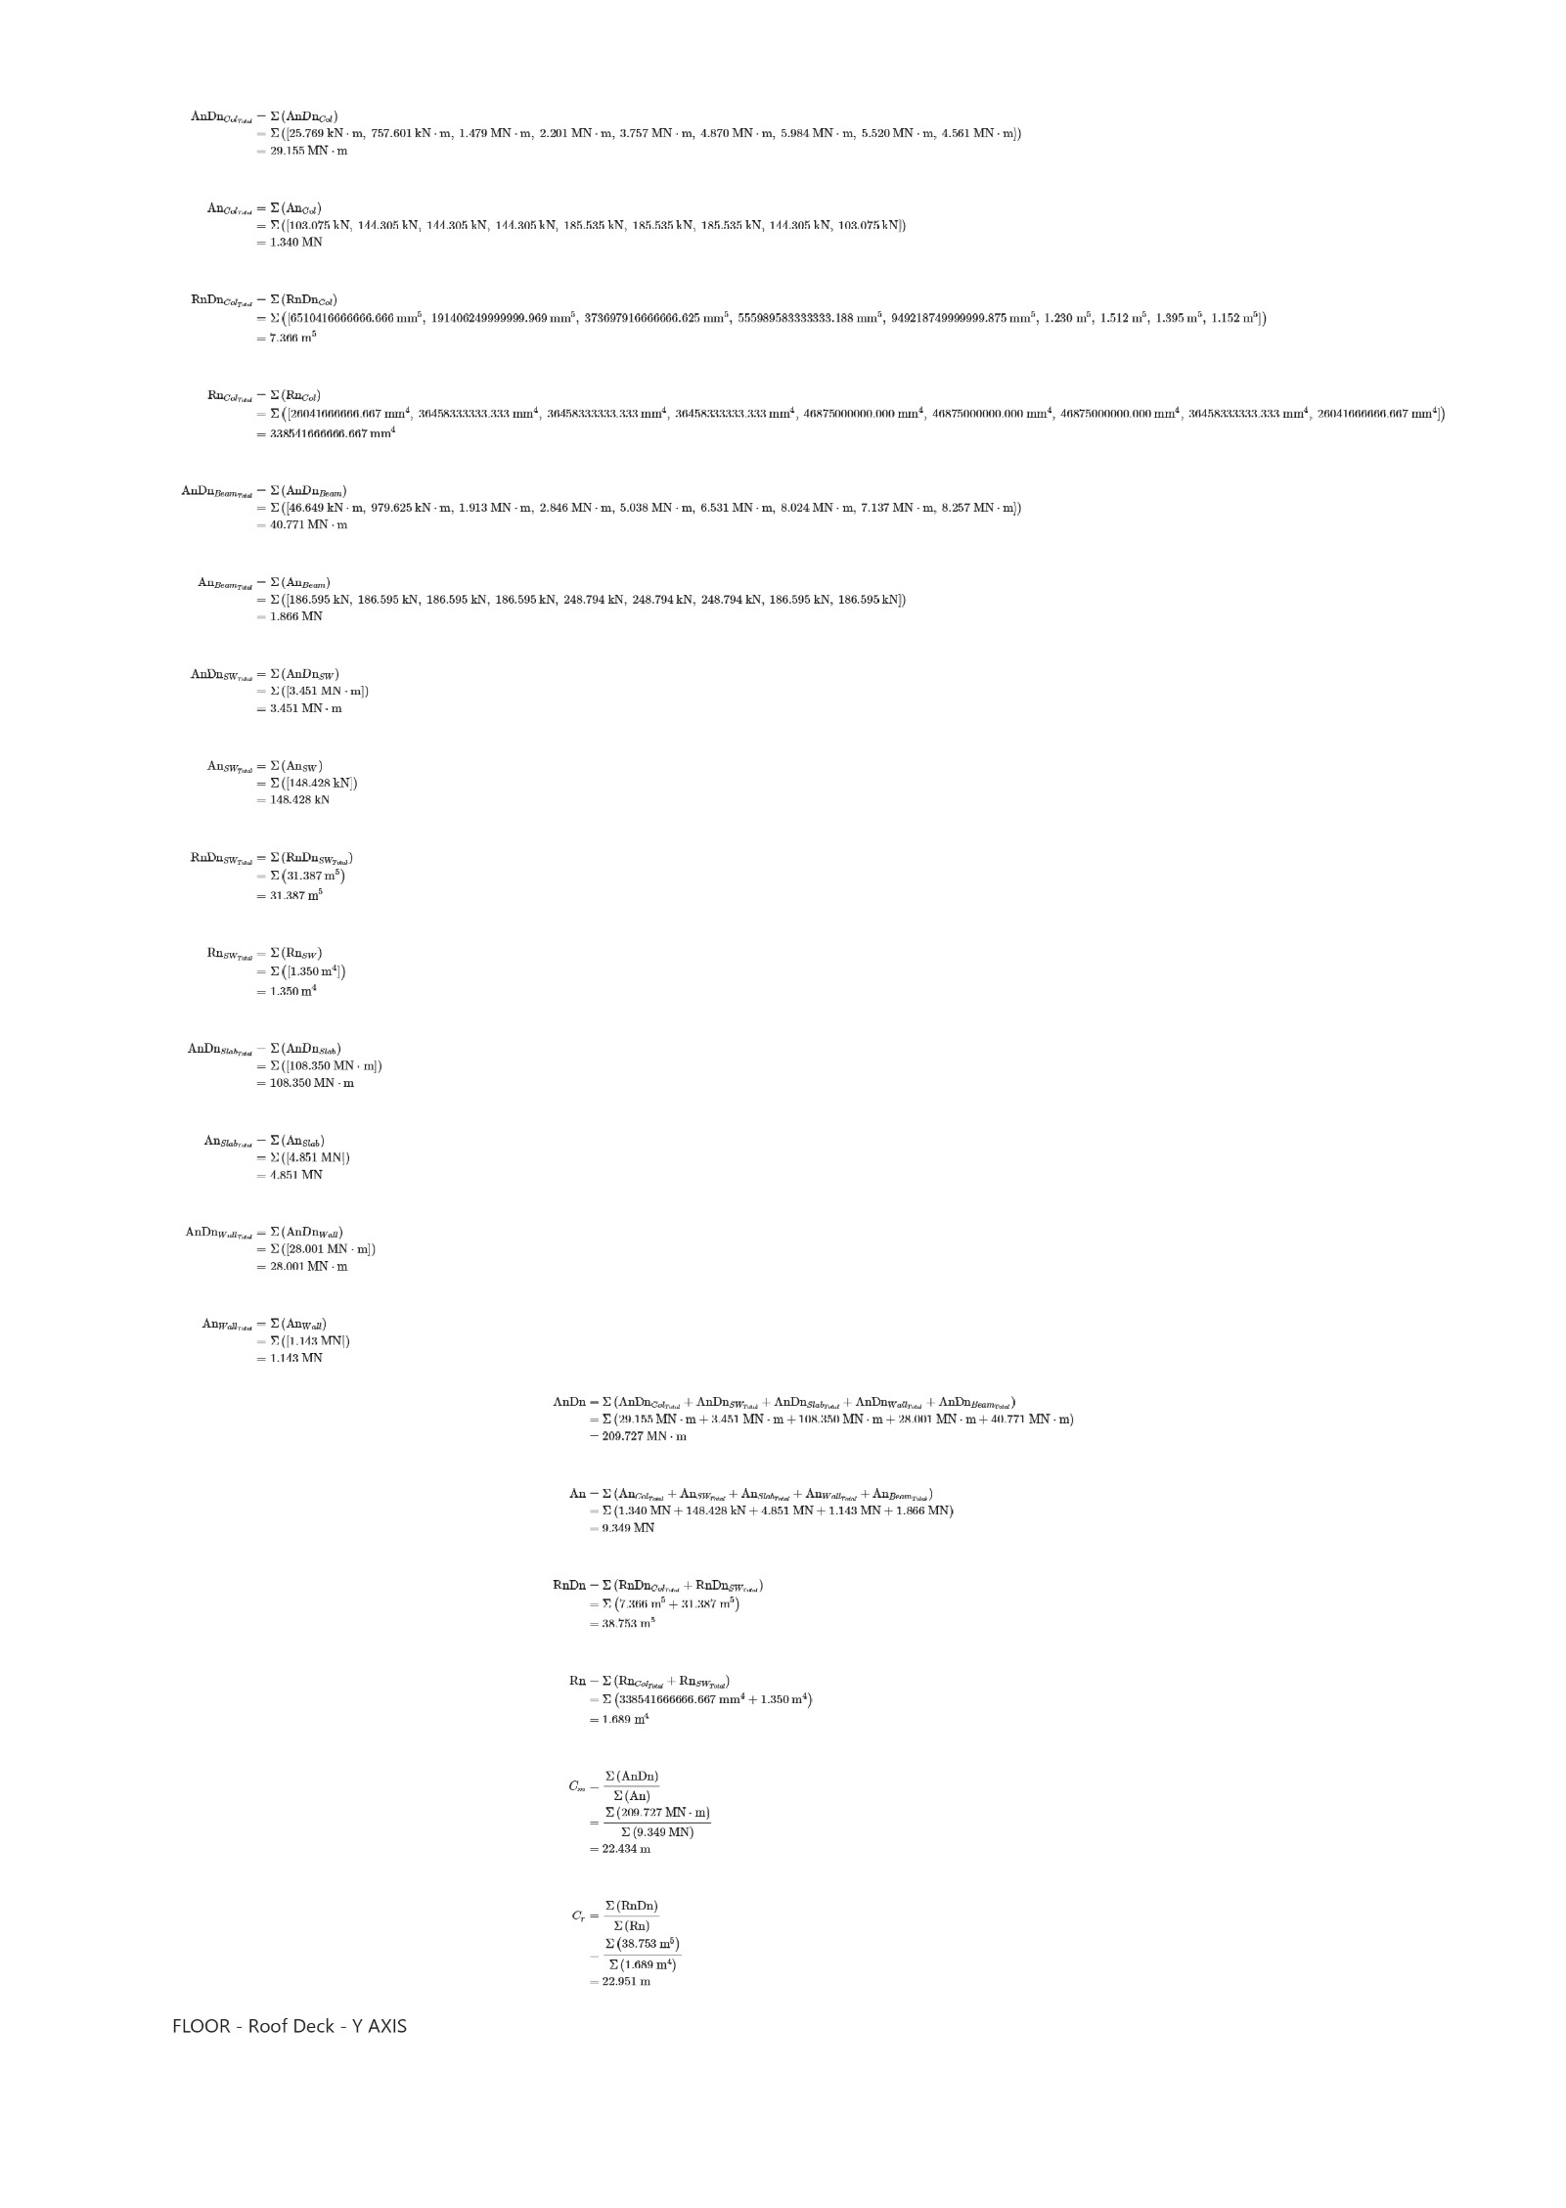

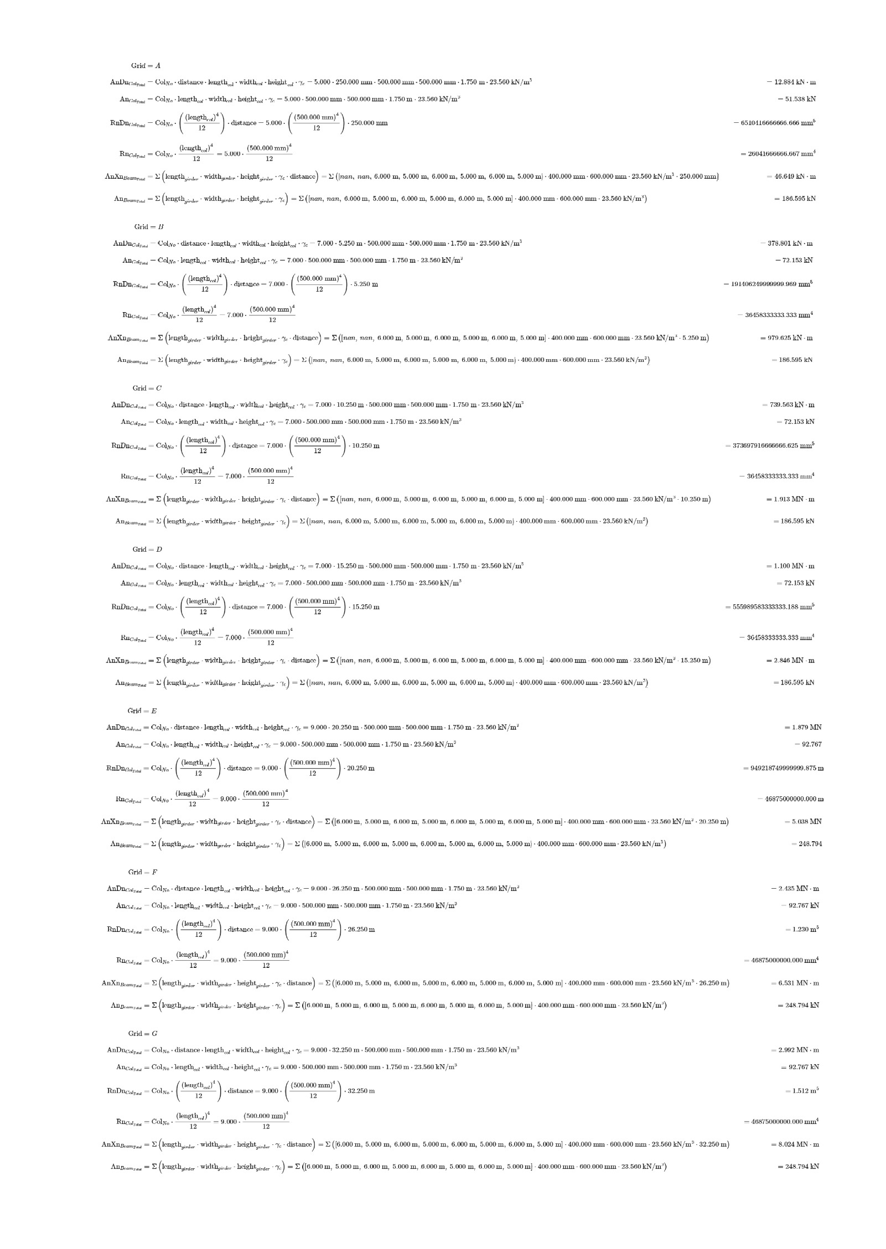

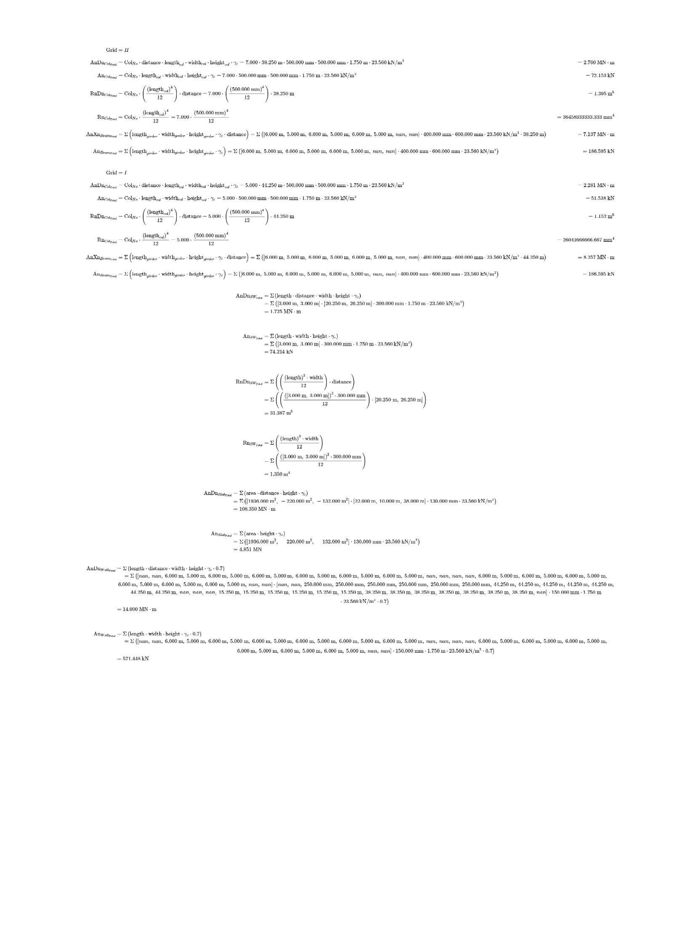

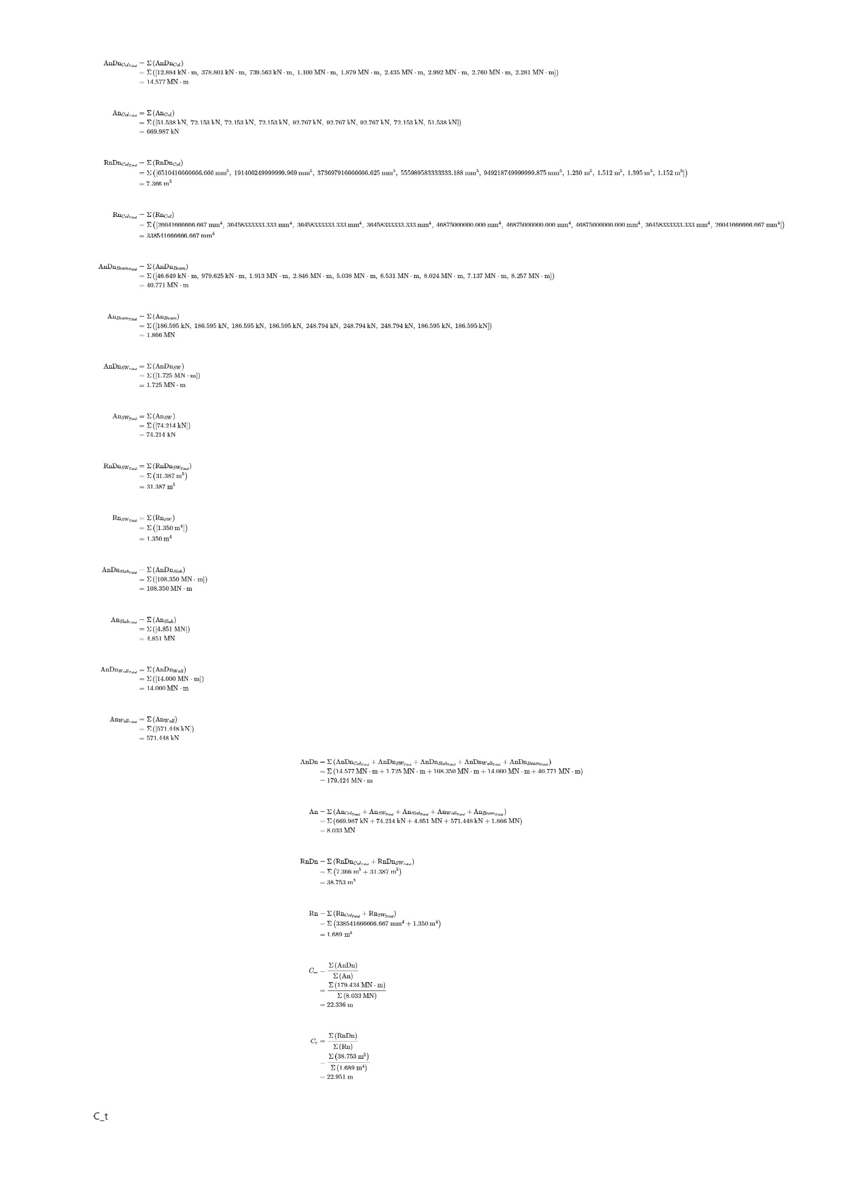

## TABULATION WEIGHT AND RIGIDITY

2ND FLOOR X,Y

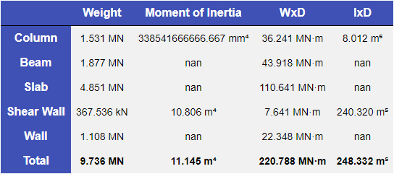 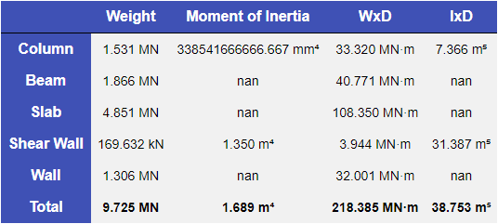

3RD FLOOR X,Y

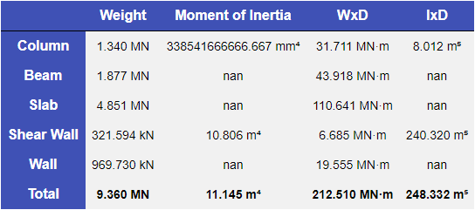 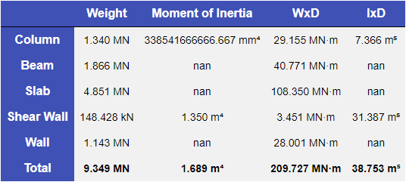

4TH FLOOR X,Y

 

ROOF DECK X,Y

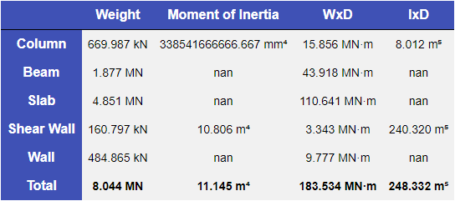 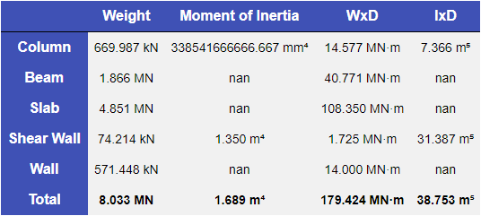

## CENTER OF MASS, CENTER OF RIGIDITY

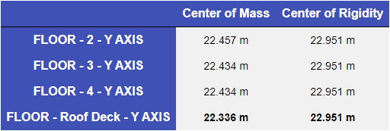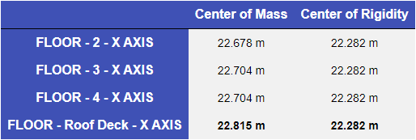

## ECCENTRICITY

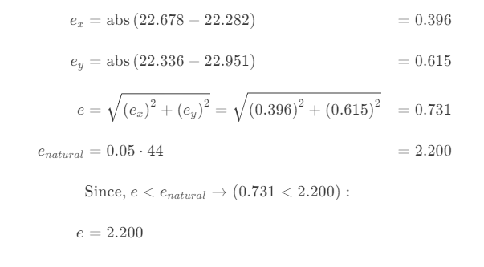

# COMPUTATION OF BASE SHEAR BASED ON STATIC PROCEDURE

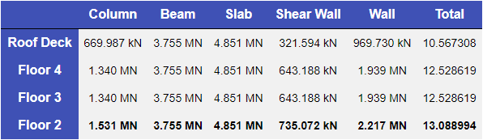

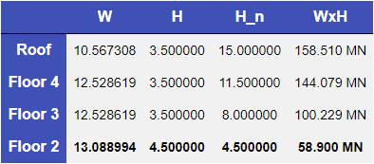

## PARAMETERS

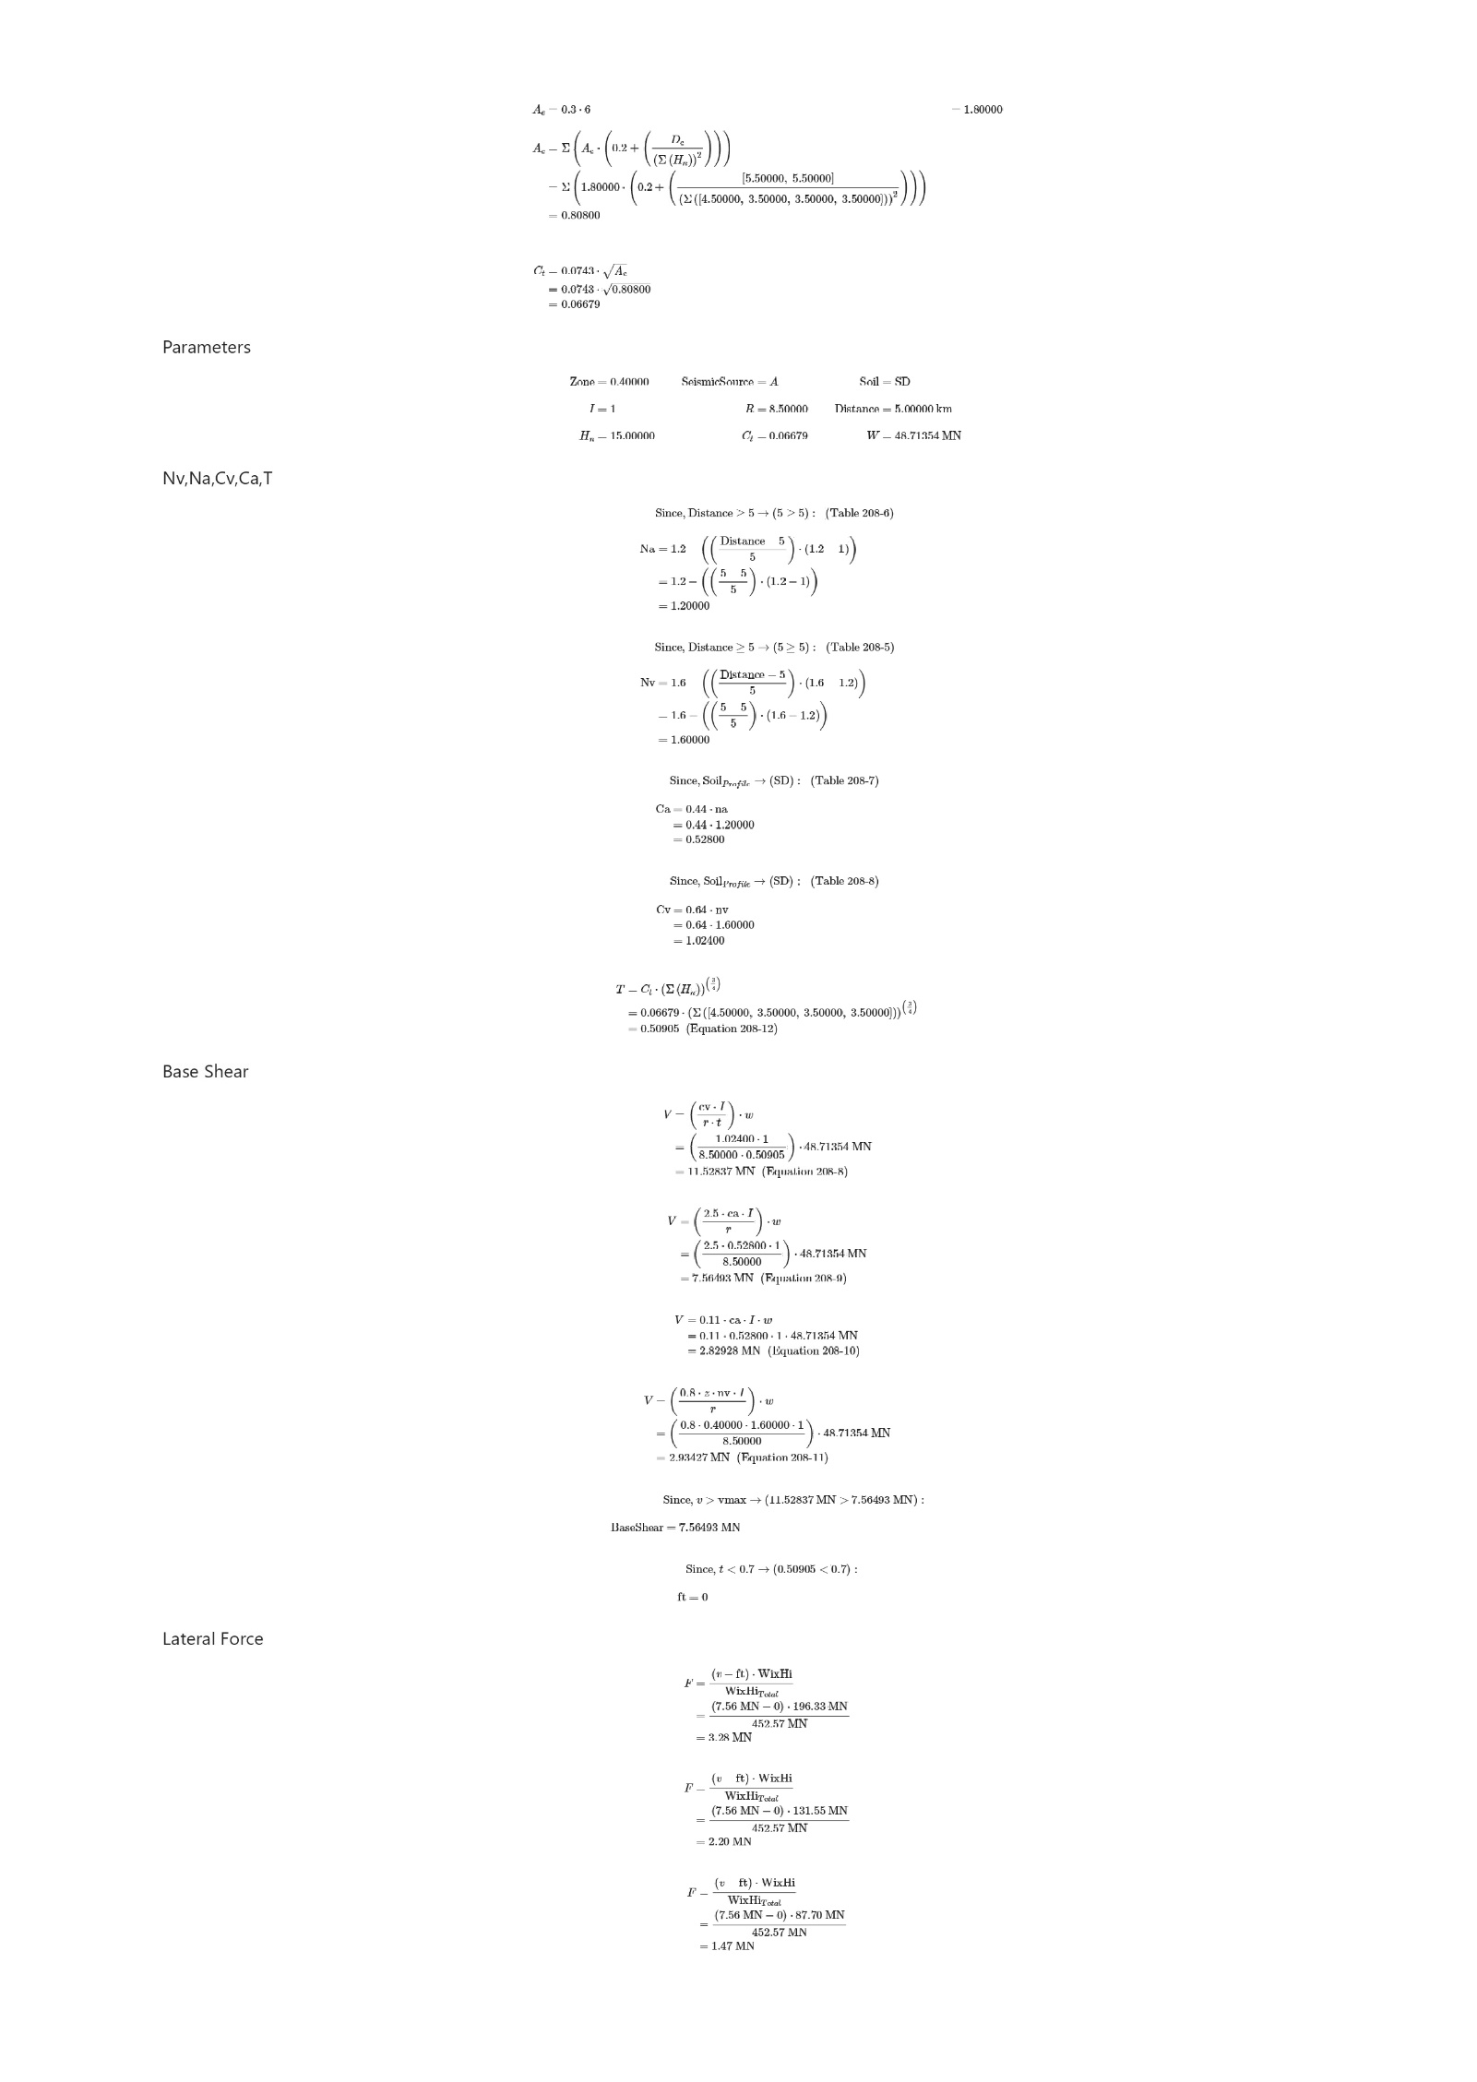

## NV,NA,CV,CA,T



## BASE SHEAR, STOREY LATERAL FORCE



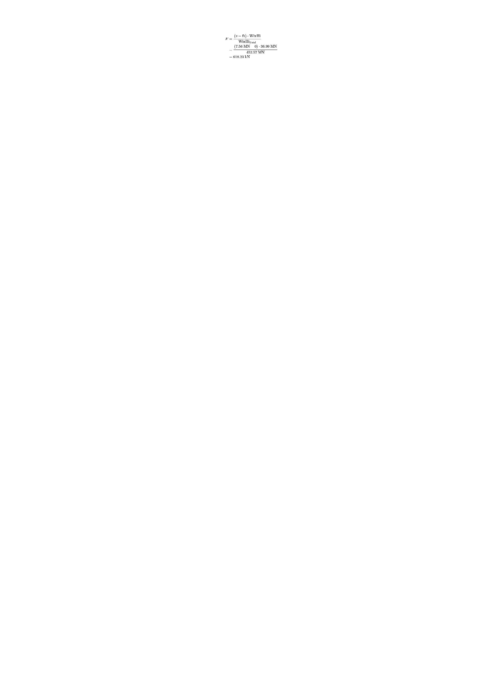

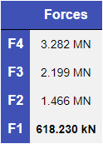

# DIRECT AND TORSIONAL COEFFICIENT











# STRUCTURAL ANALYSIS USING ( PORTAL,CANTILEVER AND FACTOR METHOD)

## FRAME 1

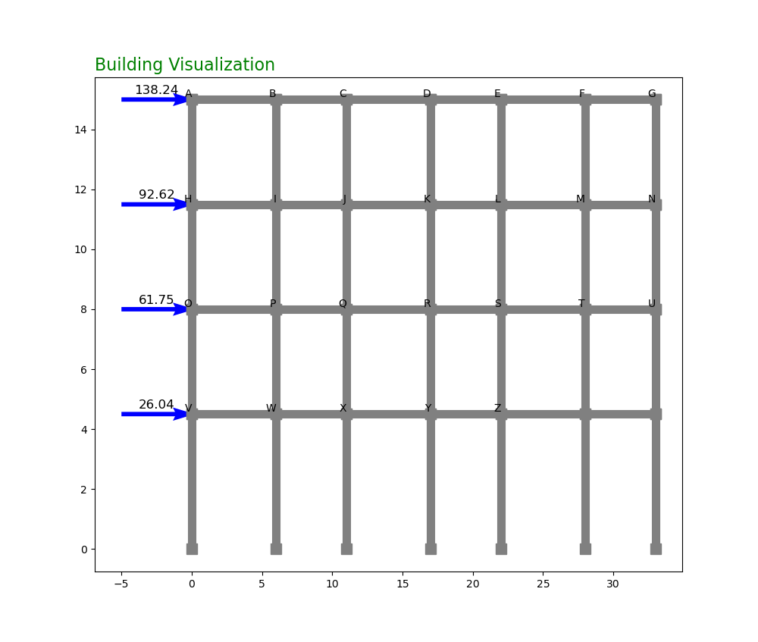

### PORTAL METHOD OF ANALYSIS

#### CALCULATION:

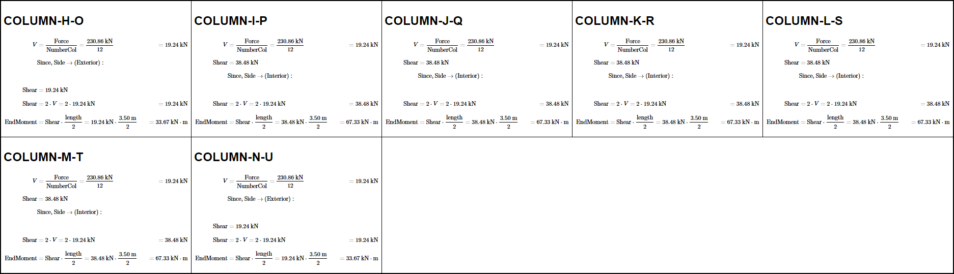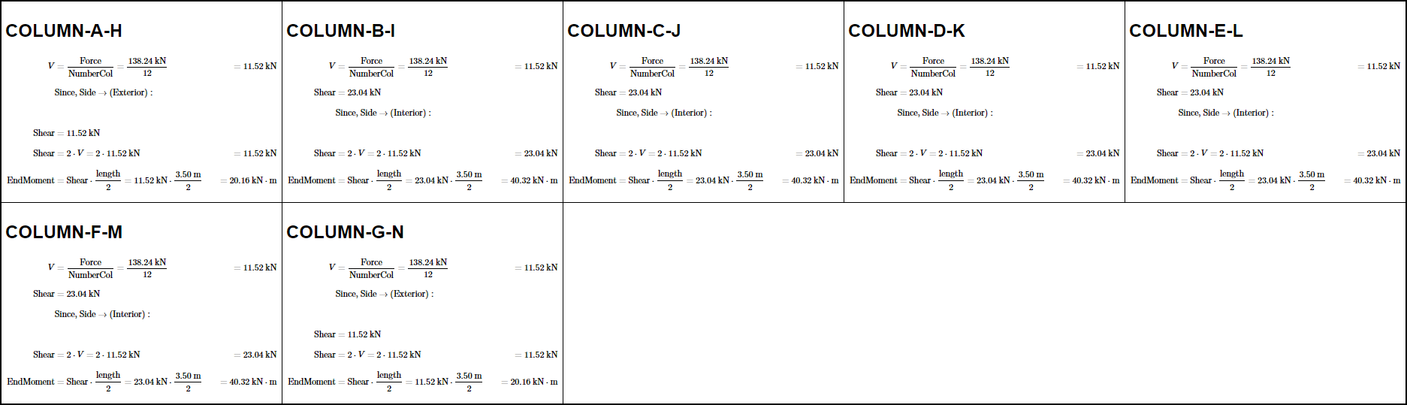

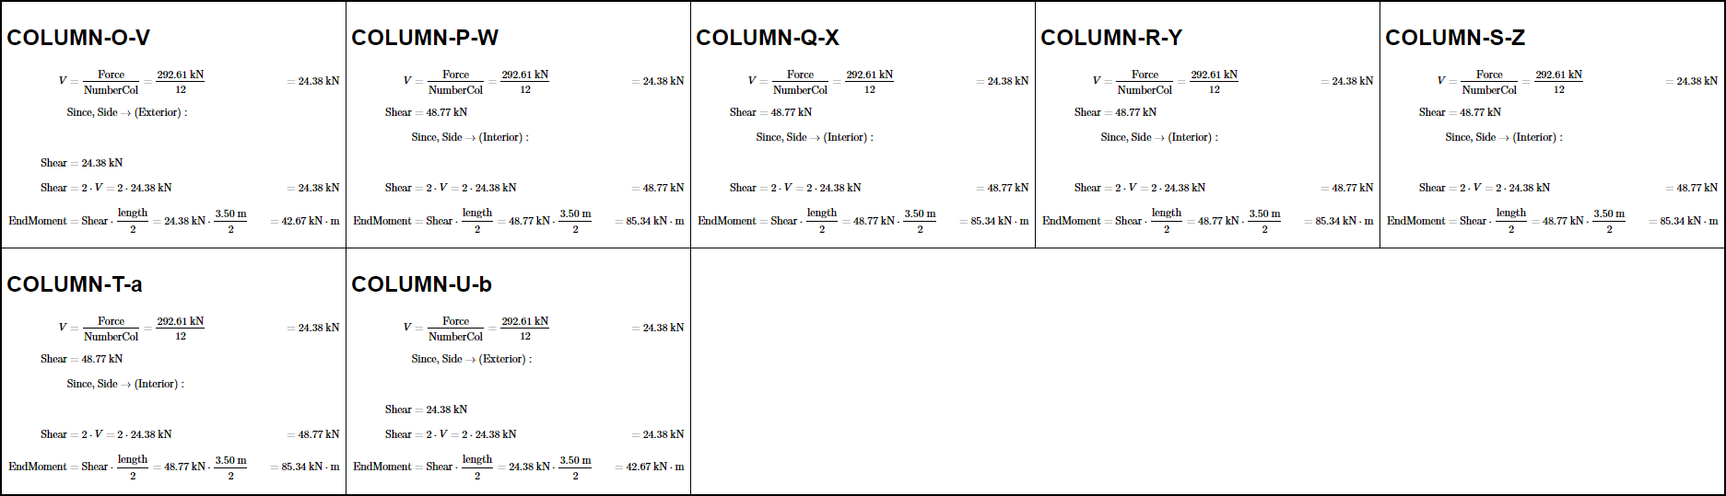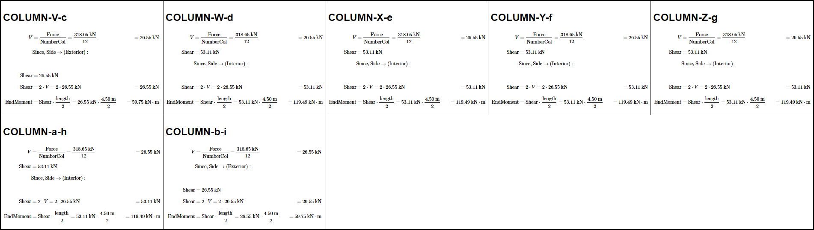

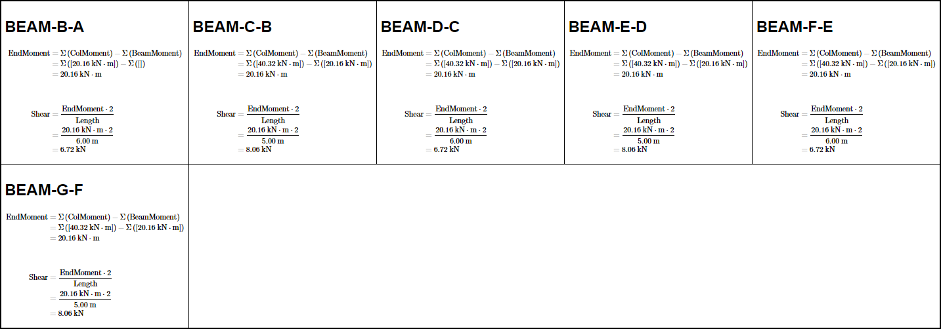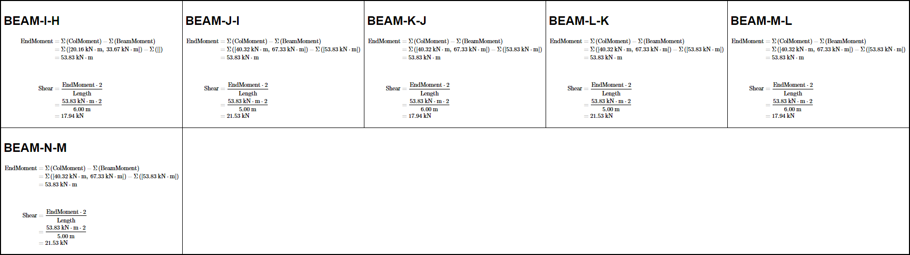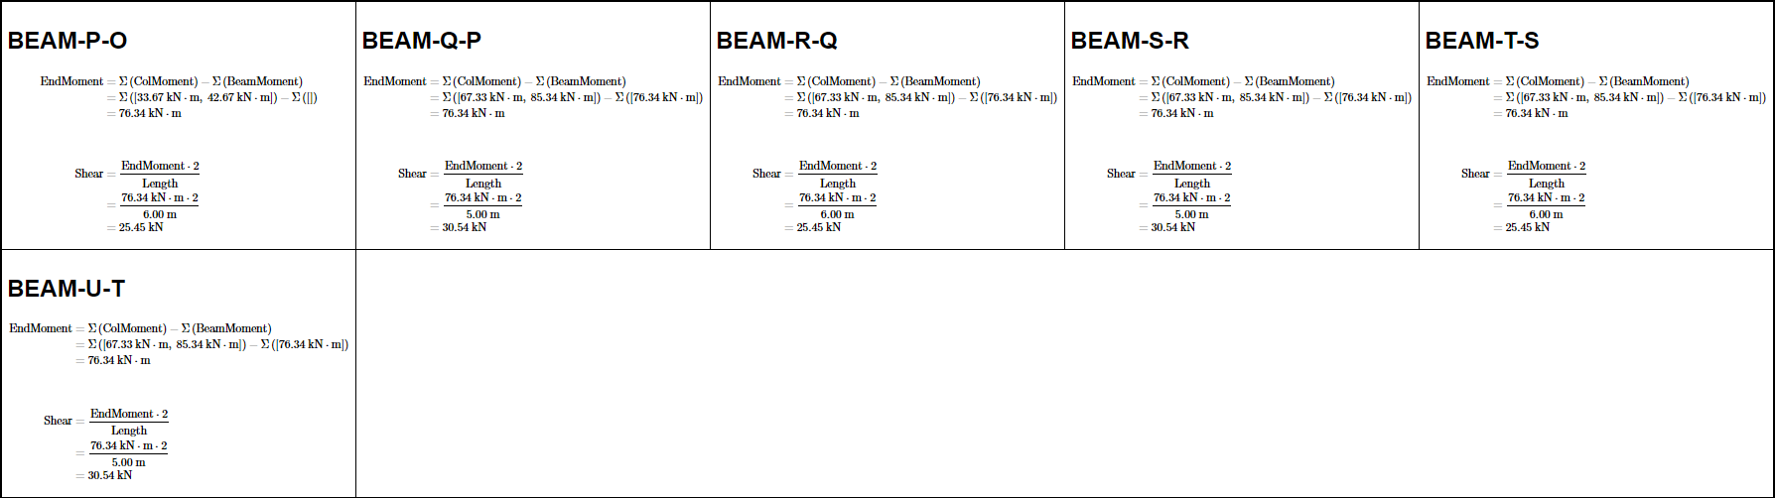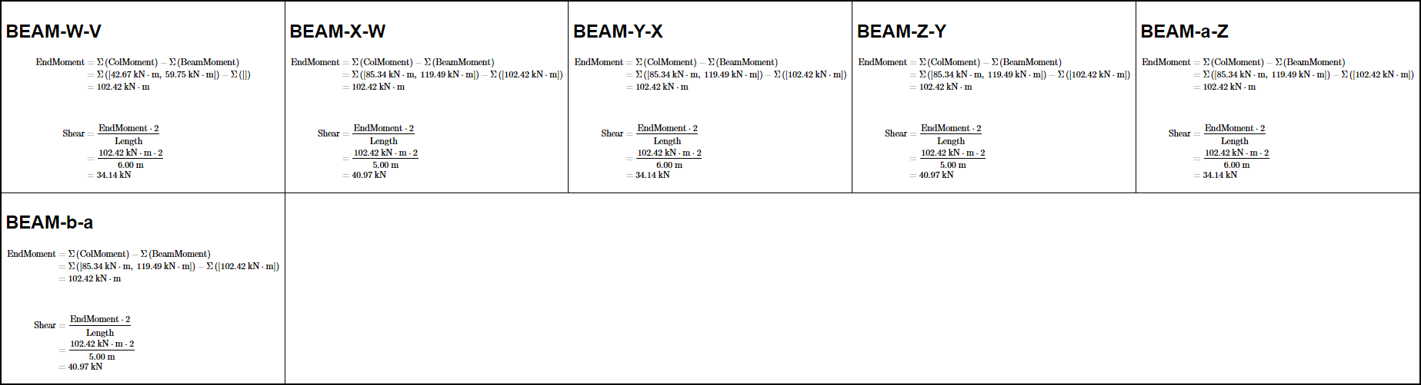

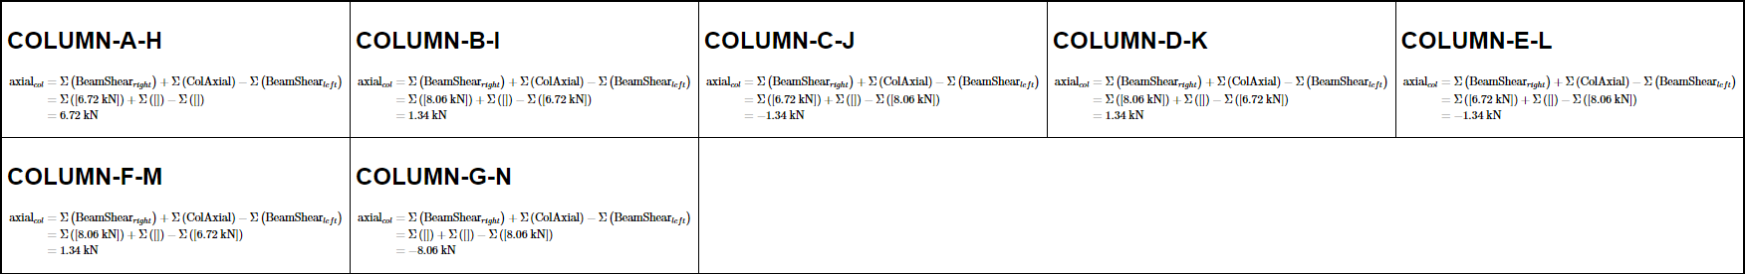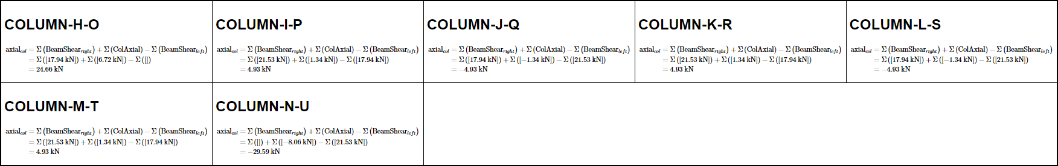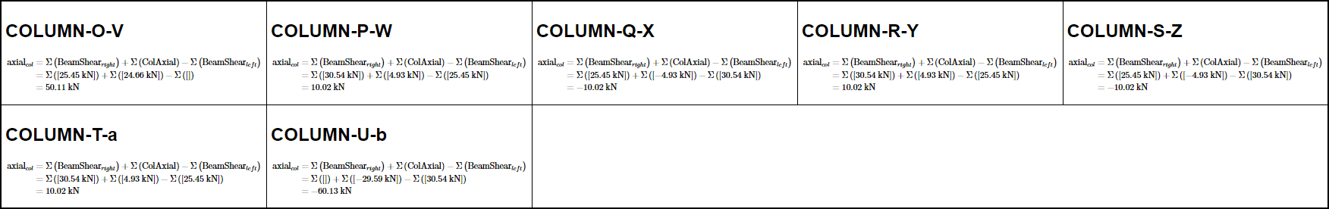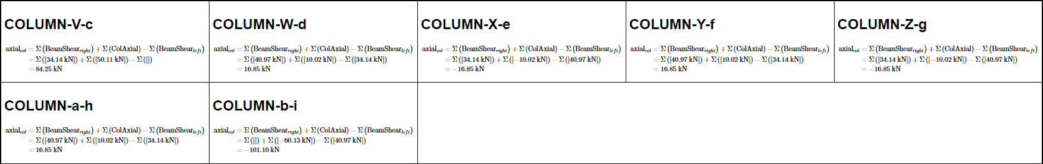

#### DIAGRAMS:

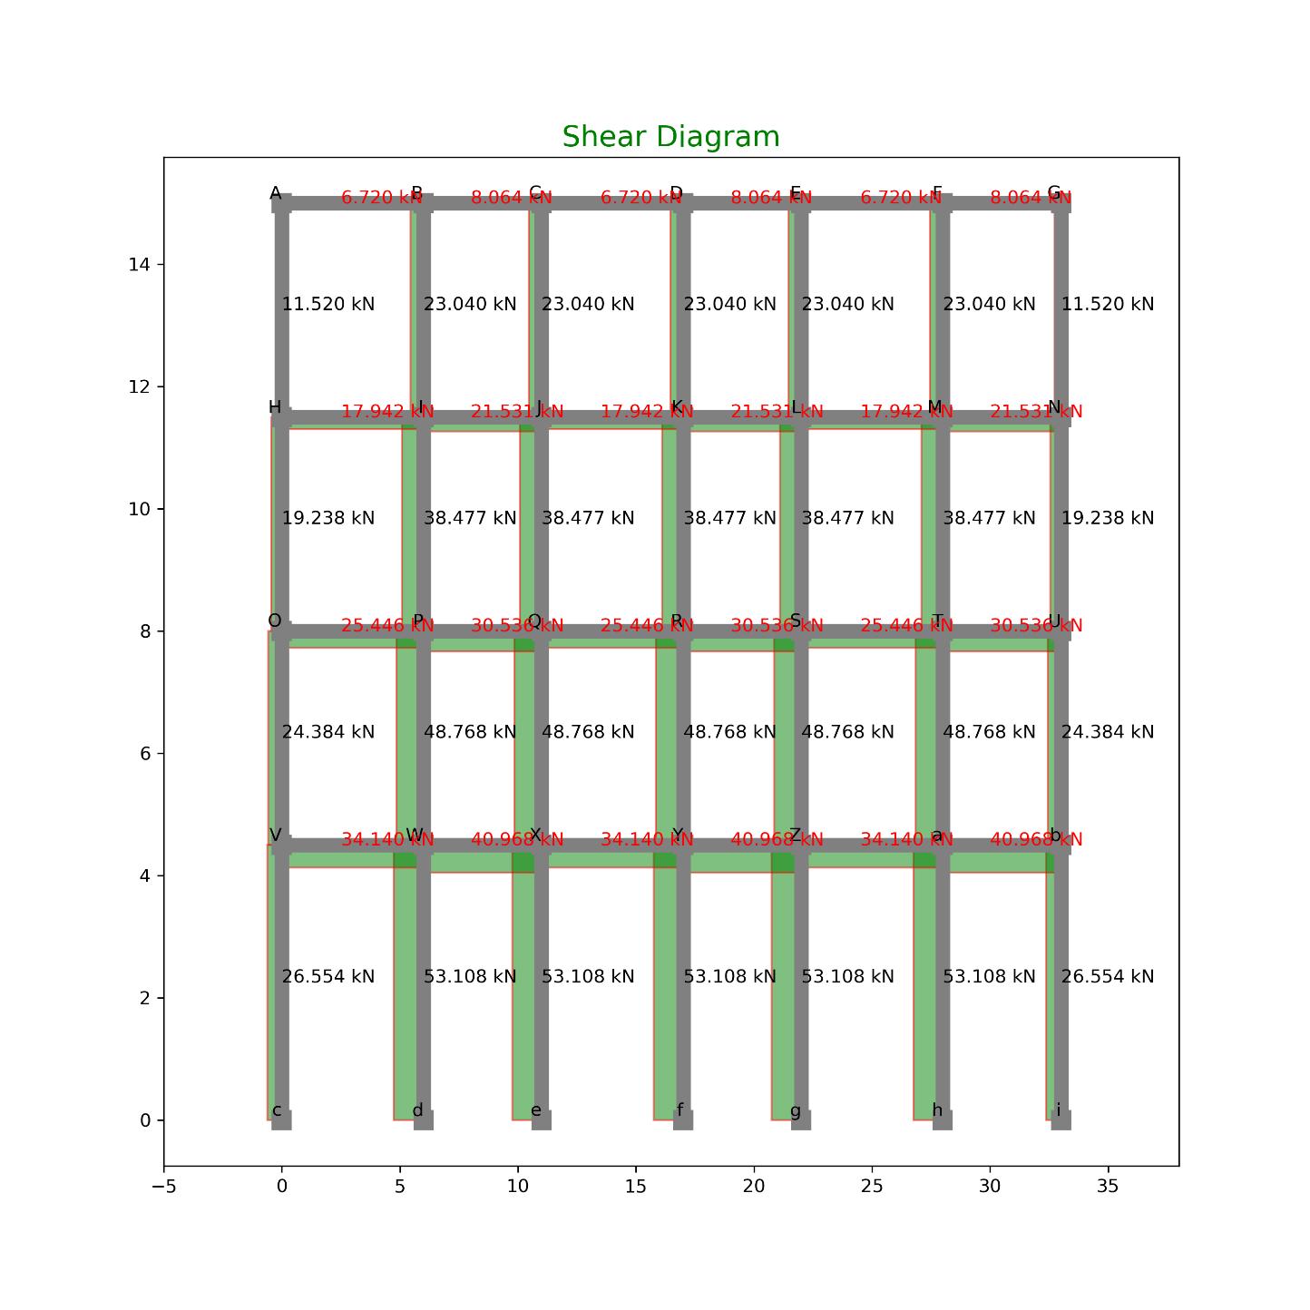

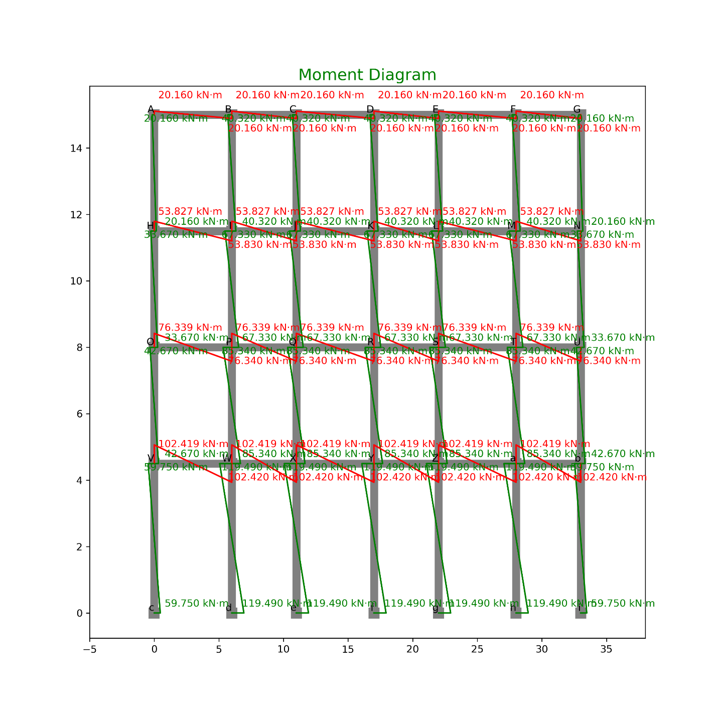

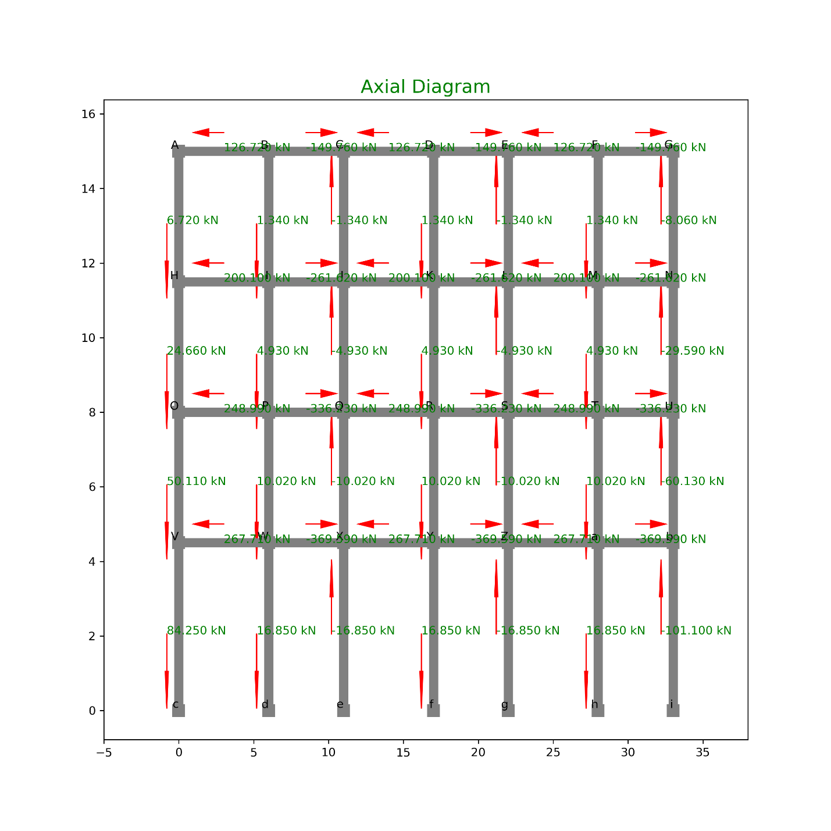

#### TABULATION OF FORCES:

SHEAR

|  |  |  |  |  |  |
| --- | --- | --- | --- | --- | --- |
| **INDEX** | **X** | **Y** | **Loc** | **Shear** | **Type** |
| 0 | 0 | 11.5 | Top | 11.52 | Col |
| 1 | 0 | 15 | Bot | 11.52 | Col |
| 2 | 6 | 11.5 | Top | 23.04 | Col |
| 3 | 6 | 15 | Bot | 23.04 | Col |
| 4 | 11 | 11.5 | Top | 23.04 | Col |
| 5 | 11 | 15 | Bot | 23.04 | Col |
| 6 | 17 | 11.5 | Top | 23.04 | Col |
| 7 | 17 | 15 | Bot | 23.04 | Col |
| 8 | 22 | 11.5 | Top | 23.04 | Col |
| 9 | 22 | 15 | Bot | 23.04 | Col |
| 10 | 28 | 11.5 | Top | 23.04 | Col |
| 11 | 28 | 15 | Bot | 23.04 | Col |
| 12 | 33 | 11.5 | Top | 11.52 | Col |
| 13 | 33 | 15 | Bot | 11.52 | Col |
| 14 | 0 | 8 | Top | 19.23833 | Col |
| 15 | 0 | 11.5 | Bot | 19.23833 | Col |
| 16 | 6 | 8 | Top | 38.47667 | Col |
| 17 | 6 | 11.5 | Bot | 38.47667 | Col |
| 18 | 11 | 8 | Top | 38.47667 | Col |
| 19 | 11 | 11.5 | Bot | 38.47667 | Col |
| 20 | 17 | 8 | Top | 38.47667 | Col |
| 21 | 17 | 11.5 | Bot | 38.47667 | Col |
| 22 | 22 | 8 | Top | 38.47667 | Col |
| 23 | 22 | 11.5 | Bot | 38.47667 | Col |
| 24 | 28 | 8 | Top | 38.47667 | Col |
| 25 | 28 | 11.5 | Bot | 38.47667 | Col |
| 26 | 33 | 8 | Top | 19.23833 | Col |
| 27 | 33 | 11.5 | Bot | 19.23833 | Col |
| 28 | 0 | 4.5 | Top | 24.38417 | Col |
| 29 | 0 | 8 | Bot | 24.38417 | Col |
| 30 | 6 | 4.5 | Top | 48.76833 | Col |
| 31 | 6 | 8 | Bot | 48.76833 | Col |
| 32 | 11 | 4.5 | Top | 48.76833 | Col |
| 33 | 11 | 8 | Bot | 48.76833 | Col |
| 34 | 17 | 4.5 | Top | 48.76833 | Col |
| 35 | 17 | 8 | Bot | 48.76833 | Col |
| 36 | 22 | 4.5 | Top | 48.76833 | Col |
| 37 | 22 | 8 | Bot | 48.76833 | Col |
| 38 | 28 | 4.5 | Top | 48.76833 | Col |
| 39 | 28 | 8 | Bot | 48.76833 | Col |
| 40 | 33 | 4.5 | Top | 24.38417 | Col |
| 41 | 33 | 8 | Bot | 24.38417 | Col |
| 42 | 0 | 0 | Top | 26.55417 | Col |
| 43 | 0 | 4.5 | Bot | 26.55417 | Col |
| 44 | 6 | 0 | Top | 53.10833 | Col |
| 45 | 6 | 4.5 | Bot | 53.10833 | Col |
| 46 | 11 | 0 | Top | 53.10833 | Col |
| 47 | 11 | 4.5 | Bot | 53.10833 | Col |
| 48 | 17 | 0 | Top | 53.10833 | Col |
| 49 | 17 | 4.5 | Bot | 53.10833 | Col |
| 50 | 22 | 0 | Top | 53.10833 | Col |
| 51 | 22 | 4.5 | Bot | 53.10833 | Col |
| 52 | 28 | 0 | Top | 53.10833 | Col |
| 53 | 28 | 4.5 | Bot | 53.10833 | Col |
| 54 | 33 | 0 | Top | 26.55417 | Col |
| 55 | 33 | 4.5 | Bot | 26.55417 | Col |
| 56 | 0 | 15 | Right | 6.72 | Beam |
| 57 | 6 | 15 | Left | 6.72 | Beam |
| 58 | 6 | 15 | Right | 8.064 | Beam |
| 59 | 11 | 15 | Left | 8.064 | Beam |
| 60 | 11 | 15 | Right | 6.72 | Beam |
| 61 | 17 | 15 | Left | 6.72 | Beam |
| 62 | 17 | 15 | Right | 8.064 | Beam |
| 63 | 22 | 15 | Left | 8.064 | Beam |
| 64 | 22 | 15 | Right | 6.72 | Beam |
| 65 | 28 | 15 | Left | 6.72 | Beam |
| 66 | 28 | 15 | Right | 8.064 | Beam |
| 67 | 33 | 15 | Left | 8.064 | Beam |
| 68 | 0 | 11.5 | Right | 17.94236 | Beam |
| 69 | 6 | 11.5 | Left | 17.94236 | Beam |
| 70 | 6 | 11.5 | Right | 21.53083 | Beam |
| 71 | 11 | 11.5 | Left | 21.53083 | Beam |
| 72 | 11 | 11.5 | Right | 17.94236 | Beam |
| 73 | 17 | 11.5 | Left | 17.94236 | Beam |
| 74 | 17 | 11.5 | Right | 21.53083 | Beam |
| 75 | 22 | 11.5 | Left | 21.53083 | Beam |
| 76 | 22 | 11.5 | Right | 17.94236 | Beam |
| 77 | 28 | 11.5 | Left | 17.94236 | Beam |
| 78 | 28 | 11.5 | Right | 21.53083 | Beam |
| 79 | 33 | 11.5 | Left | 21.53083 | Beam |
| 80 | 0 | 8 | Right | 25.44646 | Beam |
| 81 | 6 | 8 | Left | 25.44646 | Beam |
| 82 | 6 | 8 | Right | 30.53575 | Beam |
| 83 | 11 | 8 | Left | 30.53575 | Beam |
| 84 | 11 | 8 | Right | 25.44646 | Beam |
| 85 | 17 | 8 | Left | 25.44646 | Beam |
| 86 | 17 | 8 | Right | 30.53575 | Beam |
| 87 | 22 | 8 | Left | 30.53575 | Beam |
| 88 | 22 | 8 | Right | 25.44646 | Beam |
| 89 | 28 | 8 | Left | 25.44646 | Beam |
| 90 | 28 | 8 | Right | 30.53575 | Beam |
| 91 | 33 | 8 | Left | 30.53575 | Beam |
| 92 | 0 | 4.5 | Right | 34.13972 | Beam |
| 93 | 6 | 4.5 | Left | 34.13972 | Beam |
| 94 | 6 | 4.5 | Right | 40.96767 | Beam |
| 95 | 11 | 4.5 | Left | 40.96767 | Beam |
| 96 | 11 | 4.5 | Right | 34.13972 | Beam |
| 97 | 17 | 4.5 | Left | 34.13972 | Beam |
| 98 | 17 | 4.5 | Right | 40.96767 | Beam |
| 99 | 22 | 4.5 | Left | 40.96767 | Beam |
| 100 | 22 | 4.5 | Right | 34.13972 | Beam |
| 101 | 28 | 4.5 | Left | 34.13972 | Beam |
| 102 | 28 | 4.5 | Right | 40.96767 | Beam |
| 103 | 33 | 4.5 | Left | 40.96767 | Beam |

MOMENT

|  |  |  |  |  |  |
| --- | --- | --- | --- | --- | --- |
| INDEX | X | Y | Loc | Moment | Type |
| 0 | 0 | 11.5 | Top | 20.16 | Col |
| 1 | 0 | 15 | Bot | 20.16 | Col |
| 2 | 6 | 11.5 | Top | 40.32 | Col |
| 3 | 6 | 15 | Bot | 40.32 | Col |
| 4 | 11 | 11.5 | Top | 40.32 | Col |
| 5 | 11 | 15 | Bot | 40.32 | Col |
| 6 | 17 | 11.5 | Top | 40.32 | Col |
| 7 | 17 | 15 | Bot | 40.32 | Col |
| 8 | 22 | 11.5 | Top | 40.32 | Col |
| 9 | 22 | 15 | Bot | 40.32 | Col |
| 10 | 28 | 11.5 | Top | 40.32 | Col |
| 11 | 28 | 15 | Bot | 40.32 | Col |
| 12 | 33 | 11.5 | Top | 20.16 | Col |
| 13 | 33 | 15 | Bot | 20.16 | Col |
| 14 | 0 | 8 | Top | 33.6670833 | Col |
| 15 | 0 | 11.5 | Bot | 33.6670833 | Col |
| 16 | 6 | 8 | Top | 67.3341667 | Col |
| 17 | 6 | 11.5 | Bot | 67.3341667 | Col |
| 18 | 11 | 8 | Top | 67.3341667 | Col |
| 19 | 11 | 11.5 | Bot | 67.3341667 | Col |
| 20 | 17 | 8 | Top | 67.3341667 | Col |
| 21 | 17 | 11.5 | Bot | 67.3341667 | Col |
| 22 | 22 | 8 | Top | 67.3341667 | Col |
| 23 | 22 | 11.5 | Bot | 67.3341667 | Col |
| 24 | 28 | 8 | Top | 67.3341667 | Col |
| 25 | 28 | 11.5 | Bot | 67.3341667 | Col |
| 26 | 33 | 8 | Top | 33.6670833 | Col |
| 27 | 33 | 11.5 | Bot | 33.6670833 | Col |
| 28 | 0 | 4.5 | Top | 42.6722917 | Col |
| 29 | 0 | 8 | Bot | 42.6722917 | Col |
| 30 | 6 | 4.5 | Top | 85.3445833 | Col |
| 31 | 6 | 8 | Bot | 85.3445833 | Col |
| 32 | 11 | 4.5 | Top | 85.3445833 | Col |
| 33 | 11 | 8 | Bot | 85.3445833 | Col |
| 34 | 17 | 4.5 | Top | 85.3445833 | Col |
| 35 | 17 | 8 | Bot | 85.3445833 | Col |
| 36 | 22 | 4.5 | Top | 85.3445833 | Col |
| 37 | 22 | 8 | Bot | 85.3445833 | Col |
| 38 | 28 | 4.5 | Top | 85.3445833 | Col |
| 39 | 28 | 8 | Bot | 85.3445833 | Col |
| 40 | 33 | 4.5 | Top | 42.6722917 | Col |
| 41 | 33 | 8 | Bot | 42.6722917 | Col |
| 42 | 0 | 0 | Top | 59.746875 | Col |
| 43 | 0 | 4.5 | Bot | 59.746875 | Col |
| 44 | 6 | 0 | Top | 119.49375 | Col |
| 45 | 6 | 4.5 | Bot | 119.49375 | Col |
| 46 | 11 | 0 | Top | 119.49375 | Col |
| 47 | 11 | 4.5 | Bot | 119.49375 | Col |
| 48 | 17 | 0 | Top | 119.49375 | Col |
| 49 | 17 | 4.5 | Bot | 119.49375 | Col |
| 50 | 22 | 0 | Top | 119.49375 | Col |
| 51 | 22 | 4.5 | Bot | 119.49375 | Col |
| 52 | 28 | 0 | Top | 119.49375 | Col |
| 53 | 28 | 4.5 | Bot | 119.49375 | Col |
| 54 | 33 | 0 | Top | 59.746875 | Col |
| 55 | 33 | 4.5 | Bot | 59.746875 | Col |
| 56 | 0 | 15 | Right | 20.16 | Beam |
| 57 | 6 | 15 | Left | 20.16 | Beam |
| 58 | 6 | 15 | Right | 20.16 | Beam |
| 59 | 11 | 15 | Left | 20.16 | Beam |
| 60 | 11 | 15 | Right | 20.16 | Beam |
| 61 | 17 | 15 | Left | 20.16 | Beam |
| 62 | 17 | 15 | Right | 20.16 | Beam |
| 63 | 22 | 15 | Left | 20.16 | Beam |
| 64 | 22 | 15 | Right | 20.16 | Beam |
| 65 | 28 | 15 | Left | 20.16 | Beam |
| 66 | 28 | 15 | Right | 20.16 | Beam |
| 67 | 33 | 15 | Left | 20.16 | Beam |
| 68 | 0 | 11.5 | Right | 53.8270833 | Beam |
| 69 | 6 | 11.5 | Left | 53.8270833 | Beam |
| 70 | 6 | 11.5 | Right | 53.8270833 | Beam |
| 71 | 11 | 11.5 | Left | 53.8270833 | Beam |
| 72 | 11 | 11.5 | Right | 53.8270833 | Beam |
| 73 | 17 | 11.5 | Left | 53.8270833 | Beam |
| 74 | 17 | 11.5 | Right | 53.8270833 | Beam |
| 75 | 22 | 11.5 | Left | 53.8270833 | Beam |
| 76 | 22 | 11.5 | Right | 53.8270833 | Beam |
| 77 | 28 | 11.5 | Left | 53.8270833 | Beam |
| 78 | 28 | 11.5 | Right | 53.8270833 | Beam |
| 79 | 33 | 11.5 | Left | 53.8270833 | Beam |
| 80 | 0 | 8 | Right | 76.339375 | Beam |
| 81 | 6 | 8 | Left | 76.339375 | Beam |
| 82 | 6 | 8 | Right | 76.339375 | Beam |
| 83 | 11 | 8 | Left | 76.339375 | Beam |
| 84 | 11 | 8 | Right | 76.339375 | Beam |
| 85 | 17 | 8 | Left | 76.339375 | Beam |
| 86 | 17 | 8 | Right | 76.339375 | Beam |
| 87 | 22 | 8 | Left | 76.339375 | Beam |
| 88 | 22 | 8 | Right | 76.339375 | Beam |
| 89 | 28 | 8 | Left | 76.339375 | Beam |
| 90 | 28 | 8 | Right | 76.339375 | Beam |
| 91 | 33 | 8 | Left | 76.339375 | Beam |
| 92 | 0 | 4.5 | Right | 102.419167 | Beam |
| 93 | 6 | 4.5 | Left | 102.419167 | Beam |
| 94 | 6 | 4.5 | Right | 102.419167 | Beam |
| 95 | 11 | 4.5 | Left | 102.419167 | Beam |
| 96 | 11 | 4.5 | Right | 102.419167 | Beam |
| 97 | 17 | 4.5 | Left | 102.419167 | Beam |
| 98 | 17 | 4.5 | Right | 102.419167 | Beam |
| 99 | 22 | 4.5 | Left | 102.419167 | Beam |
| 100 | 22 | 4.5 | Right | 102.419167 | Beam |
| 101 | 28 | 4.5 | Left | 102.419167 | Beam |
| 102 | 28 | 4.5 | Right | 102.419167 | Beam |
| 103 | 33 | 4.5 | Left | 102.419167 | Beam |

AXIAL

|  |  |  |  |  |  |
| --- | --- | --- | --- | --- | --- |
| INDEX | X | Y | Loc | Axial | Type |
| 0 | 0 | 11.5 | Top | 6.72 | Col |
| 1 | 0 | 15 | Bot | 6.72 | Col |
| 2 | 6 | 11.5 | Top | 1.344 | Col |
| 3 | 6 | 15 | Bot | 1.344 | Col |
| 4 | 11 | 11.5 | Top | -1.344 | Col |
| 5 | 11 | 15 | Bot | -1.344 | Col |
| 6 | 17 | 11.5 | Top | 1.344 | Col |
| 7 | 17 | 15 | Bot | 1.344 | Col |
| 8 | 22 | 11.5 | Top | -1.344 | Col |
| 9 | 22 | 15 | Bot | -1.344 | Col |
| 10 | 28 | 11.5 | Top | 1.344 | Col |
| 11 | 28 | 15 | Bot | 1.344 | Col |
| 12 | 33 | 11.5 | Top | -8.064 | Col |
| 13 | 33 | 15 | Bot | -8.064 | Col |
| 14 | 0 | 8 | Top | 24.66236 | Col |
| 15 | 0 | 11.5 | Bot | 24.66236 | Col |
| 16 | 6 | 8 | Top | 4.932472 | Col |
| 17 | 6 | 11.5 | Bot | 4.932472 | Col |
| 18 | 11 | 8 | Top | -4.93247 | Col |
| 19 | 11 | 11.5 | Bot | -4.93247 | Col |
| 20 | 17 | 8 | Top | 4.932472 | Col |
| 21 | 17 | 11.5 | Bot | 4.932472 | Col |
| 22 | 22 | 8 | Top | -4.93247 | Col |
| 23 | 22 | 11.5 | Bot | -4.93247 | Col |
| 24 | 28 | 8 | Top | 4.932472 | Col |
| 25 | 28 | 11.5 | Bot | 4.932472 | Col |
| 26 | 33 | 8 | Top | -29.5948 | Col |
| 27 | 33 | 11.5 | Bot | -29.5948 | Col |
| 28 | 0 | 4.5 | Top | 50.10882 | Col |
| 29 | 0 | 8 | Bot | 50.10882 | Col |
| 30 | 6 | 4.5 | Top | 10.02176 | Col |
| 31 | 6 | 8 | Bot | 10.02176 | Col |
| 32 | 11 | 4.5 | Top | -10.0218 | Col |
| 33 | 11 | 8 | Bot | -10.0218 | Col |
| 34 | 17 | 4.5 | Top | 10.02176 | Col |
| 35 | 17 | 8 | Bot | 10.02176 | Col |
| 36 | 22 | 4.5 | Top | -10.0218 | Col |
| 37 | 22 | 8 | Bot | -10.0218 | Col |
| 38 | 28 | 4.5 | Top | 10.02176 | Col |
| 39 | 28 | 8 | Bot | 10.02176 | Col |
| 40 | 33 | 4.5 | Top | -60.1306 | Col |
| 41 | 33 | 8 | Bot | -60.1306 | Col |
| 42 | 0 | 0 | Top | 84.24854 | Col |
| 43 | 0 | 4.5 | Bot | 84.24854 | Col |
| 44 | 6 | 0 | Top | 16.84971 | Col |
| 45 | 6 | 4.5 | Bot | 16.84971 | Col |
| 46 | 11 | 0 | Top | -16.8497 | Col |
| 47 | 11 | 4.5 | Bot | -16.8497 | Col |
| 48 | 17 | 0 | Top | 16.84971 | Col |
| 49 | 17 | 4.5 | Bot | 16.84971 | Col |
| 50 | 22 | 0 | Top | -16.8497 | Col |
| 51 | 22 | 4.5 | Bot | -16.8497 | Col |
| 52 | 28 | 0 | Top | 16.84971 | Col |
| 53 | 28 | 4.5 | Bot | 16.84971 | Col |
| 54 | 33 | 0 | Top | -101.098 | Col |
| 55 | 33 | 4.5 | Bot | -101.098 | Col |
| 56 | 0 | 15 | Right | 126.72 | Beam |
| 57 | 6 | 15 | Left | 126.72 | Beam |
| 58 | 6 | 15 | Right | -149.76 | Beam |
| 59 | 11 | 15 | Left | -149.76 | Beam |
| 60 | 11 | 15 | Right | 126.72 | Beam |
| 61 | 17 | 15 | Left | 126.72 | Beam |
| 62 | 17 | 15 | Right | -149.76 | Beam |
| 63 | 22 | 15 | Left | -149.76 | Beam |
| 64 | 22 | 15 | Right | 126.72 | Beam |
| 65 | 28 | 15 | Left | 126.72 | Beam |
| 66 | 28 | 15 | Right | -149.76 | Beam |
| 67 | 33 | 15 | Left | -149.76 | Beam |
| 68 | 0 | 11.5 | Right | 200.1017 | Beam |
| 69 | 6 | 11.5 | Left | 200.1017 | Beam |
| 70 | 6 | 11.5 | Right | -261.618 | Beam |
| 71 | 11 | 11.5 | Left | -261.618 | Beam |
| 72 | 11 | 11.5 | Right | 200.1017 | Beam |
| 73 | 17 | 11.5 | Left | 200.1017 | Beam |
| 74 | 17 | 11.5 | Right | -261.618 | Beam |
| 75 | 22 | 11.5 | Left | -261.618 | Beam |
| 76 | 22 | 11.5 | Right | 200.1017 | Beam |
| 77 | 28 | 11.5 | Left | 200.1017 | Beam |
| 78 | 28 | 11.5 | Right | -261.618 | Beam |
| 79 | 33 | 11.5 | Left | -261.618 | Beam |
| 80 | 0 | 8 | Right | 248.9875 | Beam |
| 81 | 6 | 8 | Left | 248.9875 | Beam |
| 82 | 6 | 8 | Right | -336.233 | Beam |
| 83 | 11 | 8 | Left | -336.233 | Beam |
| 84 | 11 | 8 | Right | 248.9875 | Beam |
| 85 | 17 | 8 | Left | 248.9875 | Beam |
| 86 | 17 | 8 | Right | -336.233 | Beam |
| 87 | 22 | 8 | Left | -336.233 | Beam |
| 88 | 22 | 8 | Right | 248.9875 | Beam |
| 89 | 28 | 8 | Left | 248.9875 | Beam |
| 90 | 28 | 8 | Right | -336.233 | Beam |
|  |  |  |  |  |  |
| 91 | 33 | 8 | Left | -336.233 | Beam |
| 92 | 0 | 4.5 | Right | 267.7117 | Beam |
| 93 | 6 | 4.5 | Left | 267.7117 | Beam |
| 94 | 6 | 4.5 | Right | -369.588 | Beam |
| 95 | 11 | 4.5 | Left | -369.588 | Beam |
| 96 | 11 | 4.5 | Right | 267.7117 | Beam |
| 97 | 17 | 4.5 | Left | 267.7117 | Beam |
| 98 | 17 | 4.5 | Right | -369.588 | Beam |
| 99 | 22 | 4.5 | Left | -369.588 | Beam |
| 100 | 22 | 4.5 | Right | 267.7117 | Beam |
| 101 | 28 | 4.5 | Left | 267.7117 | Beam |
| 102 | 28 | 4.5 | Right | -369.588 | Beam |
| 103 | 33 | 4.5 | Left | -369.588 | Beam |

### CANTILEVER METHOD OF ANALYSIS:

#### CALCULATION

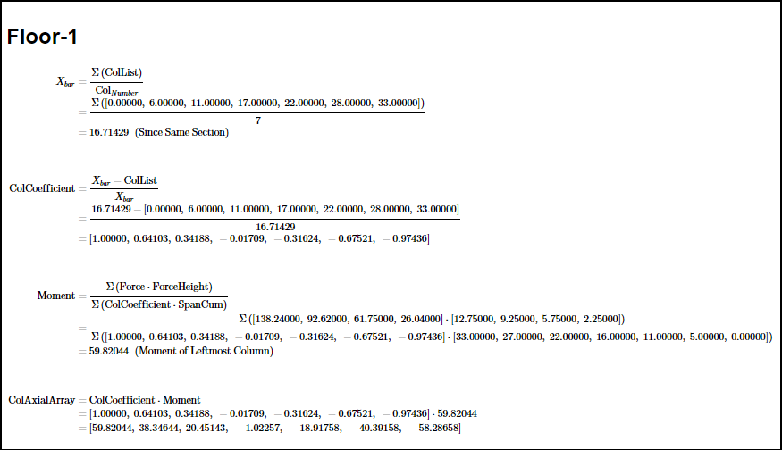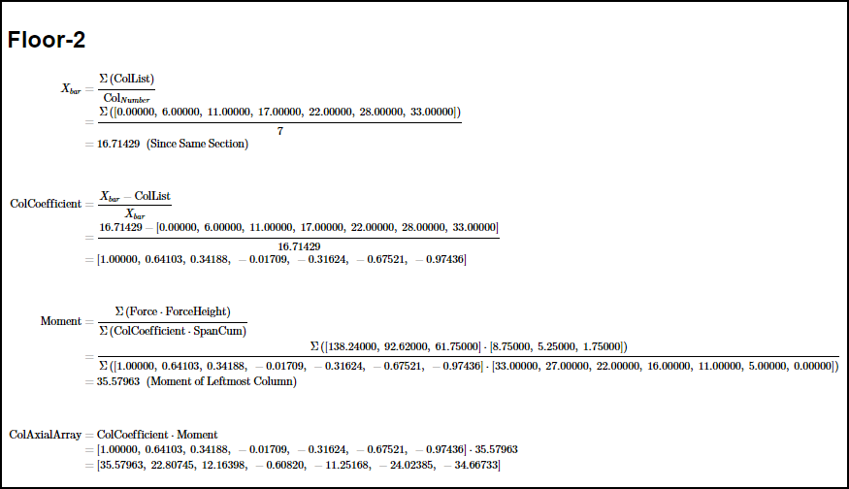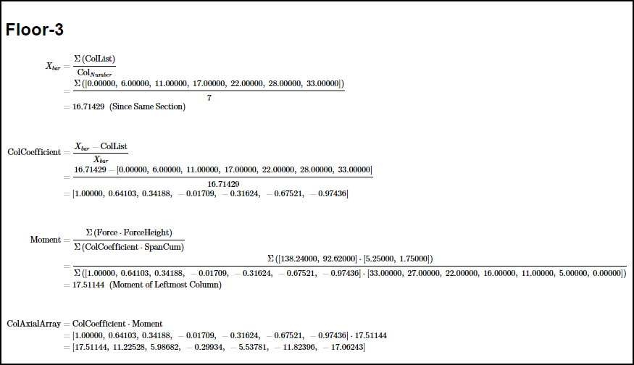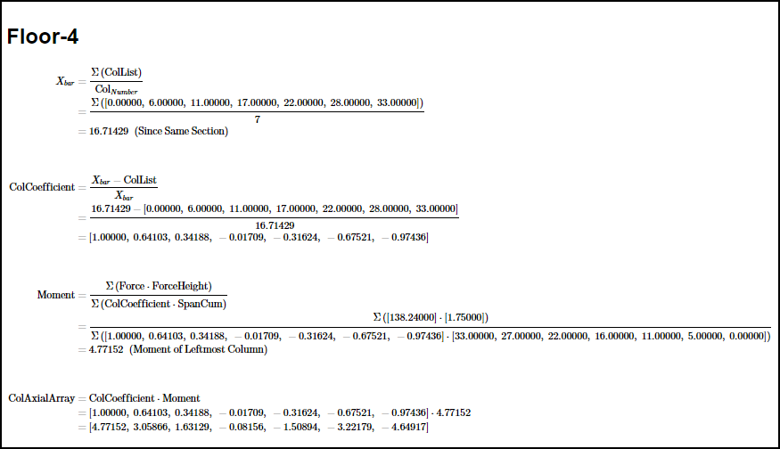

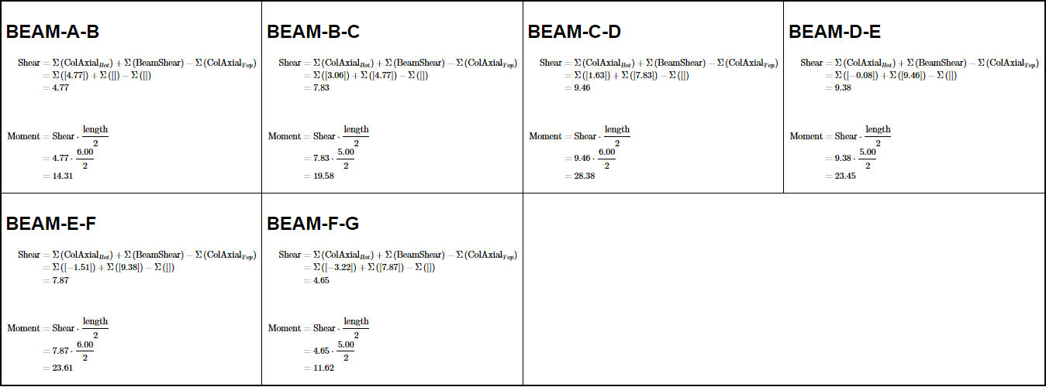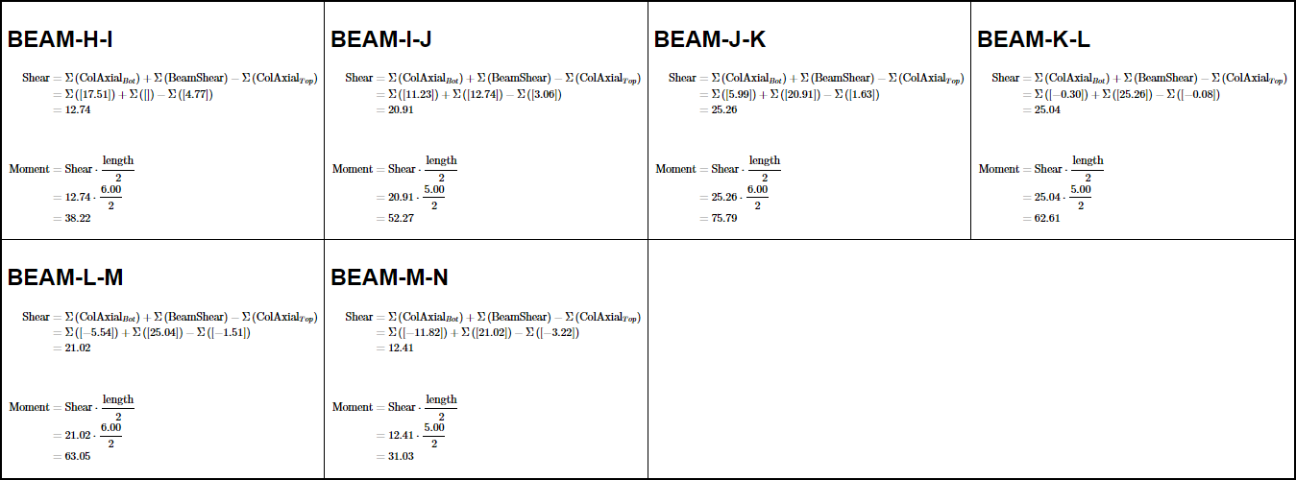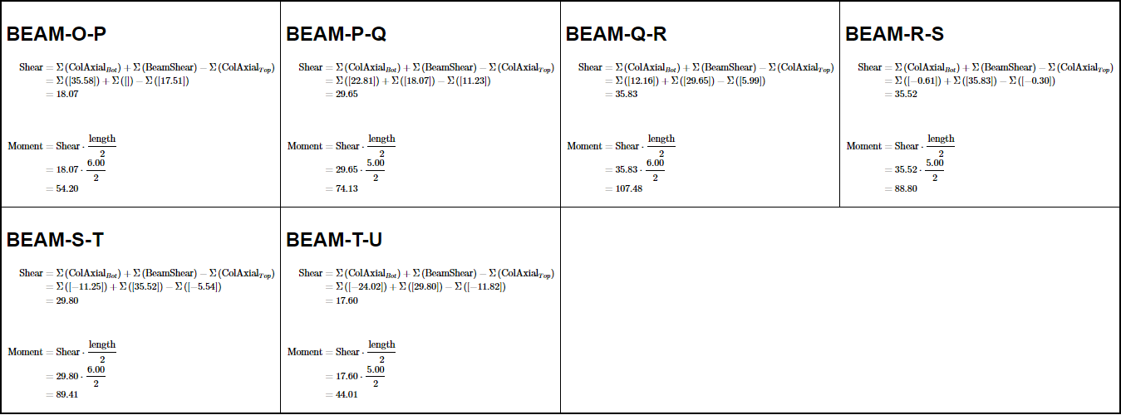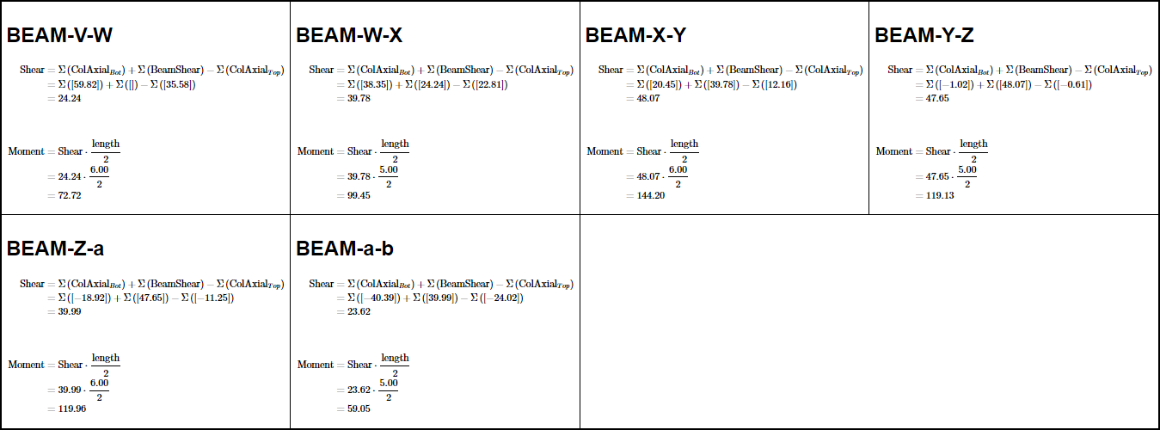

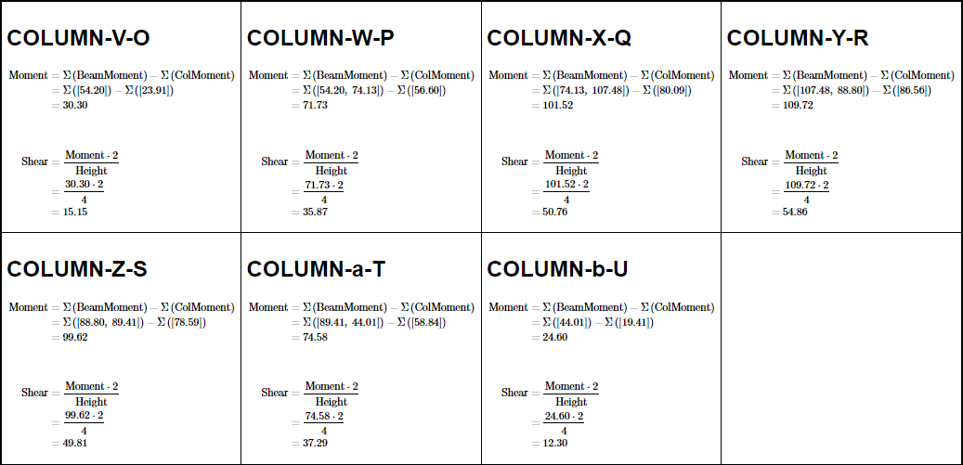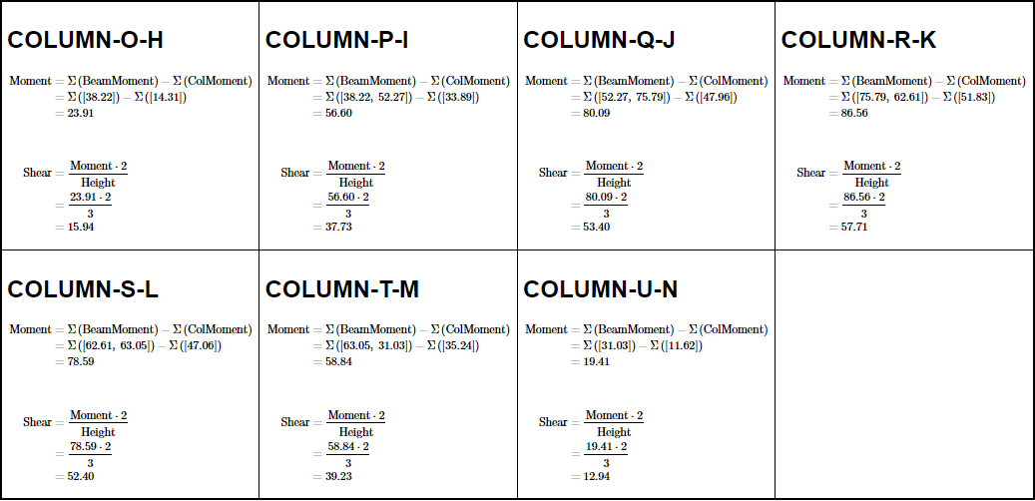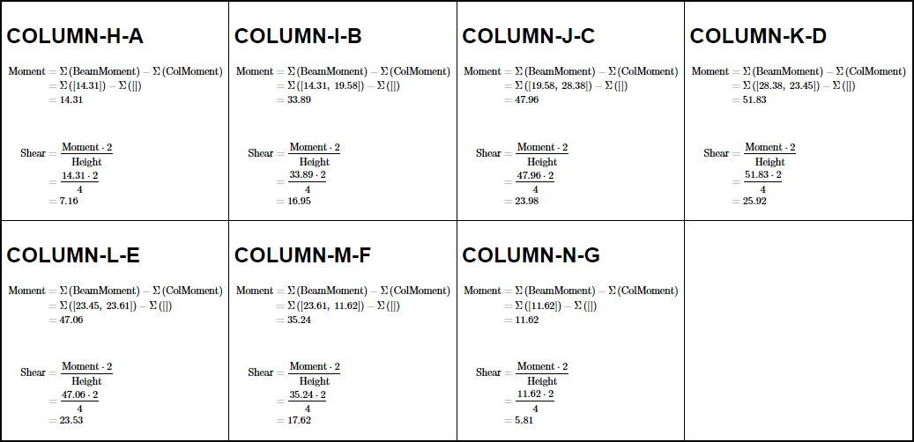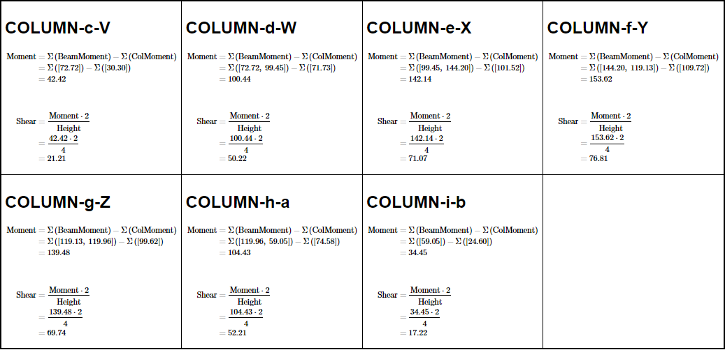

#### DIAGRAMS

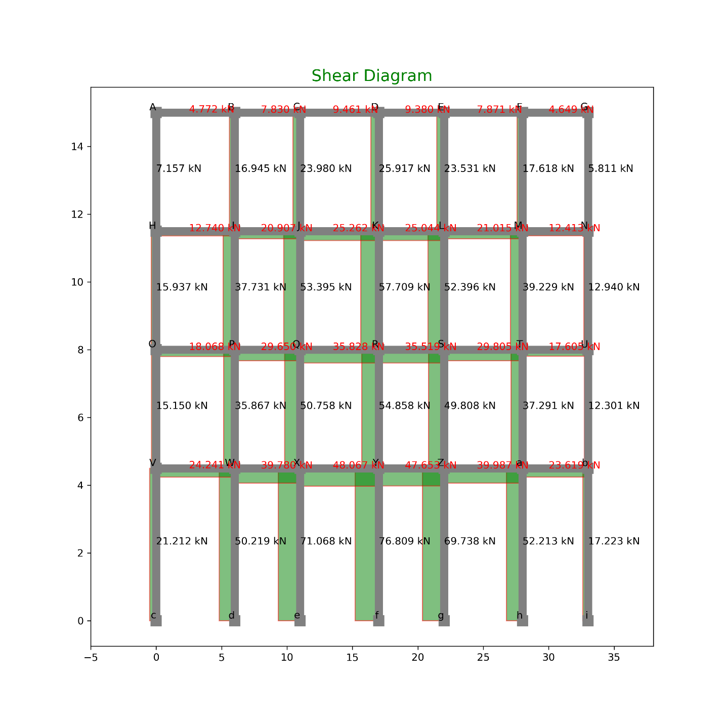

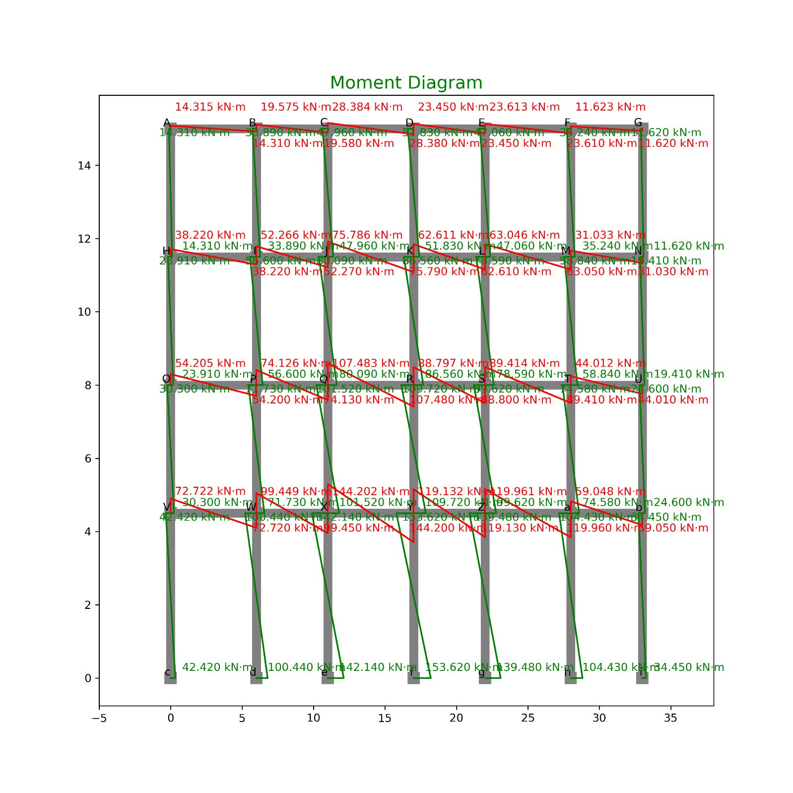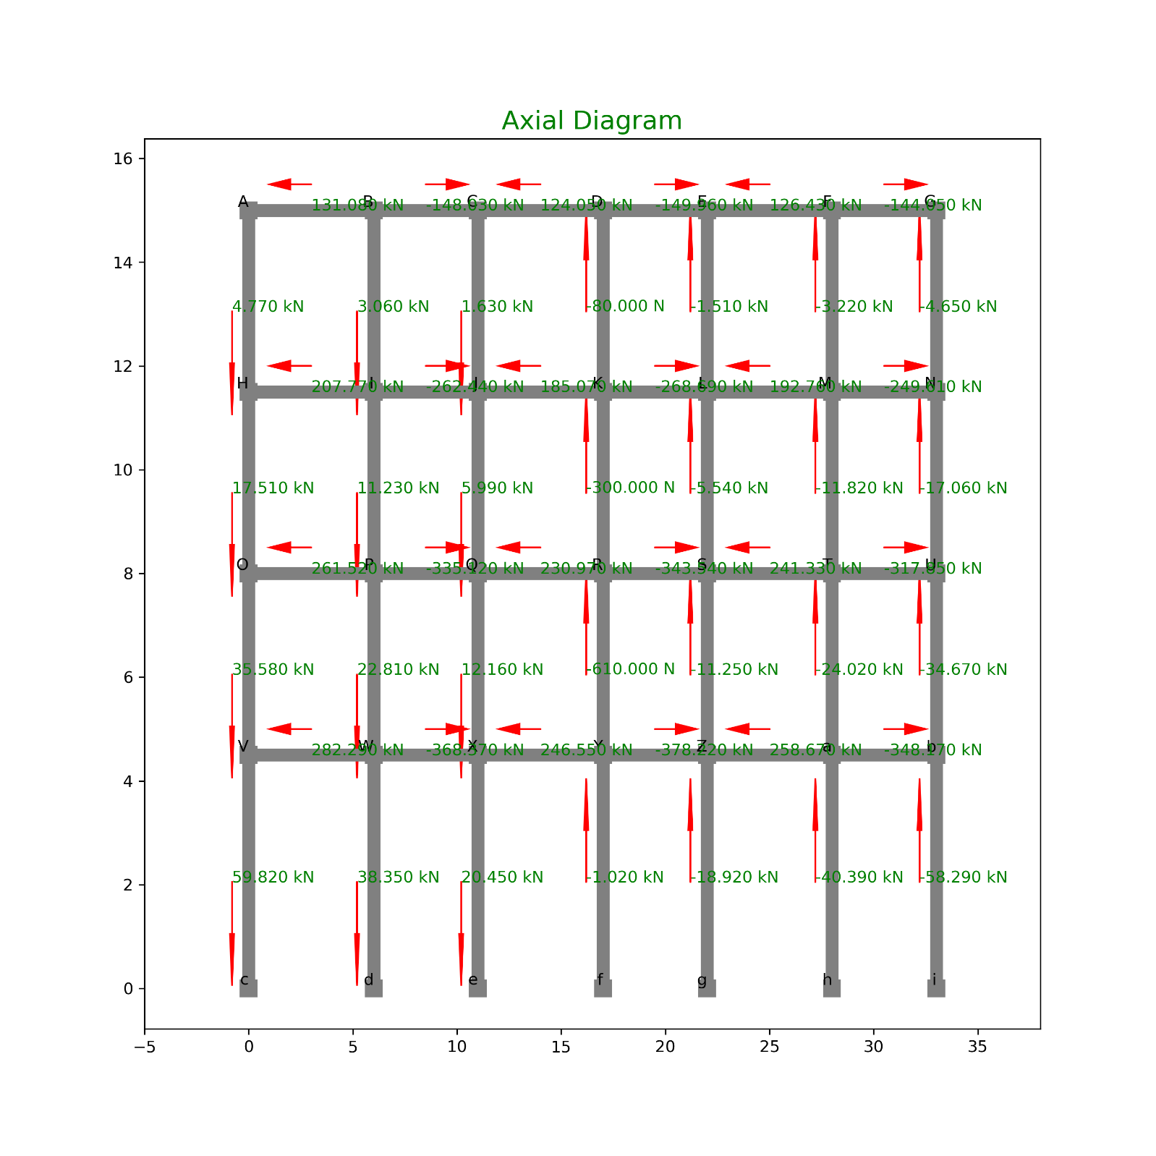

#### TABULATION OF FORCES:

|  |  |  |  |  |  |
| --- | --- | --- | --- | --- | --- |
| **INDEX** | **X** | **Y** | **Loc** | **Shear** | **Type** |
| 0 | 0 | 15 | Right | 4.771517 | Beam |
| 1 | 6 | 15 | Left | 4.771517 | Beam |
| 2 | 6 | 15 | Right | 7.830182 | Beam |
| 3 | 11 | 15 | Left | 7.830182 | Beam |
| 4 | 11 | 15 | Right | 9.46147 | Beam |
| 5 | 17 | 15 | Left | 9.46147 | Beam |
| 6 | 17 | 15 | Right | 9.379906 | Beam |
| 7 | 22 | 15 | Left | 9.379906 | Beam |
| 8 | 22 | 15 | Right | 7.870964 | Beam |
| 9 | 28 | 15 | Left | 7.870964 | Beam |
| 10 | 28 | 15 | Right | 4.649171 | Beam |
| 11 | 33 | 15 | Left | 4.649171 | Beam |
| 12 | 0 | 11.5 | Right | 12.73992 | Beam |
| 13 | 6 | 11.5 | Left | 12.73992 | Beam |
| 14 | 6 | 11.5 | Right | 20.90654 | Beam |
| 15 | 11 | 11.5 | Left | 20.90654 | Beam |
| 16 | 11 | 11.5 | Right | 25.26207 | Beam |
| 17 | 17 | 11.5 | Left | 25.26207 | Beam |
| 18 | 17 | 11.5 | Right | 25.04429 | Beam |
| 19 | 22 | 11.5 | Left | 25.04429 | Beam |
| 20 | 22 | 11.5 | Right | 21.01543 | Beam |
| 21 | 28 | 11.5 | Left | 21.01543 | Beam |
| 22 | 28 | 11.5 | Right | 12.41326 | Beam |
| 23 | 33 | 11.5 | Left | 12.41326 | Beam |
| 24 | 0 | 8 | Right | 18.06819 | Beam |
| 25 | 6 | 8 | Left | 18.06819 | Beam |
| 26 | 6 | 8 | Right | 29.65036 | Beam |
| 27 | 11 | 8 | Left | 29.65036 | Beam |
| 28 | 11 | 8 | Right | 35.82752 | Beam |
| 29 | 17 | 8 | Left | 35.82752 | Beam |
| 30 | 17 | 8 | Right | 35.51866 | Beam |
| 31 | 22 | 8 | Left | 35.51866 | Beam |
| 32 | 22 | 8 | Right | 29.80479 | Beam |
| 33 | 28 | 8 | Left | 29.80479 | Beam |
| 34 | 28 | 8 | Right | 17.6049 | Beam |
| 35 | 33 | 8 | Left | 17.6049 | Beam |
| 36 | 0 | 4.5 | Right | 24.24081 | Beam |
| 37 | 6 | 4.5 | Left | 24.24081 | Beam |
| 38 | 6 | 4.5 | Right | 39.7798 | Beam |
| 39 | 11 | 4.5 | Left | 39.7798 | Beam |
| 40 | 11 | 4.5 | Right | 48.06726 | Beam |
| 41 | 17 | 4.5 | Left | 48.06726 | Beam |
| 42 | 17 | 4.5 | Right | 47.65288 | Beam |
| 43 | 22 | 4.5 | Left | 47.65288 | Beam |
| 44 | 22 | 4.5 | Right | 39.98698 | Beam |
| 45 | 28 | 4.5 | Left | 39.98698 | Beam |
| 46 | 28 | 4.5 | Right | 23.61925 | Beam |
| 47 | 33 | 4.5 | Left | 23.61925 | Beam |
| 48 | 0 | 11.5 | Top | 7.157276 | Col |
| 49 | 0 | 15 | Bot | 7.157276 | Col |
| 50 | 6 | 11.5 | Top | 16.945 | Col |
| 51 | 6 | 15 | Bot | 16.945 | Col |
| 52 | 11 | 11.5 | Top | 23.97993 | Col |
| 53 | 11 | 15 | Bot | 23.97993 | Col |
| 54 | 17 | 11.5 | Top | 25.91709 | Col |
| 55 | 17 | 15 | Bot | 25.91709 | Col |
| 56 | 22 | 11.5 | Top | 23.53133 | Col |
| 57 | 22 | 15 | Bot | 23.53133 | Col |
| 58 | 28 | 11.5 | Top | 17.61791 | Col |
| 59 | 28 | 15 | Bot | 17.61791 | Col |
| 60 | 33 | 11.5 | Top | 5.811463 | Col |
| 61 | 33 | 15 | Bot | 5.811463 | Col |
| 62 | 0 | 8 | Top | 15.93681 | Col |
| 63 | 0 | 11.5 | Bot | 15.93681 | Col |
| 64 | 6 | 8 | Top | 37.73074 | Col |
| 65 | 6 | 11.5 | Bot | 37.73074 | Col |
| 66 | 11 | 8 | Top | 53.39513 | Col |
| 67 | 11 | 11.5 | Bot | 53.39513 | Col |
| 68 | 17 | 8 | Top | 57.70851 | Col |
| 69 | 17 | 11.5 | Bot | 57.70851 | Col |
| 70 | 22 | 8 | Top | 52.39624 | Col |
| 71 | 22 | 11.5 | Bot | 52.39624 | Col |
| 72 | 28 | 8 | Top | 39.22908 | Col |
| 73 | 28 | 11.5 | Bot | 39.22908 | Col |
| 74 | 33 | 8 | Top | 12.94015 | Col |
| 75 | 33 | 11.5 | Bot | 12.94015 | Col |
| 76 | 0 | 4.5 | Top | 15.14967 | Col |
| 77 | 0 | 8 | Bot | 15.14967 | Col |
| 78 | 6 | 4.5 | Top | 35.86717 | Col |
| 79 | 6 | 8 | Bot | 35.86717 | Col |
| 80 | 11 | 4.5 | Top | 50.75787 | Col |
| 81 | 11 | 8 | Bot | 50.75787 | Col |
| 82 | 17 | 4.5 | Top | 54.85821 | Col |
| 83 | 17 | 8 | Bot | 54.85821 | Col |
| 84 | 22 | 4.5 | Top | 49.80832 | Col |
| 85 | 22 | 8 | Bot | 49.80832 | Col |
| 86 | 28 | 4.5 | Top | 37.2915 | Col |
| 87 | 28 | 8 | Bot | 37.2915 | Col |
| 88 | 33 | 4.5 | Top | 12.30101 | Col |
| 89 | 33 | 8 | Bot | 12.30101 | Col |
| 90 | 0 | 0 | Top | 21.21155 | Col |
| 91 | 0 | 4.5 | Bot | 21.21155 | Col |
| 92 | 6 | 0 | Top | 50.2188 | Col |
| 93 | 6 | 4.5 | Bot | 50.2188 | Col |
| 94 | 11 | 0 | Top | 71.06776 | Col |
| 95 | 11 | 4.5 | Bot | 71.06776 | Col |
| 96 | 17 | 0 | Top | 76.80878 | Col |
| 97 | 17 | 4.5 | Bot | 76.80878 | Col |
| 98 | 22 | 0 | Top | 69.73826 | Col |
| 99 | 22 | 4.5 | Bot | 69.73826 | Col |
| 100 | 28 | 0 | Top | 52.21305 | Col |
| 101 | 28 | 4.5 | Bot | 52.21305 | Col |
| 102 | 33 | 0 | Top | 17.22305 | Col |
| 103 | 33 | 4.5 | Bot | 17.22305 | Col |

MOMENT

|  |  |  |  |  |  |
| --- | --- | --- | --- | --- | --- |
| **INDEX** | **X** | **Y** | **Loc** | **Moment** | **Type** |
| 0 | 0 | 15 | Right | 14.3145516 | Beam |
| 1 | 6 | 15 | Left | 14.3145516 | Beam |
| 2 | 6 | 15 | Right | 19.5754552 | Beam |
| 3 | 11 | 15 | Left | 19.5754552 | Beam |
| 4 | 11 | 15 | Right | 28.38441 | Beam |
| 5 | 17 | 15 | Left | 28.38441 | Beam |
| 6 | 17 | 15 | Right | 23.449764 | Beam |
| 7 | 22 | 15 | Left | 23.449764 | Beam |
| 8 | 22 | 15 | Right | 23.6128928 | Beam |
| 9 | 28 | 15 | Left | 23.6128928 | Beam |
| 10 | 28 | 15 | Right | 11.6229265 | Beam |
| 11 | 33 | 15 | Left | 11.6229265 | Beam |
| 12 | 0 | 11.5 | Right | 38.2197699 | Beam |
| 13 | 6 | 11.5 | Left | 38.2197699 | Beam |
| 14 | 6 | 11.5 | Right | 52.266352 | Beam |
| 15 | 11 | 11.5 | Left | 52.266352 | Beam |
| 16 | 11 | 11.5 | Right | 75.7862104 | Beam |
| 17 | 17 | 11.5 | Left | 75.7862104 | Beam |
| 18 | 17 | 11.5 | Right | 62.6107342 | Beam |
| 19 | 22 | 11.5 | Left | 62.6107342 | Beam |
| 20 | 22 | 11.5 | Right | 63.0462871 | Beam |
| 21 | 28 | 11.5 | Left | 63.0462871 | Beam |
| 22 | 28 | 11.5 | Right | 31.0331465 | Beam |
| 23 | 33 | 11.5 | Left | 31.0331465 | Beam |
| 24 | 0 | 8 | Right | 54.2045596 | Beam |
| 25 | 6 | 8 | Left | 54.2045596 | Beam |
| 26 | 6 | 8 | Right | 74.1258935 | Beam |
| 27 | 11 | 8 | Left | 74.1258935 | Beam |
| 28 | 11 | 8 | Right | 107.482546 | Beam |
| 29 | 17 | 8 | Left | 107.482546 | Beam |
| 30 | 17 | 8 | Right | 88.7966432 | Beam |
| 31 | 22 | 8 | Left | 88.7966432 | Beam |
| 32 | 22 | 8 | Right | 89.414359 | Beam |
| 33 | 28 | 8 | Left | 89.414359 | Beam |
| 34 | 28 | 8 | Right | 44.0122492 | Beam |
| 35 | 33 | 8 | Left | 44.0122492 | Beam |
| 36 | 0 | 4.5 | Right | 72.7224427 | Beam |
| 37 | 6 | 4.5 | Left | 72.7224427 | Beam |
| 38 | 6 | 4.5 | Right | 99.4494943 | Beam |
| 39 | 11 | 4.5 | Left | 99.4494943 | Beam |
| 40 | 11 | 4.5 | Right | 144.201767 | Beam |
| 41 | 17 | 4.5 | Left | 144.201767 | Beam |
| 42 | 17 | 4.5 | Right | 119.132207 | Beam |
| 43 | 22 | 4.5 | Left | 119.132207 | Beam |
| 44 | 22 | 4.5 | Right | 119.960952 | Beam |
| 45 | 28 | 4.5 | Left | 119.960952 | Beam |
| 46 | 28 | 4.5 | Right | 59.0481372 | Beam |
| 47 | 33 | 4.5 | Left | 59.0481372 | Beam |
| 48 | 0 | 11.5 | Top | 14.3145516 | Col |
| 49 | 0 | 15 | Bot | 14.3145516 | Col |
| 50 | 6 | 11.5 | Top | 33.8900067 | Col |
| 51 | 6 | 15 | Bot | 33.8900067 | Col |
| 52 | 11 | 11.5 | Top | 47.9598651 | Col |
| 53 | 11 | 15 | Bot | 47.9598651 | Col |
| 54 | 17 | 11.5 | Top | 51.834174 | Col |
| 55 | 17 | 15 | Bot | 51.834174 | Col |
| 56 | 22 | 11.5 | Top | 47.0626568 | Col |
| 57 | 22 | 15 | Bot | 47.0626568 | Col |
| 58 | 28 | 11.5 | Top | 35.2358193 | Col |
| 59 | 28 | 15 | Bot | 35.2358193 | Col |
| 60 | 33 | 11.5 | Top | 11.6229265 | Col |
| 61 | 33 | 15 | Bot | 11.6229265 | Col |
| 62 | 0 | 8 | Top | 23.9052183 | Col |
| 63 | 0 | 11.5 | Bot | 23.9052183 | Col |
| 64 | 6 | 8 | Top | 56.5961151 | Col |
| 65 | 6 | 11.5 | Bot | 56.5961151 | Col |
| 66 | 11 | 8 | Top | 80.0926972 | Col |
| 67 | 11 | 11.5 | Bot | 80.0926972 | Col |
| 68 | 17 | 8 | Top | 86.5627706 | Col |
| 69 | 17 | 11.5 | Bot | 86.5627706 | Col |
| 70 | 22 | 8 | Top | 78.5943645 | Col |
| 71 | 22 | 11.5 | Bot | 78.5943645 | Col |
| 72 | 28 | 8 | Top | 58.8436143 | Col |
| 73 | 28 | 11.5 | Bot | 58.8436143 | Col |
| 74 | 33 | 8 | Top | 19.41022 | Col |
| 75 | 33 | 11.5 | Bot | 19.41022 | Col |
| 76 | 0 | 4.5 | Top | 30.2993413 | Col |
| 77 | 0 | 8 | Bot | 30.2993413 | Col |
| 78 | 6 | 4.5 | Top | 71.7343379 | Col |
| 79 | 6 | 8 | Bot | 71.7343379 | Col |
| 80 | 11 | 4.5 | Top | 101.515742 | Col |
| 81 | 11 | 8 | Bot | 101.515742 | Col |
| 82 | 17 | 4.5 | Top | 109.716418 | Col |
| 83 | 17 | 8 | Bot | 109.716418 | Col |
| 84 | 22 | 4.5 | Top | 99.6166377 | Col |
| 85 | 22 | 8 | Bot | 99.6166377 | Col |
| 86 | 28 | 4.5 | Top | 74.5829939 | Col |
| 87 | 28 | 8 | Bot | 74.5829939 | Col |
| 88 | 33 | 4.5 | Top | 24.6020292 | Col |
| 89 | 33 | 8 | Bot | 24.6020292 | Col |
| 90 | 0 | 0 | Top | 42.4231014 | Col |
| 91 | 0 | 4.5 | Bot | 42.4231014 | Col |
| 92 | 6 | 0 | Top | 100.437599 | Col |
| 93 | 6 | 4.5 | Bot | 100.437599 | Col |
| 94 | 11 | 0 | Top | 142.135519 | Col |
| 95 | 11 | 4.5 | Bot | 142.135519 | Col |
| 96 | 17 | 0 | Top | 153.617555 | Col |
| 97 | 17 | 4.5 | Bot | 153.617555 | Col |
| 98 | 22 | 0 | Top | 139.476521 | Col |
| 99 | 22 | 4.5 | Bot | 139.476521 | Col |
| 100 | 28 | 0 | Top | 104.426096 | Col |
| 101 | 28 | 4.5 | Bot | 104.426096 | Col |
| 102 | 33 | 0 | Top | 34.446108 | Col |
| 103 | 33 | 4.5 | Bot | 34.446108 | Col |

AXIAL

|  |  |  |  |  |  |
| --- | --- | --- | --- | --- | --- |
| **INDEX** | **X** | **Y** | **Loc** | **Axial** | **Type** |
| 0 | 0 | 11.5 | Top | 4.771517 | Col |
| 1 | 0 | 15 | Bot | 4.771517 | Col |
| 2 | 6 | 11.5 | Top | 3.058665 | Col |
| 3 | 6 | 15 | Bot | 3.058665 | Col |
| 4 | 11 | 11.5 | Top | 1.631288 | Col |
| 5 | 11 | 15 | Bot | 1.631288 | Col |
| 6 | 17 | 11.5 | Top | -0.08156 | Col |
| 7 | 17 | 15 | Bot | -0.08156 | Col |
| 8 | 22 | 11.5 | Top | -1.50894 | Col |
| 9 | 22 | 15 | Bot | -1.50894 | Col |
| 10 | 28 | 11.5 | Top | -3.22179 | Col |
| 11 | 28 | 15 | Bot | -3.22179 | Col |
| 12 | 33 | 11.5 | Top | -4.64917 | Col |
| 13 | 33 | 15 | Bot | -4.64917 | Col |
| 14 | 0 | 8 | Top | 17.51144 | Col |
| 15 | 0 | 11.5 | Bot | 17.51144 | Col |
| 16 | 6 | 8 | Top | 11.22528 | Col |
| 17 | 6 | 11.5 | Bot | 11.22528 | Col |
| 18 | 11 | 8 | Top | 5.986817 | Col |
| 19 | 11 | 11.5 | Bot | 5.986817 | Col |
| 20 | 17 | 8 | Top | -0.29934 | Col |
| 21 | 17 | 11.5 | Bot | -0.29934 | Col |
| 22 | 22 | 8 | Top | -5.53781 | Col |
| 23 | 22 | 11.5 | Bot | -5.53781 | Col |
| 24 | 28 | 8 | Top | -11.824 | Col |
| 25 | 28 | 11.5 | Bot | -11.824 | Col |
| 26 | 33 | 8 | Top | -17.0624 | Col |
| 27 | 33 | 11.5 | Bot | -17.0624 | Col |
| 28 | 0 | 4.5 | Top | 35.57963 | Col |
| 29 | 0 | 8 | Bot | 35.57963 | Col |
| 30 | 6 | 4.5 | Top | 22.80745 | Col |
| 31 | 6 | 8 | Bot | 22.80745 | Col |
| 32 | 11 | 4.5 | Top | 12.16398 | Col |
| 33 | 11 | 8 | Bot | 12.16398 | Col |
| 34 | 17 | 4.5 | Top | -0.6082 | Col |
| 35 | 17 | 8 | Bot | -0.6082 | Col |
| 36 | 22 | 4.5 | Top | -11.2517 | Col |
| 37 | 22 | 8 | Bot | -11.2517 | Col |
| 38 | 28 | 4.5 | Top | -24.0239 | Col |
| 39 | 28 | 8 | Bot | -24.0239 | Col |
| 40 | 33 | 4.5 | Top | -34.6673 | Col |
| 41 | 33 | 8 | Bot | -34.6673 | Col |
| 42 | 0 | 0 | Top | 59.82044 | Col |
| 43 | 0 | 4.5 | Bot | 59.82044 | Col |
| 44 | 6 | 0 | Top | 38.34644 | Col |
| 45 | 6 | 4.5 | Bot | 38.34644 | Col |
| 46 | 11 | 0 | Top | 20.45143 | Col |
| 47 | 11 | 4.5 | Bot | 20.45143 | Col |
| 48 | 17 | 0 | Top | -1.02257 | Col |
| 49 | 17 | 4.5 | Bot | -1.02257 | Col |
| 50 | 22 | 0 | Top | -18.9176 | Col |
| 51 | 22 | 4.5 | Bot | -18.9176 | Col |
| 52 | 28 | 0 | Top | -40.3916 | Col |
| 53 | 28 | 4.5 | Bot | -40.3916 | Col |
| 54 | 33 | 0 | Top | -58.2866 | Col |
| 55 | 33 | 4.5 | Bot | -58.2866 | Col |
| 56 | 0 | 15 | Right | 131.0827 | Beam |
| 57 | 6 | 15 | Left | 131.0827 | Beam |
| 58 | 6 | 15 | Right | -148.028 | Beam |
| 59 | 11 | 15 | Left | -148.028 | Beam |
| 60 | 11 | 15 | Right | 124.0478 | Beam |
| 61 | 17 | 15 | Left | 124.0478 | Beam |
| 62 | 17 | 15 | Right | -149.965 | Beam |
| 63 | 22 | 15 | Left | -149.965 | Beam |
| 64 | 22 | 15 | Right | 126.4336 | Beam |
| 65 | 28 | 15 | Left | 126.4336 | Beam |
| 66 | 28 | 15 | Right | -144.051 | Beam |
| 67 | 33 | 15 | Left | -144.051 | Beam |
| 68 | 0 | 11.5 | Right | 207.7659 | Beam |
| 69 | 6 | 11.5 | Left | 207.7659 | Beam |
| 70 | 6 | 11.5 | Right | -262.442 | Beam |
| 71 | 11 | 11.5 | Left | -262.442 | Beam |
| 72 | 11 | 11.5 | Right | 185.0666 | Beam |
| 73 | 17 | 11.5 | Left | 185.0666 | Beam |
| 74 | 17 | 11.5 | Right | -268.692 | Beam |
| 75 | 22 | 11.5 | Left | -268.692 | Beam |
| 76 | 22 | 11.5 | Right | 192.7646 | Beam |
| 77 | 28 | 11.5 | Left | 192.7646 | Beam |
| 78 | 28 | 11.5 | Right | -249.612 | Beam |
| 79 | 33 | 11.5 | Left | -249.612 | Beam |
| 80 | 0 | 8 | Right | 261.5235 | Beam |
| 81 | 6 | 8 | Left | 261.5235 | Beam |
| 82 | 6 | 8 | Right | -335.121 | Beam |
| 83 | 11 | 8 | Left | -335.121 | Beam |
| 84 | 11 | 8 | Right | 230.9684 | Beam |
| 85 | 17 | 8 | Left | 230.9684 | Beam |
| 86 | 17 | 8 | Right | -343.535 | Beam |
| 87 | 22 | 8 | Left | -343.535 | Beam |
| 88 | 22 | 8 | Right | 241.3306 | Beam |
| 89 | 28 | 8 | Left | 241.3306 | Beam |
| 90 | 28 | 8 | Right | -317.851 | Beam |
| 91 | 33 | 8 | Left | -317.851 | Beam |
| 92 | 0 | 4.5 | Right | 282.2888 | Beam |
| 93 | 6 | 4.5 | Left | 282.2888 | Beam |
| 94 | 6 | 4.5 | Right | -368.375 | Beam |
| 95 | 11 | 4.5 | Left | -368.375 | Beam |
| 96 | 11 | 4.5 | Right | 246.5491 | Beam |
| 97 | 17 | 4.5 | Left | 246.5491 | Beam |
| 98 | 17 | 4.5 | Right | -378.216 | Beam |
| 99 | 22 | 4.5 | Left | -378.216 | Beam |
| 100 | 22 | 4.5 | Right | 258.6695 | Beam |
| 101 | 28 | 4.5 | Left | 258.6695 | Beam |
| 102 | 28 | 4.5 | Right | -348.174 | Beam |
| 103 | 33 | 4.5 | Left | -348.174 | Beam |

### FACTOR METHOD OF ANALYSIS:

#### CALCULATION:

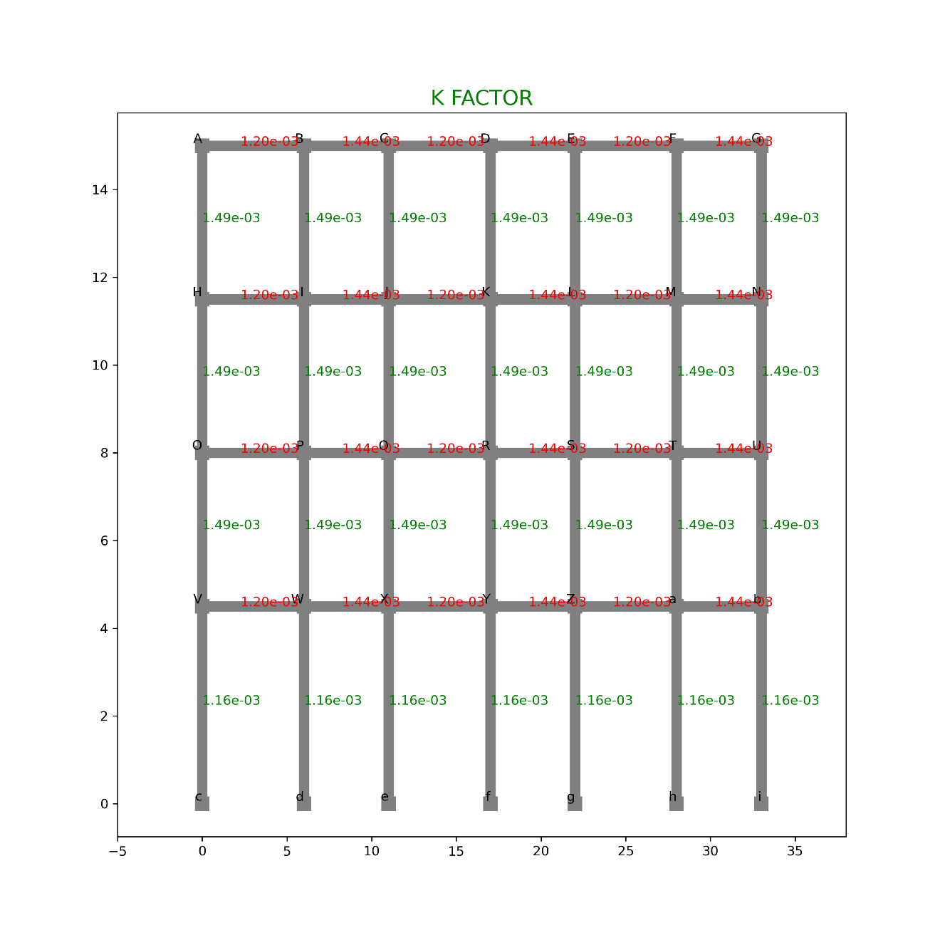

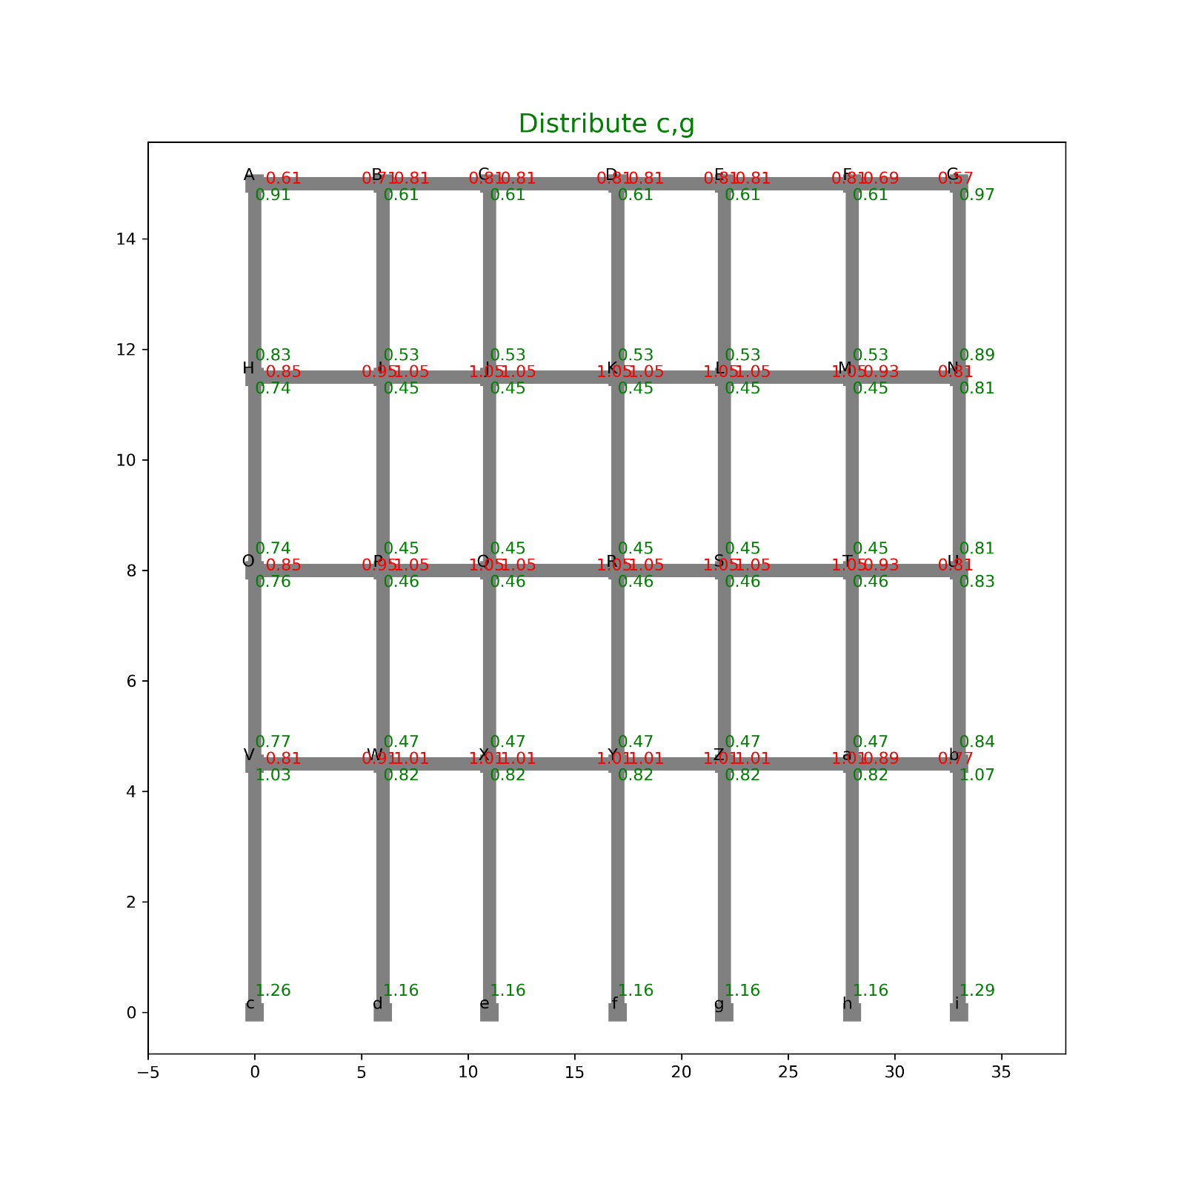

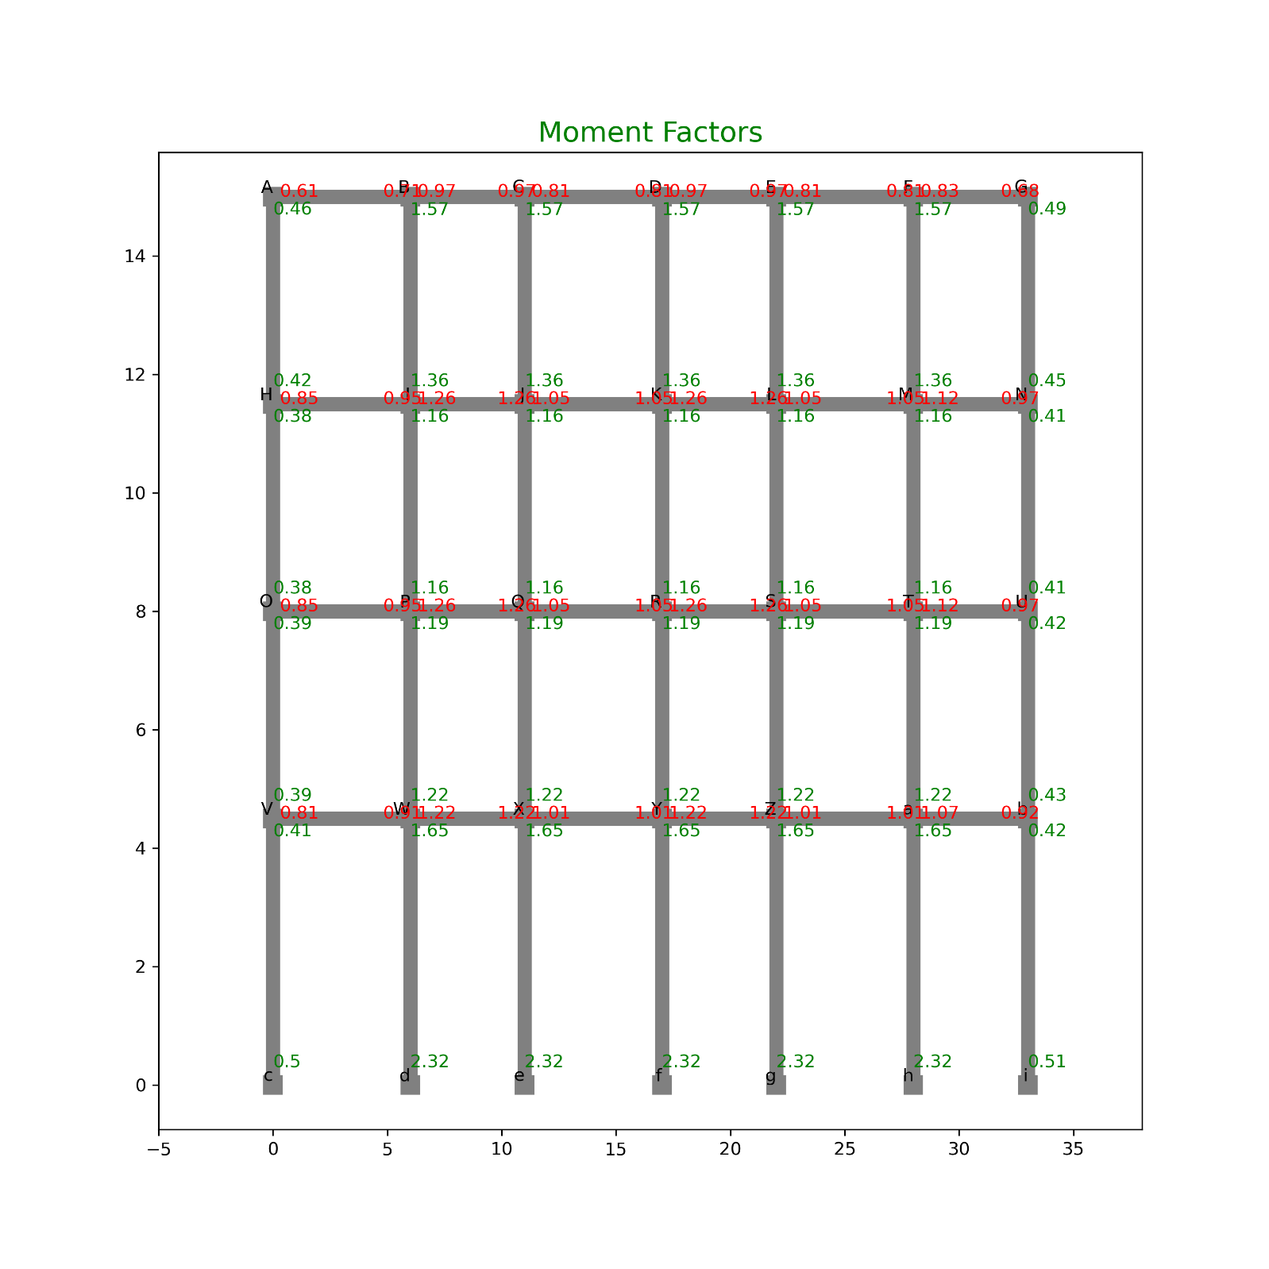

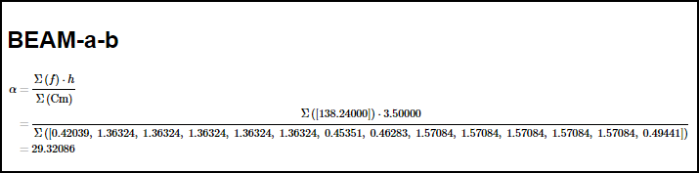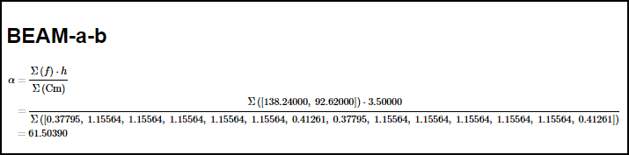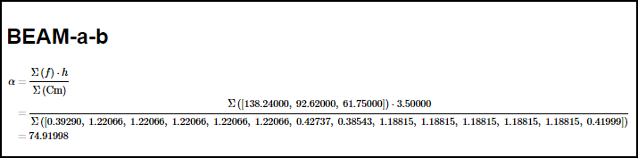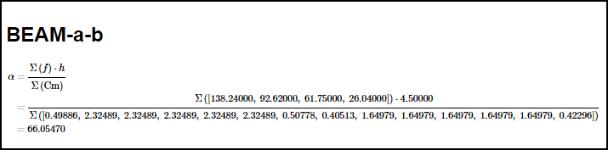

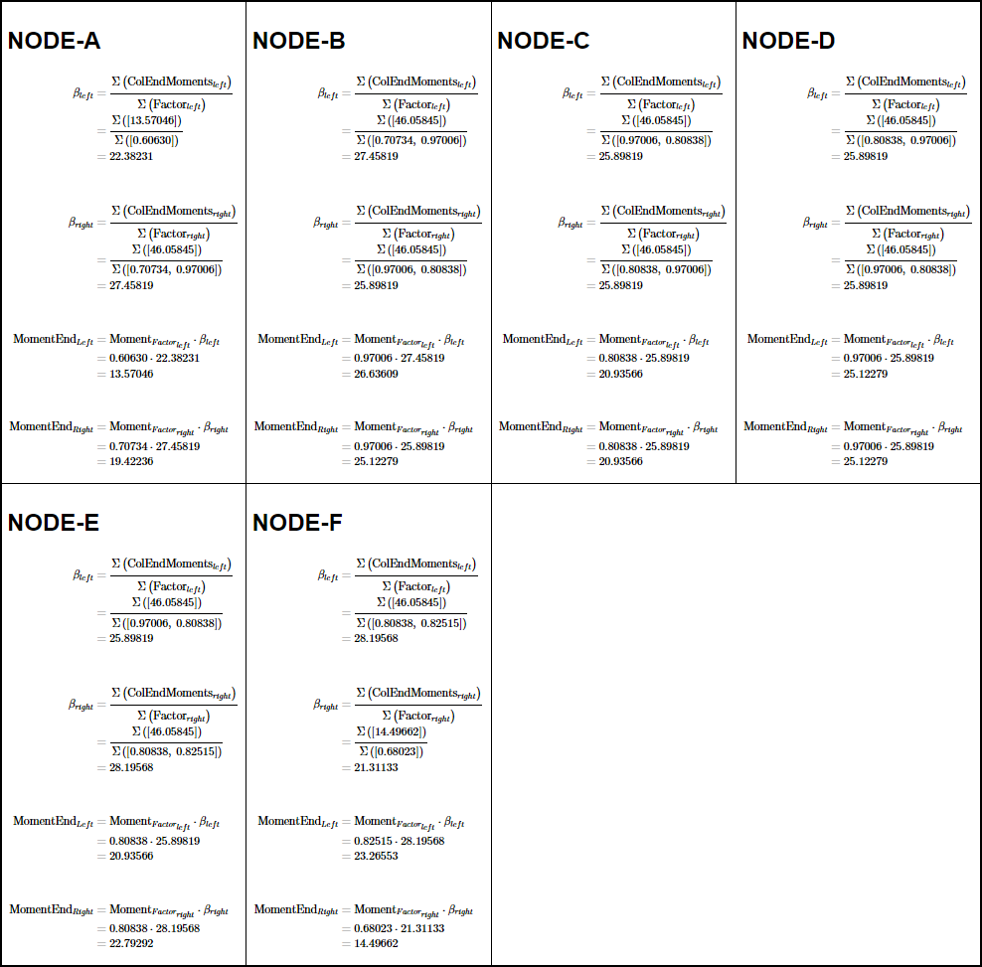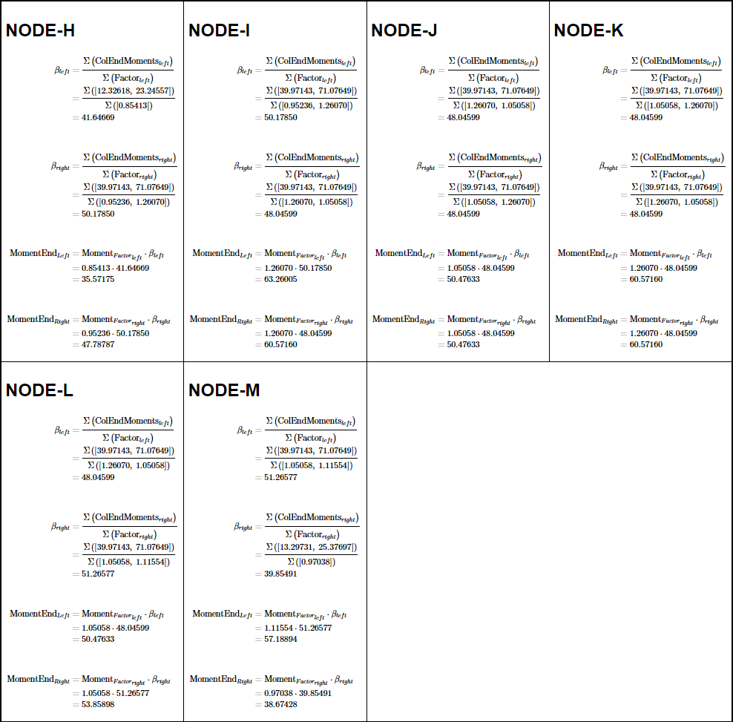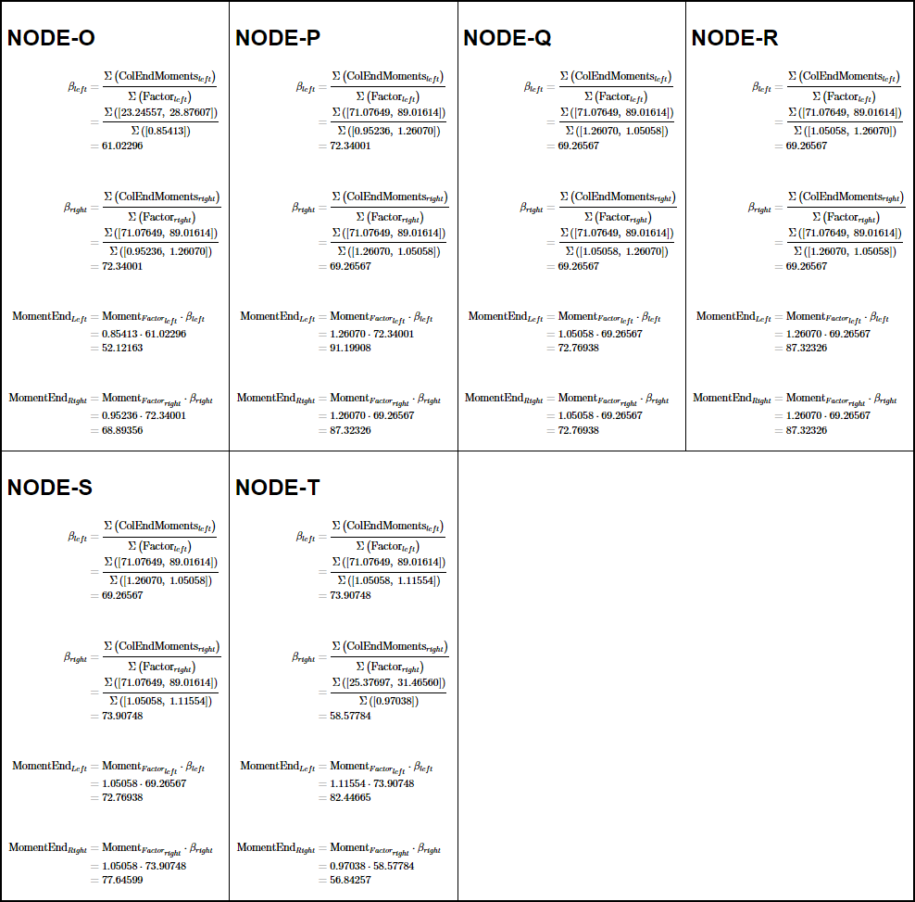

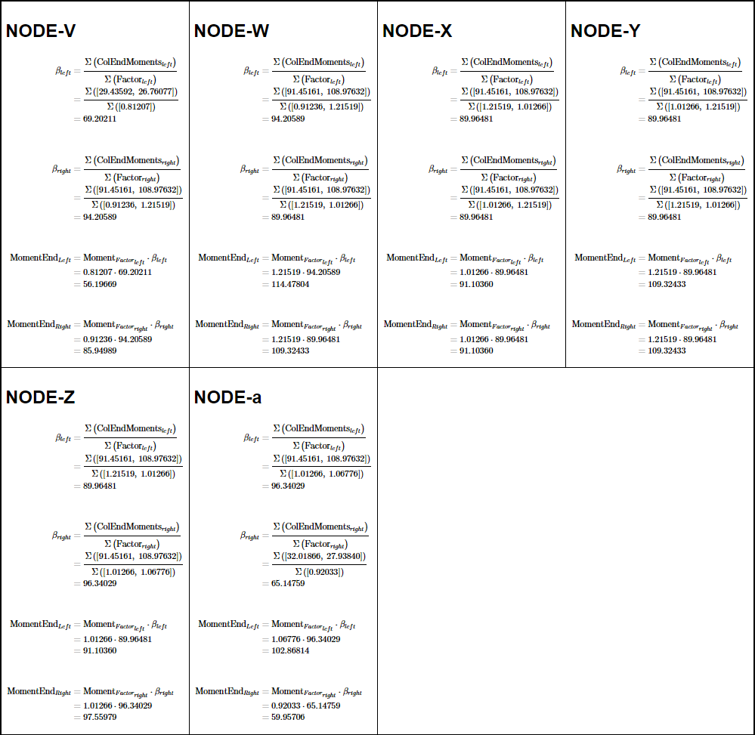

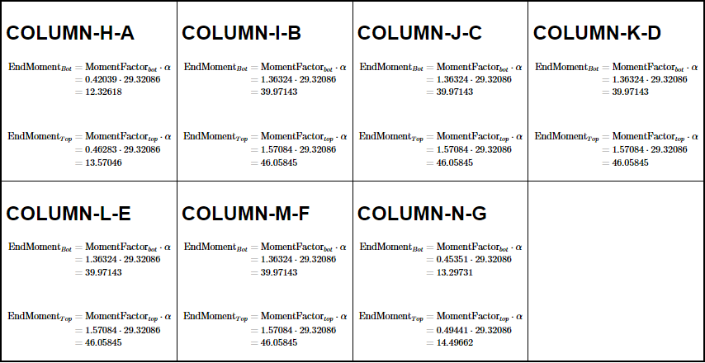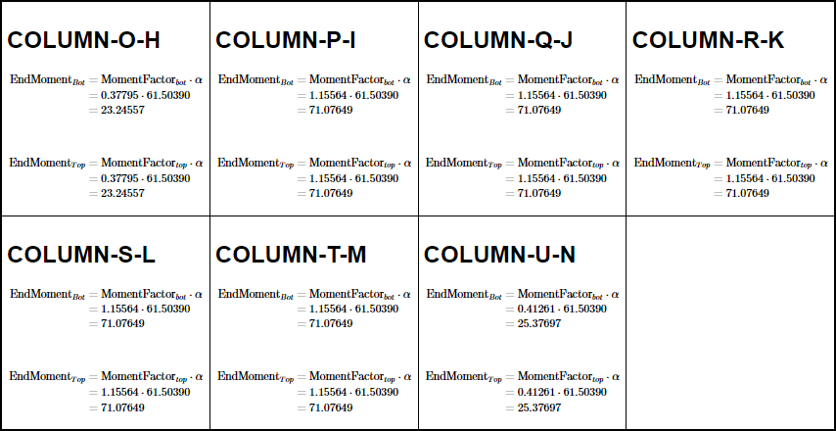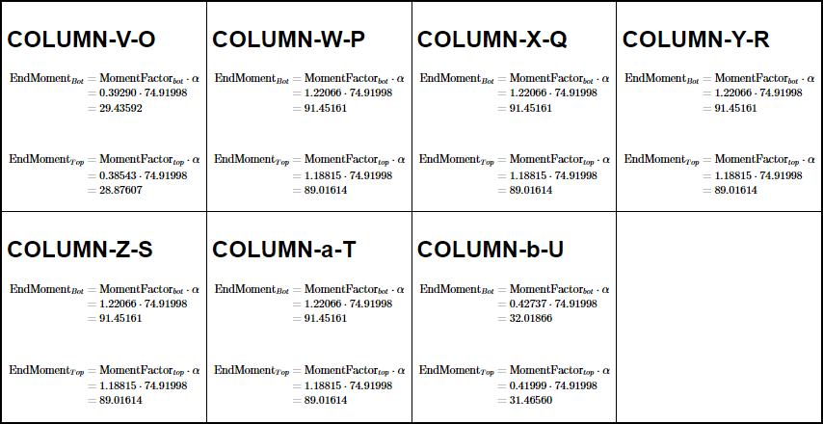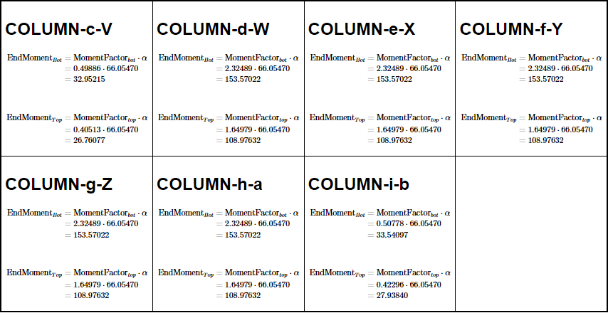

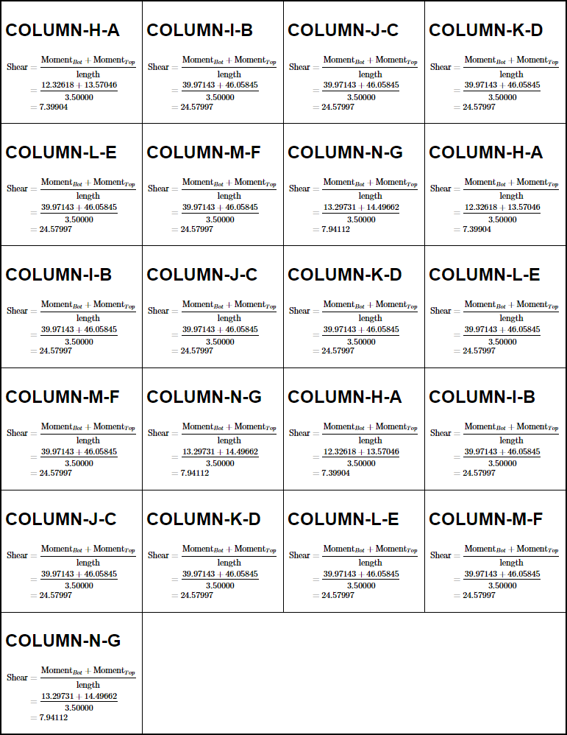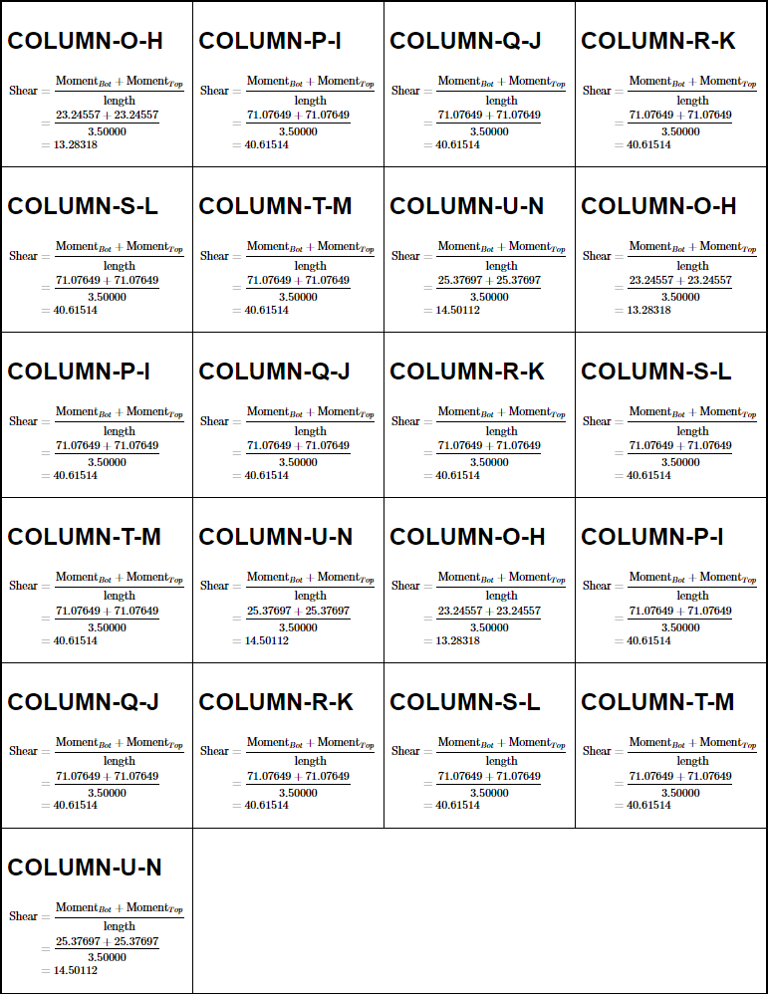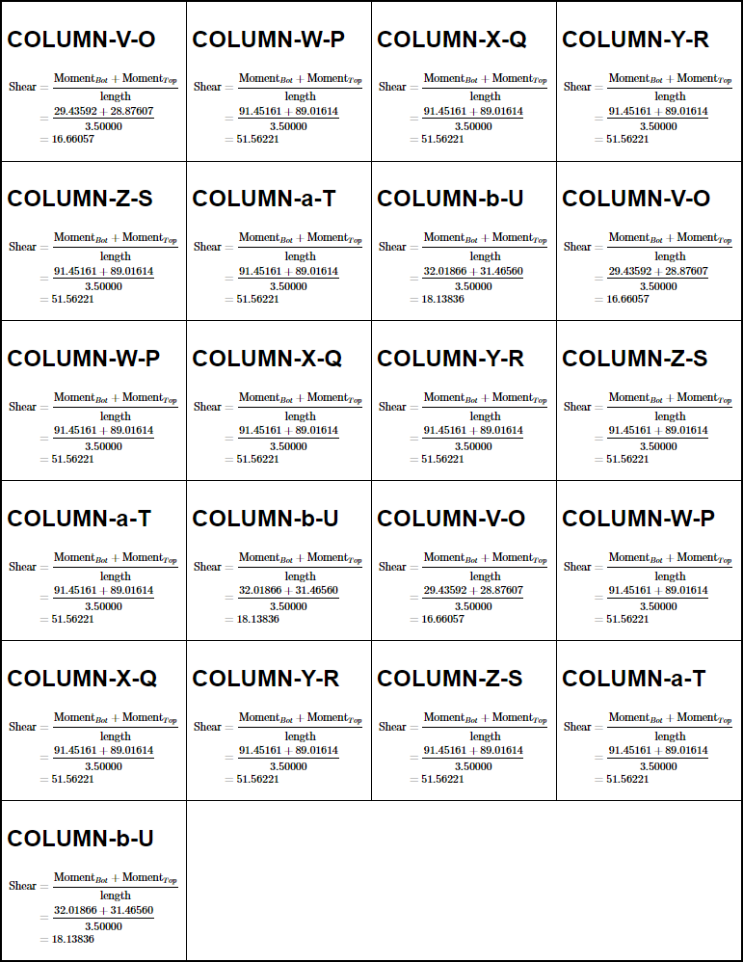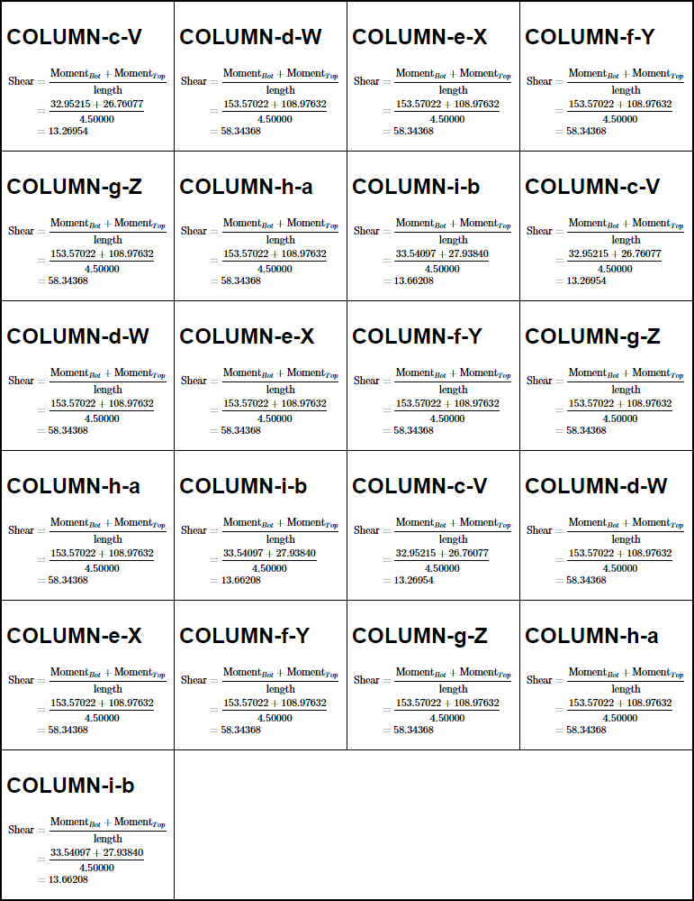

#### DIAGRAMS

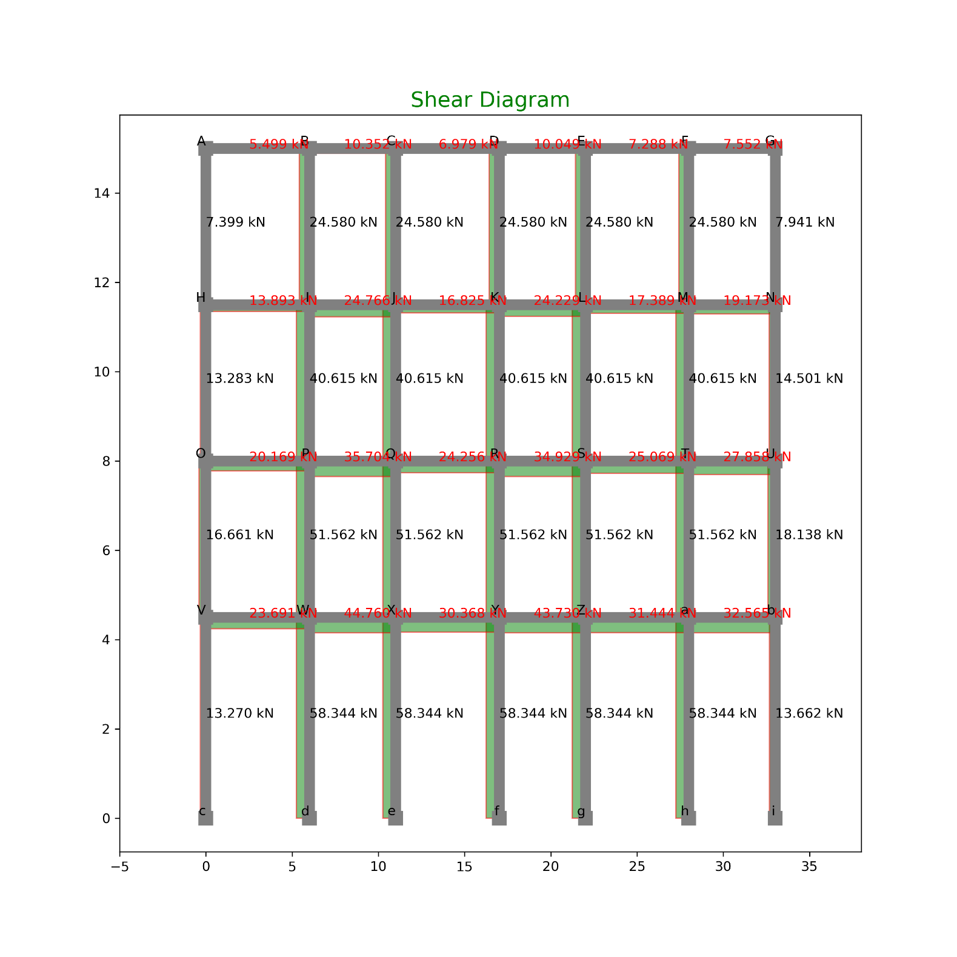

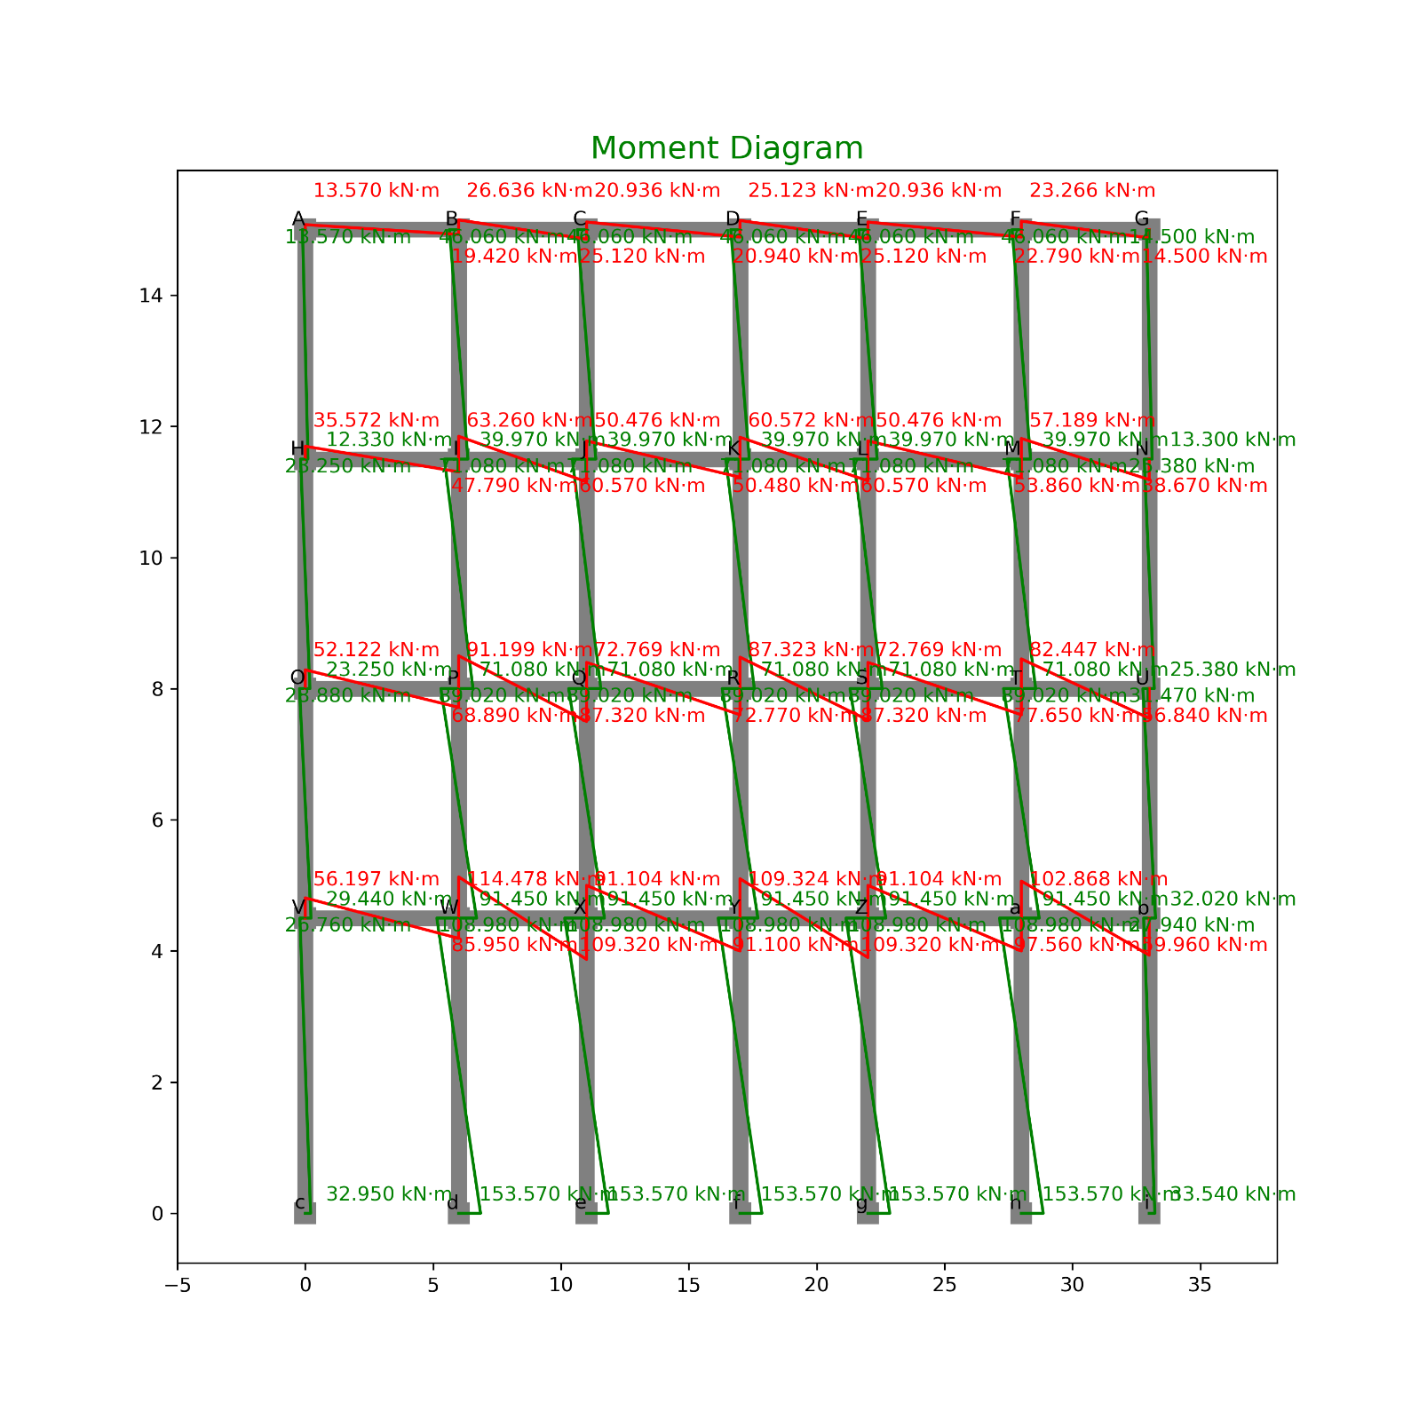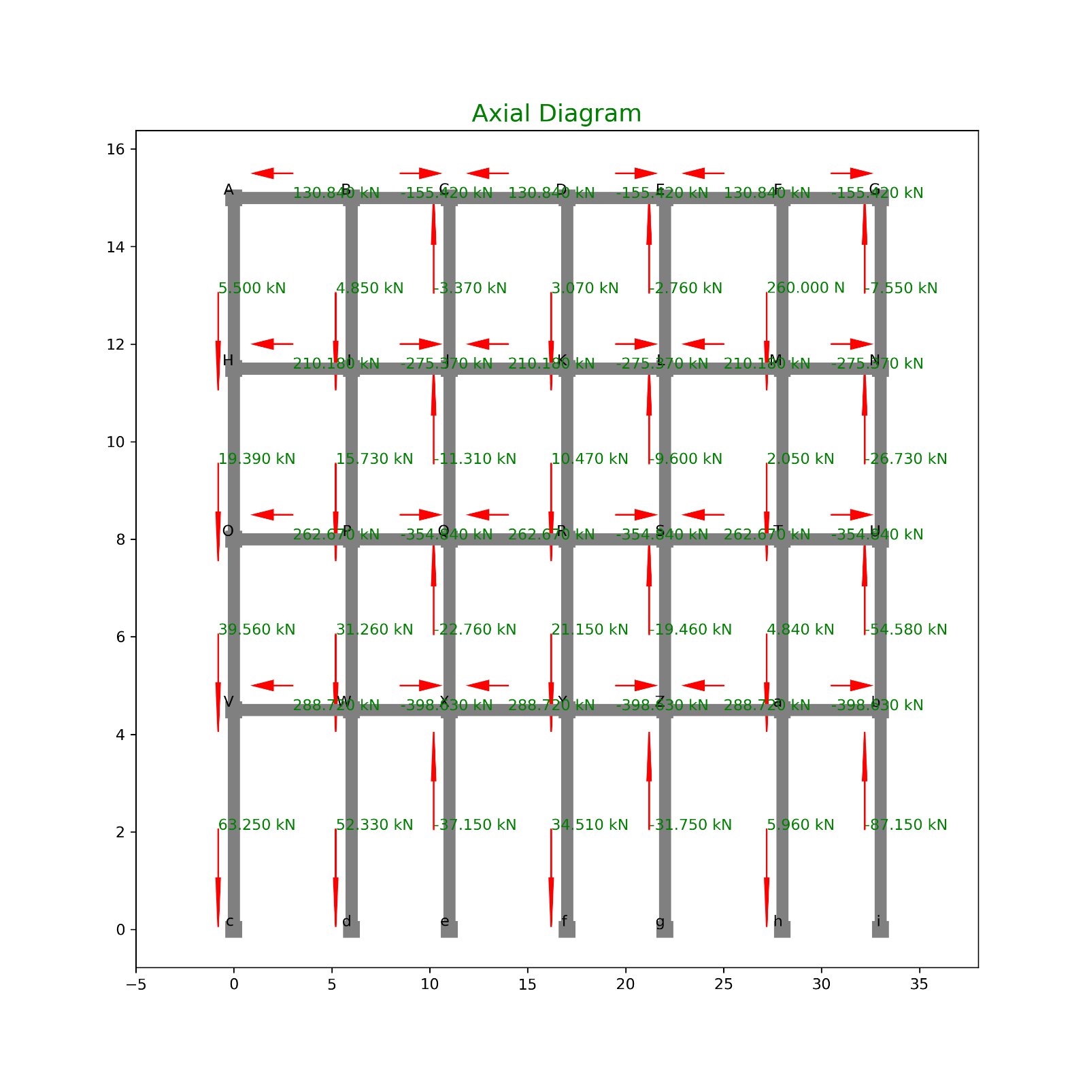

#### TABULATION OF FORCES

SHEAR

|  |  |  |  |  |  |
| --- | --- | --- | --- | --- | --- |
| **INDEX** | **X** | **Y** | **Loc** | **Shear** | **Type** |
| 0 | 0 | 15 | Right | 5.498805 | Beam |
| 1 | 6 | 15 | Left | 5.498805 | Beam |
| 2 | 6 | 15 | Right | 10.35178 | Beam |
| 3 | 11 | 15 | Left | 10.35178 | Beam |
| 4 | 11 | 15 | Right | 6.978553 | Beam |
| 5 | 17 | 15 | Left | 6.978553 | Beam |
| 6 | 17 | 15 | Right | 10.04912 | Beam |
| 7 | 22 | 15 | Left | 10.04912 | Beam |
| 8 | 22 | 15 | Right | 7.288096 | Beam |
| 9 | 28 | 15 | Left | 7.288096 | Beam |
| 10 | 28 | 15 | Right | 7.55243 | Beam |
| 11 | 33 | 15 | Left | 7.55243 | Beam |
| 12 | 0 | 11.5 | Right | 13.89327 | Beam |
| 13 | 6 | 11.5 | Left | 13.89327 | Beam |
| 14 | 6 | 11.5 | Right | 24.76633 | Beam |
| 15 | 11 | 11.5 | Left | 24.76633 | Beam |
| 16 | 11 | 11.5 | Right | 16.82544 | Beam |
| 17 | 17 | 11.5 | Left | 16.82544 | Beam |
| 18 | 17 | 11.5 | Right | 24.22864 | Beam |
| 19 | 22 | 11.5 | Left | 24.22864 | Beam |
| 20 | 22 | 11.5 | Right | 17.38922 | Beam |
| 21 | 28 | 11.5 | Left | 17.38922 | Beam |
| 22 | 28 | 11.5 | Right | 19.17264 | Beam |
| 23 | 33 | 11.5 | Left | 19.17264 | Beam |
| 24 | 0 | 8 | Right | 20.1692 | Beam |
| 25 | 6 | 8 | Left | 20.1692 | Beam |
| 26 | 6 | 8 | Right | 35.70447 | Beam |
| 27 | 11 | 8 | Left | 35.70447 | Beam |
| 28 | 11 | 8 | Right | 24.25646 | Beam |
| 29 | 17 | 8 | Left | 24.25646 | Beam |
| 30 | 17 | 8 | Right | 34.9293 | Beam |
| 31 | 22 | 8 | Left | 34.9293 | Beam |
| 32 | 22 | 8 | Right | 25.06923 | Beam |
| 33 | 28 | 8 | Left | 25.06923 | Beam |
| 34 | 28 | 8 | Right | 27.85784 | Beam |
| 35 | 33 | 8 | Left | 27.85784 | Beam |
| 36 | 0 | 4.5 | Right | 23.6911 | Beam |
| 37 | 6 | 4.5 | Left | 23.6911 | Beam |
| 38 | 6 | 4.5 | Right | 44.76047 | Beam |
| 39 | 11 | 4.5 | Left | 44.76047 | Beam |
| 40 | 11 | 4.5 | Right | 30.36787 | Beam |
| 41 | 17 | 4.5 | Left | 30.36787 | Beam |
| 42 | 17 | 4.5 | Right | 43.72973 | Beam |
| 43 | 22 | 4.5 | Left | 43.72973 | Beam |
| 44 | 22 | 4.5 | Right | 31.4439 | Beam |
| 45 | 28 | 4.5 | Left | 31.4439 | Beam |
| 46 | 28 | 4.5 | Right | 32.56504 | Beam |
| 47 | 33 | 4.5 | Left | 32.56504 | Beam |
| 48 | 0 | 11.5 | Top | 7.399042 | Col |
| 49 | 0 | 15 | Bot | 7.399042 | Col |
| 50 | 6 | 11.5 | Top | 24.57997 | Col |
| 51 | 6 | 15 | Bot | 24.57997 | Col |
| 52 | 11 | 11.5 | Top | 24.57997 | Col |
| 53 | 11 | 15 | Bot | 24.57997 | Col |
| 54 | 17 | 11.5 | Top | 24.57997 | Col |
| 55 | 17 | 15 | Bot | 24.57997 | Col |
| 56 | 22 | 11.5 | Top | 24.57997 | Col |
| 57 | 22 | 15 | Bot | 24.57997 | Col |
| 58 | 28 | 11.5 | Top | 24.57997 | Col |
| 59 | 28 | 15 | Bot | 24.57997 | Col |
| 60 | 33 | 11.5 | Top | 7.941122 | Col |
| 61 | 33 | 15 | Bot | 7.941122 | Col |
| 62 | 0 | 8 | Top | 13.28318 | Col |
| 63 | 0 | 11.5 | Bot | 13.28318 | Col |
| 64 | 6 | 8 | Top | 40.61514 | Col |
| 65 | 6 | 11.5 | Bot | 40.61514 | Col |
| 66 | 11 | 8 | Top | 40.61514 | Col |
| 67 | 11 | 11.5 | Bot | 40.61514 | Col |
| 68 | 17 | 8 | Top | 40.61514 | Col |
| 69 | 17 | 11.5 | Bot | 40.61514 | Col |
| 70 | 22 | 8 | Top | 40.61514 | Col |
| 71 | 22 | 11.5 | Bot | 40.61514 | Col |
| 72 | 28 | 8 | Top | 40.61514 | Col |
| 73 | 28 | 11.5 | Bot | 40.61514 | Col |
| 74 | 33 | 8 | Top | 14.50112 | Col |
| 75 | 33 | 11.5 | Bot | 14.50112 | Col |
| 76 | 0 | 4.5 | Top | 16.66057 | Col |
| 77 | 0 | 8 | Bot | 16.66057 | Col |
| 78 | 6 | 4.5 | Top | 51.56221 | Col |
| 79 | 6 | 8 | Bot | 51.56221 | Col |
| 80 | 11 | 4.5 | Top | 51.56221 | Col |
| 81 | 11 | 8 | Bot | 51.56221 | Col |
| 82 | 17 | 4.5 | Top | 51.56221 | Col |
| 83 | 17 | 8 | Bot | 51.56221 | Col |
| 84 | 22 | 4.5 | Top | 51.56221 | Col |
| 85 | 22 | 8 | Bot | 51.56221 | Col |
| 86 | 28 | 4.5 | Top | 51.56221 | Col |
| 87 | 28 | 8 | Bot | 51.56221 | Col |
| 88 | 33 | 4.5 | Top | 18.13836 | Col |
| 89 | 33 | 8 | Bot | 18.13836 | Col |
| 90 | 0 | 0 | Top | 13.26954 | Col |
| 91 | 0 | 4.5 | Bot | 13.26954 | Col |
| 92 | 6 | 0 | Top | 58.34368 | Col |
| 93 | 6 | 4.5 | Bot | 58.34368 | Col |
| 94 | 11 | 0 | Top | 58.34368 | Col |
| 95 | 11 | 4.5 | Bot | 58.34368 | Col |
| 96 | 17 | 0 | Top | 58.34368 | Col |
| 97 | 17 | 4.5 | Bot | 58.34368 | Col |
| 98 | 22 | 0 | Top | 58.34368 | Col |
| 99 | 22 | 4.5 | Bot | 58.34368 | Col |
| 100 | 28 | 0 | Top | 58.34368 | Col |
| 101 | 28 | 4.5 | Bot | 58.34368 | Col |
| 102 | 33 | 0 | Top | 13.66208 | Col |
| 103 | 33 | 4.5 | Bot | 13.66208 | Col |

MOMENT

|  |  |  |  |  |  |
| --- | --- | --- | --- | --- | --- |
| **INDEX** | **X** | **Y** | **Loc** | **Moment** | **Type** |
| 0 | 0 | 11.5 | Top | 12.3261813 | Col |
| 1 | 0 | 15 | Bot | 13.5704646 | Col |
| 2 | 6 | 11.5 | Top | 39.9714327 | Col |
| 3 | 6 | 15 | Bot | 46.0584529 | Col |
| 4 | 11 | 11.5 | Top | 39.9714327 | Col |
| 5 | 11 | 15 | Bot | 46.0584529 | Col |
| 6 | 17 | 11.5 | Top | 39.9714327 | Col |
| 7 | 17 | 15 | Bot | 46.0584529 | Col |
| 8 | 22 | 11.5 | Top | 39.9714327 | Col |
| 9 | 22 | 15 | Bot | 46.0584529 | Col |
| 10 | 28 | 11.5 | Top | 39.9714327 | Col |
| 11 | 28 | 15 | Bot | 46.0584529 | Col |
| 12 | 33 | 11.5 | Top | 13.2973097 | Col |
| 13 | 33 | 15 | Bot | 14.4966161 | Col |
| 14 | 0 | 8 | Top | 23.2455689 | Col |
| 15 | 0 | 11.5 | Bot | 23.2455689 | Col |
| 16 | 6 | 8 | Top | 71.0764927 | Col |
| 17 | 6 | 11.5 | Bot | 71.0764927 | Col |
| 18 | 11 | 8 | Top | 71.0764927 | Col |
| 19 | 11 | 11.5 | Bot | 71.0764927 | Col |
| 20 | 17 | 8 | Top | 71.0764927 | Col |
| 21 | 17 | 11.5 | Bot | 71.0764927 | Col |
| 22 | 22 | 8 | Top | 71.0764927 | Col |
| 23 | 22 | 11.5 | Bot | 71.0764927 | Col |
| 24 | 28 | 8 | Top | 71.0764927 | Col |
| 25 | 28 | 11.5 | Bot | 71.0764927 | Col |
| 26 | 33 | 8 | Top | 25.3769678 | Col |
| 27 | 33 | 11.5 | Bot | 25.3769678 | Col |
| 28 | 0 | 4.5 | Top | 29.4359165 | Col |
| 29 | 0 | 8 | Bot | 28.8760655 | Col |
| 30 | 6 | 4.5 | Top | 91.4516065 | Col |
| 31 | 6 | 8 | Bot | 89.0161443 | Col |
| 32 | 11 | 4.5 | Top | 91.4516065 | Col |
| 33 | 11 | 8 | Bot | 89.0161443 | Col |
| 34 | 17 | 4.5 | Top | 91.4516065 | Col |
| 35 | 17 | 8 | Bot | 89.0161443 | Col |
| 36 | 22 | 4.5 | Top | 91.4516065 | Col |
| 37 | 22 | 8 | Bot | 89.0161443 | Col |
| 38 | 28 | 4.5 | Top | 91.4516065 | Col |
| 39 | 28 | 8 | Bot | 89.0161443 | Col |
| 40 | 33 | 4.5 | Top | 32.0186617 | Col |
| 41 | 33 | 8 | Bot | 31.4656026 | Col |
| 42 | 0 | 0 | Top | 32.9521511 | Col |
| 43 | 0 | 4.5 | Bot | 26.7607744 | Col |
| 44 | 6 | 0 | Top | 153.570217 | Col |
| 45 | 6 | 4.5 | Bot | 108.976324 | Col |
| 46 | 11 | 0 | Top | 153.570217 | Col |
| 47 | 11 | 4.5 | Bot | 108.976324 | Col |
| 48 | 17 | 0 | Top | 153.570217 | Col |
| 49 | 17 | 4.5 | Bot | 108.976324 | Col |
| 50 | 22 | 0 | Top | 153.570217 | Col |
| 51 | 22 | 4.5 | Bot | 108.976324 | Col |
| 52 | 28 | 0 | Top | 153.570217 | Col |
| 53 | 28 | 4.5 | Bot | 108.976324 | Col |
| 54 | 33 | 0 | Top | 33.5409653 | Col |
| 55 | 33 | 4.5 | Bot | 27.9384029 | Col |
| 56 | 0 | 15 | Right | 13.5704646 | Beam |
| 57 | 6 | 15 | Left | 19.4223643 | Beam |
| 58 | 6 | 15 | Right | 26.6360886 | Beam |
| 59 | 11 | 15 | Left | 25.1227925 | Beam |
| 60 | 11 | 15 | Right | 20.9356604 | Beam |
| 61 | 17 | 15 | Left | 20.9356604 | Beam |
| 62 | 17 | 15 | Right | 25.1227925 | Beam |
| 63 | 22 | 15 | Left | 25.1227925 | Beam |
| 64 | 22 | 15 | Right | 20.9356604 | Beam |
| 65 | 28 | 15 | Left | 22.7929182 | Beam |
| 66 | 28 | 15 | Right | 23.2655347 | Beam |
| 67 | 33 | 15 | Left | 14.4966161 | Beam |
| 68 | 0 | 11.5 | Right | 35.5717502 | Beam |
| 69 | 6 | 11.5 | Left | 47.787874 | Beam |
| 70 | 6 | 11.5 | Right | 63.2600514 | Beam |
| 71 | 11 | 11.5 | Left | 60.5715957 | Beam |
| 72 | 11 | 11.5 | Right | 50.4763297 | Beam |
| 73 | 17 | 11.5 | Left | 50.4763297 | Beam |
| 74 | 17 | 11.5 | Right | 60.5715957 | Beam |
| 75 | 22 | 11.5 | Left | 60.5715957 | Beam |
| 76 | 22 | 11.5 | Right | 50.4763297 | Beam |
| 77 | 28 | 11.5 | Left | 53.8589811 | Beam |
| 78 | 28 | 11.5 | Right | 57.1889442 | Beam |
| 79 | 33 | 11.5 | Left | 38.6742775 | Beam |
| 80 | 0 | 8 | Right | 52.1216344 | Beam |
| 81 | 6 | 8 | Left | 68.8935586 | Beam |
| 82 | 6 | 8 | Right | 91.1990783 | Beam |
| 83 | 11 | 8 | Left | 87.3232565 | Beam |
| 84 | 11 | 8 | Right | 72.7693804 | Beam |
| 85 | 17 | 8 | Left | 72.7693804 | Beam |
| 86 | 17 | 8 | Right | 87.3232565 | Beam |
| 87 | 22 | 8 | Left | 87.3232565 | Beam |
| 88 | 22 | 8 | Right | 72.7693804 | Beam |
| 89 | 28 | 8 | Left | 77.6459919 | Beam |
| 90 | 28 | 8 | Right | 82.4466451 | Beam |
| 91 | 33 | 8 | Left | 56.8425704 | Beam |
| 92 | 0 | 4.5 | Right | 56.1966909 | Beam |
| 93 | 6 | 4.5 | Left | 85.9498909 | Beam |
| 94 | 6 | 4.5 | Right | 114.47804 | Beam |
| 95 | 11 | 4.5 | Left | 109.324326 | Beam |
| 96 | 11 | 4.5 | Right | 91.103605 | Beam |
| 97 | 17 | 4.5 | Left | 91.103605 | Beam |
| 98 | 17 | 4.5 | Right | 109.324326 | Beam |
| 99 | 22 | 4.5 | Left | 109.324326 | Beam |
| 100 | 22 | 4.5 | Right | 91.103605 | Beam |
| 101 | 28 | 4.5 | Left | 97.5597894 | Beam |
| 102 | 28 | 4.5 | Right | 102.868142 | Beam |
| 103 | 33 | 4.5 | Left | 59.9570646 | Beam |

AXIAL

|  |  |  |  |  |  |
| --- | --- | --- | --- | --- | --- |
| **INDEX** | **X** | **Y** | **Loc** | **Axial** | **Type** |
| 0 | 0 | 11.5 | Top | 5.498805 | Col |
| 1 | 0 | 15 | Bot | 5.498805 | Col |
| 2 | 6 | 11.5 | Top | 4.852971 | Col |
| 3 | 6 | 15 | Bot | 4.852971 | Col |
| 4 | 11 | 11.5 | Top | -3.37322 | Col |
| 5 | 11 | 15 | Bot | -3.37322 | Col |
| 6 | 17 | 11.5 | Top | 3.070564 | Col |
| 7 | 17 | 15 | Bot | 3.070564 | Col |
| 8 | 22 | 11.5 | Top | -2.76102 | Col |
| 9 | 22 | 15 | Bot | -2.76102 | Col |
| 10 | 28 | 11.5 | Top | 0.264334 | Col |
| 11 | 28 | 15 | Bot | 0.264334 | Col |
| 12 | 33 | 11.5 | Top | -7.55243 | Col |
| 13 | 33 | 15 | Bot | -7.55243 | Col |
| 14 | 0 | 8 | Top | 19.39208 | Col |
| 15 | 0 | 11.5 | Bot | 19.39208 | Col |
| 16 | 6 | 8 | Top | 15.72603 | Col |
| 17 | 6 | 11.5 | Bot | 15.72603 | Col |
| 18 | 11 | 8 | Top | -11.3141 | Col |
| 19 | 11 | 11.5 | Bot | -11.3141 | Col |
| 20 | 17 | 8 | Top | 10.47376 | Col |
| 21 | 17 | 11.5 | Bot | 10.47376 | Col |
| 22 | 22 | 8 | Top | -9.60044 | Col |
| 23 | 22 | 11.5 | Bot | -9.60044 | Col |
| 24 | 28 | 8 | Top | 2.04776 | Col |
| 25 | 28 | 11.5 | Bot | 2.04776 | Col |
| 26 | 33 | 8 | Top | -26.7251 | Col |
| 27 | 33 | 11.5 | Bot | -26.7251 | Col |
| 28 | 0 | 4.5 | Top | 39.56127 | Col |
| 29 | 0 | 8 | Bot | 39.56127 | Col |
| 30 | 6 | 4.5 | Top | 31.2613 | Col |
| 31 | 6 | 8 | Bot | 31.2613 | Col |
| 32 | 11 | 4.5 | Top | -22.7621 | Col |
| 33 | 11 | 8 | Bot | -22.7621 | Col |
| 34 | 17 | 4.5 | Top | 21.1466 | Col |
| 35 | 17 | 8 | Bot | 21.1466 | Col |
| 36 | 22 | 4.5 | Top | -19.4605 | Col |
| 37 | 22 | 8 | Bot | -19.4605 | Col |
| 38 | 28 | 4.5 | Top | 4.836374 | Col |
| 39 | 28 | 8 | Bot | 4.836374 | Col |
| 40 | 33 | 4.5 | Top | -54.5829 | Col |
| 41 | 33 | 8 | Bot | -54.5829 | Col |
| 42 | 0 | 0 | Top | 63.25237 | Col |
| 43 | 0 | 4.5 | Bot | 63.25237 | Col |
| 44 | 6 | 0 | Top | 52.33067 | Col |
| 45 | 6 | 4.5 | Bot | 52.33067 | Col |
| 46 | 11 | 0 | Top | -37.1547 | Col |
| 47 | 11 | 4.5 | Bot | -37.1547 | Col |
| 48 | 17 | 0 | Top | 34.50846 | Col |
| 49 | 17 | 4.5 | Bot | 34.50846 | Col |
| 50 | 22 | 0 | Top | -31.7463 | Col |
| 51 | 22 | 4.5 | Bot | -31.7463 | Col |
| 52 | 28 | 0 | Top | 5.957516 | Col |
| 53 | 28 | 4.5 | Bot | 5.957516 | Col |
| 54 | 33 | 0 | Top | -87.148 | Col |
| 55 | 33 | 4.5 | Bot | -87.148 | Col |
| 56 | 0 | 15 | Right | 130.841 | Beam |
| 57 | 6 | 15 | Left | 130.841 | Beam |
| 58 | 6 | 15 | Right | -155.421 | Beam |
| 59 | 11 | 15 | Left | -155.421 | Beam |
| 60 | 11 | 15 | Right | 130.841 | Beam |
| 61 | 17 | 15 | Left | 130.841 | Beam |
| 62 | 17 | 15 | Right | -155.421 | Beam |
| 63 | 22 | 15 | Left | -155.421 | Beam |
| 64 | 22 | 15 | Right | 130.841 | Beam |
| 65 | 28 | 15 | Left | 130.841 | Beam |
| 66 | 28 | 15 | Right | -155.421 | Beam |
| 67 | 33 | 15 | Left | -155.421 | Beam |
| 68 | 0 | 11.5 | Right | 210.1778 | Beam |
| 69 | 6 | 11.5 | Left | 210.1778 | Beam |
| 70 | 6 | 11.5 | Right | -275.373 | Beam |
| 71 | 11 | 11.5 | Left | -275.373 | Beam |
| 72 | 11 | 11.5 | Right | 210.1778 | Beam |
| 73 | 17 | 11.5 | Left | 210.1778 | Beam |
| 74 | 17 | 11.5 | Right | -275.373 | Beam |
| 75 | 22 | 11.5 | Left | -275.373 | Beam |
| 76 | 22 | 11.5 | Right | 210.1778 | Beam |
| 77 | 28 | 11.5 | Left | 210.1778 | Beam |
| 78 | 28 | 11.5 | Right | -275.373 | Beam |
| 79 | 33 | 11.5 | Left | -275.373 | Beam |
| 80 | 0 | 8 | Right | 262.6663 | Beam |
| 81 | 6 | 8 | Left | 262.6663 | Beam |
| 82 | 6 | 8 | Right | -354.844 | Beam |
| 83 | 11 | 8 | Left | -354.844 | Beam |
| 84 | 11 | 8 | Right | 262.6663 | Beam |
| 85 | 17 | 8 | Left | 262.6663 | Beam |
| 86 | 17 | 8 | Right | -354.844 | Beam |
| 87 | 22 | 8 | Left | -354.844 | Beam |
| 88 | 22 | 8 | Right | 262.6663 | Beam |
| 89 | 28 | 8 | Left | 262.6663 | Beam |
| 90 | 28 | 8 | Right | -354.844 | Beam |
| 91 | 33 | 8 | Left | -354.844 | Beam |
| 92 | 0 | 4.5 | Right | 288.7199 | Beam |
| 93 | 6 | 4.5 | Left | 288.7199 | Beam |
| 94 | 6 | 4.5 | Right | -398.626 | Beam |
| 95 | 11 | 4.5 | Left | -398.626 | Beam |
| 96 | 11 | 4.5 | Right | 288.7199 | Beam |
| 97 | 17 | 4.5 | Left | 288.7199 | Beam |
| 98 | 17 | 4.5 | Right | -398.626 | Beam |
| 99 | 22 | 4.5 | Left | -398.626 | Beam |
| 100 | 22 | 4.5 | Right | 288.7199 | Beam |
| 101 | 28 | 4.5 | Left | 288.7199 | Beam |
| 102 | 28 | 4.5 | Right | -398.626 | Beam |
| 103 | 33 | 4.5 | Left | -398.626 | Beam |

## FRAME C

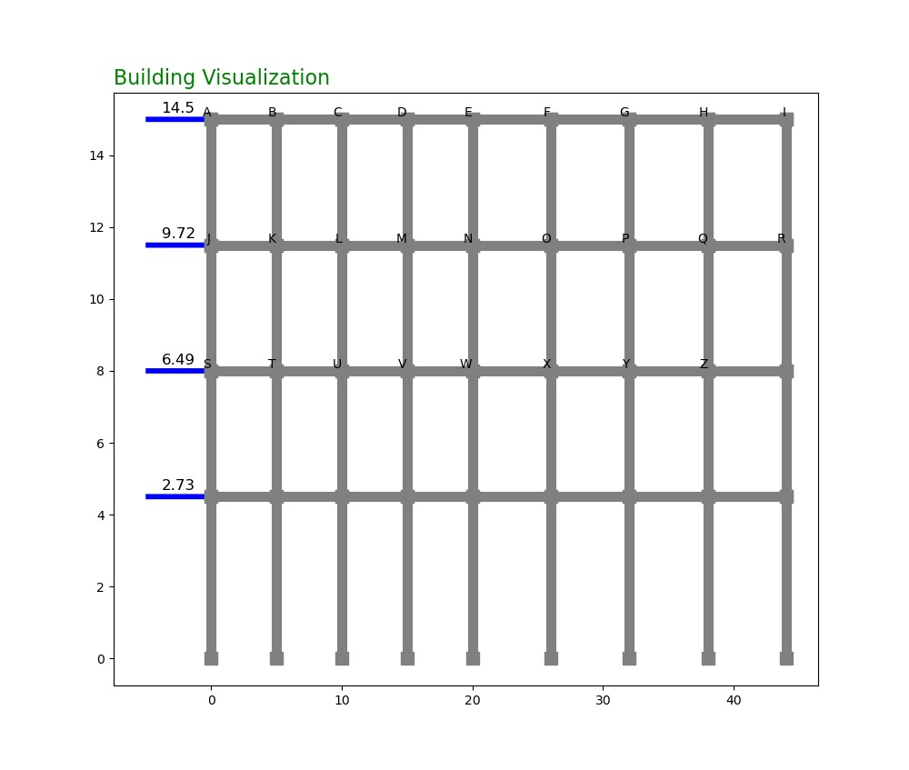

### PORTAL METHOD OF ANALYSIS

#### CALCULATION:

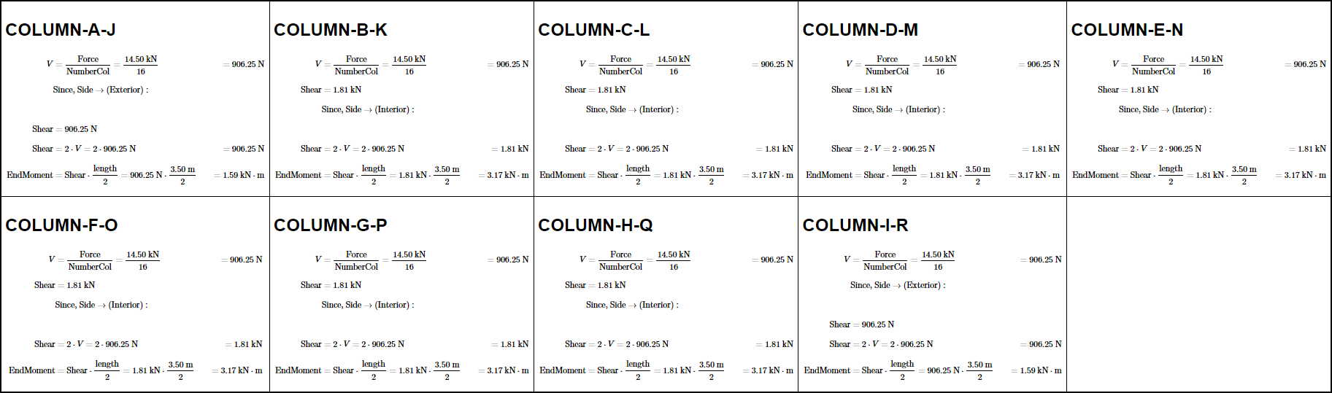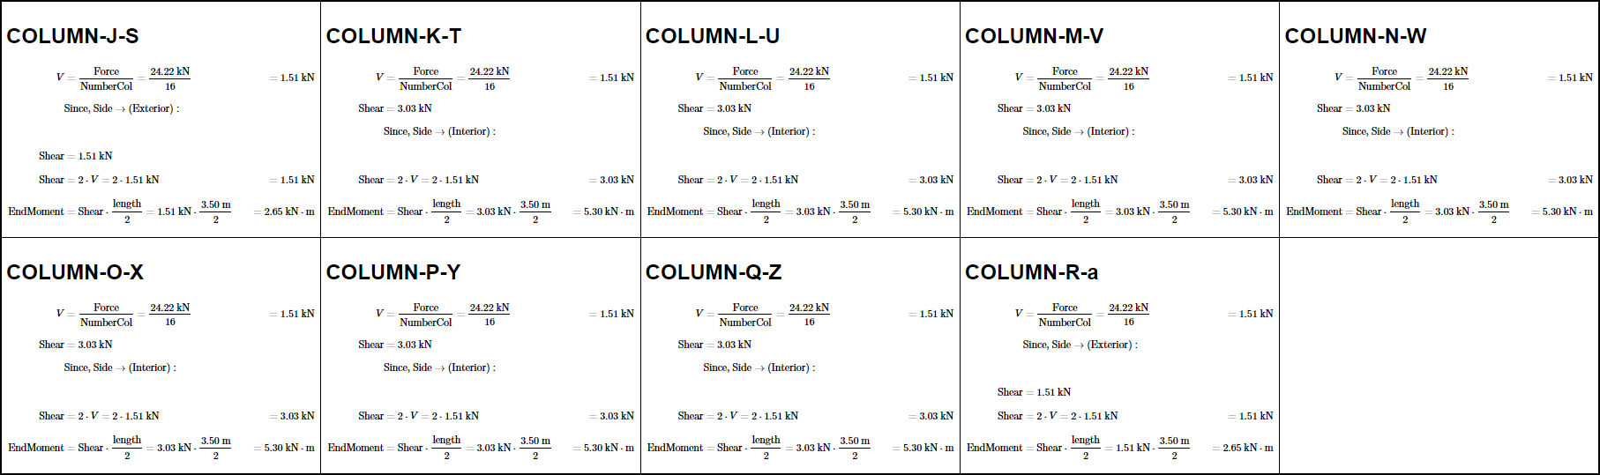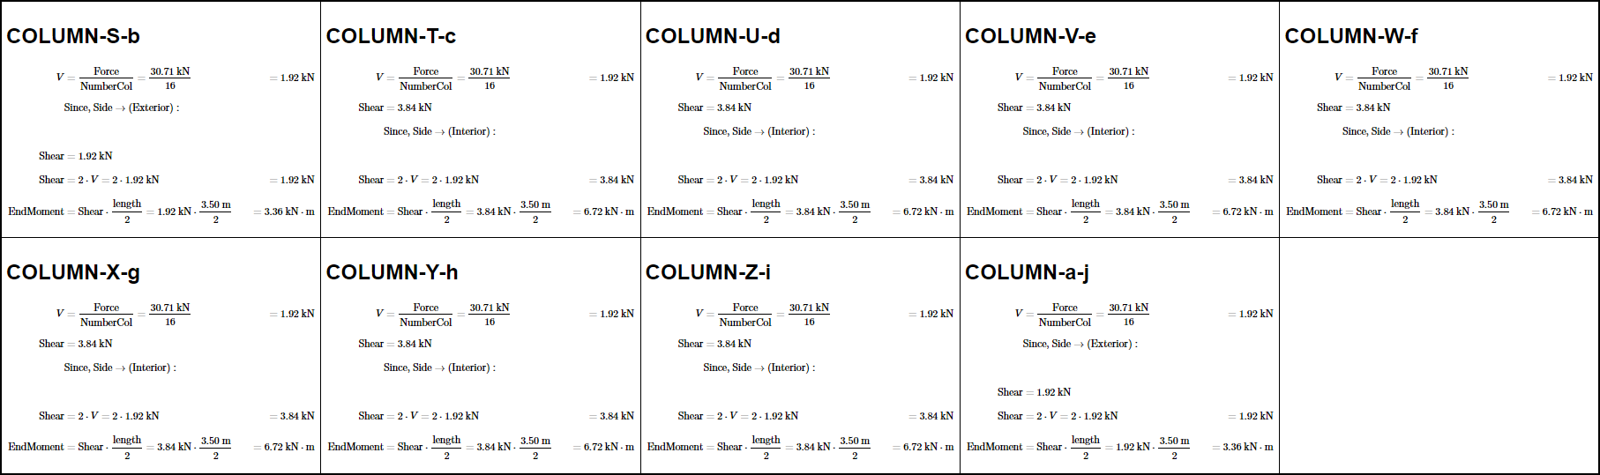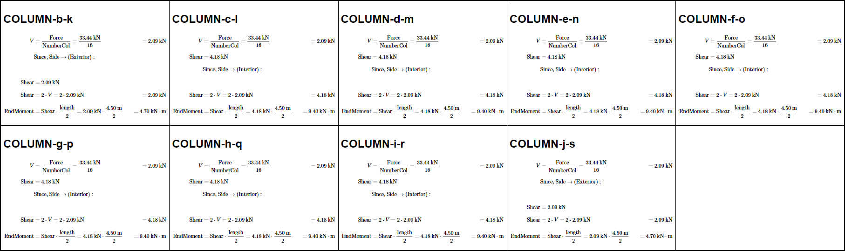

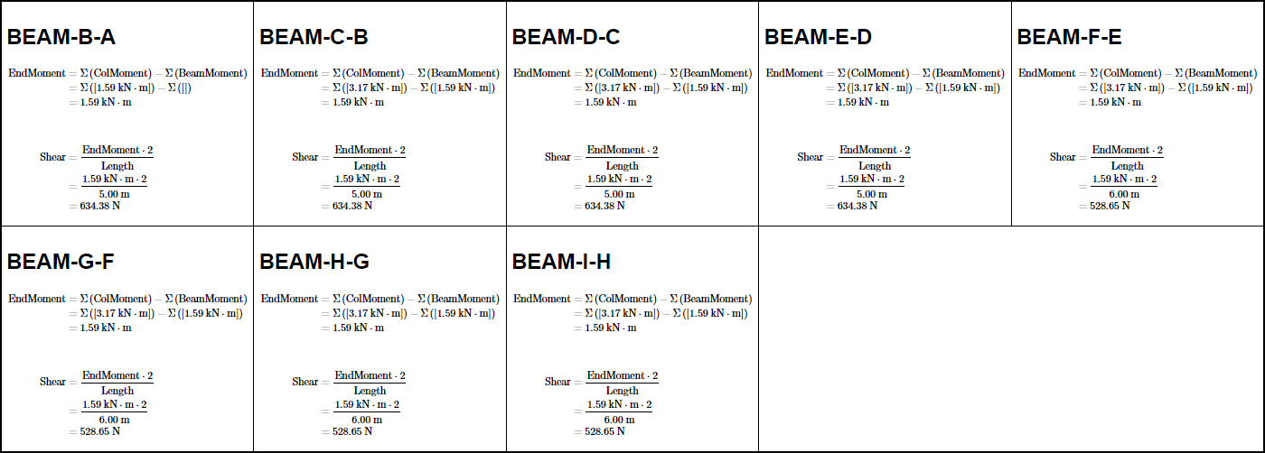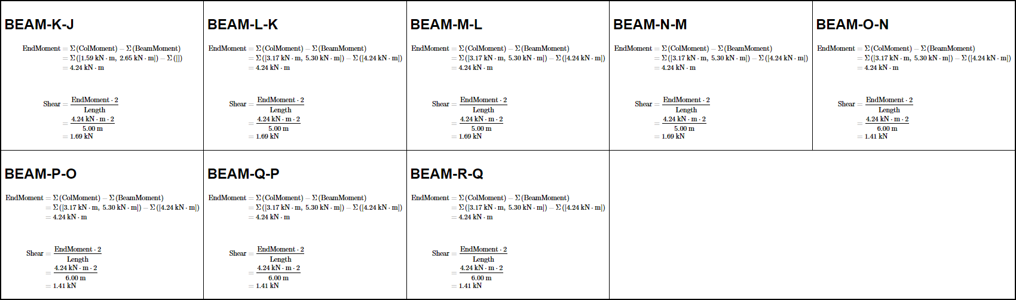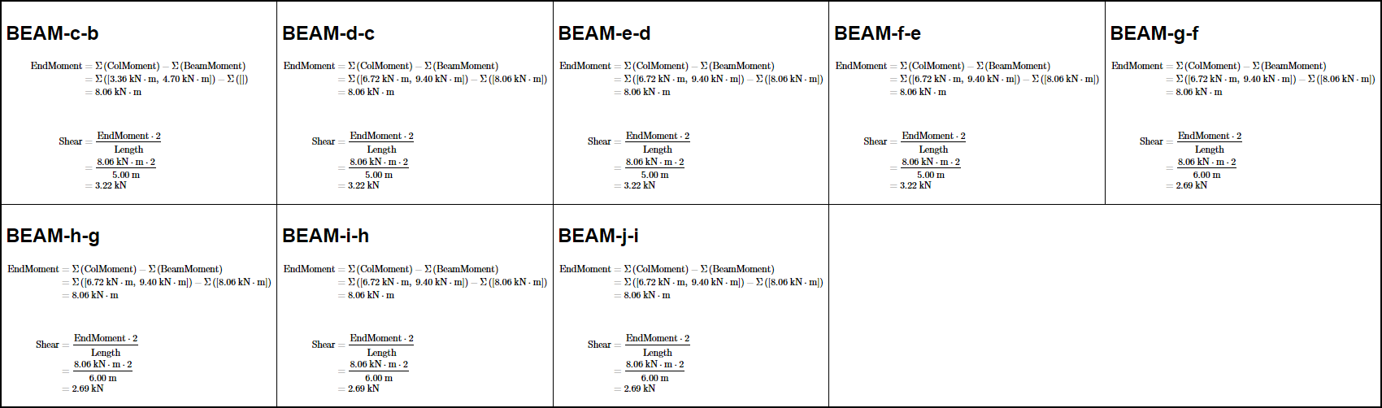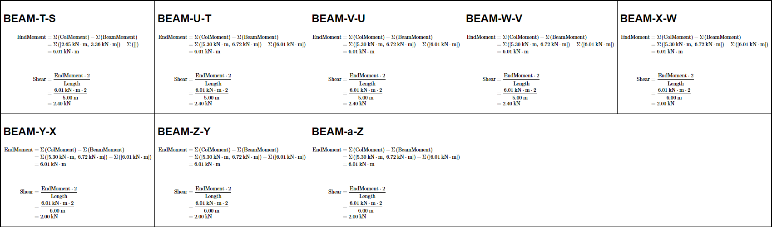

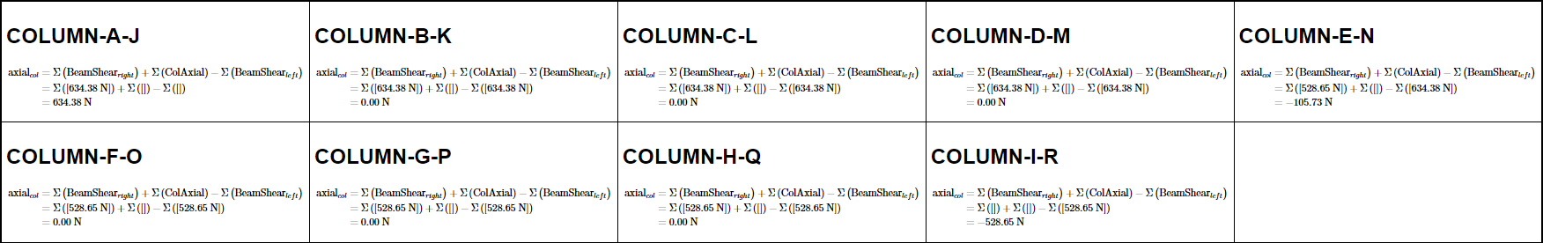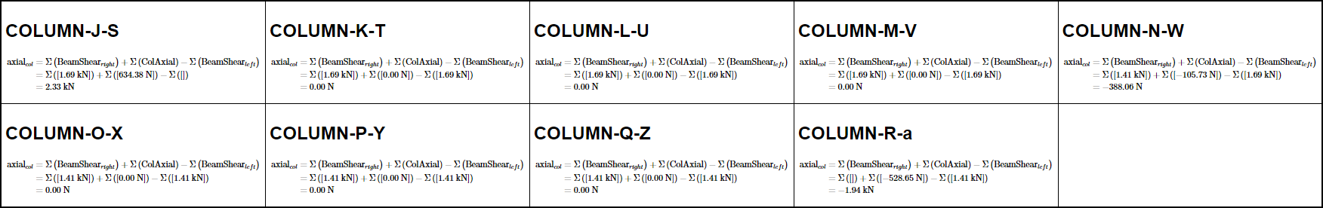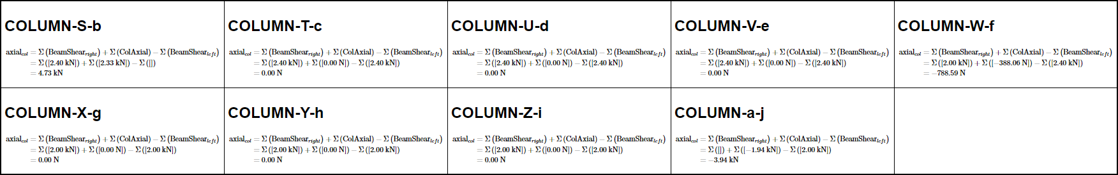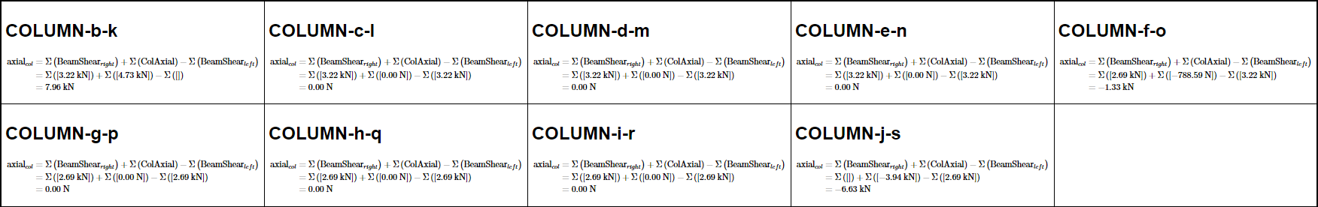

#### DIAGRAMS

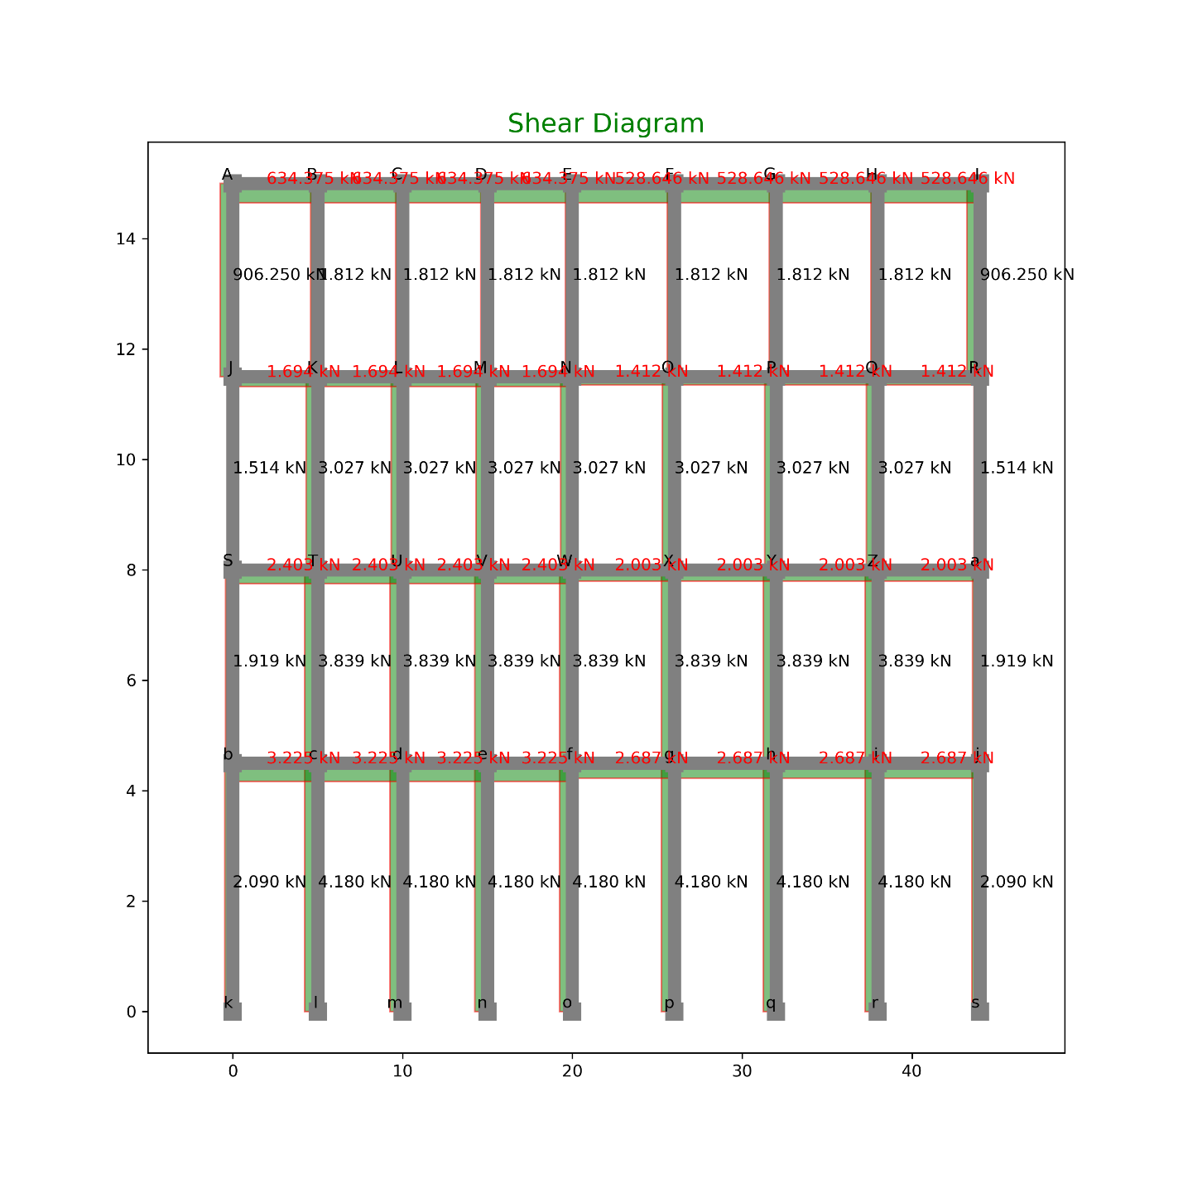

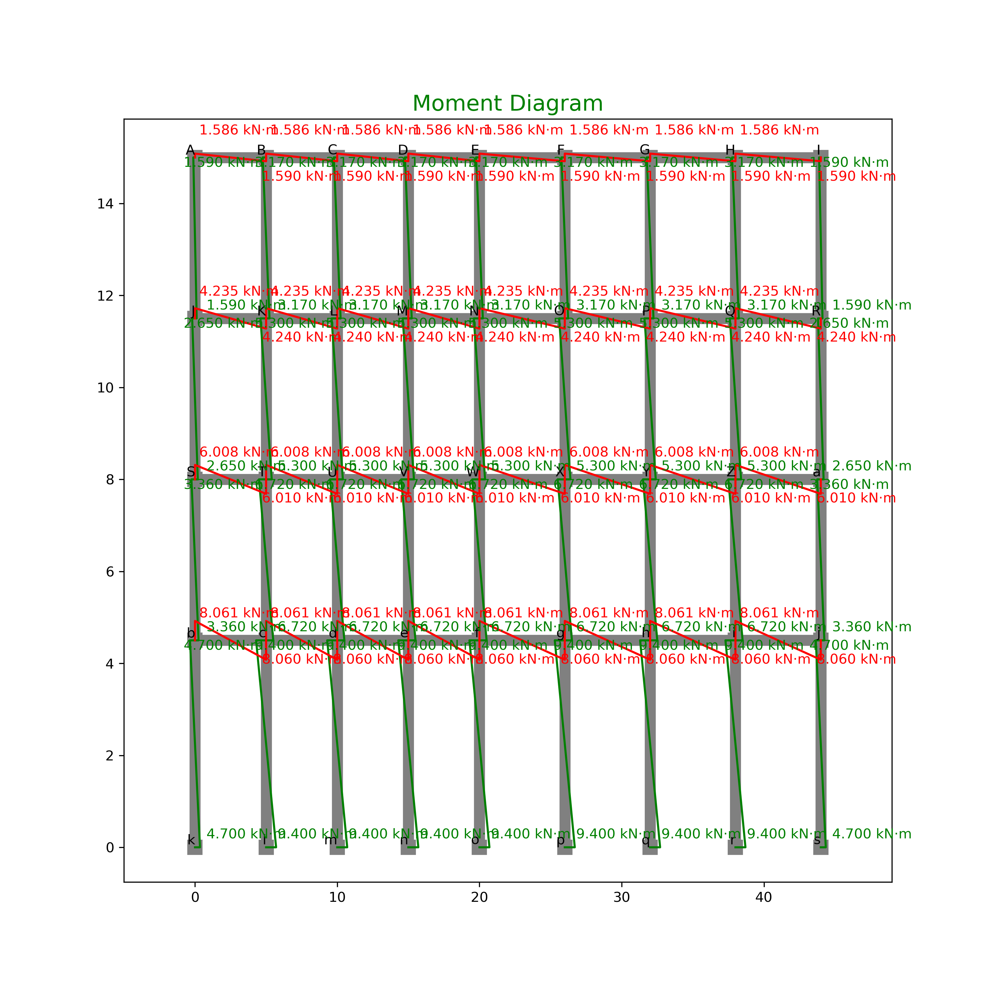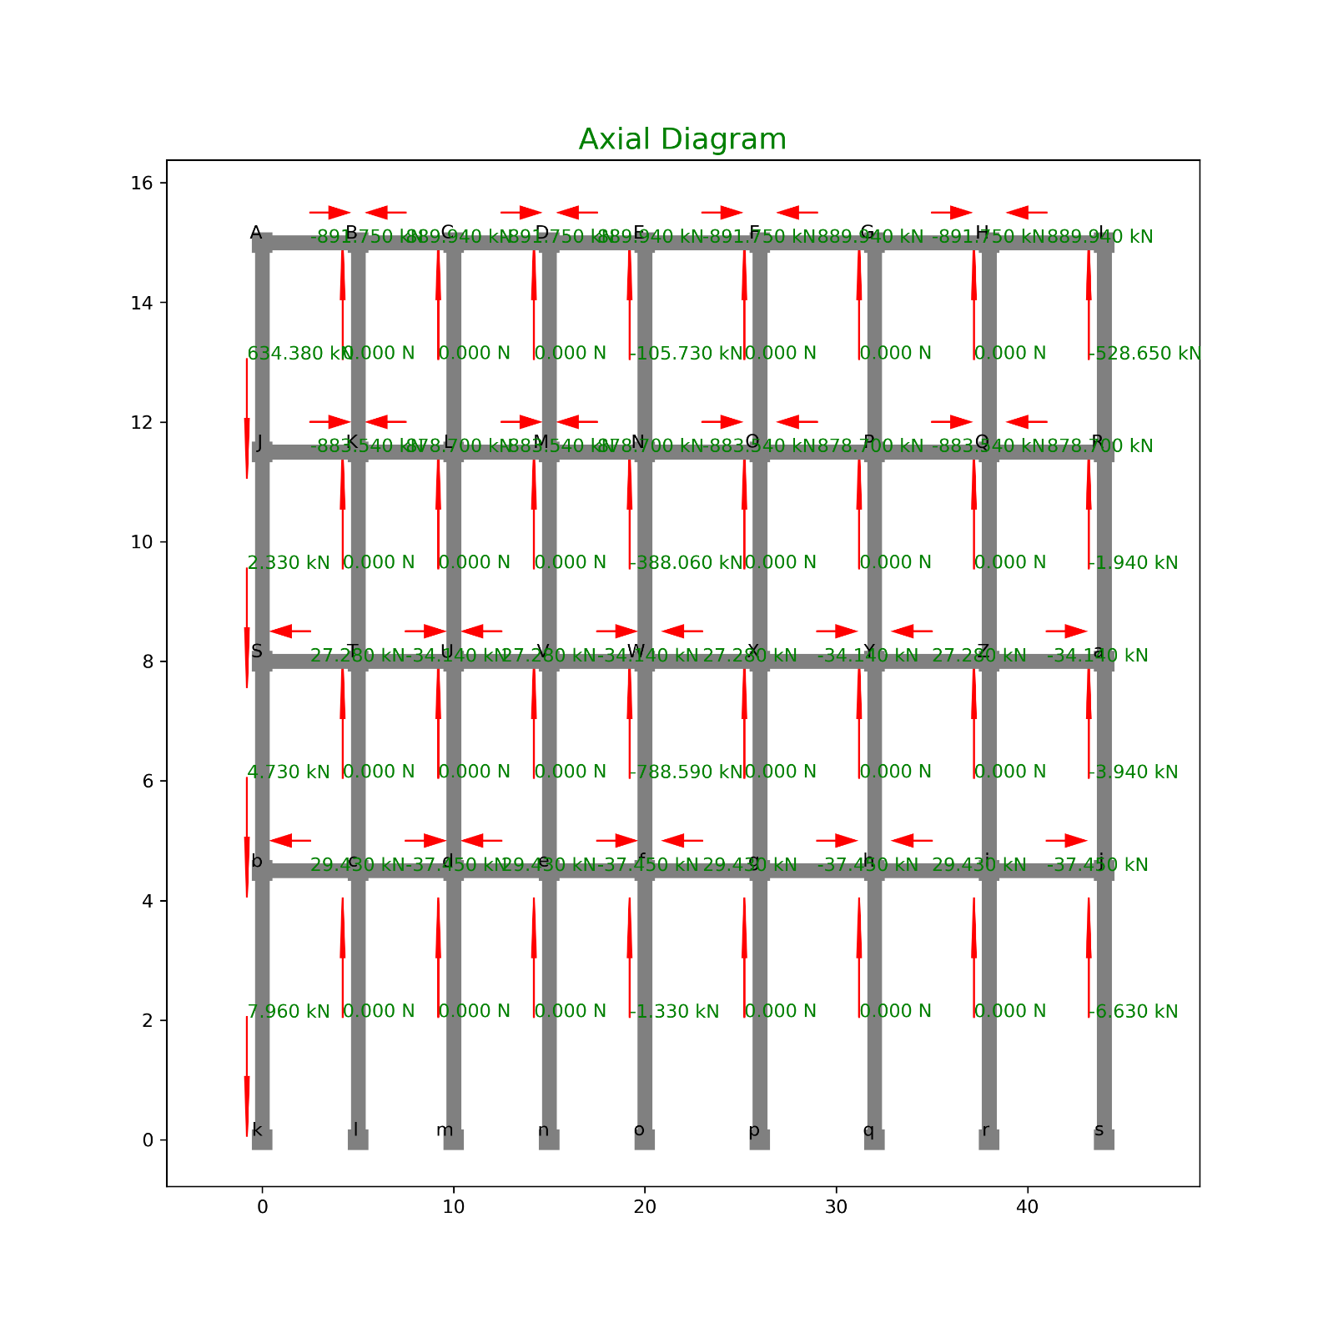

### TABULATION OF FORCES:

SHEAR:

|  |  |  |  |  |  |
| --- | --- | --- | --- | --- | --- |
| INDEX | X | Y | Loc | Shear | Type |
| 0 | 0 | 11.5 | Top | 906.25 | Col |
| 1 | 0 | 15 | Bot | 906.25 | Col |
| 2 | 5 | 11.5 | Top | 1.8125 | Col |
| 3 | 5 | 15 | Bot | 1.8125 | Col |
| 4 | 10 | 11.5 | Top | 1.8125 | Col |
| 5 | 10 | 15 | Bot | 1.8125 | Col |
| 6 | 15 | 11.5 | Top | 1.8125 | Col |
| 7 | 15 | 15 | Bot | 1.8125 | Col |
| 8 | 20 | 11.5 | Top | 1.8125 | Col |
| 9 | 20 | 15 | Bot | 1.8125 | Col |
| 10 | 26 | 11.5 | Top | 1.8125 | Col |
| 11 | 26 | 15 | Bot | 1.8125 | Col |
| 12 | 32 | 11.5 | Top | 1.8125 | Col |
| 13 | 32 | 15 | Bot | 1.8125 | Col |
| 14 | 38 | 11.5 | Top | 1.8125 | Col |
| 15 | 38 | 15 | Bot | 1.8125 | Col |
| 16 | 44 | 11.5 | Top | 906.25 | Col |
| 17 | 44 | 15 | Bot | 906.25 | Col |
| 18 | 0 | 8 | Top | 1.51375 | Col |
| 19 | 0 | 11.5 | Bot | 1.51375 | Col |
| 20 | 5 | 8 | Top | 3.0275 | Col |
| 21 | 5 | 11.5 | Bot | 3.0275 | Col |
| 22 | 10 | 8 | Top | 3.0275 | Col |
| 23 | 10 | 11.5 | Bot | 3.0275 | Col |
| 24 | 15 | 8 | Top | 3.0275 | Col |
| 25 | 15 | 11.5 | Bot | 3.0275 | Col |
| 26 | 20 | 8 | Top | 3.0275 | Col |
| 27 | 20 | 11.5 | Bot | 3.0275 | Col |
| 28 | 26 | 8 | Top | 3.0275 | Col |
| 29 | 26 | 11.5 | Bot | 3.0275 | Col |
| 30 | 32 | 8 | Top | 3.0275 | Col |
| 31 | 32 | 11.5 | Bot | 3.0275 | Col |
| 32 | 38 | 8 | Top | 3.0275 | Col |
| 33 | 38 | 11.5 | Bot | 3.0275 | Col |
| 34 | 44 | 8 | Top | 1.51375 | Col |
| 35 | 44 | 11.5 | Bot | 1.51375 | Col |
| 36 | 0 | 4.5 | Top | 1.919375 | Col |
| 37 | 0 | 8 | Bot | 1.919375 | Col |
| 38 | 5 | 4.5 | Top | 3.83875 | Col |
| 39 | 5 | 8 | Bot | 3.83875 | Col |
| 40 | 10 | 4.5 | Top | 3.83875 | Col |
| 41 | 10 | 8 | Bot | 3.83875 | Col |
| 42 | 15 | 4.5 | Top | 3.83875 | Col |
| 43 | 15 | 8 | Bot | 3.83875 | Col |
| 44 | 20 | 4.5 | Top | 3.83875 | Col |
| 45 | 20 | 8 | Bot | 3.83875 | Col |
| 46 | 26 | 4.5 | Top | 3.83875 | Col |
| 47 | 26 | 8 | Bot | 3.83875 | Col |
| 48 | 32 | 4.5 | Top | 3.83875 | Col |
| 49 | 32 | 8 | Bot | 3.83875 | Col |
| 50 | 38 | 4.5 | Top | 3.83875 | Col |
| 51 | 38 | 8 | Bot | 3.83875 | Col |
| 52 | 44 | 4.5 | Top | 1.919375 | Col |
| 53 | 44 | 8 | Bot | 1.919375 | Col |
| 54 | 0 | 0 | Top | 2.09 | Col |
| 55 | 0 | 4.5 | Bot | 2.09 | Col |
| 56 | 5 | 0 | Top | 4.18 | Col |
| 57 | 5 | 4.5 | Bot | 4.18 | Col |
| 58 | 10 | 0 | Top | 4.18 | Col |
| 59 | 10 | 4.5 | Bot | 4.18 | Col |
| 60 | 15 | 0 | Top | 4.18 | Col |
| 61 | 15 | 4.5 | Bot | 4.18 | Col |
| 62 | 20 | 0 | Top | 4.18 | Col |
| 63 | 20 | 4.5 | Bot | 4.18 | Col |
| 64 | 26 | 0 | Top | 4.18 | Col |
| 65 | 26 | 4.5 | Bot | 4.18 | Col |
| 66 | 32 | 0 | Top | 4.18 | Col |
| 67 | 32 | 4.5 | Bot | 4.18 | Col |
| 68 | 38 | 0 | Top | 4.18 | Col |
| 69 | 38 | 4.5 | Bot | 4.18 | Col |
| 70 | 44 | 0 | Top | 2.09 | Col |
| 71 | 44 | 4.5 | Bot | 2.09 | Col |
| 72 | 0 | 15 | Right | 634.375 | Beam |
| 73 | 5 | 15 | Left | 634.375 | Beam |
| 74 | 5 | 15 | Right | 634.375 | Beam |
| 75 | 10 | 15 | Left | 634.375 | Beam |
| 76 | 10 | 15 | Right | 634.375 | Beam |
| 77 | 15 | 15 | Left | 634.375 | Beam |
| 78 | 15 | 15 | Right | 634.375 | Beam |
| 79 | 20 | 15 | Left | 634.375 | Beam |
| 80 | 20 | 15 | Right | 528.6458 | Beam |
| 81 | 26 | 15 | Left | 528.6458 | Beam |
| 82 | 26 | 15 | Right | 528.6458 | Beam |
| 83 | 32 | 15 | Left | 528.6458 | Beam |
| 84 | 32 | 15 | Right | 528.6458 | Beam |
| 85 | 38 | 15 | Left | 528.6458 | Beam |
| 86 | 38 | 15 | Right | 528.6458 | Beam |
| 87 | 44 | 15 | Left | 528.6458 | Beam |
| 88 | 0 | 11.5 | Right | 1.694 | Beam |
| 89 | 5 | 11.5 | Left | 1.694 | Beam |
| 90 | 5 | 11.5 | Right | 1.694 | Beam |
| 91 | 10 | 11.5 | Left | 1.694 | Beam |
| 92 | 10 | 11.5 | Right | 1.694 | Beam |
| 93 | 15 | 11.5 | Left | 1.694 | Beam |
| 94 | 15 | 11.5 | Right | 1.694 | Beam |
| 95 | 20 | 11.5 | Left | 1.694 | Beam |
| 96 | 20 | 11.5 | Right | 1.411667 | Beam |
| 97 | 26 | 11.5 | Left | 1.411667 | Beam |
| 98 | 26 | 11.5 | Right | 1.411667 | Beam |
| 99 | 32 | 11.5 | Left | 1.411667 | Beam |
| 100 | 32 | 11.5 | Right | 1.411667 | Beam |
| 101 | 38 | 11.5 | Left | 1.411667 | Beam |
| 102 | 38 | 11.5 | Right | 1.411667 | Beam |
| 103 | 44 | 11.5 | Left | 1.411667 | Beam |
| 104 | 0 | 8 | Right | 2.403188 | Beam |
| 105 | 5 | 8 | Left | 2.403188 | Beam |
| 106 | 5 | 8 | Right | 2.403188 | Beam |
| 107 | 10 | 8 | Left | 2.403188 | Beam |
| 108 | 10 | 8 | Right | 2.403188 | Beam |
| 109 | 15 | 8 | Left | 2.403188 | Beam |
| 110 | 15 | 8 | Right | 2.403188 | Beam |
| 111 | 20 | 8 | Left | 2.403188 | Beam |
| 112 | 20 | 8 | Right | 2.002656 | Beam |
| 113 | 26 | 8 | Left | 2.002656 | Beam |
| 114 | 26 | 8 | Right | 2.002656 | Beam |
| 115 | 32 | 8 | Left | 2.002656 | Beam |
| 116 | 32 | 8 | Right | 2.002656 | Beam |
| 117 | 38 | 8 | Left | 2.002656 | Beam |
| 118 | 38 | 8 | Right | 2.002656 | Beam |
| 119 | 44 | 8 | Left | 2.002656 | Beam |
| 120 | 0 | 4.5 | Right | 3.224563 | Beam |
| 121 | 5 | 4.5 | Left | 3.224563 | Beam |
| 122 | 5 | 4.5 | Right | 3.224563 | Beam |
| 123 | 10 | 4.5 | Left | 3.224563 | Beam |
| 124 | 10 | 4.5 | Right | 3.224563 | Beam |
| 125 | 15 | 4.5 | Left | 3.224563 | Beam |
| 126 | 15 | 4.5 | Right | 3.224563 | Beam |
| 127 | 20 | 4.5 | Left | 3.224563 | Beam |
| 128 | 20 | 4.5 | Right | 2.687135 | Beam |
| 129 | 26 | 4.5 | Left | 2.687135 | Beam |
| 130 | 26 | 4.5 | Right | 2.687135 | Beam |
| 131 | 32 | 4.5 | Left | 2.687135 | Beam |
| 132 | 32 | 4.5 | Right | 2.687135 | Beam |
| 133 | 38 | 4.5 | Left | 2.687135 | Beam |
| 134 | 38 | 4.5 | Right | 2.687135 | Beam |
| 135 | 44 | 4.5 | Left | 2.687135 | Beam |

MOMENT

|  |  |  |  |  |  |
| --- | --- | --- | --- | --- | --- |
| INDEX | X | Y | Loc | Moment | Type |
| 0 | 0 | 11.5 | Top | 1.5859375 | Col |
| 1 | 0 | 15 | Bot | 1.5859375 | Col |
| 2 | 5 | 11.5 | Top | 3.171875 | Col |
| 3 | 5 | 15 | Bot | 3.171875 | Col |
| 4 | 10 | 11.5 | Top | 3.171875 | Col |
| 5 | 10 | 15 | Bot | 3.171875 | Col |
| 6 | 15 | 11.5 | Top | 3.171875 | Col |
| 7 | 15 | 15 | Bot | 3.171875 | Col |
| 8 | 20 | 11.5 | Top | 3.171875 | Col |
| 9 | 20 | 15 | Bot | 3.171875 | Col |
| 10 | 26 | 11.5 | Top | 3.171875 | Col |
| 11 | 26 | 15 | Bot | 3.171875 | Col |
| 12 | 32 | 11.5 | Top | 3.171875 | Col |
| 13 | 32 | 15 | Bot | 3.171875 | Col |
| 14 | 38 | 11.5 | Top | 3.171875 | Col |
| 15 | 38 | 15 | Bot | 3.171875 | Col |
| 16 | 44 | 11.5 | Top | 1.5859375 | Col |
| 17 | 44 | 15 | Bot | 1.5859375 | Col |
| 18 | 0 | 8 | Top | 2.6490625 | Col |
| 19 | 0 | 11.5 | Bot | 2.6490625 | Col |
| 20 | 5 | 8 | Top | 5.298125 | Col |
| 21 | 5 | 11.5 | Bot | 5.298125 | Col |
| 22 | 10 | 8 | Top | 5.298125 | Col |
| 23 | 10 | 11.5 | Bot | 5.298125 | Col |
| 24 | 15 | 8 | Top | 5.298125 | Col |
| 25 | 15 | 11.5 | Bot | 5.298125 | Col |
| 26 | 20 | 8 | Top | 5.298125 | Col |
| 27 | 20 | 11.5 | Bot | 5.298125 | Col |
| 28 | 26 | 8 | Top | 5.298125 | Col |
| 29 | 26 | 11.5 | Bot | 5.298125 | Col |
| 30 | 32 | 8 | Top | 5.298125 | Col |
| 31 | 32 | 11.5 | Bot | 5.298125 | Col |
| 32 | 38 | 8 | Top | 5.298125 | Col |
| 33 | 38 | 11.5 | Bot | 5.298125 | Col |
| 34 | 44 | 8 | Top | 2.6490625 | Col |
| 35 | 44 | 11.5 | Bot | 2.6490625 | Col |
| 36 | 0 | 4.5 | Top | 3.35890625 | Col |
| 37 | 0 | 8 | Bot | 3.35890625 | Col |
| 38 | 5 | 4.5 | Top | 6.7178125 | Col |
| 39 | 5 | 8 | Bot | 6.7178125 | Col |
| 40 | 10 | 4.5 | Top | 6.7178125 | Col |
| 41 | 10 | 8 | Bot | 6.7178125 | Col |
| 42 | 15 | 4.5 | Top | 6.7178125 | Col |
| 43 | 15 | 8 | Bot | 6.7178125 | Col |
| 44 | 20 | 4.5 | Top | 6.7178125 | Col |
| 45 | 20 | 8 | Bot | 6.7178125 | Col |
| 46 | 26 | 4.5 | Top | 6.7178125 | Col |
| 47 | 26 | 8 | Bot | 6.7178125 | Col |
| 48 | 32 | 4.5 | Top | 6.7178125 | Col |
| 49 | 32 | 8 | Bot | 6.7178125 | Col |
| 50 | 38 | 4.5 | Top | 6.7178125 | Col |
| 51 | 38 | 8 | Bot | 6.7178125 | Col |
| 52 | 44 | 4.5 | Top | 3.35890625 | Col |
| 53 | 44 | 8 | Bot | 3.35890625 | Col |
| 54 | 0 | 0 | Top | 4.7025 | Col |
| 55 | 0 | 4.5 | Bot | 4.7025 | Col |
| 56 | 5 | 0 | Top | 9.405 | Col |
| 57 | 5 | 4.5 | Bot | 9.405 | Col |
| 58 | 10 | 0 | Top | 9.405 | Col |
| 59 | 10 | 4.5 | Bot | 9.405 | Col |
| 60 | 15 | 0 | Top | 9.405 | Col |
| 61 | 15 | 4.5 | Bot | 9.405 | Col |
| 62 | 20 | 0 | Top | 9.405 | Col |
| 63 | 20 | 4.5 | Bot | 9.405 | Col |
| 64 | 26 | 0 | Top | 9.405 | Col |
| 65 | 26 | 4.5 | Bot | 9.405 | Col |
| 66 | 32 | 0 | Top | 9.405 | Col |
| 67 | 32 | 4.5 | Bot | 9.405 | Col |
| 68 | 38 | 0 | Top | 9.405 | Col |
| 69 | 38 | 4.5 | Bot | 9.405 | Col |
| 70 | 44 | 0 | Top | 4.7025 | Col |
| 71 | 44 | 4.5 | Bot | 4.7025 | Col |
| 72 | 0 | 15 | Right | 1.5859375 | Beam |
| 73 | 5 | 15 | Left | 1.5859375 | Beam |
| 74 | 5 | 15 | Right | 1.5859375 | Beam |
| 75 | 10 | 15 | Left | 1.5859375 | Beam |
| 76 | 10 | 15 | Right | 1.5859375 | Beam |
| 77 | 15 | 15 | Left | 1.5859375 | Beam |
| 78 | 15 | 15 | Right | 1.5859375 | Beam |
| 79 | 20 | 15 | Left | 1.5859375 | Beam |
| 80 | 20 | 15 | Right | 1.5859375 | Beam |
| 81 | 26 | 15 | Left | 1.5859375 | Beam |
| 82 | 26 | 15 | Right | 1.5859375 | Beam |
| 83 | 32 | 15 | Left | 1.5859375 | Beam |
| 84 | 32 | 15 | Right | 1.5859375 | Beam |
| 85 | 38 | 15 | Left | 1.5859375 | Beam |
| 86 | 38 | 15 | Right | 1.5859375 | Beam |
| 87 | 44 | 15 | Left | 1.5859375 | Beam |
| 88 | 0 | 11.5 | Right | 4.235 | Beam |
| 89 | 5 | 11.5 | Left | 4.235 | Beam |
| 90 | 5 | 11.5 | Right | 4.235 | Beam |
| 91 | 10 | 11.5 | Left | 4.235 | Beam |
| 92 | 10 | 11.5 | Right | 4.235 | Beam |
| 93 | 15 | 11.5 | Left | 4.235 | Beam |
| 94 | 15 | 11.5 | Right | 4.235 | Beam |
| 95 | 20 | 11.5 | Left | 4.235 | Beam |
| 96 | 20 | 11.5 | Right | 4.235 | Beam |
| 97 | 26 | 11.5 | Left | 4.235 | Beam |
| 98 | 26 | 11.5 | Right | 4.235 | Beam |
| 99 | 32 | 11.5 | Left | 4.235 | Beam |
| 100 | 32 | 11.5 | Right | 4.235 | Beam |
| 101 | 38 | 11.5 | Left | 4.235 | Beam |
| 102 | 38 | 11.5 | Right | 4.235 | Beam |
| 103 | 44 | 11.5 | Left | 4.235 | Beam |
| 104 | 0 | 8 | Right | 6.00796875 | Beam |
| 105 | 5 | 8 | Left | 6.00796875 | Beam |
| 106 | 5 | 8 | Right | 6.00796875 | Beam |
| 107 | 10 | 8 | Left | 6.00796875 | Beam |
| 108 | 10 | 8 | Right | 6.00796875 | Beam |
| 109 | 15 | 8 | Left | 6.00796875 | Beam |
| 110 | 15 | 8 | Right | 6.00796875 | Beam |
| 111 | 20 | 8 | Left | 6.00796875 | Beam |
| 112 | 20 | 8 | Right | 6.00796875 | Beam |
| 113 | 26 | 8 | Left | 6.00796875 | Beam |
| 114 | 26 | 8 | Right | 6.00796875 | Beam |
| 115 | 32 | 8 | Left | 6.00796875 | Beam |
| 116 | 32 | 8 | Right | 6.00796875 | Beam |
| 117 | 38 | 8 | Left | 6.00796875 | Beam |
| 118 | 38 | 8 | Right | 6.00796875 | Beam |
| 119 | 44 | 8 | Left | 6.00796875 | Beam |
| 120 | 0 | 4.5 | Right | 8.06140625 | Beam |
| 121 | 5 | 4.5 | Left | 8.06140625 | Beam |
| 122 | 5 | 4.5 | Right | 8.06140625 | Beam |
| 123 | 10 | 4.5 | Left | 8.06140625 | Beam |
| 124 | 10 | 4.5 | Right | 8.06140625 | Beam |
| 125 | 15 | 4.5 | Left | 8.06140625 | Beam |
| 126 | 15 | 4.5 | Right | 8.06140625 | Beam |
| 127 | 20 | 4.5 | Left | 8.06140625 | Beam |
| 128 | 20 | 4.5 | Right | 8.06140625 | Beam |
| 129 | 26 | 4.5 | Left | 8.06140625 | Beam |
| 130 | 26 | 4.5 | Right | 8.06140625 | Beam |
| 131 | 32 | 4.5 | Left | 8.06140625 | Beam |
| 132 | 32 | 4.5 | Right | 8.06140625 | Beam |
| 133 | 38 | 4.5 | Left | 8.06140625 | Beam |
| 134 | 38 | 4.5 | Right | 8.06140625 | Beam |
| 135 | 44 | 4.5 | Left | 8.06140625 | Beam |

AXIAL

|  |  |  |  |  |  |
| --- | --- | --- | --- | --- | --- |
| INDEX | X | Y | Loc | Axial | Type |
| 0 | 0 | 11.5 | Top | 634.375 | Col |
| 1 | 0 | 15 | Bot | 634.375 | Col |
| 2 | 5 | 11.5 | Top | 0 | Col |
| 3 | 5 | 15 | Bot | 0 | Col |
| 4 | 10 | 11.5 | Top | 0 | Col |
| 5 | 10 | 15 | Bot | 0 | Col |
| 6 | 15 | 11.5 | Top | 0 | Col |
| 7 | 15 | 15 | Bot | 0 | Col |
| 8 | 20 | 11.5 | Top | -105.729 | Col |
| 9 | 20 | 15 | Bot | -105.729 | Col |
| 10 | 26 | 11.5 | Top | 0 | Col |
| 11 | 26 | 15 | Bot | 0 | Col |
| 12 | 32 | 11.5 | Top | 0 | Col |
| 13 | 32 | 15 | Bot | 0 | Col |
| 14 | 38 | 11.5 | Top | 0 | Col |
| 15 | 38 | 15 | Bot | 0 | Col |
| 16 | 44 | 11.5 | Top | -528.646 | Col |
| 17 | 44 | 15 | Bot | -528.646 | Col |
| 18 | 0 | 8 | Top | 2.328375 | Col |
| 19 | 0 | 11.5 | Bot | 2.328375 | Col |
| 20 | 5 | 8 | Top | 0 | Col |
| 21 | 5 | 11.5 | Bot | 0 | Col |
| 22 | 10 | 8 | Top | 0 | Col |
| 23 | 10 | 11.5 | Bot | 0 | Col |
| 24 | 15 | 8 | Top | 0 | Col |
| 25 | 15 | 11.5 | Bot | 0 | Col |
| 26 | 20 | 8 | Top | -388.063 | Col |
| 27 | 20 | 11.5 | Bot | -388.063 | Col |
| 28 | 26 | 8 | Top | 0 | Col |
| 29 | 26 | 11.5 | Bot | 0 | Col |
| 30 | 32 | 8 | Top | 0 | Col |
| 31 | 32 | 11.5 | Bot | 0 | Col |
| 32 | 38 | 8 | Top | 0 | Col |
| 33 | 38 | 11.5 | Bot | 0 | Col |
| 34 | 44 | 8 | Top | -1.94031 | Col |
| 35 | 44 | 11.5 | Bot | -1.94031 | Col |
| 36 | 0 | 4.5 | Top | 4.731563 | Col |
| 37 | 0 | 8 | Bot | 4.731563 | Col |
| 38 | 5 | 4.5 | Top | 0 | Col |
| 39 | 5 | 8 | Bot | 0 | Col |
| 40 | 10 | 4.5 | Top | 0 | Col |
| 41 | 10 | 8 | Bot | 0 | Col |
| 42 | 15 | 4.5 | Top | 0 | Col |
| 43 | 15 | 8 | Bot | 0 | Col |
| 44 | 20 | 4.5 | Top | -788.594 | Col |
| 45 | 20 | 8 | Bot | -788.594 | Col |
| 46 | 26 | 4.5 | Top | 0 | Col |
| 47 | 26 | 8 | Bot | 0 | Col |
| 48 | 32 | 4.5 | Top | 0 | Col |
| 49 | 32 | 8 | Bot | 0 | Col |
| 50 | 38 | 4.5 | Top | 0 | Col |
| 51 | 38 | 8 | Bot | 0 | Col |
| 52 | 44 | 4.5 | Top | -3.94297 | Col |
| 53 | 44 | 8 | Bot | -3.94297 | Col |
| 54 | 0 | 0 | Top | 7.956125 | Col |
| 55 | 0 | 4.5 | Bot | 7.956125 | Col |
| 56 | 5 | 0 | Top | 0 | Col |
| 57 | 5 | 4.5 | Bot | 0 | Col |
| 58 | 10 | 0 | Top | 0 | Col |
| 59 | 10 | 4.5 | Bot | 0 | Col |
| 60 | 15 | 0 | Top | 0 | Col |
| 61 | 15 | 4.5 | Bot | 0 | Col |
| 62 | 20 | 0 | Top | -1.32602 | Col |
| 63 | 20 | 4.5 | Bot | -1.32602 | Col |
| 64 | 26 | 0 | Top | 0 | Col |
| 65 | 26 | 4.5 | Bot | 0 | Col |
| 66 | 32 | 0 | Top | 0 | Col |
| 67 | 32 | 4.5 | Bot | 0 | Col |
| 68 | 38 | 0 | Top | 0 | Col |
| 69 | 38 | 4.5 | Bot | 0 | Col |
| 70 | 44 | 0 | Top | -6.6301 | Col |
| 71 | 44 | 4.5 | Bot | -6.6301 | Col |
| 72 | 0 | 15 | Right | -891.75 | Beam |
| 73 | 5 | 15 | Left | -891.75 | Beam |
| 74 | 5 | 15 | Right | 889.9375 | Beam |
| 75 | 10 | 15 | Left | 889.9375 | Beam |
| 76 | 10 | 15 | Right | -891.75 | Beam |
| 77 | 15 | 15 | Left | -891.75 | Beam |
| 78 | 15 | 15 | Right | 889.9375 | Beam |
| 79 | 20 | 15 | Left | 889.9375 | Beam |
| 80 | 20 | 15 | Right | -891.75 | Beam |
| 81 | 26 | 15 | Left | -891.75 | Beam |
| 82 | 26 | 15 | Right | 889.9375 | Beam |
| 83 | 32 | 15 | Left | 889.9375 | Beam |
| 84 | 32 | 15 | Right | -891.75 | Beam |
| 85 | 38 | 15 | Left | -891.75 | Beam |
| 86 | 38 | 15 | Right | 889.9375 | Beam |
| 87 | 44 | 15 | Left | 889.9375 | Beam |
| 88 | 0 | 11.5 | Right | -883.544 | Beam |
| 89 | 5 | 11.5 | Left | -883.544 | Beam |
| 90 | 5 | 11.5 | Right | 878.7037 | Beam |
| 91 | 10 | 11.5 | Left | 878.7037 | Beam |
| 92 | 10 | 11.5 | Right | -883.544 | Beam |
| 93 | 15 | 11.5 | Left | -883.544 | Beam |
| 94 | 15 | 11.5 | Right | 878.7037 | Beam |
| 95 | 20 | 11.5 | Left | 878.7037 | Beam |
| 96 | 20 | 11.5 | Right | -883.544 | Beam |
| 97 | 26 | 11.5 | Left | -883.544 | Beam |
| 98 | 26 | 11.5 | Right | 878.7037 | Beam |
| 99 | 32 | 11.5 | Left | 878.7037 | Beam |
| 100 | 32 | 11.5 | Right | -883.544 | Beam |
| 101 | 38 | 11.5 | Left | -883.544 | Beam |
| 102 | 38 | 11.5 | Right | 878.7037 | Beam |
| 103 | 44 | 11.5 | Left | 878.7037 | Beam |
| 104 | 0 | 8 | Right | 27.27688 | Beam |
| 105 | 5 | 8 | Left | 27.27688 | Beam |
| 106 | 5 | 8 | Right | -34.1431 | Beam |
| 107 | 10 | 8 | Left | -34.1431 | Beam |
| 108 | 10 | 8 | Right | 27.27687 | Beam |
| 109 | 15 | 8 | Left | 27.27687 | Beam |
| 110 | 15 | 8 | Right | -34.1431 | Beam |
| 111 | 20 | 8 | Left | -34.1431 | Beam |
| 112 | 20 | 8 | Right | 27.27687 | Beam |
| 113 | 26 | 8 | Left | 27.27687 | Beam |
| 114 | 26 | 8 | Right | -34.1431 | Beam |
| 115 | 32 | 8 | Left | -34.1431 | Beam |
| 116 | 32 | 8 | Right | 27.27687 | Beam |
| 117 | 38 | 8 | Left | 27.27687 | Beam |
| 118 | 38 | 8 | Right | -34.1431 | Beam |
| 119 | 44 | 8 | Left | -34.1431 | Beam |
| 120 | 0 | 4.5 | Right | 29.43063 | Beam |
| 121 | 5 | 4.5 | Left | 29.43063 | Beam |
| 122 | 5 | 4.5 | Right | -37.4494 | Beam |
| 123 | 10 | 4.5 | Left | -37.4494 | Beam |
| 124 | 10 | 4.5 | Right | 29.43063 | Beam |
| 125 | 15 | 4.5 | Left | 29.43063 | Beam |
| 126 | 15 | 4.5 | Right | -37.4494 | Beam |
| 127 | 20 | 4.5 | Left | -37.4494 | Beam |
| 128 | 20 | 4.5 | Right | 29.43063 | Beam |
| 129 | 26 | 4.5 | Left | 29.43063 | Beam |
| 130 | 26 | 4.5 | Right | -37.4494 | Beam |
| 131 | 32 | 4.5 | Left | -37.4494 | Beam |
| 132 | 32 | 4.5 | Right | 29.43063 | Beam |
| 133 | 38 | 4.5 | Left | 29.43063 | Beam |
| 134 | 38 | 4.5 | Right | -37.4494 | Beam |
| 135 | 44 | 4.5 | Left | -37.4494 | Beam |

### CANTILEVER METHOD OF ANALYSIS

#### CALCULATION:

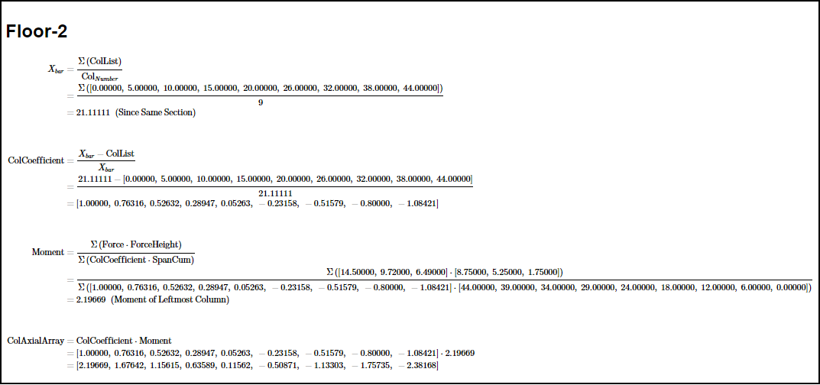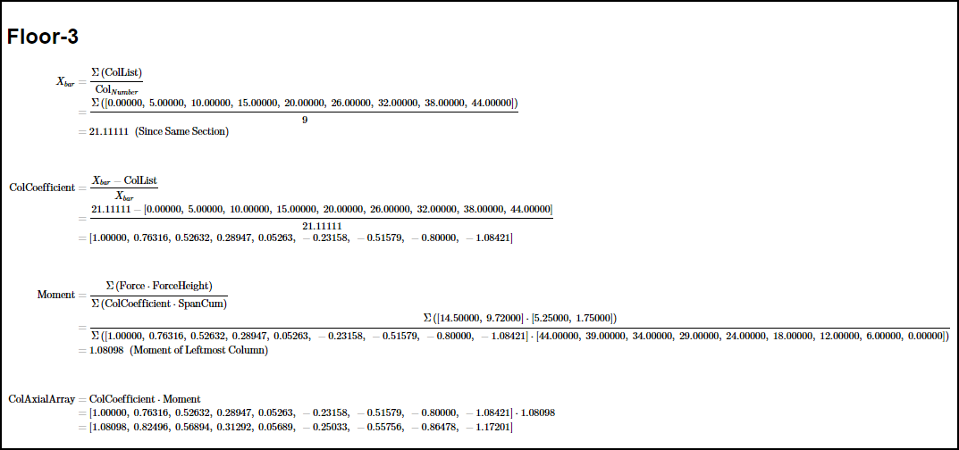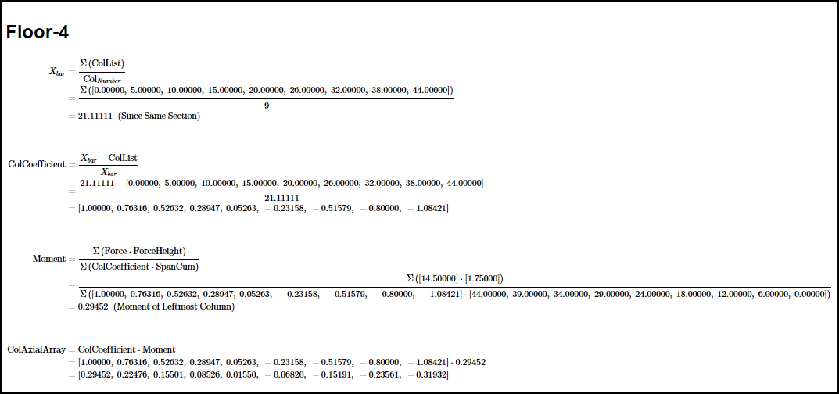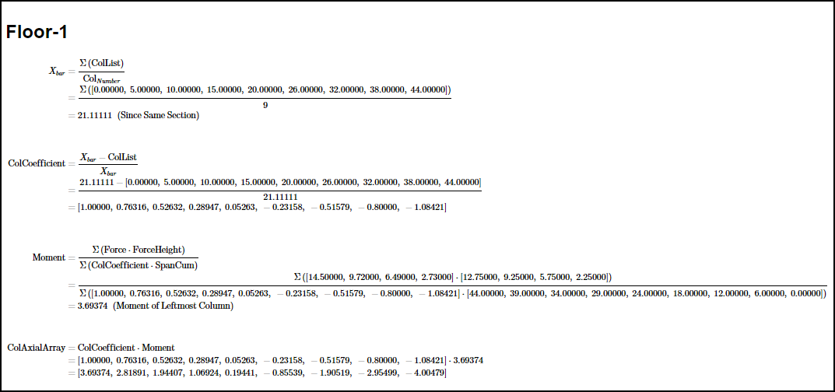

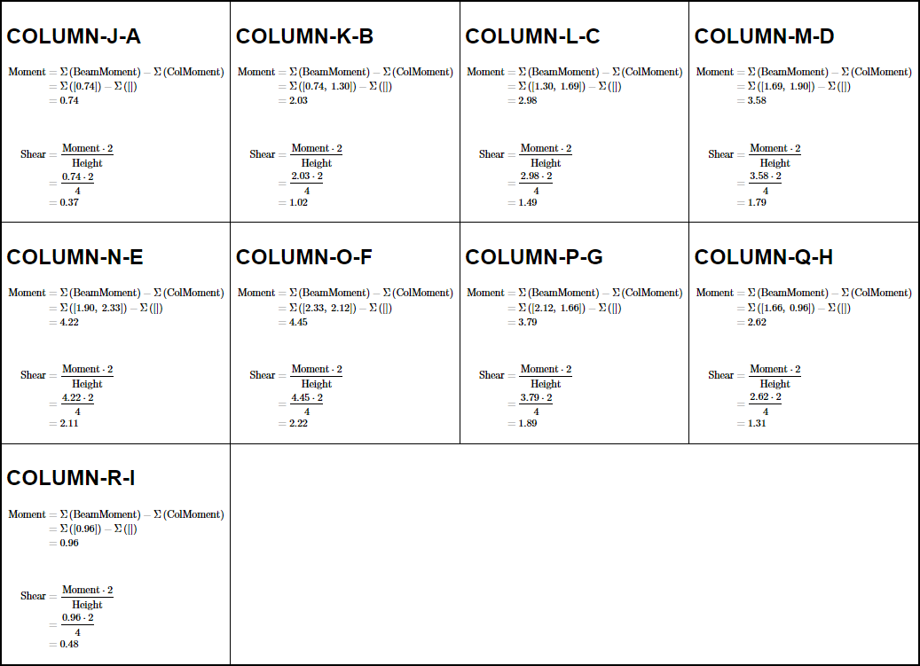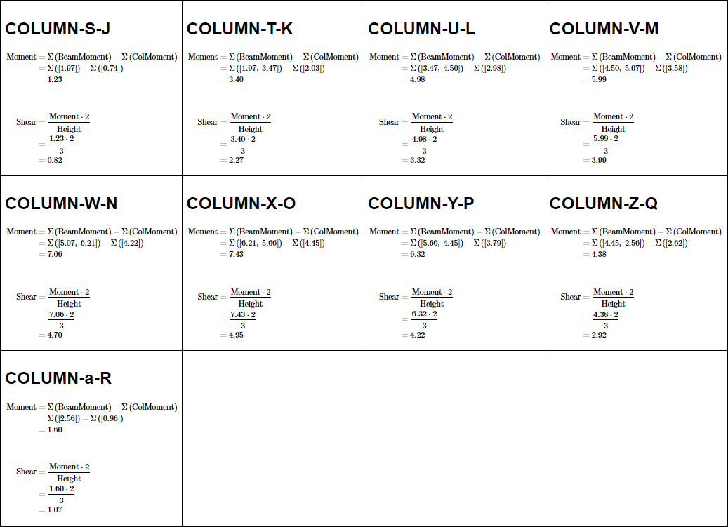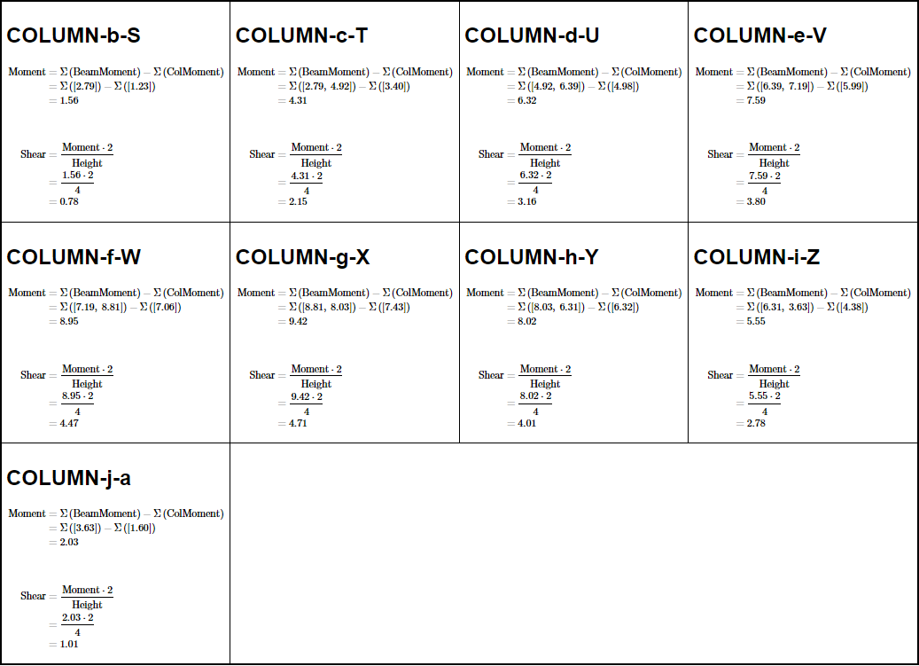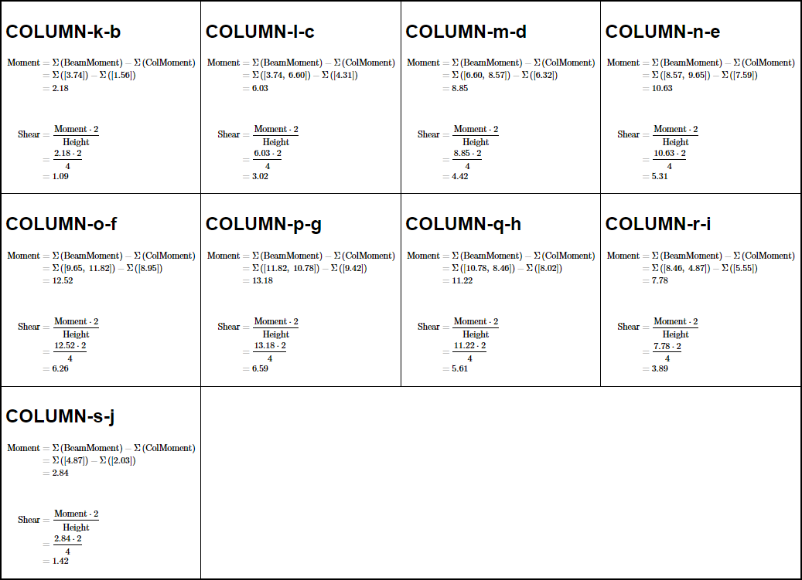

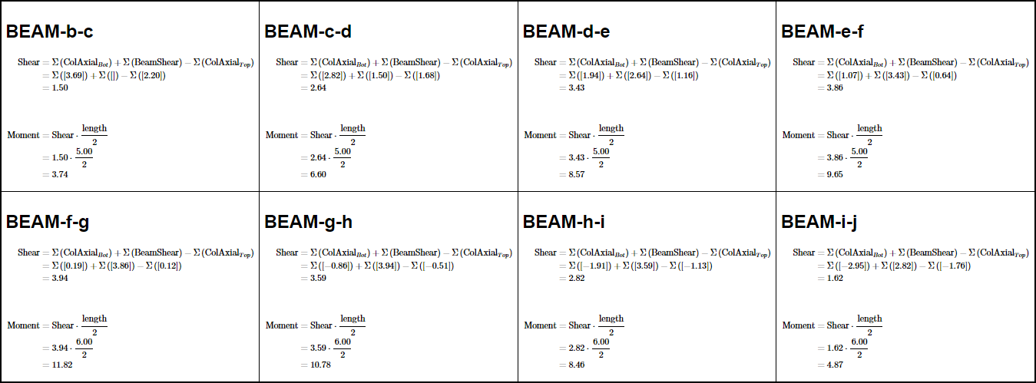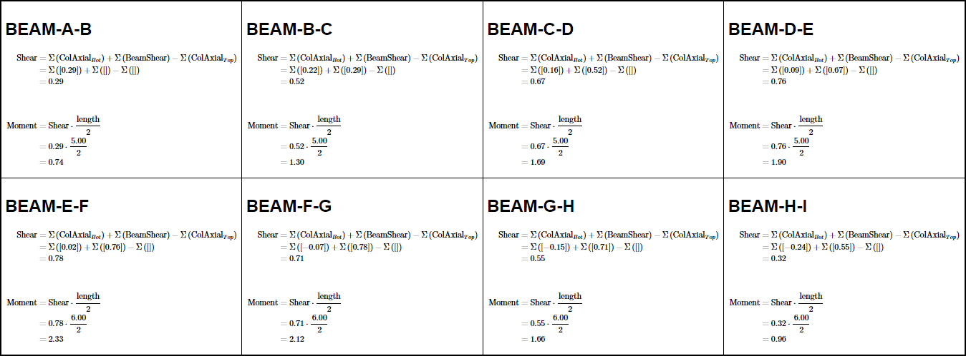

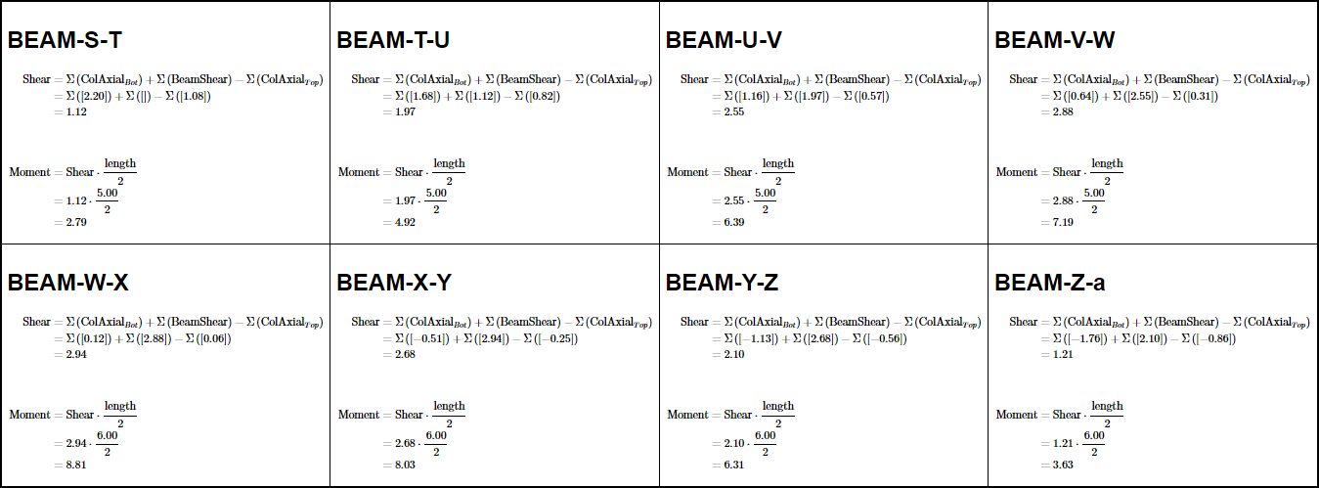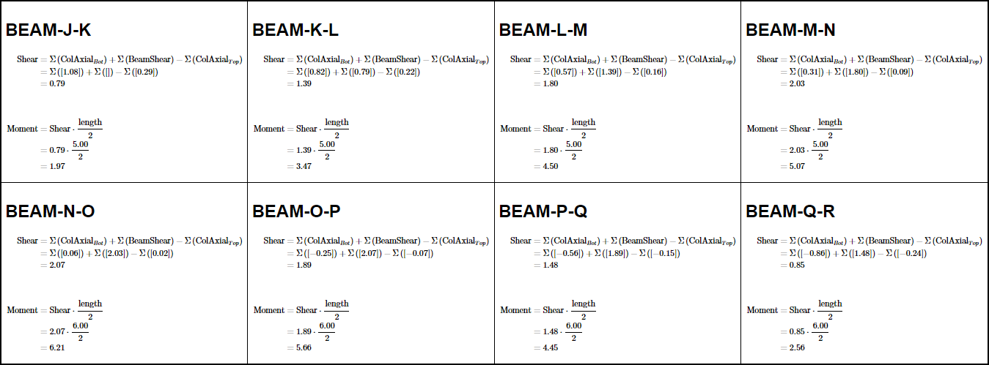

#### DIAGRAMS

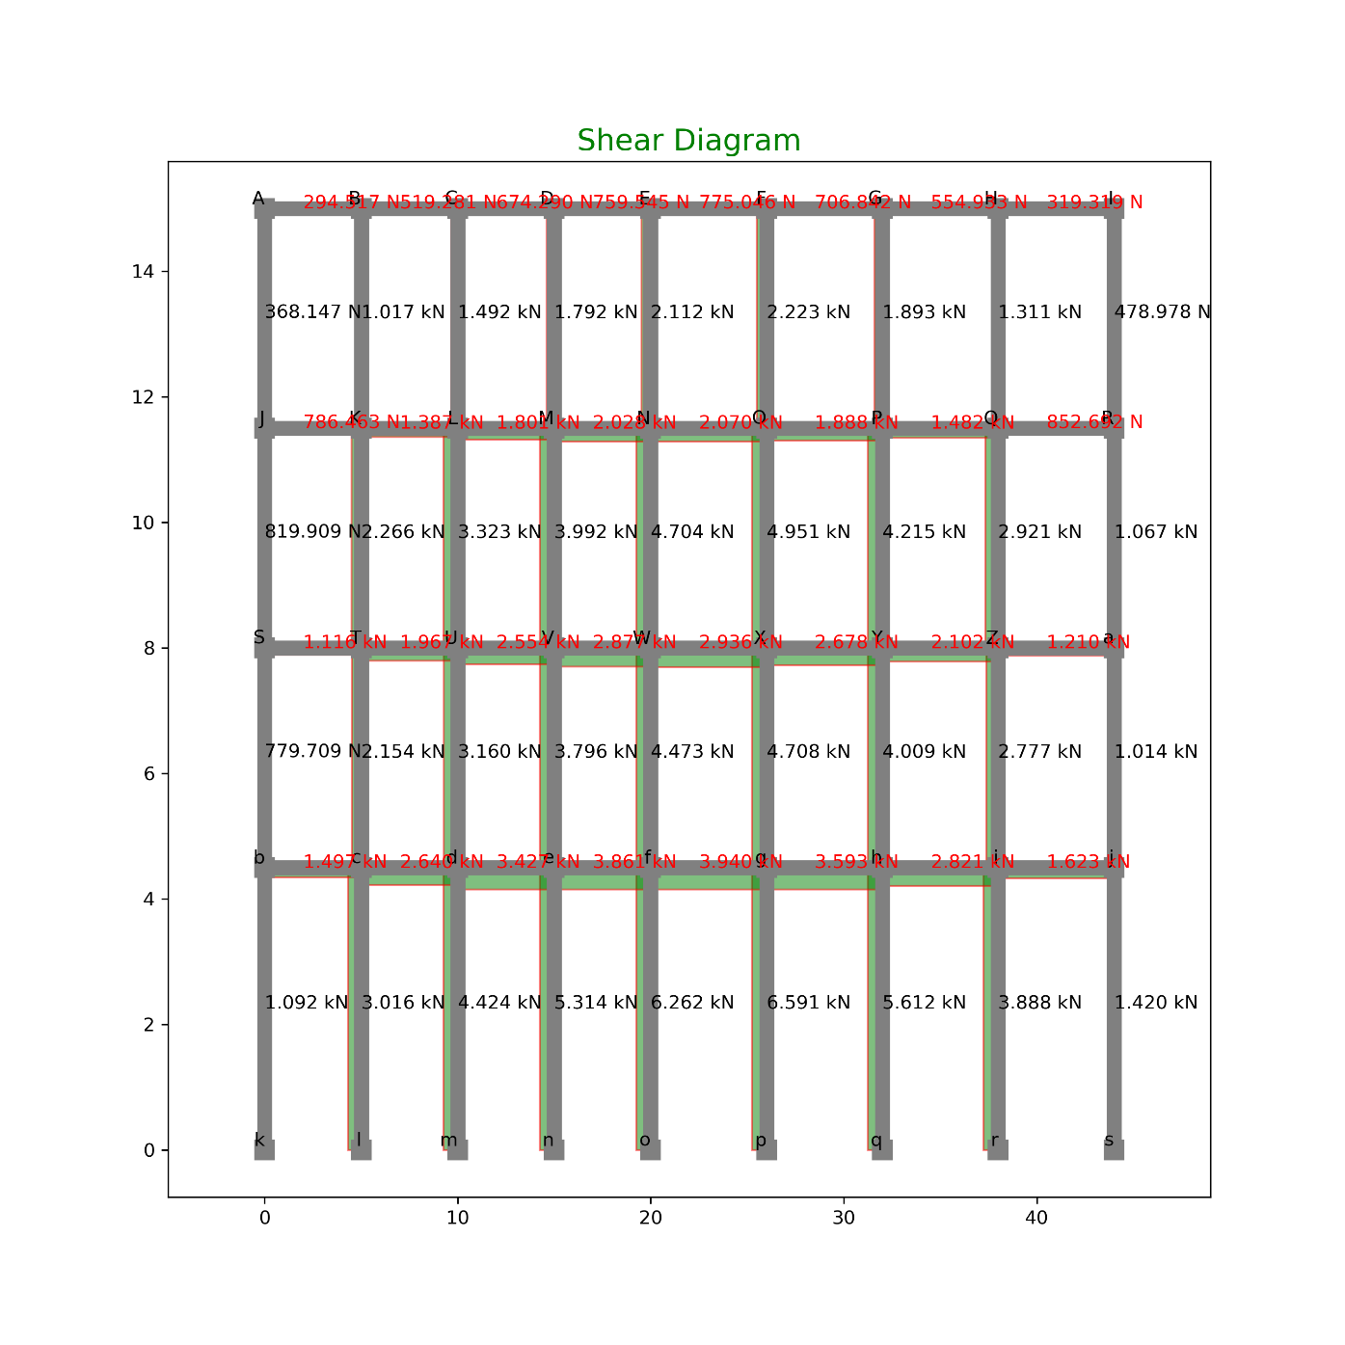

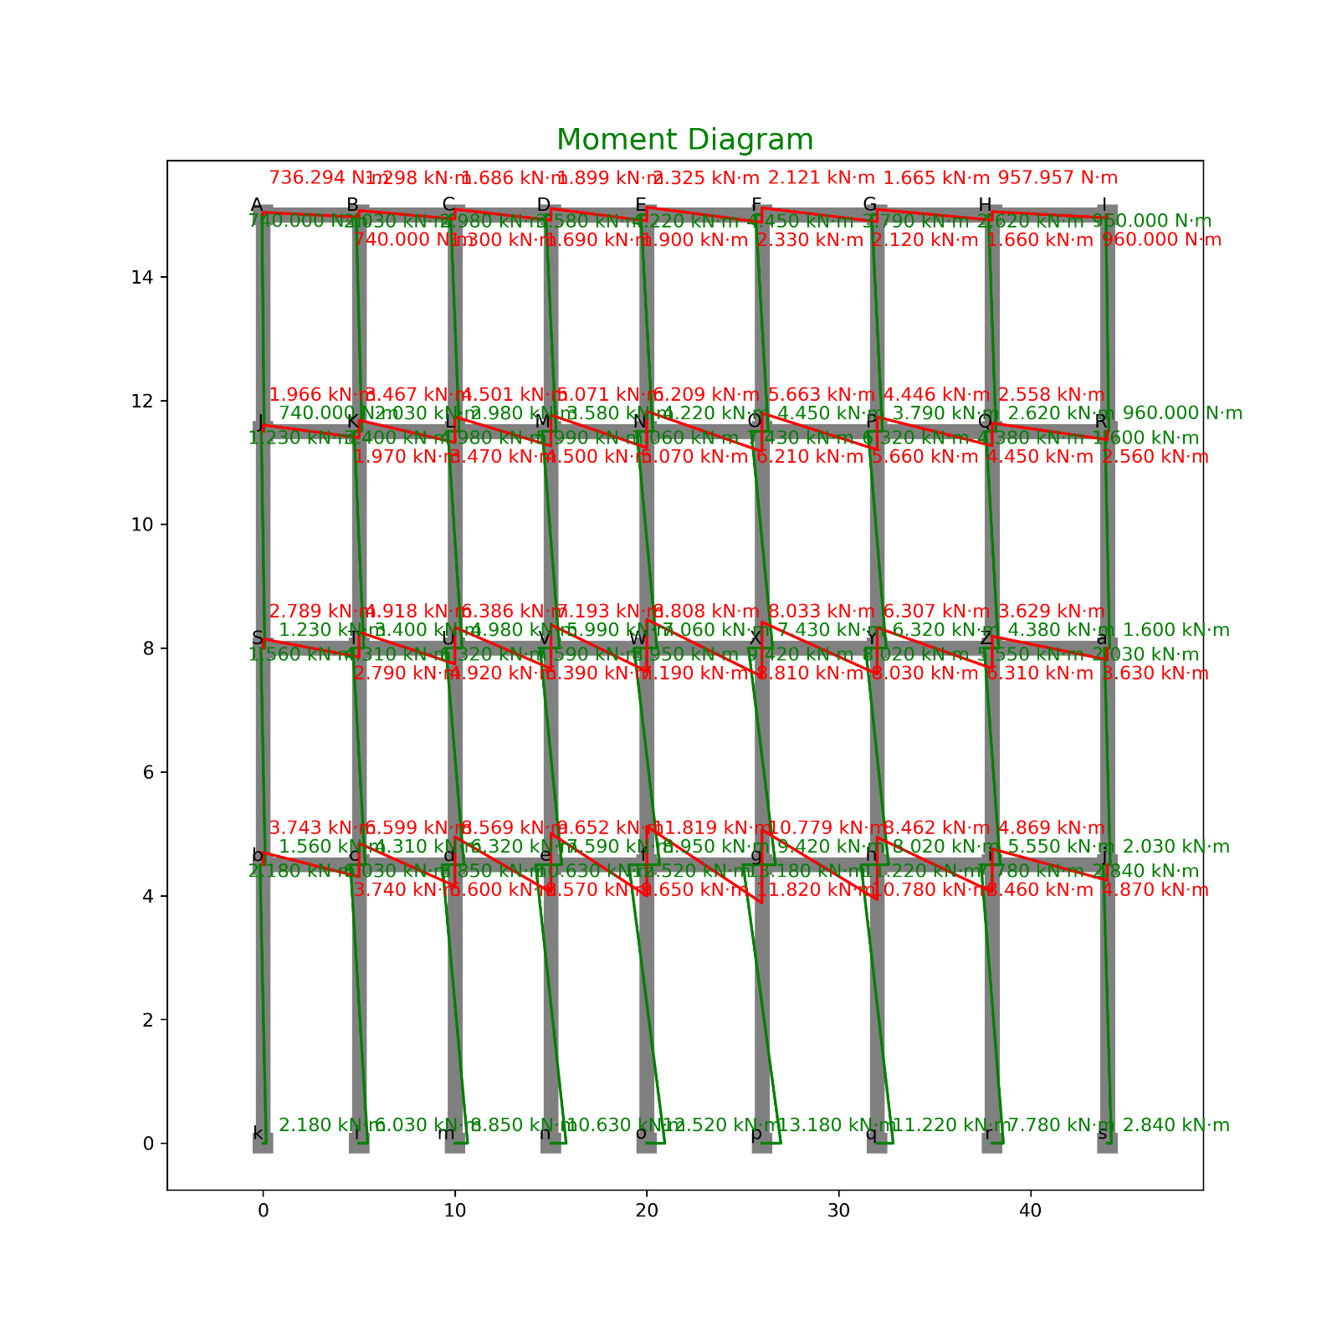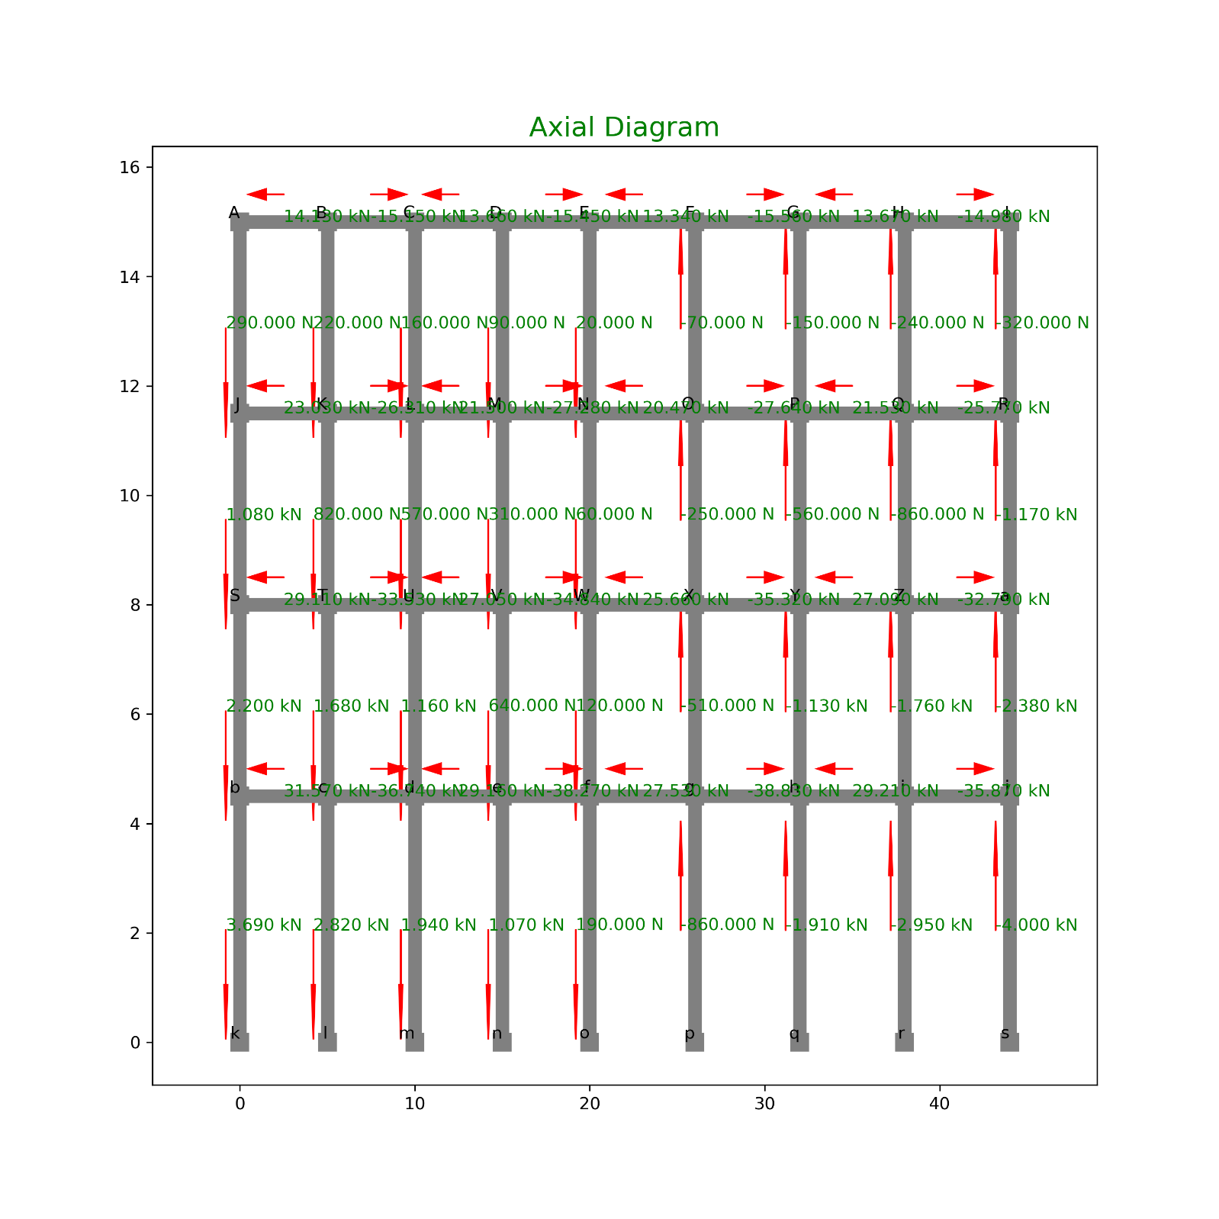

#### TABULATION OF FORCES:

SHEAR

|  |  |  |  |  |  |
| --- | --- | --- | --- | --- | --- |
| **INDEX** | **X** | **Y** | **Loc** | **Shear** | **Type** |
| 0 | 0 | 15 | Right | 0.294517 | Beam |
| 1 | 5 | 15 | Left | 0.294517 | Beam |
| 2 | 5 | 15 | Right | 0.519281 | Beam |
| 3 | 10 | 15 | Left | 0.519281 | Beam |
| 4 | 10 | 15 | Right | 0.67429 | Beam |
| 5 | 15 | 15 | Left | 0.67429 | Beam |
| 6 | 15 | 15 | Right | 0.759545 | Beam |
| 7 | 20 | 15 | Left | 0.759545 | Beam |
| 8 | 20 | 15 | Right | 0.775046 | Beam |
| 9 | 26 | 15 | Left | 0.775046 | Beam |
| 10 | 26 | 15 | Right | 0.706842 | Beam |
| 11 | 32 | 15 | Left | 0.706842 | Beam |
| 12 | 32 | 15 | Right | 0.554933 | Beam |
| 13 | 38 | 15 | Left | 0.554933 | Beam |
| 14 | 38 | 15 | Right | 0.319319 | Beam |
| 15 | 44 | 15 | Left | 0.319319 | Beam |
| 16 | 0 | 11.5 | Right | 0.786463 | Beam |
| 17 | 5 | 11.5 | Left | 0.786463 | Beam |
| 18 | 5 | 11.5 | Right | 1.386659 | Beam |
| 19 | 10 | 11.5 | Left | 1.386659 | Beam |
| 20 | 10 | 11.5 | Right | 1.800586 | Beam |
| 21 | 15 | 11.5 | Left | 1.800586 | Beam |
| 22 | 15 | 11.5 | Right | 2.028247 | Beam |
| 23 | 20 | 11.5 | Left | 2.028247 | Beam |
| 24 | 20 | 11.5 | Right | 2.06964 | Beam |
| 25 | 26 | 11.5 | Left | 2.06964 | Beam |
| 26 | 26 | 11.5 | Right | 1.887511 | Beam |
| 27 | 32 | 11.5 | Left | 1.887511 | Beam |
| 28 | 32 | 11.5 | Right | 1.481862 | Beam |
| 29 | 38 | 11.5 | Left | 1.481862 | Beam |
| 30 | 38 | 11.5 | Right | 0.852692 | Beam |
| 31 | 44 | 11.5 | Left | 0.852692 | Beam |
| 32 | 0 | 8 | Right | 1.115713 | Beam |
| 33 | 5 | 8 | Left | 1.115713 | Beam |
| 34 | 5 | 8 | Right | 1.967179 | Beam |
| 35 | 10 | 8 | Left | 1.967179 | Beam |
| 36 | 10 | 8 | Right | 2.554396 | Beam |
| 37 | 15 | 8 | Left | 2.554396 | Beam |
| 38 | 15 | 8 | Right | 2.877366 | Beam |
| 39 | 20 | 8 | Left | 2.877366 | Beam |
| 40 | 20 | 8 | Right | 2.936087 | Beam |
| 41 | 26 | 8 | Left | 2.936087 | Beam |
| 42 | 26 | 8 | Right | 2.677712 | Beam |
| 43 | 32 | 8 | Left | 2.677712 | Beam |
| 44 | 32 | 8 | Right | 2.102239 | Beam |
| 45 | 38 | 8 | Left | 2.102239 | Beam |
| 46 | 38 | 8 | Right | 1.209668 | Beam |
| 47 | 44 | 8 | Left | 1.209668 | Beam |
| 48 | 0 | 4.5 | Right | 1.497048 | Beam |
| 49 | 5 | 4.5 | Left | 1.497048 | Beam |
| 50 | 5 | 4.5 | Right | 2.639532 | Beam |
| 51 | 10 | 4.5 | Left | 2.639532 | Beam |
| 52 | 10 | 4.5 | Right | 3.427452 | Beam |
| 53 | 15 | 4.5 | Left | 3.427452 | Beam |
| 54 | 15 | 4.5 | Right | 3.860808 | Beam |
| 55 | 20 | 4.5 | Left | 3.860808 | Beam |
| 56 | 20 | 4.5 | Right | 3.9396 | Beam |
| 57 | 26 | 4.5 | Left | 3.9396 | Beam |
| 58 | 26 | 4.5 | Right | 3.592915 | Beam |
| 59 | 32 | 4.5 | Left | 3.592915 | Beam |
| 60 | 32 | 4.5 | Right | 2.820754 | Beam |
| 61 | 38 | 4.5 | Left | 2.820754 | Beam |
| 62 | 38 | 4.5 | Right | 1.623115 | Beam |
| 63 | 44 | 4.5 | Left | 1.623115 | Beam |
| 64 | 0 | 11.5 | Top | 0.368147 | Col |
| 65 | 0 | 15 | Bot | 0.368147 | Col |
| 66 | 5 | 11.5 | Top | 1.017248 | Col |
| 67 | 5 | 15 | Bot | 1.017248 | Col |
| 68 | 10 | 11.5 | Top | 1.491963 | Col |
| 69 | 10 | 15 | Bot | 1.491963 | Col |
| 70 | 15 | 11.5 | Top | 1.792293 | Col |
| 71 | 15 | 15 | Bot | 1.792293 | Col |
| 72 | 20 | 11.5 | Top | 2.112 | Col |
| 73 | 20 | 15 | Bot | 2.112 | Col |
| 74 | 26 | 11.5 | Top | 2.222831 | Col |
| 75 | 26 | 15 | Bot | 2.222831 | Col |
| 76 | 32 | 11.5 | Top | 1.892662 | Col |
| 77 | 32 | 15 | Bot | 1.892662 | Col |
| 78 | 38 | 11.5 | Top | 1.311378 | Col |
| 79 | 38 | 15 | Bot | 1.311378 | Col |
| 80 | 44 | 11.5 | Top | 0.478978 | Col |
| 81 | 44 | 15 | Bot | 0.478978 | Col |
| 82 | 0 | 8 | Top | 0.819909 | Col |
| 83 | 0 | 11.5 | Bot | 0.819909 | Col |
| 84 | 5 | 8 | Top | 2.265539 | Col |
| 85 | 5 | 11.5 | Bot | 2.265539 | Col |
| 86 | 10 | 8 | Top | 3.322791 | Col |
| 87 | 10 | 11.5 | Bot | 3.322791 | Col |
| 88 | 15 | 8 | Top | 3.991664 | Col |
| 89 | 15 | 11.5 | Bot | 3.991664 | Col |
| 90 | 20 | 8 | Top | 4.703691 | Col |
| 91 | 20 | 11.5 | Bot | 4.703691 | Col |
| 92 | 26 | 8 | Top | 4.950527 | Col |
| 93 | 26 | 11.5 | Bot | 4.950527 | Col |
| 94 | 32 | 8 | Top | 4.215197 | Col |
| 95 | 32 | 11.5 | Bot | 4.215197 | Col |
| 96 | 38 | 8 | Top | 2.920604 | Col |
| 97 | 38 | 11.5 | Bot | 2.920604 | Col |
| 98 | 44 | 8 | Top | 1.066745 | Col |
| 99 | 44 | 11.5 | Bot | 1.066745 | Col |
| 100 | 0 | 4.5 | Top | 0.779709 | Col |
| 101 | 0 | 8 | Bot | 0.779709 | Col |
| 102 | 5 | 4.5 | Top | 2.15446 | Col |
| 103 | 5 | 8 | Bot | 2.15446 | Col |
| 104 | 10 | 4.5 | Top | 3.159875 | Col |
| 105 | 10 | 8 | Bot | 3.159875 | Col |
| 106 | 15 | 4.5 | Top | 3.795954 | Col |
| 107 | 15 | 8 | Bot | 3.795954 | Col |
| 108 | 20 | 4.5 | Top | 4.47307 | Col |
| 109 | 20 | 8 | Bot | 4.47307 | Col |
| 110 | 26 | 4.5 | Top | 4.707804 | Col |
| 111 | 26 | 8 | Bot | 4.707804 | Col |
| 112 | 32 | 4.5 | Top | 4.008527 | Col |
| 113 | 32 | 8 | Bot | 4.008527 | Col |
| 114 | 38 | 4.5 | Top | 2.777407 | Col |
| 115 | 38 | 8 | Bot | 2.777407 | Col |
| 116 | 44 | 4.5 | Top | 1.014443 | Col |
| 117 | 44 | 8 | Bot | 1.014443 | Col |
| 118 | 0 | 0 | Top | 1.0916 | Col |
| 119 | 0 | 4.5 | Bot | 1.0916 | Col |
| 120 | 5 | 0 | Top | 3.016265 | Col |
| 121 | 5 | 4.5 | Bot | 3.016265 | Col |
| 122 | 10 | 0 | Top | 4.423855 | Col |
| 123 | 10 | 4.5 | Bot | 4.423855 | Col |
| 124 | 15 | 0 | Top | 5.314371 | Col |
| 125 | 15 | 4.5 | Bot | 5.314371 | Col |
| 126 | 20 | 0 | Top | 6.26234 | Col |
| 127 | 20 | 4.5 | Bot | 6.26234 | Col |
| 128 | 26 | 0 | Top | 6.590969 | Col |
| 129 | 26 | 4.5 | Bot | 6.590969 | Col |
| 130 | 32 | 0 | Top | 5.611976 | Col |
| 131 | 32 | 4.5 | Bot | 5.611976 | Col |
| 132 | 38 | 0 | Top | 3.888396 | Col |
| 133 | 38 | 4.5 | Bot | 3.888396 | Col |
| 134 | 44 | 0 | Top | 1.42023 | Col |
| 135 | 44 | 4.5 | Bot | 1.42023 | Col |

MOMENT

|  |  |  |  |  |  |
| --- | --- | --- | --- | --- | --- |
| **INDEX** | **X** | **Y** | **Loc** | **Shear** | **Type** |
| 0 | 0 | 15 | Right | 0.294517 | Beam |
| 1 | 5 | 15 | Left | 0.294517 | Beam |
| 2 | 5 | 15 | Right | 0.519281 | Beam |
| 3 | 10 | 15 | Left | 0.519281 | Beam |
| 4 | 10 | 15 | Right | 0.67429 | Beam |
| 5 | 15 | 15 | Left | 0.67429 | Beam |
| 6 | 15 | 15 | Right | 0.759545 | Beam |
| 7 | 20 | 15 | Left | 0.759545 | Beam |
| 8 | 20 | 15 | Right | 0.775046 | Beam |
| 9 | 26 | 15 | Left | 0.775046 | Beam |
| 10 | 26 | 15 | Right | 0.706842 | Beam |
| 11 | 32 | 15 | Left | 0.706842 | Beam |
| 12 | 32 | 15 | Right | 0.554933 | Beam |
| 13 | 38 | 15 | Left | 0.554933 | Beam |
| 14 | 38 | 15 | Right | 0.319319 | Beam |
| 15 | 44 | 15 | Left | 0.319319 | Beam |
| 16 | 0 | 11.5 | Right | 0.786463 | Beam |
| 17 | 5 | 11.5 | Left | 0.786463 | Beam |
| 18 | 5 | 11.5 | Right | 1.386659 | Beam |
| 19 | 10 | 11.5 | Left | 1.386659 | Beam |
| 20 | 10 | 11.5 | Right | 1.800586 | Beam |
| 21 | 15 | 11.5 | Left | 1.800586 | Beam |
| 22 | 15 | 11.5 | Right | 2.028247 | Beam |
| 23 | 20 | 11.5 | Left | 2.028247 | Beam |
| 24 | 20 | 11.5 | Right | 2.06964 | Beam |
| 25 | 26 | 11.5 | Left | 2.06964 | Beam |
| 26 | 26 | 11.5 | Right | 1.887511 | Beam |
| 27 | 32 | 11.5 | Left | 1.887511 | Beam |
| 28 | 32 | 11.5 | Right | 1.481862 | Beam |
| 29 | 38 | 11.5 | Left | 1.481862 | Beam |
| 30 | 38 | 11.5 | Right | 0.852692 | Beam |
| 31 | 44 | 11.5 | Left | 0.852692 | Beam |
| 32 | 0 | 8 | Right | 1.115713 | Beam |
| 33 | 5 | 8 | Left | 1.115713 | Beam |
| 34 | 5 | 8 | Right | 1.967179 | Beam |
| 35 | 10 | 8 | Left | 1.967179 | Beam |
| 36 | 10 | 8 | Right | 2.554396 | Beam |
| 37 | 15 | 8 | Left | 2.554396 | Beam |
| 38 | 15 | 8 | Right | 2.877366 | Beam |
| 39 | 20 | 8 | Left | 2.877366 | Beam |
| 40 | 20 | 8 | Right | 2.936087 | Beam |
| 41 | 26 | 8 | Left | 2.936087 | Beam |
| 42 | 26 | 8 | Right | 2.677712 | Beam |
| 43 | 32 | 8 | Left | 2.677712 | Beam |
| 44 | 32 | 8 | Right | 2.102239 | Beam |
| 45 | 38 | 8 | Left | 2.102239 | Beam |
| 46 | 38 | 8 | Right | 1.209668 | Beam |
| 47 | 44 | 8 | Left | 1.209668 | Beam |
| 48 | 0 | 4.5 | Right | 1.497048 | Beam |
| 49 | 5 | 4.5 | Left | 1.497048 | Beam |
| 50 | 5 | 4.5 | Right | 2.639532 | Beam |
| 51 | 10 | 4.5 | Left | 2.639532 | Beam |
| 52 | 10 | 4.5 | Right | 3.427452 | Beam |
| 53 | 15 | 4.5 | Left | 3.427452 | Beam |
| 54 | 15 | 4.5 | Right | 3.860808 | Beam |
| 55 | 20 | 4.5 | Left | 3.860808 | Beam |
| 56 | 20 | 4.5 | Right | 3.9396 | Beam |
| 57 | 26 | 4.5 | Left | 3.9396 | Beam |
| 58 | 26 | 4.5 | Right | 3.592915 | Beam |
| 59 | 32 | 4.5 | Left | 3.592915 | Beam |
| 60 | 32 | 4.5 | Right | 2.820754 | Beam |
| 61 | 38 | 4.5 | Left | 2.820754 | Beam |
| 62 | 38 | 4.5 | Right | 1.623115 | Beam |
| 63 | 44 | 4.5 | Left | 1.623115 | Beam |
| 64 | 0 | 11.5 | Top | 0.368147 | Col |
| 65 | 0 | 15 | Bot | 0.368147 | Col |
| 66 | 5 | 11.5 | Top | 1.017248 | Col |
| 67 | 5 | 15 | Bot | 1.017248 | Col |
| 68 | 10 | 11.5 | Top | 1.491963 | Col |
| 69 | 10 | 15 | Bot | 1.491963 | Col |
| 70 | 15 | 11.5 | Top | 1.792293 | Col |
| 71 | 15 | 15 | Bot | 1.792293 | Col |
| 72 | 20 | 11.5 | Top | 2.112 | Col |
| 73 | 20 | 15 | Bot | 2.112 | Col |
| 74 | 26 | 11.5 | Top | 2.222831 | Col |
| 75 | 26 | 15 | Bot | 2.222831 | Col |
| 76 | 32 | 11.5 | Top | 1.892662 | Col |
| 77 | 32 | 15 | Bot | 1.892662 | Col |
| 78 | 38 | 11.5 | Top | 1.311378 | Col |
| 79 | 38 | 15 | Bot | 1.311378 | Col |
| 80 | 44 | 11.5 | Top | 0.478978 | Col |
| 81 | 44 | 15 | Bot | 0.478978 | Col |
| 82 | 0 | 8 | Top | 0.819909 | Col |
| 83 | 0 | 11.5 | Bot | 0.819909 | Col |
| 84 | 5 | 8 | Top | 2.265539 | Col |
| 85 | 5 | 11.5 | Bot | 2.265539 | Col |
| 86 | 10 | 8 | Top | 3.322791 | Col |
| 87 | 10 | 11.5 | Bot | 3.322791 | Col |
| 88 | 15 | 8 | Top | 3.991664 | Col |
| 89 | 15 | 11.5 | Bot | 3.991664 | Col |
| 90 | 20 | 8 | Top | 4.703691 | Col |
| 91 | 20 | 11.5 | Bot | 4.703691 | Col |
| 92 | 26 | 8 | Top | 4.950527 | Col |
| 93 | 26 | 11.5 | Bot | 4.950527 | Col |
| 94 | 32 | 8 | Top | 4.215197 | Col |
| 95 | 32 | 11.5 | Bot | 4.215197 | Col |
| 96 | 38 | 8 | Top | 2.920604 | Col |
| 97 | 38 | 11.5 | Bot | 2.920604 | Col |
| 98 | 44 | 8 | Top | 1.066745 | Col |
| 99 | 44 | 11.5 | Bot | 1.066745 | Col |
| 100 | 0 | 4.5 | Top | 0.779709 | Col |
| 101 | 0 | 8 | Bot | 0.779709 | Col |
| 102 | 5 | 4.5 | Top | 2.15446 | Col |
| 103 | 5 | 8 | Bot | 2.15446 | Col |
| 104 | 10 | 4.5 | Top | 3.159875 | Col |
| 105 | 10 | 8 | Bot | 3.159875 | Col |
| 106 | 15 | 4.5 | Top | 3.795954 | Col |
| 107 | 15 | 8 | Bot | 3.795954 | Col |
| 108 | 20 | 4.5 | Top | 4.47307 | Col |
| 109 | 20 | 8 | Bot | 4.47307 | Col |
| 110 | 26 | 4.5 | Top | 4.707804 | Col |
| 111 | 26 | 8 | Bot | 4.707804 | Col |
| 112 | 32 | 4.5 | Top | 4.008527 | Col |
| 113 | 32 | 8 | Bot | 4.008527 | Col |
| 114 | 38 | 4.5 | Top | 2.777407 | Col |
| 115 | 38 | 8 | Bot | 2.777407 | Col |
| 116 | 44 | 4.5 | Top | 1.014443 | Col |
| 117 | 44 | 8 | Bot | 1.014443 | Col |
| 118 | 0 | 0 | Top | 1.0916 | Col |
| 119 | 0 | 4.5 | Bot | 1.0916 | Col |
| 120 | 5 | 0 | Top | 3.016265 | Col |
| 121 | 5 | 4.5 | Bot | 3.016265 | Col |
| 122 | 10 | 0 | Top | 4.423855 | Col |
| 123 | 10 | 4.5 | Bot | 4.423855 | Col |
| 124 | 15 | 0 | Top | 5.314371 | Col |
| 125 | 15 | 4.5 | Bot | 5.314371 | Col |
| 126 | 20 | 0 | Top | 6.26234 | Col |
| 127 | 20 | 4.5 | Bot | 6.26234 | Col |
| 128 | 26 | 0 | Top | 6.590969 | Col |
| 129 | 26 | 4.5 | Bot | 6.590969 | Col |
| 130 | 32 | 0 | Top | 5.611976 | Col |
| 131 | 32 | 4.5 | Bot | 5.611976 | Col |
| 132 | 38 | 0 | Top | 3.888396 | Col |
| 133 | 38 | 4.5 | Bot | 3.888396 | Col |
| 134 | 44 | 0 | Top | 1.42023 | Col |
| 135 | 44 | 4.5 | Bot | 1.42023 | Col |

AXIAL

|  |  |  |  |  |  |
| --- | --- | --- | --- | --- | --- |
| **INDEX** | **X** | **Y** | **Loc** | **Axial2** | **Type** |
| 0 | 0 | 11.5 | Top | 0.294517 | Col |
| 1 | 0 | 15 | Bot | 0.294517 | Col |
| 2 | 5 | 11.5 | Top | 0.224763 | Col |
| 3 | 5 | 15 | Bot | 0.224763 | Col |
| 4 | 10 | 11.5 | Top | 0.155009 | Col |
| 5 | 10 | 15 | Bot | 0.155009 | Col |
| 6 | 15 | 11.5 | Top | 0.085255 | Col |
| 7 | 15 | 15 | Bot | 0.085255 | Col |
| 8 | 20 | 11.5 | Top | 0.015501 | Col |
| 9 | 20 | 15 | Bot | 0.015501 | Col |
| 10 | 26 | 11.5 | Top | -0.0682 | Col |
| 11 | 26 | 15 | Bot | -0.0682 | Col |
| 12 | 32 | 11.5 | Top | -0.15191 | Col |
| 13 | 32 | 15 | Bot | -0.15191 | Col |
| 14 | 38 | 11.5 | Top | -0.23561 | Col |
| 15 | 38 | 15 | Bot | -0.23561 | Col |
| 16 | 44 | 11.5 | Top | -0.31932 | Col |
| 17 | 44 | 15 | Bot | -0.31932 | Col |
| 18 | 0 | 8 | Top | 1.08098 | Col |
| 19 | 0 | 11.5 | Bot | 1.08098 | Col |
| 20 | 5 | 8 | Top | 0.824959 | Col |
| 21 | 5 | 11.5 | Bot | 0.824959 | Col |
| 22 | 10 | 8 | Top | 0.568937 | Col |
| 23 | 10 | 11.5 | Bot | 0.568937 | Col |
| 24 | 15 | 8 | Top | 0.312915 | Col |
| 25 | 15 | 11.5 | Bot | 0.312915 | Col |
| 26 | 20 | 8 | Top | 0.056894 | Col |
| 27 | 20 | 11.5 | Bot | 0.056894 | Col |
| 28 | 26 | 8 | Top | -0.25033 | Col |
| 29 | 26 | 11.5 | Bot | -0.25033 | Col |
| 30 | 32 | 8 | Top | -0.55756 | Col |
| 31 | 32 | 11.5 | Bot | -0.55756 | Col |
| 32 | 38 | 8 | Top | -0.86478 | Col |
| 33 | 38 | 11.5 | Bot | -0.86478 | Col |
| 34 | 44 | 8 | Top | -1.17201 | Col |
| 35 | 44 | 11.5 | Bot | -1.17201 | Col |
| 36 | 0 | 4.5 | Top | 2.196694 | Col |
| 37 | 0 | 8 | Bot | 2.196694 | Col |
| 38 | 5 | 4.5 | Top | 1.676424 | Col |
| 39 | 5 | 8 | Bot | 1.676424 | Col |
| 40 | 10 | 4.5 | Top | 1.156155 | Col |
| 41 | 10 | 8 | Bot | 1.156155 | Col |
| 42 | 15 | 4.5 | Top | 0.635885 | Col |
| 43 | 15 | 8 | Bot | 0.635885 | Col |
| 44 | 20 | 4.5 | Top | 0.115615 | Col |
| 45 | 20 | 8 | Bot | 0.115615 | Col |
| 46 | 26 | 4.5 | Top | -0.50871 | Col |
| 47 | 26 | 8 | Bot | -0.50871 | Col |
| 48 | 32 | 4.5 | Top | -1.13303 | Col |
| 49 | 32 | 8 | Bot | -1.13303 | Col |
| 50 | 38 | 4.5 | Top | -1.75735 | Col |
| 51 | 38 | 8 | Bot | -1.75735 | Col |
| 52 | 44 | 4.5 | Top | -2.38168 | Col |
| 53 | 44 | 8 | Bot | -2.38168 | Col |
| 54 | 0 | 0 | Top | 3.693742 | Col |
| 55 | 0 | 4.5 | Bot | 3.693742 | Col |
| 56 | 5 | 0 | Top | 2.818908 | Col |
| 57 | 5 | 4.5 | Bot | 2.818908 | Col |
| 58 | 10 | 0 | Top | 1.944075 | Col |
| 59 | 10 | 4.5 | Bot | 1.944075 | Col |
| 60 | 15 | 0 | Top | 1.069241 | Col |
| 61 | 15 | 4.5 | Bot | 1.069241 | Col |
| 62 | 20 | 0 | Top | 0.194407 | Col |
| 63 | 20 | 4.5 | Bot | 0.194407 | Col |
| 64 | 26 | 0 | Top | -0.85539 | Col |
| 65 | 26 | 4.5 | Bot | -0.85539 | Col |
| 66 | 32 | 0 | Top | -1.90519 | Col |
| 67 | 32 | 4.5 | Bot | -1.90519 | Col |
| 68 | 38 | 0 | Top | -2.95499 | Col |
| 69 | 38 | 4.5 | Bot | -2.95499 | Col |
| 70 | 44 | 0 | Top | -4.00479 | Col |
| 71 | 44 | 4.5 | Bot | -4.00479 | Col |
| 72 | 0 | 15 | Right | 14.13185 | Beam |
| 73 | 5 | 15 | Left | 14.13185 | Beam |
| 74 | 5 | 15 | Right | -15.1491 | Beam |
| 75 | 10 | 15 | Left | -15.1491 | Beam |
| 76 | 10 | 15 | Right | 13.65714 | Beam |
| 77 | 15 | 15 | Left | 13.65714 | Beam |
| 78 | 15 | 15 | Right | -15.4494 | Beam |
| 79 | 20 | 15 | Left | -15.4494 | Beam |
| 80 | 20 | 15 | Right | 13.33743 | Beam |
| 81 | 26 | 15 | Left | 13.33743 | Beam |
| 82 | 26 | 15 | Right | -15.5603 | Beam |
| 83 | 32 | 15 | Left | -15.5603 | Beam |
| 84 | 32 | 15 | Right | 13.6676 | Beam |
| 85 | 38 | 15 | Left | 13.6676 | Beam |
| 86 | 38 | 15 | Right | -14.979 | Beam |
| 87 | 44 | 15 | Left | -14.979 | Beam |
| 88 | 0 | 11.5 | Right | 23.03194 | Beam |
| 89 | 5 | 11.5 | Left | 23.03194 | Beam |
| 90 | 5 | 11.5 | Right | -26.3147 | Beam |
| 91 | 10 | 11.5 | Left | -26.3147 | Beam |
| 92 | 10 | 11.5 | Right | 21.49998 | Beam |
| 93 | 15 | 11.5 | Left | 21.49998 | Beam |
| 94 | 15 | 11.5 | Right | -27.2839 | Beam |
| 95 | 20 | 11.5 | Left | -27.2839 | Beam |
| 96 | 20 | 11.5 | Right | 20.46824 | Beam |
| 97 | 26 | 11.5 | Left | 20.46824 | Beam |
| 98 | 26 | 11.5 | Right | -27.6416 | Beam |
| 99 | 32 | 11.5 | Left | -27.6416 | Beam |
| 100 | 32 | 11.5 | Right | 21.53374 | Beam |
| 101 | 38 | 11.5 | Left | 21.53374 | Beam |
| 102 | 38 | 11.5 | Right | -25.7657 | Beam |
| 103 | 44 | 11.5 | Left | -25.7657 | Beam |
| 104 | 0 | 8 | Right | 29.11038 | Beam |
| 105 | 5 | 8 | Left | 29.11038 | Beam |
| 106 | 5 | 8 | Right | -33.5304 | Beam |
| 107 | 10 | 8 | Left | -33.5304 | Beam |
| 108 | 10 | 8 | Right | 27.04771 | Beam |
| 109 | 15 | 8 | Left | 27.04771 | Beam |
| 110 | 15 | 8 | Right | -34.8353 | Beam |
| 111 | 20 | 8 | Left | -34.8353 | Beam |
| 112 | 20 | 8 | Right | 25.65857 | Beam |
| 113 | 26 | 8 | Left | 25.65857 | Beam |
| 114 | 26 | 8 | Right | -35.3169 | Beam |
| 115 | 32 | 8 | Left | -35.3169 | Beam |
| 116 | 32 | 8 | Right | 27.09318 | Beam |
| 117 | 38 | 8 | Left | 27.09318 | Beam |
| 118 | 38 | 8 | Right | -32.7912 | Beam |
| 119 | 44 | 8 | Left | -32.7912 | Beam |
| 120 | 0 | 4.5 | Right | 31.56869 | Beam |
| 121 | 5 | 4.5 | Left | 31.56869 | Beam |
| 122 | 5 | 4.5 | Right | -36.7394 | Beam |
| 123 | 10 | 4.5 | Left | -36.7394 | Beam |
| 124 | 10 | 4.5 | Right | 29.15569 | Beam |
| 125 | 15 | 4.5 | Left | 29.15569 | Beam |
| 126 | 15 | 4.5 | Right | -38.266 | Beam |
| 127 | 20 | 4.5 | Left | -38.266 | Beam |
| 128 | 20 | 4.5 | Right | 27.5306 | Beam |
| 129 | 26 | 4.5 | Left | 27.5306 | Beam |
| 130 | 26 | 4.5 | Right | -38.8294 | Beam |
| 131 | 32 | 4.5 | Left | -38.8294 | Beam |
| 132 | 32 | 4.5 | Right | 29.20887 | Beam |
| 133 | 38 | 4.5 | Left | 29.20887 | Beam |
| 134 | 38 | 4.5 | Right | -35.8747 | Beam |
| 135 | 44 | 4.5 | Left | -35.8747 | Beam |

### FACTOR METHOD OF ANALYSIS

#### CALCULATION:

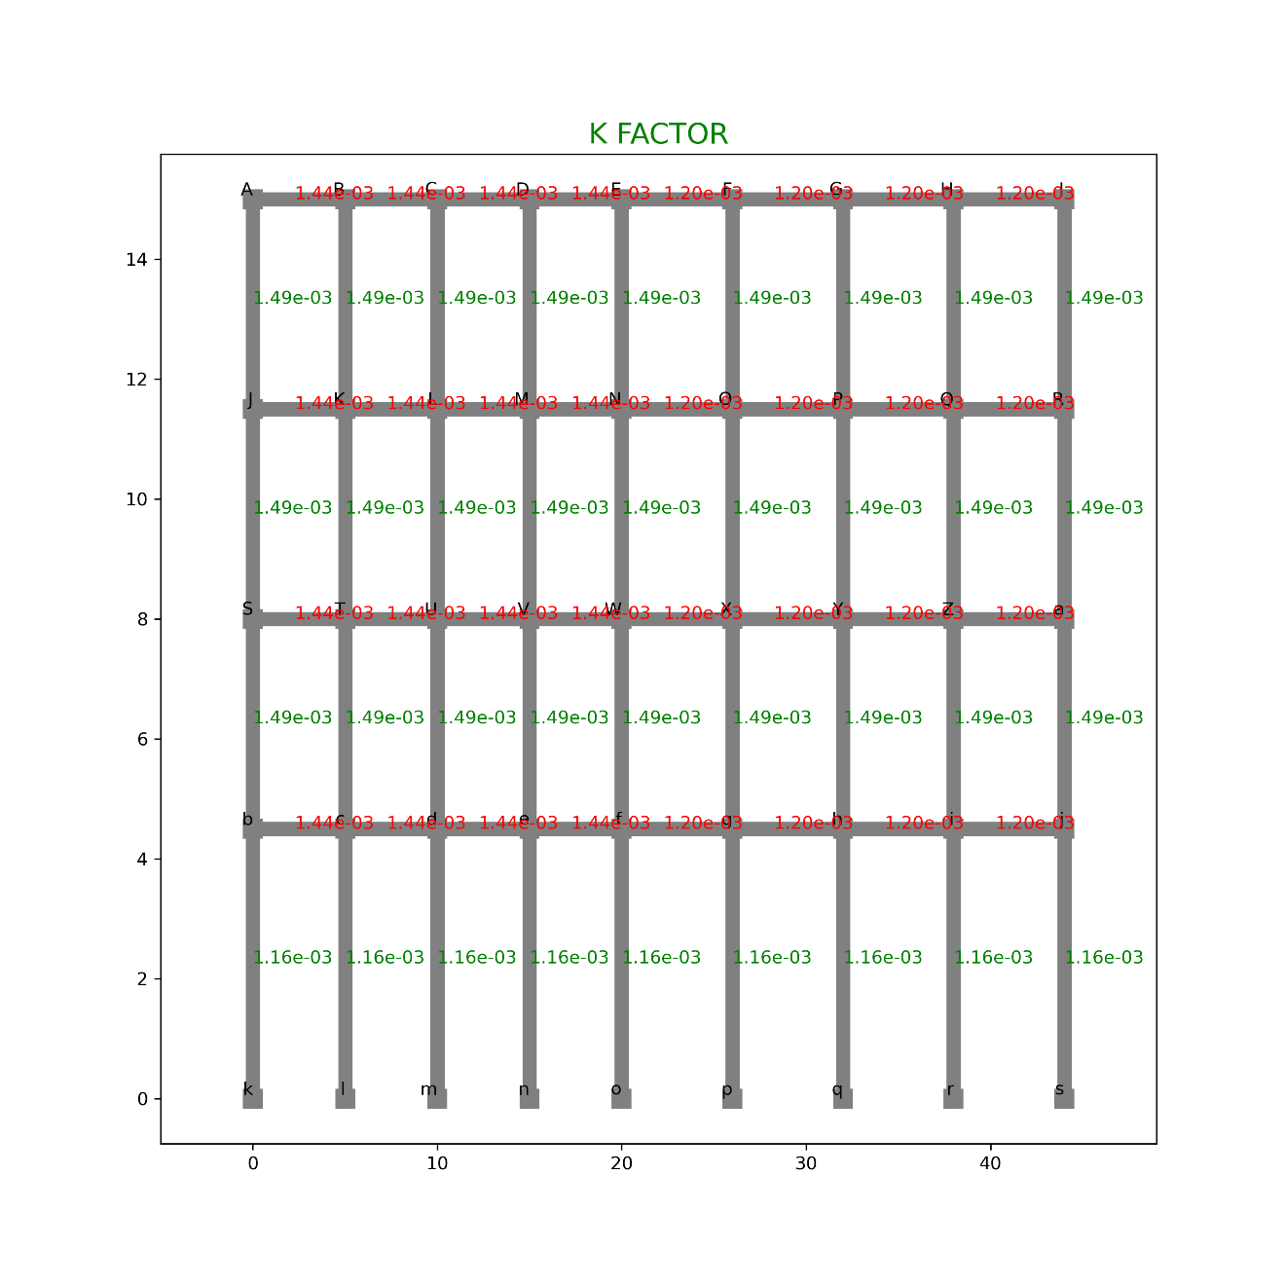

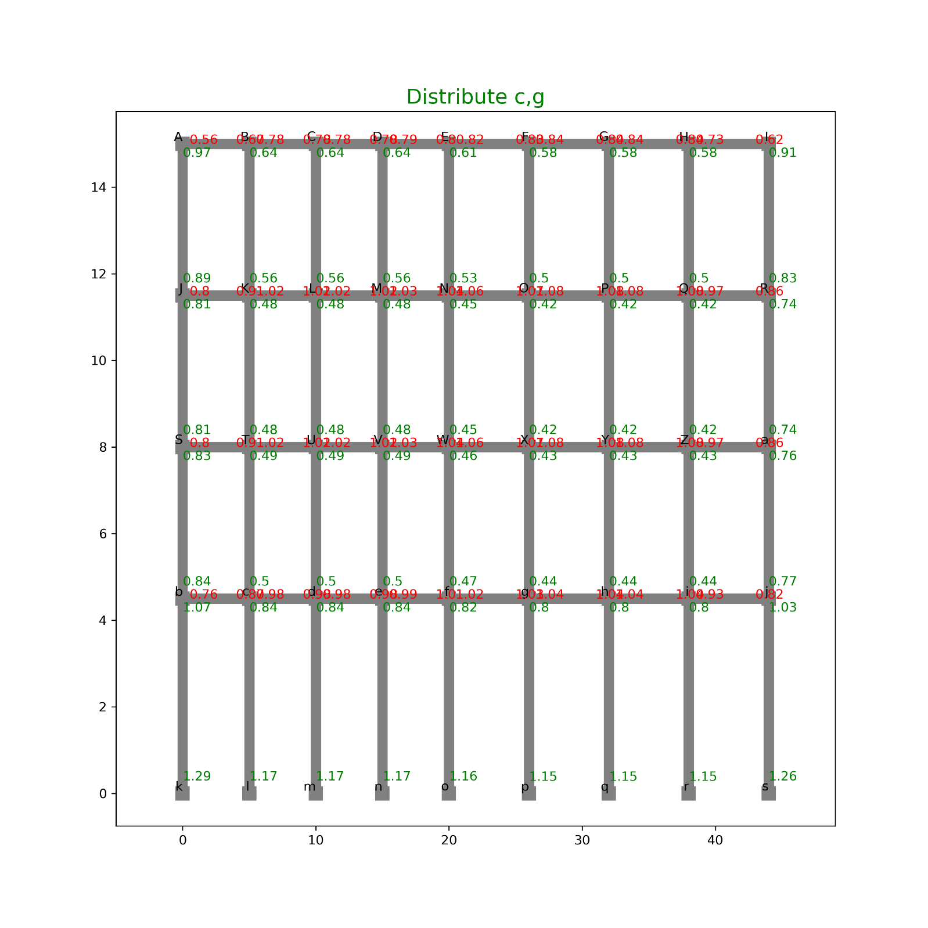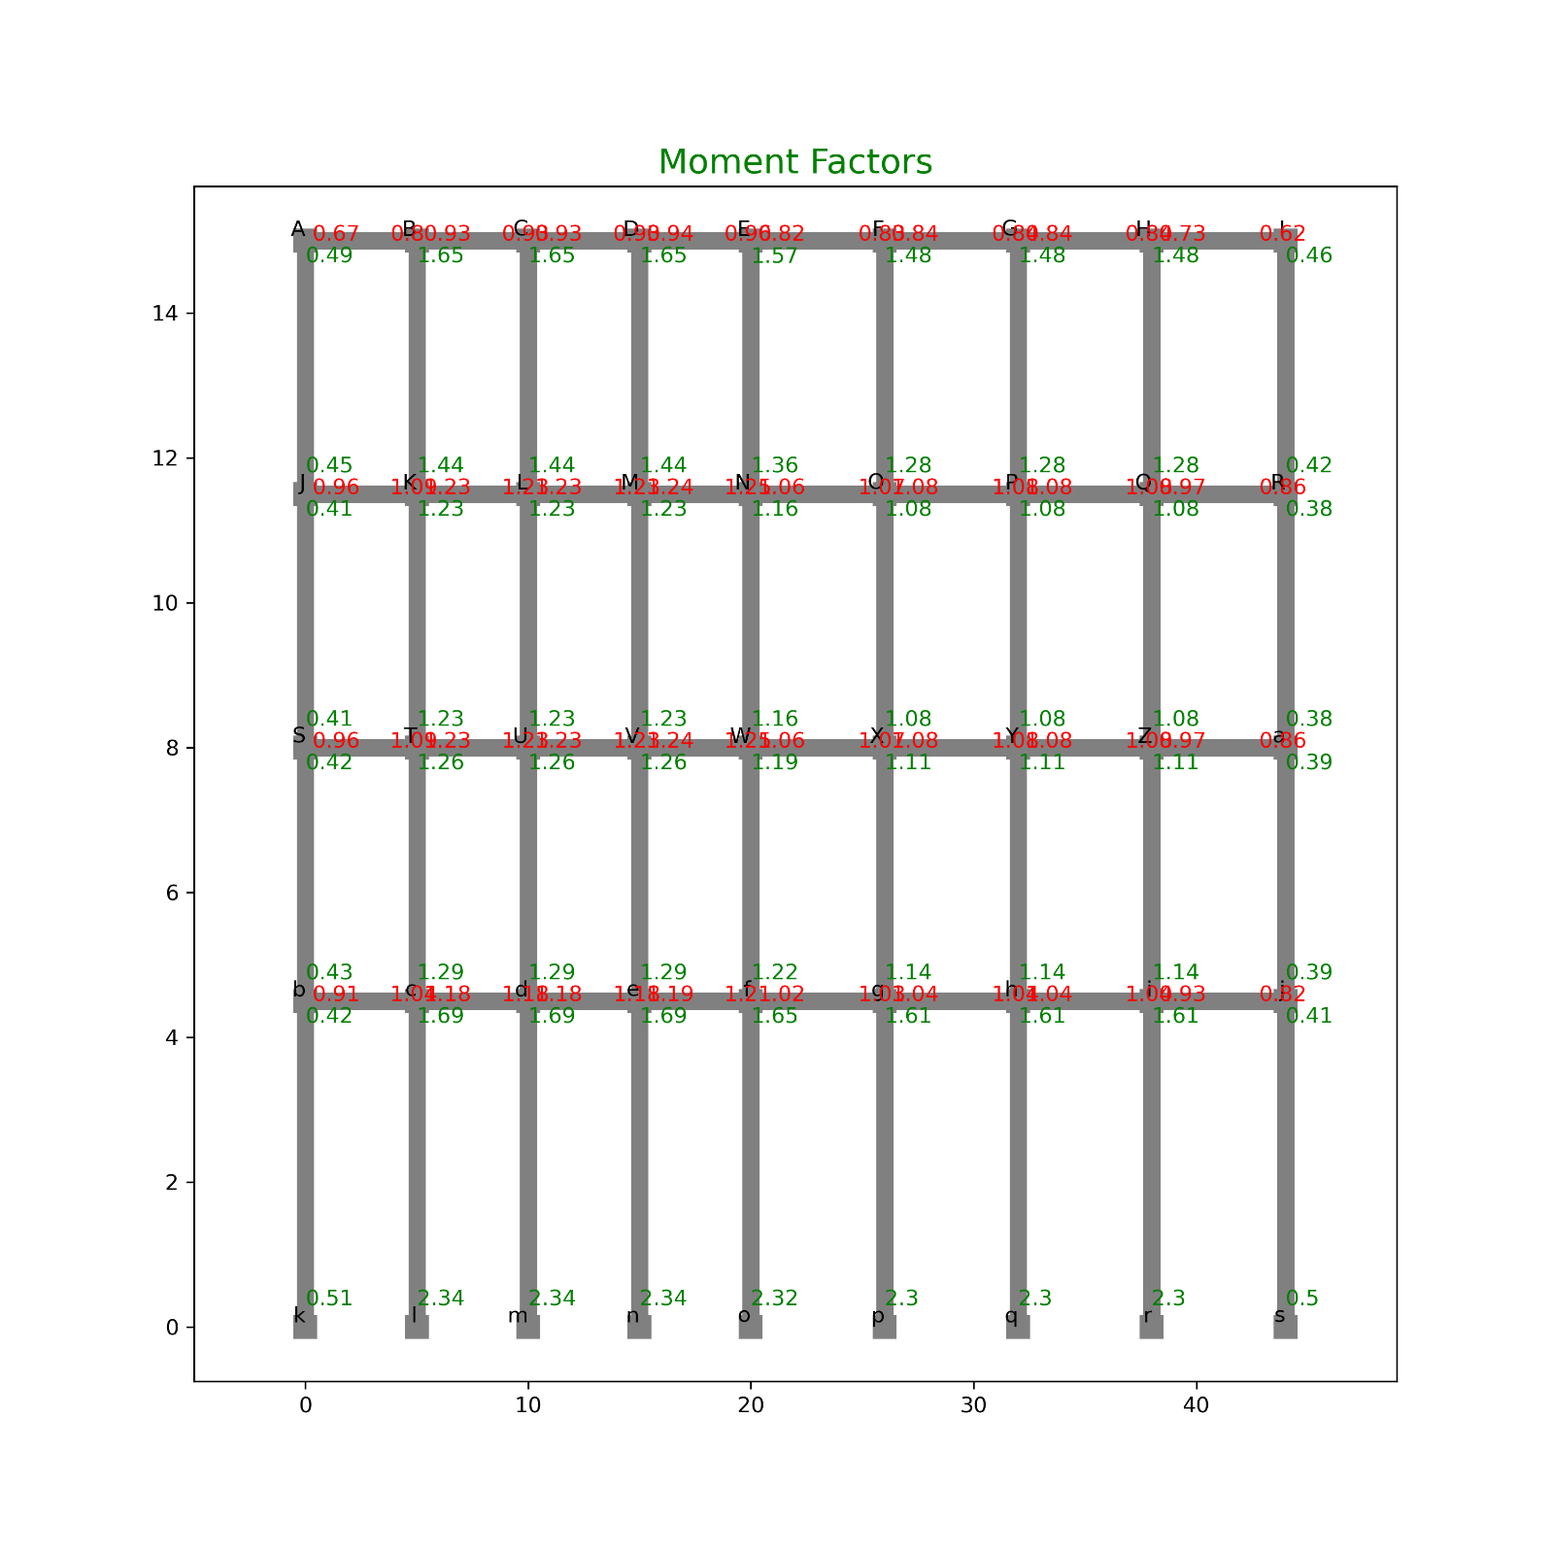

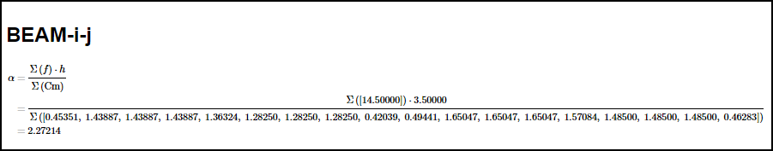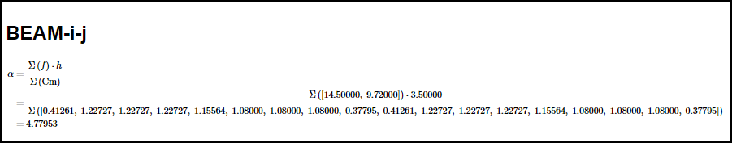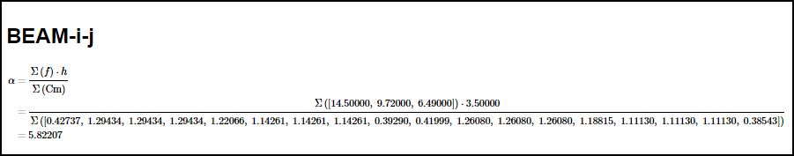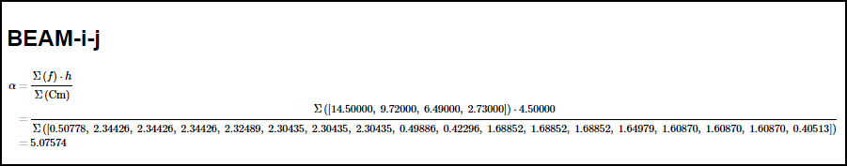

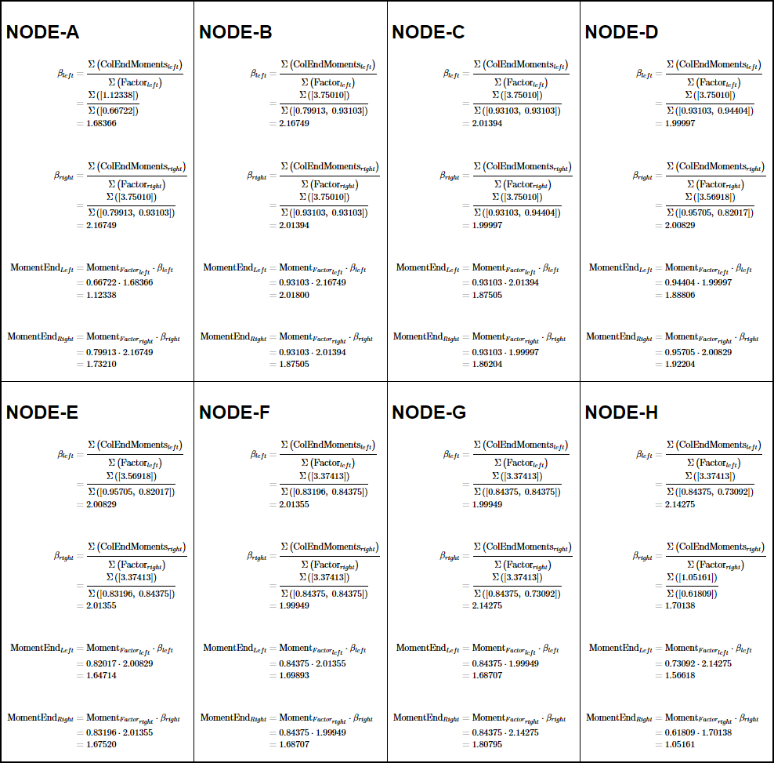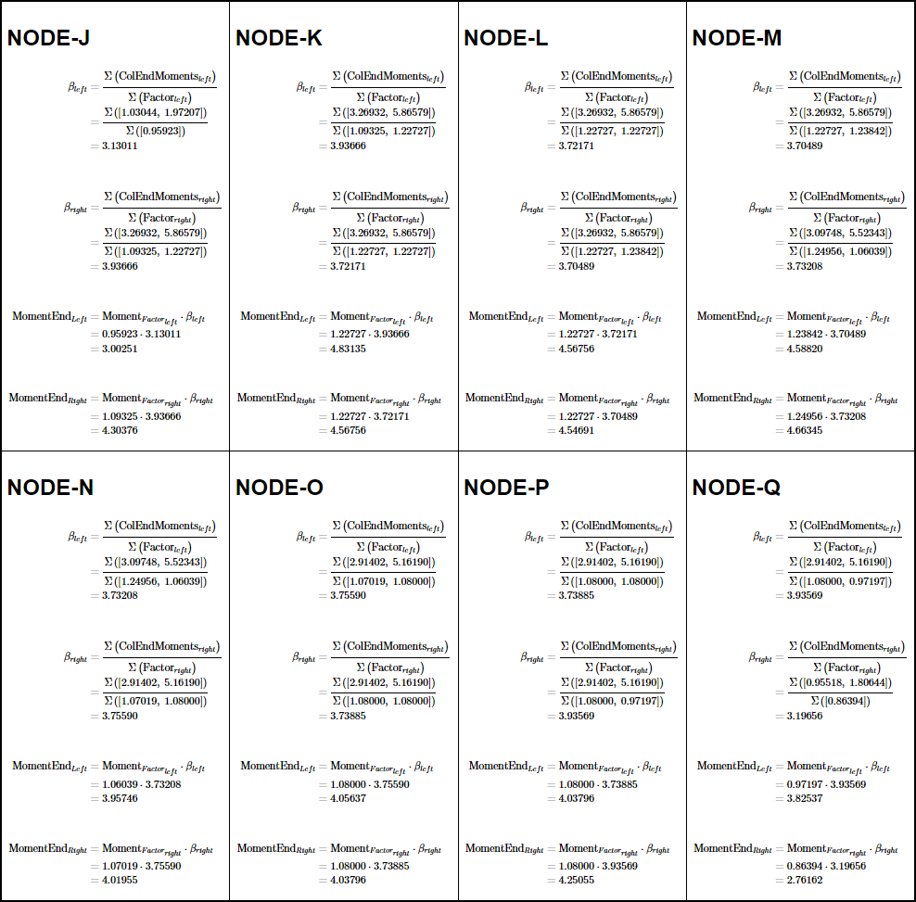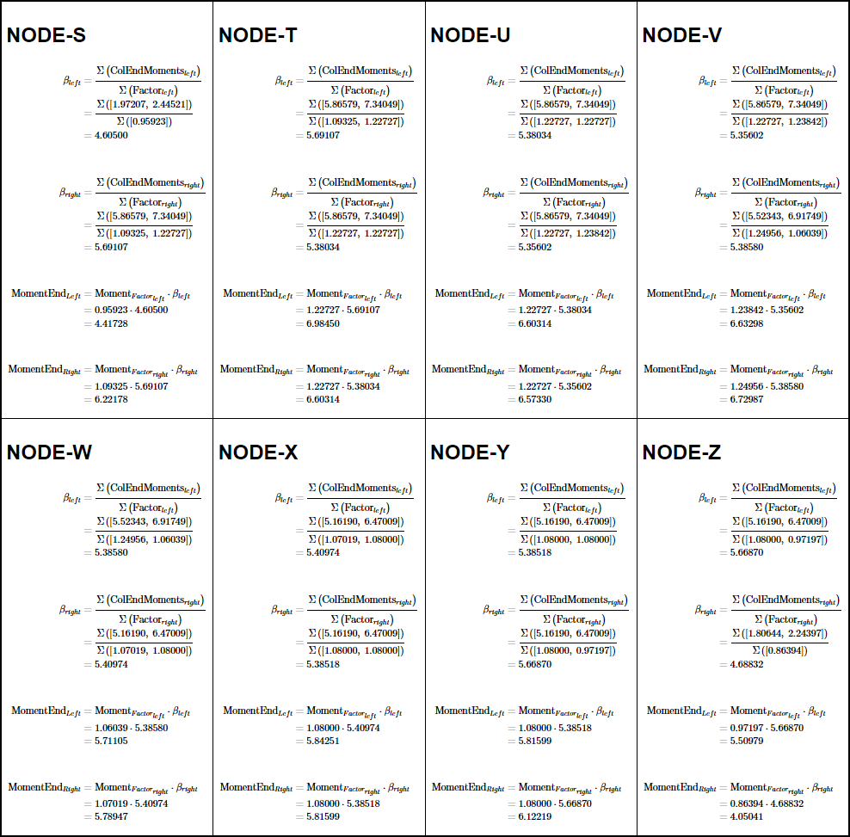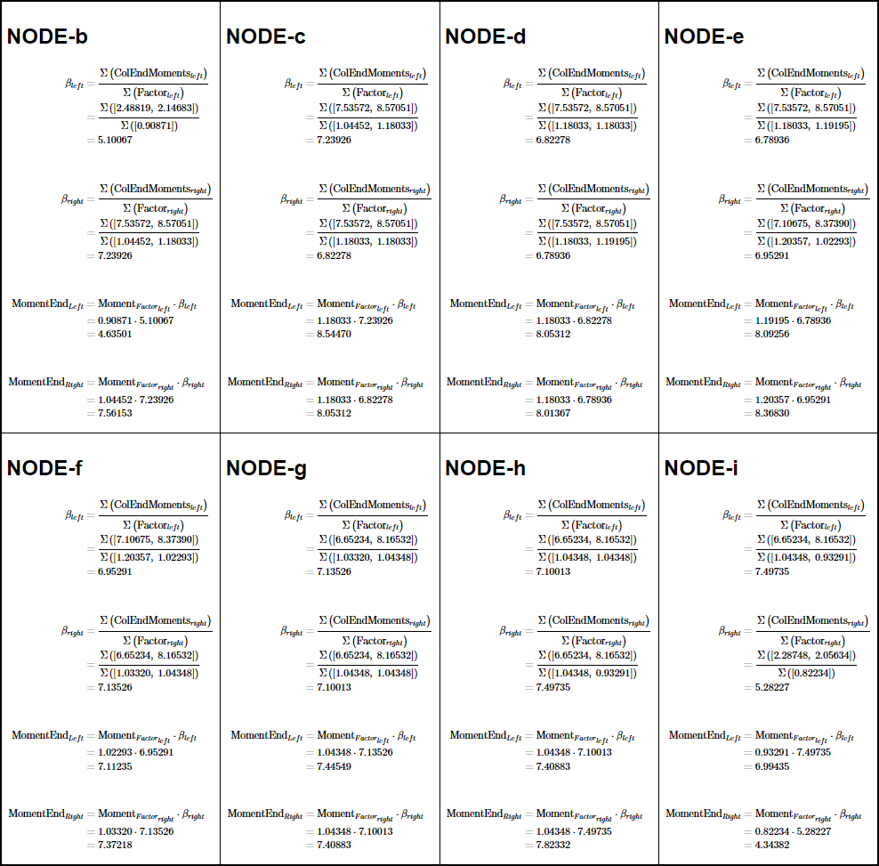

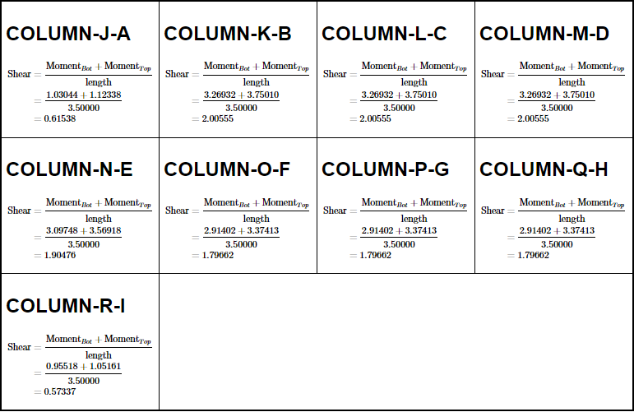

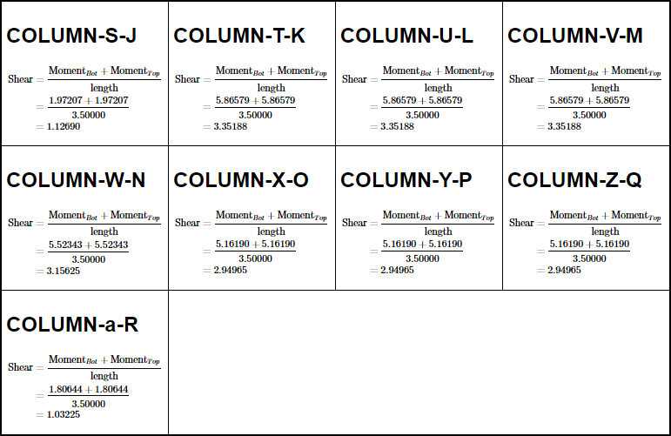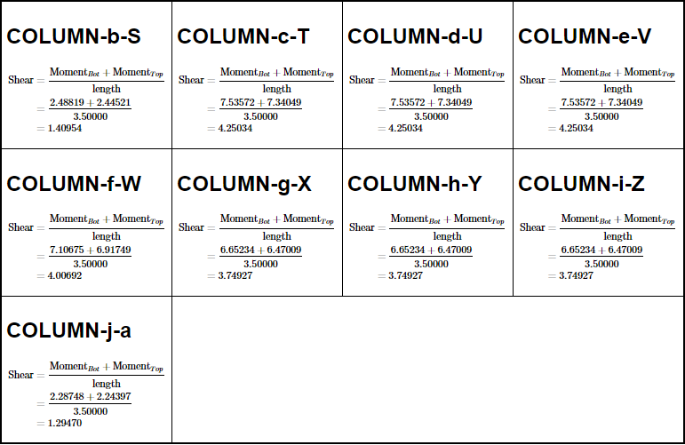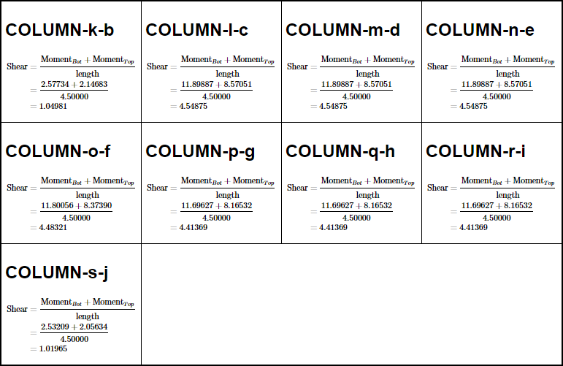

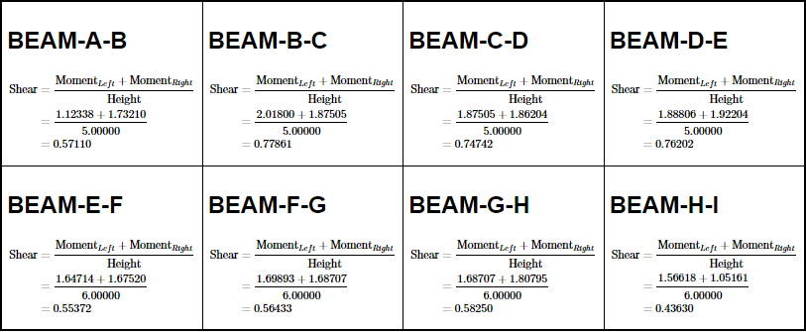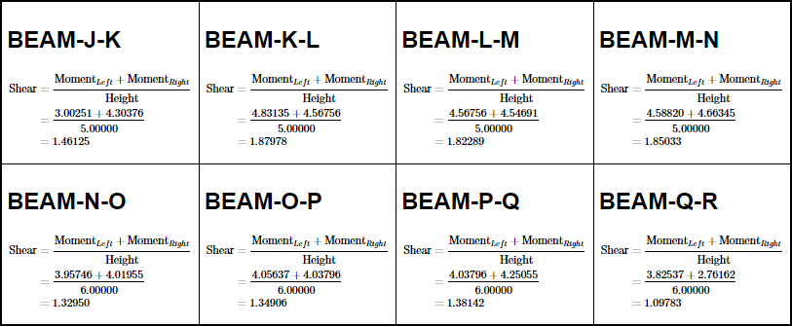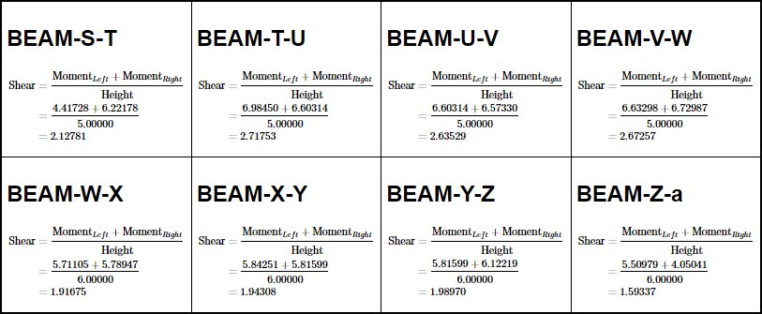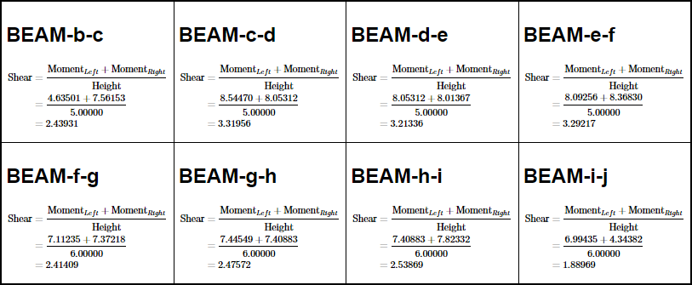

#### DIAGRAMS

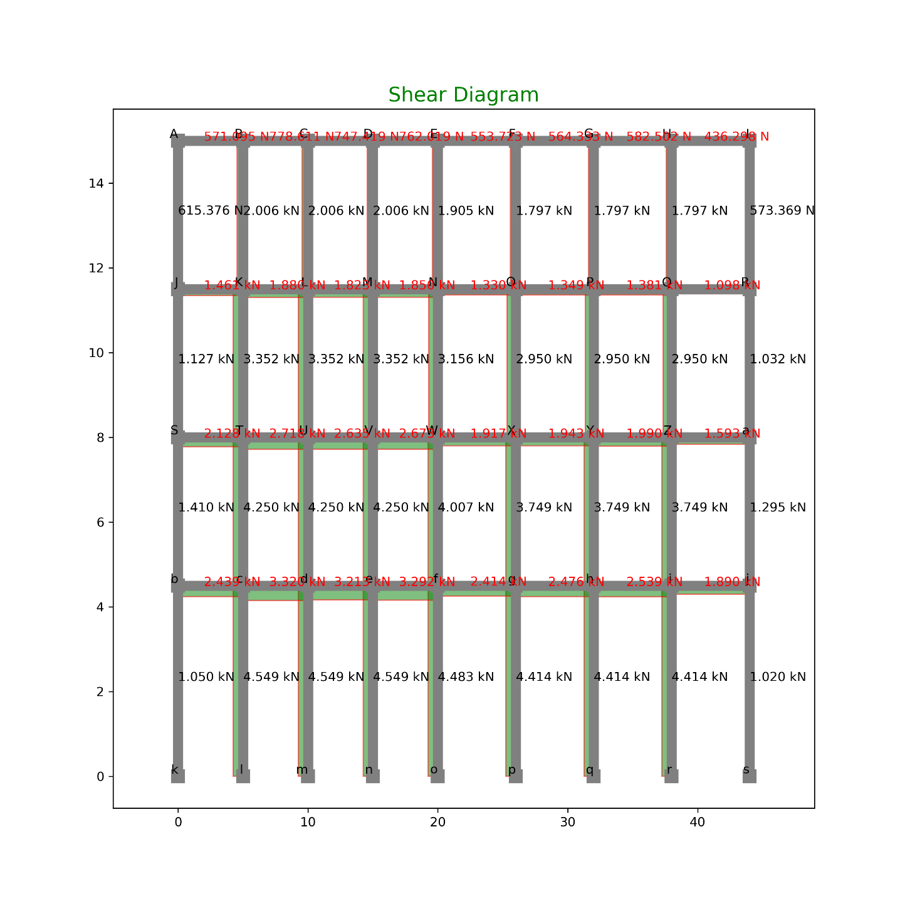

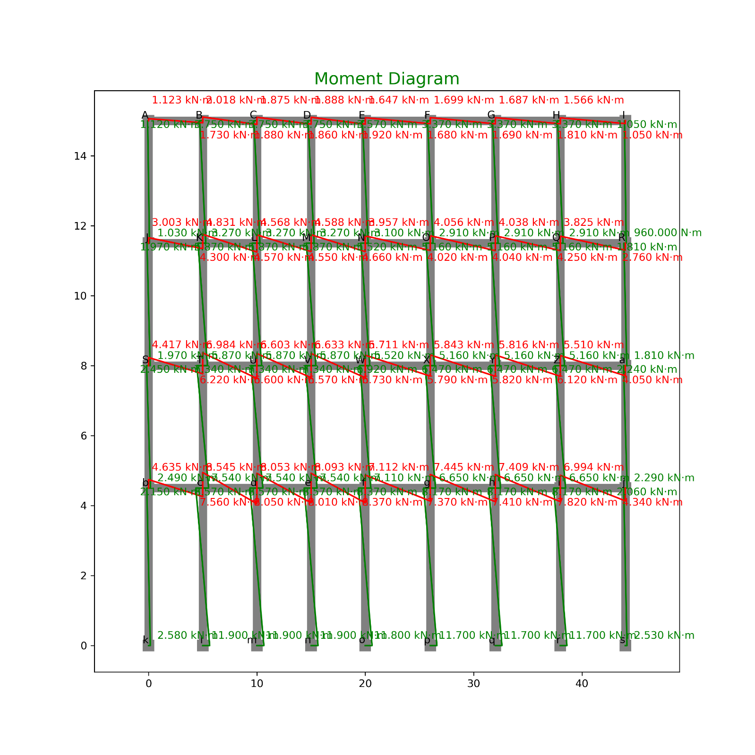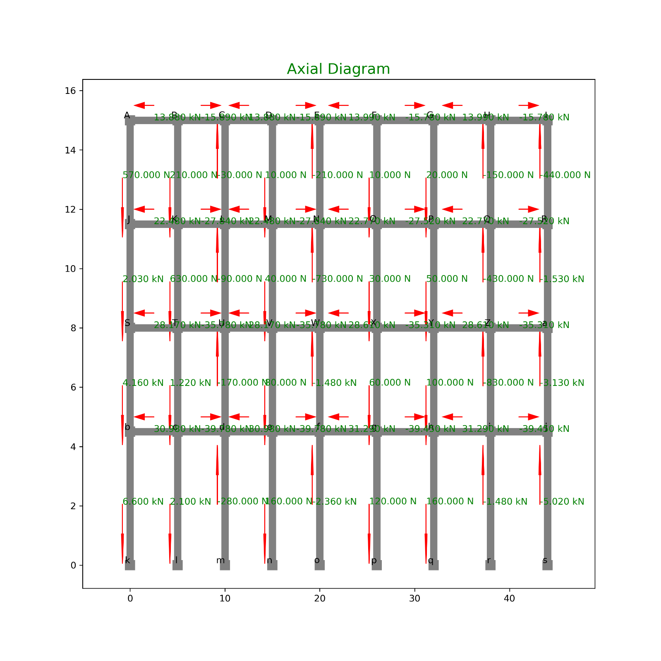

#### TABULATION OF FORCES:

SHEAR

|  |  |  |  |  |  |
| --- | --- | --- | --- | --- | --- |
| **INDEX** | **X** | **Y** | **Loc** | **Shear** | **Type** |
| 0 | 0 | 15 | Right | 0.571095 | Beam |
| 1 | 5 | 15 | Left | 0.571095 | Beam |
| 2 | 5 | 15 | Right | 0.778611 | Beam |
| 3 | 10 | 15 | Left | 0.778611 | Beam |
| 4 | 10 | 15 | Right | 0.747419 | Beam |
| 5 | 15 | 15 | Left | 0.747419 | Beam |
| 6 | 15 | 15 | Right | 0.762019 | Beam |
| 7 | 20 | 15 | Left | 0.762019 | Beam |
| 8 | 20 | 15 | Right | 0.553723 | Beam |
| 9 | 26 | 15 | Left | 0.553723 | Beam |
| 10 | 26 | 15 | Right | 0.564333 | Beam |
| 11 | 32 | 15 | Left | 0.564333 | Beam |
| 12 | 32 | 15 | Right | 0.582502 | Beam |
| 13 | 38 | 15 | Left | 0.582502 | Beam |
| 14 | 38 | 15 | Right | 0.436298 | Beam |
| 15 | 44 | 15 | Left | 0.436298 | Beam |
| 16 | 0 | 11.5 | Right | 1.461255 | Beam |
| 17 | 5 | 11.5 | Left | 1.461255 | Beam |
| 18 | 5 | 11.5 | Right | 1.879781 | Beam |
| 19 | 10 | 11.5 | Left | 1.879781 | Beam |
| 20 | 10 | 11.5 | Right | 1.822894 | Beam |
| 21 | 15 | 11.5 | Left | 1.822894 | Beam |
| 22 | 15 | 11.5 | Right | 1.85033 | Beam |
| 23 | 20 | 11.5 | Left | 1.85033 | Beam |
| 24 | 20 | 11.5 | Right | 1.329501 | Beam |
| 25 | 26 | 11.5 | Left | 1.329501 | Beam |
| 26 | 26 | 11.5 | Right | 1.349055 | Beam |
| 27 | 32 | 11.5 | Left | 1.349055 | Beam |
| 28 | 32 | 11.5 | Right | 1.381418 | Beam |
| 29 | 38 | 11.5 | Left | 1.381418 | Beam |
| 30 | 38 | 11.5 | Right | 1.097832 | Beam |
| 31 | 44 | 11.5 | Left | 1.097832 | Beam |
| 32 | 0 | 8 | Right | 2.127812 | Beam |
| 33 | 5 | 8 | Left | 2.127812 | Beam |
| 34 | 5 | 8 | Right | 2.717528 | Beam |
| 35 | 10 | 8 | Left | 2.717528 | Beam |
| 36 | 10 | 8 | Right | 2.635288 | Beam |
| 37 | 15 | 8 | Left | 2.635288 | Beam |
| 38 | 15 | 8 | Right | 2.67257 | Beam |
| 39 | 20 | 8 | Left | 2.67257 | Beam |
| 40 | 20 | 8 | Right | 1.916753 | Beam |
| 41 | 26 | 8 | Left | 1.916753 | Beam |
| 42 | 26 | 8 | Right | 1.943085 | Beam |
| 43 | 32 | 8 | Left | 1.943085 | Beam |
| 44 | 32 | 8 | Right | 1.989697 | Beam |
| 45 | 38 | 8 | Left | 1.989697 | Beam |
| 46 | 38 | 8 | Right | 1.593367 | Beam |
| 47 | 44 | 8 | Left | 1.593367 | Beam |
| 48 | 0 | 4.5 | Right | 2.439309 | Beam |
| 49 | 5 | 4.5 | Left | 2.439309 | Beam |
| 50 | 5 | 4.5 | Right | 3.319563 | Beam |
| 51 | 10 | 4.5 | Left | 3.319563 | Beam |
| 52 | 10 | 4.5 | Right | 3.213356 | Beam |
| 53 | 15 | 4.5 | Left | 3.213356 | Beam |
| 54 | 15 | 4.5 | Right | 3.292173 | Beam |
| 55 | 20 | 4.5 | Left | 3.292173 | Beam |
| 56 | 20 | 4.5 | Right | 2.414088 | Beam |
| 57 | 26 | 4.5 | Left | 2.414088 | Beam |
| 58 | 26 | 4.5 | Right | 2.47572 | Beam |
| 59 | 32 | 4.5 | Left | 2.47572 | Beam |
| 60 | 32 | 4.5 | Right | 2.538693 | Beam |
| 61 | 38 | 4.5 | Left | 2.538693 | Beam |
| 62 | 38 | 4.5 | Right | 1.889694 | Beam |
| 63 | 44 | 4.5 | Left | 1.889694 | Beam |
| 64 | 0 | 11.5 | Top | 0.615376 | Col |
| 65 | 0 | 15 | Bot | 0.615376 | Col |
| 66 | 5 | 11.5 | Top | 2.00555 | Col |
| 67 | 5 | 15 | Bot | 2.00555 | Col |
| 68 | 10 | 11.5 | Top | 2.00555 | Col |
| 69 | 10 | 15 | Bot | 2.00555 | Col |
| 70 | 15 | 11.5 | Top | 2.00555 | Col |
| 71 | 15 | 15 | Bot | 2.00555 | Col |
| 72 | 20 | 11.5 | Top | 1.90476 | Col |
| 73 | 20 | 15 | Bot | 1.90476 | Col |
| 74 | 26 | 11.5 | Top | 1.796615 | Col |
| 75 | 26 | 15 | Bot | 1.796615 | Col |
| 76 | 32 | 11.5 | Top | 1.796615 | Col |
| 77 | 32 | 15 | Bot | 1.796615 | Col |
| 78 | 38 | 11.5 | Top | 1.796615 | Col |
| 79 | 38 | 15 | Bot | 1.796615 | Col |
| 80 | 44 | 11.5 | Top | 0.573369 | Col |
| 81 | 44 | 15 | Bot | 0.573369 | Col |
| 82 | 0 | 8 | Top | 1.126898 | Col |
| 83 | 0 | 11.5 | Bot | 1.126898 | Col |
| 84 | 5 | 8 | Top | 3.351881 | Col |
| 85 | 5 | 11.5 | Bot | 3.351881 | Col |
| 86 | 10 | 8 | Top | 3.351881 | Col |
| 87 | 10 | 11.5 | Bot | 3.351881 | Col |
| 88 | 15 | 8 | Top | 3.351881 | Col |
| 89 | 15 | 11.5 | Bot | 3.351881 | Col |
| 90 | 20 | 8 | Top | 3.156246 | Col |
| 91 | 20 | 11.5 | Bot | 3.156246 | Col |
| 92 | 26 | 8 | Top | 2.949655 | Col |
| 93 | 26 | 11.5 | Bot | 2.949655 | Col |
| 94 | 32 | 8 | Top | 2.949655 | Col |
| 95 | 32 | 11.5 | Bot | 2.949655 | Col |
| 96 | 38 | 8 | Top | 2.949655 | Col |
| 97 | 38 | 11.5 | Bot | 2.949655 | Col |
| 98 | 44 | 8 | Top | 1.03225 | Col |
| 99 | 44 | 11.5 | Bot | 1.03225 | Col |
| 100 | 0 | 4.5 | Top | 1.409541 | Col |
| 101 | 0 | 8 | Bot | 1.409541 | Col |
| 102 | 5 | 4.5 | Top | 4.250345 | Col |
| 103 | 5 | 8 | Bot | 4.250345 | Col |
| 104 | 10 | 4.5 | Top | 4.250345 | Col |
| 105 | 10 | 8 | Bot | 4.250345 | Col |
| 106 | 15 | 4.5 | Top | 4.250345 | Col |
| 107 | 15 | 8 | Bot | 4.250345 | Col |
| 108 | 20 | 4.5 | Top | 4.006924 | Col |
| 109 | 20 | 8 | Bot | 4.006924 | Col |
| 110 | 26 | 4.5 | Top | 3.749267 | Col |
| 111 | 26 | 8 | Bot | 3.749267 | Col |
| 112 | 32 | 4.5 | Top | 3.749267 | Col |
| 113 | 32 | 8 | Bot | 3.749267 | Col |
| 114 | 38 | 4.5 | Top | 3.749267 | Col |
| 115 | 38 | 8 | Bot | 3.749267 | Col |
| 116 | 44 | 4.5 | Top | 1.294701 | Col |
| 117 | 44 | 8 | Bot | 1.294701 | Col |
| 118 | 0 | 0 | Top | 1.049815 | Col |
| 119 | 0 | 4.5 | Bot | 1.049815 | Col |
| 120 | 5 | 0 | Top | 4.548752 | Col |
| 121 | 5 | 4.5 | Bot | 4.548752 | Col |
| 122 | 10 | 0 | Top | 4.548752 | Col |
| 123 | 10 | 4.5 | Bot | 4.548752 | Col |
| 124 | 15 | 0 | Top | 4.548752 | Col |
| 125 | 15 | 4.5 | Bot | 4.548752 | Col |
| 126 | 20 | 0 | Top | 4.483215 | Col |
| 127 | 20 | 4.5 | Bot | 4.483215 | Col |
| 128 | 26 | 0 | Top | 4.413688 | Col |
| 129 | 26 | 4.5 | Bot | 4.413688 | Col |
| 130 | 32 | 0 | Top | 4.413688 | Col |
| 131 | 32 | 4.5 | Bot | 4.413688 | Col |
| 132 | 38 | 0 | Top | 4.413688 | Col |
| 133 | 38 | 4.5 | Bot | 4.413688 | Col |
| 134 | 44 | 0 | Top | 1.019651 | Col |
| 135 | 44 | 4.5 | Bot | 1.019651 | Col |

MOMENT

|  |  |  |  |  |  |
| --- | --- | --- | --- | --- | --- |
| **INDEX** | **X** | **Y** | **Loc** | **Moment** | **Type** |
| 0 | 0 | 11.5 | Top | 1.0304399 | Col |
| 1 | 0 | 15 | Bot | 1.12337698 | Col |
| 2 | 5 | 11.5 | Top | 3.26932065 | Col |
| 3 | 5 | 15 | Bot | 3.7501031 | Col |
| 4 | 10 | 11.5 | Top | 3.26932065 | Col |
| 5 | 10 | 15 | Bot | 3.7501031 | Col |
| 6 | 15 | 11.5 | Top | 3.26932065 | Col |
| 7 | 15 | 15 | Bot | 3.7501031 | Col |
| 8 | 20 | 11.5 | Top | 3.09748061 | Col |
| 9 | 20 | 15 | Bot | 3.56917816 | Col |
| 10 | 26 | 11.5 | Top | 2.91402242 | Col |
| 11 | 26 | 15 | Bot | 3.37413122 | Col |
| 12 | 32 | 11.5 | Top | 2.91402242 | Col |
| 13 | 32 | 15 | Bot | 3.37413122 | Col |
| 14 | 38 | 11.5 | Top | 2.91402242 | Col |
| 15 | 38 | 15 | Bot | 3.37413122 | Col |
| 16 | 44 | 11.5 | Top | 0.95518487 | Col |
| 17 | 44 | 15 | Bot | 1.05160732 | Col |
| 18 | 0 | 8 | Top | 1.9720711 | Col |
| 19 | 0 | 11.5 | Bot | 1.9720711 | Col |
| 20 | 5 | 8 | Top | 5.86579103 | Col |
| 21 | 5 | 11.5 | Bot | 5.86579103 | Col |
| 22 | 10 | 8 | Top | 5.86579103 | Col |
| 23 | 10 | 11.5 | Bot | 5.86579103 | Col |
| 24 | 15 | 8 | Top | 5.86579103 | Col |
| 25 | 15 | 11.5 | Bot | 5.86579103 | Col |
| 26 | 20 | 8 | Top | 5.52342968 | Col |
| 27 | 20 | 11.5 | Bot | 5.52342968 | Col |
| 28 | 26 | 8 | Top | 5.1618961 | Col |
| 29 | 26 | 11.5 | Bot | 5.1618961 | Col |
| 30 | 32 | 8 | Top | 5.1618961 | Col |
| 31 | 32 | 11.5 | Bot | 5.1618961 | Col |
| 32 | 38 | 8 | Top | 5.1618961 | Col |
| 33 | 38 | 11.5 | Bot | 5.1618961 | Col |
| 34 | 44 | 8 | Top | 1.80643783 | Col |
| 35 | 44 | 11.5 | Bot | 1.80643783 | Col |
| 36 | 0 | 4.5 | Top | 2.48818537 | Col |
| 37 | 0 | 8 | Bot | 2.44520689 | Col |
| 38 | 5 | 4.5 | Top | 7.53571625 | Col |
| 39 | 5 | 8 | Bot | 7.34049044 | Col |
| 40 | 10 | 4.5 | Top | 7.53571625 | Col |
| 41 | 10 | 8 | Bot | 7.34049044 | Col |
| 42 | 15 | 4.5 | Top | 7.53571625 | Col |
| 43 | 15 | 8 | Bot | 7.34049044 | Col |
| 44 | 20 | 4.5 | Top | 7.10674768 | Col |
| 45 | 20 | 8 | Bot | 6.91748676 | Col |
| 46 | 26 | 4.5 | Top | 6.65234492 | Col |
| 47 | 26 | 8 | Bot | 6.4700889 | Col |
| 48 | 32 | 4.5 | Top | 6.65234492 | Col |
| 49 | 32 | 8 | Bot | 6.4700889 | Col |
| 50 | 38 | 4.5 | Top | 6.65234492 | Col |
| 51 | 38 | 8 | Bot | 6.4700889 | Col |
| 52 | 44 | 4.5 | Top | 2.28747902 | Col |
| 53 | 44 | 8 | Bot | 2.24397273 | Col |
| 54 | 0 | 0 | Top | 2.57733751 | Col |
| 55 | 0 | 4.5 | Bot | 2.14682831 | Col |
| 56 | 5 | 0 | Top | 11.898869 | Col |
| 57 | 5 | 4.5 | Bot | 8.57051406 | Col |
| 58 | 10 | 0 | Top | 11.898869 | Col |
| 59 | 10 | 4.5 | Bot | 8.57051406 | Col |
| 60 | 15 | 0 | Top | 11.898869 | Col |
| 61 | 15 | 4.5 | Bot | 8.57051406 | Col |
| 62 | 20 | 0 | Top | 11.8005632 | Col |
| 63 | 20 | 4.5 | Bot | 8.37390237 | Col |
| 64 | 26 | 0 | Top | 11.6962735 | Col |
| 65 | 26 | 4.5 | Bot | 8.16532302 | Col |
| 66 | 32 | 0 | Top | 11.6962735 | Col |
| 67 | 32 | 4.5 | Bot | 8.16532302 | Col |
| 68 | 38 | 0 | Top | 11.6962735 | Col |
| 69 | 38 | 4.5 | Bot | 8.16532302 | Col |
| 70 | 44 | 0 | Top | 2.53209215 | Col |
| 71 | 44 | 4.5 | Bot | 2.05633759 | Col |
| 72 | 0 | 15 | Right | 1.12337698 | Beam |
| 73 | 5 | 15 | Left | 1.73209919 | Beam |
| 74 | 5 | 15 | Right | 2.01800391 | Beam |
| 75 | 10 | 15 | Left | 1.87505155 | Beam |
| 76 | 10 | 15 | Right | 1.87505155 | Beam |
| 77 | 15 | 15 | Left | 1.86204326 | Beam |
| 78 | 15 | 15 | Right | 1.88805984 | Beam |
| 79 | 20 | 15 | Left | 1.92203562 | Beam |
| 80 | 20 | 15 | Right | 1.64714254 | Beam |
| 81 | 26 | 15 | Left | 1.67519681 | Beam |
| 82 | 26 | 15 | Right | 1.69893441 | Beam |
| 83 | 32 | 15 | Left | 1.68706561 | Beam |
| 84 | 32 | 15 | Right | 1.68706561 | Beam |
| 85 | 38 | 15 | Left | 1.8079479 | Beam |
| 86 | 38 | 15 | Right | 1.56618333 | Beam |
| 87 | 44 | 15 | Left | 1.05160732 | Beam |
| 88 | 0 | 11.5 | Right | 3.002511 | Beam |
| 89 | 5 | 11.5 | Left | 4.30376199 | Beam |
| 90 | 5 | 11.5 | Right | 4.83134968 | Beam |
| 91 | 10 | 11.5 | Left | 4.56755584 | Beam |
| 92 | 10 | 11.5 | Right | 4.56755584 | Beam |
| 93 | 15 | 11.5 | Left | 4.54691485 | Beam |
| 94 | 15 | 11.5 | Right | 4.58819683 | Beam |
| 95 | 20 | 11.5 | Left | 4.66345171 | Beam |
| 96 | 20 | 11.5 | Right | 3.95745858 | Beam |
| 97 | 26 | 11.5 | Left | 4.01954512 | Beam |
| 98 | 26 | 11.5 | Right | 4.05637341 | Beam |
| 99 | 32 | 11.5 | Left | 4.03795926 | Beam |
| 100 | 32 | 11.5 | Right | 4.03795926 | Beam |
| 101 | 38 | 11.5 | Left | 4.25054867 | Beam |
| 102 | 38 | 11.5 | Right | 3.82536985 | Beam |
| 103 | 44 | 11.5 | Left | 2.7616227 | Beam |
| 104 | 0 | 8 | Right | 4.41727799 | Beam |
| 105 | 5 | 8 | Left | 6.22178406 | Beam |
| 106 | 5 | 8 | Right | 6.9844974 | Beam |
| 107 | 10 | 8 | Left | 6.60314073 | Beam |
| 108 | 10 | 8 | Right | 6.60314073 | Beam |
| 109 | 15 | 8 | Left | 6.57330085 | Beam |
| 110 | 15 | 8 | Right | 6.63298062 | Beam |
| 111 | 20 | 8 | Left | 6.72987087 | Beam |
| 112 | 20 | 8 | Right | 5.71104558 | Beam |
| 113 | 26 | 8 | Left | 5.78947006 | Beam |
| 114 | 26 | 8 | Right | 5.84251494 | Beam |
| 115 | 32 | 8 | Left | 5.8159925 | Beam |
| 116 | 32 | 8 | Right | 5.8159925 | Beam |
| 117 | 38 | 8 | Left | 6.12219134 | Beam |
| 118 | 38 | 8 | Right | 5.50979366 | Beam |
| 119 | 44 | 8 | Left | 4.05041057 | Beam |
| 120 | 0 | 4.5 | Right | 4.63501369 | Beam |
| 121 | 5 | 4.5 | Left | 7.56152973 | Beam |
| 122 | 5 | 4.5 | Right | 8.54470058 | Beam |
| 123 | 10 | 4.5 | Left | 8.05311515 | Beam |
| 124 | 10 | 4.5 | Right | 8.05311515 | Beam |
| 125 | 15 | 4.5 | Left | 8.01366672 | Beam |
| 126 | 15 | 4.5 | Right | 8.09256358 | Beam |
| 127 | 20 | 4.5 | Left | 8.36830325 | Beam |
| 128 | 20 | 4.5 | Right | 7.11234681 | Beam |
| 129 | 26 | 4.5 | Left | 7.3721825 | Beam |
| 130 | 26 | 4.5 | Right | 7.44548545 | Beam |
| 131 | 32 | 4.5 | Left | 7.40883397 | Beam |
| 132 | 32 | 4.5 | Right | 7.40883397 | Beam |
| 133 | 38 | 4.5 | Left | 7.82332264 | Beam |
| 134 | 38 | 4.5 | Right | 6.9943453 | Beam |
| 135 | 44 | 4.5 | Left | 4.34381661 | Beam |

AXIAL

|  |  |  |  |  |  |
| --- | --- | --- | --- | --- | --- |
| **INDEX** | **X** | **Y** | **Loc** | **Axial** | **Type** |
| 0 | 0 | 11.5 | Top | 0.571095 | Col |
| 1 | 0 | 15 | Bot | 0.571095 | Col |
| 2 | 5 | 11.5 | Top | 0.207516 | Col |
| 3 | 5 | 15 | Bot | 0.207516 | Col |
| 4 | 10 | 11.5 | Top | -0.03119 | Col |
| 5 | 10 | 15 | Bot | -0.03119 | Col |
| 6 | 15 | 11.5 | Top | 0.0146 | Col |
| 7 | 15 | 15 | Bot | 0.0146 | Col |
| 8 | 20 | 11.5 | Top | -0.2083 | Col |
| 9 | 20 | 15 | Bot | -0.2083 | Col |
| 10 | 26 | 11.5 | Top | 0.01061 | Col |
| 11 | 26 | 15 | Bot | 0.01061 | Col |
| 12 | 32 | 11.5 | Top | 0.018169 | Col |
| 13 | 32 | 15 | Bot | 0.018169 | Col |
| 14 | 38 | 11.5 | Top | -0.1462 | Col |
| 15 | 38 | 15 | Bot | -0.1462 | Col |
| 16 | 44 | 11.5 | Top | -0.4363 | Col |
| 17 | 44 | 15 | Bot | -0.4363 | Col |
| 18 | 0 | 8 | Top | 2.03235 | Col |
| 19 | 0 | 11.5 | Bot | 2.03235 | Col |
| 20 | 5 | 8 | Top | 0.626042 | Col |
| 21 | 5 | 11.5 | Bot | 0.626042 | Col |
| 22 | 10 | 8 | Top | -0.08808 | Col |
| 23 | 10 | 11.5 | Bot | -0.08808 | Col |
| 24 | 15 | 8 | Top | 0.042036 | Col |
| 25 | 15 | 11.5 | Bot | 0.042036 | Col |
| 26 | 20 | 8 | Top | -0.72912 | Col |
| 27 | 20 | 11.5 | Bot | -0.72912 | Col |
| 28 | 26 | 8 | Top | 0.030165 | Col |
| 29 | 26 | 11.5 | Bot | 0.030165 | Col |
| 30 | 32 | 8 | Top | 0.050531 | Col |
| 31 | 32 | 11.5 | Bot | 0.050531 | Col |
| 32 | 38 | 8 | Top | -0.42979 | Col |
| 33 | 38 | 11.5 | Bot | -0.42979 | Col |
| 34 | 44 | 8 | Top | -1.53413 | Col |
| 35 | 44 | 11.5 | Bot | -1.53413 | Col |
| 36 | 0 | 4.5 | Top | 4.160162 | Col |
| 37 | 0 | 8 | Bot | 4.160162 | Col |
| 38 | 5 | 4.5 | Top | 1.215758 | Col |
| 39 | 5 | 8 | Bot | 1.215758 | Col |
| 40 | 10 | 4.5 | Top | -0.17032 | Col |
| 41 | 10 | 8 | Bot | -0.17032 | Col |
| 42 | 15 | 4.5 | Top | 0.079318 | Col |
| 43 | 15 | 8 | Bot | 0.079318 | Col |
| 44 | 20 | 4.5 | Top | -1.48494 | Col |
| 45 | 20 | 8 | Bot | -1.48494 | Col |
| 46 | 26 | 4.5 | Top | 0.056497 | Col |
| 47 | 26 | 8 | Bot | 0.056497 | Col |
| 48 | 32 | 4.5 | Top | 0.097144 | Col |
| 49 | 32 | 8 | Bot | 0.097144 | Col |
| 50 | 38 | 4.5 | Top | -0.82612 | Col |
| 51 | 38 | 8 | Bot | -0.82612 | Col |
| 52 | 44 | 4.5 | Top | -3.1275 | Col |
| 53 | 44 | 8 | Bot | -3.1275 | Col |
| 54 | 0 | 0 | Top | 6.599471 | Col |
| 55 | 0 | 4.5 | Bot | 6.599471 | Col |
| 56 | 5 | 0 | Top | 2.096012 | Col |
| 57 | 5 | 4.5 | Bot | 2.096012 | Col |
| 58 | 10 | 0 | Top | -0.27653 | Col |
| 59 | 10 | 4.5 | Bot | -0.27653 | Col |
| 60 | 15 | 0 | Top | 0.158135 | Col |
| 61 | 15 | 4.5 | Bot | 0.158135 | Col |
| 62 | 20 | 0 | Top | -2.36303 | Col |
| 63 | 20 | 4.5 | Bot | -2.36303 | Col |
| 64 | 26 | 0 | Top | 0.118129 | Col |
| 65 | 26 | 4.5 | Bot | 0.118129 | Col |
| 66 | 32 | 0 | Top | 0.160117 | Col |
| 67 | 32 | 4.5 | Bot | 0.160117 | Col |
| 68 | 38 | 0 | Top | -1.47512 | Col |
| 69 | 38 | 4.5 | Bot | -1.47512 | Col |
| 70 | 44 | 0 | Top | -5.01719 | Col |
| 71 | 44 | 4.5 | Bot | -5.01719 | Col |
| 72 | 0 | 15 | Right | 13.88462 | Beam |
| 73 | 5 | 15 | Left | 13.88462 | Beam |
| 74 | 5 | 15 | Right | -15.8902 | Beam |
| 75 | 10 | 15 | Left | -15.8902 | Beam |
| 76 | 10 | 15 | Right | 13.88462 | Beam |
| 77 | 15 | 15 | Left | 13.88462 | Beam |
| 78 | 15 | 15 | Right | -15.8902 | Beam |
| 79 | 20 | 15 | Left | -15.8902 | Beam |
| 80 | 20 | 15 | Right | 13.98541 | Beam |
| 81 | 26 | 15 | Left | 13.98541 | Beam |
| 82 | 26 | 15 | Right | -15.782 | Beam |
| 83 | 32 | 15 | Left | -15.782 | Beam |
| 84 | 32 | 15 | Right | 13.98541 | Beam |
| 85 | 38 | 15 | Left | 13.98541 | Beam |
| 86 | 38 | 15 | Right | -15.782 | Beam |
| 87 | 44 | 15 | Left | -15.782 | Beam |
| 88 | 0 | 11.5 | Right | 22.47773 | Beam |
| 89 | 5 | 11.5 | Left | 22.47773 | Beam |
| 90 | 5 | 11.5 | Right | -27.8352 | Beam |
| 91 | 10 | 11.5 | Left | -27.8352 | Beam |
| 92 | 10 | 11.5 | Right | 22.47773 | Beam |
| 93 | 15 | 11.5 | Left | 22.47773 | Beam |
| 94 | 15 | 11.5 | Right | -27.8352 | Beam |
| 95 | 20 | 11.5 | Left | -27.8352 | Beam |
| 96 | 20 | 11.5 | Right | 22.77415 | Beam |
| 97 | 26 | 11.5 | Left | 22.77415 | Beam |
| 98 | 26 | 11.5 | Right | -27.5204 | Beam |
| 99 | 32 | 11.5 | Left | -27.5204 | Beam |
| 100 | 32 | 11.5 | Right | 22.77415 | Beam |
| 101 | 38 | 11.5 | Left | 22.77415 | Beam |
| 102 | 38 | 11.5 | Right | -27.5204 | Beam |
| 103 | 44 | 11.5 | Left | -27.5204 | Beam |
| 104 | 0 | 8 | Right | 28.17356 | Beam |
| 105 | 5 | 8 | Left | 28.17356 | Beam |
| 106 | 5 | 8 | Right | -35.7758 | Beam |
| 107 | 10 | 8 | Left | -35.7758 | Beam |
| 108 | 10 | 8 | Right | 28.17356 | Beam |
| 109 | 15 | 8 | Left | 28.17356 | Beam |
| 110 | 15 | 8 | Right | -35.7758 | Beam |
| 111 | 20 | 8 | Left | -35.7758 | Beam |
| 112 | 20 | 8 | Right | 28.61262 | Beam |
| 113 | 26 | 8 | Left | 28.61262 | Beam |
| 114 | 26 | 8 | Right | -35.3115 | Beam |
| 115 | 32 | 8 | Left | -35.3115 | Beam |
| 116 | 32 | 8 | Right | 28.61262 | Beam |
| 117 | 38 | 8 | Left | 28.61262 | Beam |
| 118 | 38 | 8 | Right | -35.3115 | Beam |
| 119 | 44 | 8 | Left | -35.3115 | Beam |
| 120 | 0 | 4.5 | Right | 30.98064 | Beam |
| 121 | 5 | 4.5 | Left | 30.98064 | Beam |
| 122 | 5 | 4.5 | Right | -39.7797 | Beam |
| 123 | 10 | 4.5 | Left | -39.7797 | Beam |
| 124 | 10 | 4.5 | Right | 30.98064 | Beam |
| 125 | 15 | 4.5 | Left | 30.98064 | Beam |
| 126 | 15 | 4.5 | Right | -39.7797 | Beam |
| 127 | 20 | 4.5 | Left | -39.7797 | Beam |
| 128 | 20 | 4.5 | Right | 31.2896 | Beam |
| 129 | 26 | 4.5 | Left | 31.2896 | Beam |
| 130 | 26 | 4.5 | Right | -39.4526 | Beam |
| 131 | 32 | 4.5 | Left | -39.4526 | Beam |
| 132 | 32 | 4.5 | Right | 31.2896 | Beam |
| 133 | 38 | 4.5 | Left | 31.2896 | Beam |
| 134 | 38 | 4.5 | Right | -39.4526 | Beam |
| 135 | 44 | 4.5 | Left | -39.4526 | Beam |